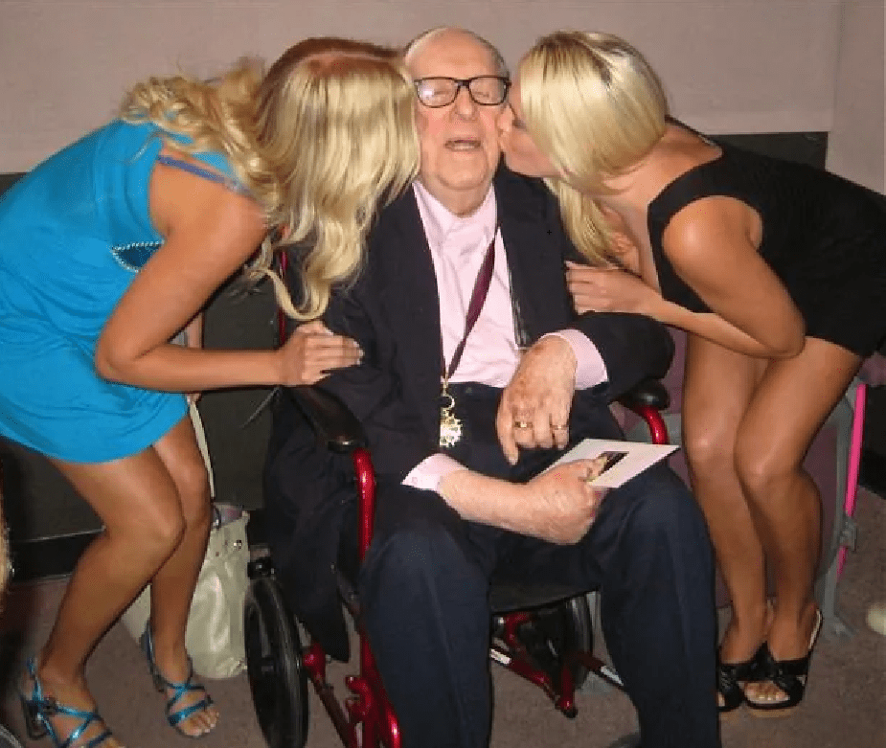

The Wind, Ray Bradbury

The Wind

The phone rang at five-thirty that evening. It was December, and long since dark as Thompson picked up the phone.

“Hello.”

“Hello, Herb?”

“Oh, it’s you, Allin.”

“Is your wife home, Herb?”

“Sure. Why?”

“Damn it.”

Herb Thompson held the receiver quietly. “What’s up? You sound funny.”

“I wanted you to come over tonight.”

“We’re having company.”

“I wanted you to spend the night. When’s your wife going away?”

“That’s next week,” said Thompson. “She’ll be in Ohio for about nine days. Her mother’s sick. I’ll come over then.”

“I wish you could come over tonight.”

“Wish I could. Company and all, my wife’d kill me.”

“I wish you could come over.”

“What’s it? the wind again?”

“Oh, no. No.”

“Is it the wind?” asked Thompson.

The voice on the phone hesitated. “Yeah. Yeah, it’s the wind.”

“It’s a clear night, there’s not much wind.”

“There’s enough. It comes in the window and blows the curtains a little bit. Just enough to tell me.”

“Look, why don’t you come and spend the night here?” said Herb Thompson looking around the lighted hall.

“Oh, no. It’s too late for that. It might catch me on the way over. It’s a damned long distance. I wouldn’t dare, but thanks, anyway. It’s thirty miles, but thanks.”

“Take a sleeping-tablet.”

“I’ve been standing in the door for the past hour, Herb. I can see it building up in the west. There are some clouds there and I saw one of them kind of rip apart. There’s a wind coming, all right.”

“Well, you just take a nice sleeping-tablet. And call me anytime you want to call. Later this evening if you want.”

“Any time?” said the voice on the phone.

“Sure.”

“I’ll do that, but I wish you could come out. Yet I wouldn’t want you hurt. You’re my best friend and I wouldn’t want that. Maybe it’s best I face this thing alone. I’m sorry I bother you.”

“Hell, what’s a friend for? Tell you what you do, sit down and get some writing done this evening,” said Herb. Thompson, shifting from one foot to the other in the hall. “You’ll forget about the Himalayas and the Valley of the Winds and this preoccupation of yours with storms and hurricanes. Get another chapter done on your next travel book.”

“I might do that. Maybe I will, I don’t know. Maybe I will. I might do that. Thanks a lot for letting me bother you.”

“Thanks, hell. Get off the line, now, you. My wife’s calling me to dinner.”

Herb Thompson hung up.

He went and sat down at the supper table and his wife sat across from him. “Was that Allin?” she asked. He nodded. “Him and his winds that blow up and winds that blow down and winds that blow hot and blow cold,” she said, handing him his plate heaped with food.

“He did have a time in the Himalayas, during the war,” said Herb Thompson.

“You don’t believe what he said about that valley, do you?”

“It makes a good story.”

“Climbing around, climbing up things. Why do men climb mountains and scare themselves?”

“It was snowing,” said Herb Thompson.

“Was it?”

“And raining and hailing and blowing all at once, in that valley. Allin’s told me a dozen times. He tells it well. He was up pretty high. Clouds, and all. The valley made a noise.”

“I bet it did,” she said.

“Like a lot of winds instead of just one. Winds from all over the world.” He took a bite. “So says Allin.”

“He shouldn’t have gone there and looked, in the first place,” she said. “You go poking around and first thing you know you get ideas. Winds start getting angry at you for intruding, and they follow you.”

“Don’t joke, he’s my best friend,” snapped Herb Thompson.

“It’s all so silly!”

“Nevertheless he’s been through a lot. That storm in Bombay, later, and the typhoon off New Guinea two months after that. And that time, in Cornwall.”

“I have no sympathy for a man who continually runs into wind storms and hurricanes, and then gets a persecution complex because of it.”

The phone rang just then.

“Don’t answer it,” she said.

“Maybe it’s important.”

“It’s only Allin, again.”

They sat there and the phone rang nine times and they didn’t answer. Finally, it quieted. They finished dinner. Out in the kitchen, the window curtains gently moved in the small breeze from a slightly opened window.

The phone rang again.

“I can’t let it ring,” he said, and answered it. “Oh, hello, Allin.”

“Herb! It’s here! It got here!”

“You’re too near the phone, back up a little.”

“I stood in the open door and waited for it. I saw it coming down the highway, shaking all the trees, one by one, until it shook the trees just outside the house and it dived down toward the door and I slammed the door in its face!”

Thompson didn’t say anything. He couldn’t think of anything to say, his wife was watching him in the hall door.

“How interesting,” he said, at last.

“It’s all around the house, Herb. I can’t get out now, I can’t do anything. But I fooled it, I let it think it had me, and just as it came down to get me I slammed and locked the door! I was ready for it, I’ve been getting ready for weeks.”

“Have you, now; tell me about it, Allin, old man.” Herb Thompson played it jovially into the phone, while his wife looked on and his neck began to sweat.

“It began six weeks ago. . . .”

“Oh, yes? Well, well.”

“. . . I thought I had it licked. I thought it had given up following and trying to get me. But it was just waiting. Six weeks ago I heard the wind laughing and whispering around the corners of my house, out here. Just for an hour or so, not very long, not very loud. Then it went away.”

Thompson nodded into the phone. “Glad to hear it, glad to hear it.” His wife stared at him.

“It came back, the next night. It slammed the shutters and kicked sparks out of the chimney. It came back five nights in a row, a little stronger each time. When I opened the front door, it came in at me and tried to pull me out, but it wasn’t strong enough. Tonight it is.”

“Glad to hear you’re feeling better,” said Thompson.

“I’m not better, what’s wrong with you? Is your wife listening to us?”

“Yes.”

“Oh, I see. I know I sound like a fool.”

“Not at all. Go on.”

Thompson’s wife went back into the kitchen. He relaxed. He sat down on a little chair near the phone. “Go on, Allin, get it out of you, you’ll sleep better.”

“It’s all around the house now, like a great big vacuum machine nuzzling at all the gables. It’s knocking the trees around.”

“That’s funny, there’s no wind here. Allin.”

“Of course not, it doesn’t care about you, only about me.”

“I guess that’s one way to explain it.”

“It’s a killer, Herb, the biggest damnedest prehistoric killer that ever hunted prey. A big sniffling hound, trying to smell me out, find me. It pushes its big cold nose up to the house, taking air, and when it finds me in the parlor it drives its pressure there, and when I’m in the kitchen it goes there. It’s trying to get in the windows, now, but I had them reinforced and I put new hinges on the doors, and bolts.

It’s a strong house. They built them strong in the old days. I’ve got all the lights in the house on, now. The house is all lighted up, bright. The wind followed me from room to room, looking through all the windows, when I switched them on. Oh!”

“What’s wrong?”

“It just snatched off the front screen door!”

“I wish you’d come over here and spend the night, Allin.”

“I can’t! God, I can’t leave the house. I can’t do anything. I know this wind. Lord, it’s big and it’s clever. I tried to light a cigarette a moment ago, and a little draft sucked the match out. The wind likes to play games, it likes to taunt me, it’s taking its time with me; it’s got all night.

And now! God, right now, one of my old travel books, on the library table, I wish you could see it. A little breeze from God knows what small hole in the house, the little breeze is—blowing the pages one by one. I wish you could see it. There’s my introduction. Do you remember the introduction to my book on Tibet, Herb?”

“Yes.”

“This book is dedicated to those who lost the game of elements, written by one who has seen, but who has always escaped.”

“Yes, I remember.”

“The lights have gone out!”

The phone crackled.

“The power lines just went down. Are you there, Herb?”

“I still hear you.”

“The wind doesn’t like all that light in my house, it tore the power lines down. The telephone will probably go next. Oh, it’s a real party, me and the wind, I tell you! Just a second.”

“Allin?” A silence. Herb leaned against the mouthpiece. His wife glanced in from the kitchen. Herb Thompson waited. “Allin?”

“I’m back,” said the voice on the phone. “There was a draft from the door and I shoved some wadding under it to keep it from blowing on my feet. I’m glad you didn’t come out after all, Herb, I wouldn’t want you in this mess. There! It just broke one of the living room windows and a regular gale is in the house, knocking pictures off the wall! Do you hear it?”

Herb Thompson listened. There was a wild sirening on the phone and a whistling and banging. Allin shouted over it. “Do you hear it?”

Herb Thompson swallowed dryly. “I hear it.”

“It wants me alive, Herb. It doesn’t dare knock the house down in one fell blow. That’d kill me. It wants me alive, so it can pull me apart, finger by finger. It wants what’s inside me. My mind, my brain. It wants my life-power, my psychic force, my ego. It wants intellect.”

“My wife’s calling me, Allin. I have to go wipe the dishes.”

“It’s a big cloud of vapors, winds from all over the world. The same wind that ripped the Celebes a year ago, the same pampero that killed in Argentina, the typhoon that fed on Hawaii, the hurricane that knocked the coast of Africa early this year.

It’s part of all those storms I escaped. It followed me from the Himalayas because it didn’t want me to know what I know about the Valley of the Winds where it gathers and plans its destruction. Something, a long time ago, gave it a start in the direction of life. I know its feeding grounds, I know where it is born and where parts of it expire.

For that reason, it hates me; and my books that tell how to defeat it. It doesn’t want me preaching anymore. It wants to incorporate me into its huge body, to give it knowledge. It wants me on its own side!”

“I have to hang up, Allin, my wife—”

“What?” A pause, the blowing of the wind in the phone, distantly. “What did you say?”

“Call me back in about an hour, Allin.”

He hung up.

He went out to wipe the dishes. His wife looked at him and he looked at the dishes, rubbing them with a towel.

“What’s it like out tonight?” he said.

“Nice. Not very chilly. Stars,” she said. “Why?”

“Nothing.”

The phone rang three times in the next hour. At eight o’clock the company arrived, Stoddard and his wife. They sat around until eight-thirty talking and then got out and set up the card table and began to play Gin.

Herb Thompson shuffled the cards over and over, with a clittering, shuttering effect and clapped them out, one at a time before the three other players. Talk went back and forth. He lit a cigar and made it into a fine gray ash at the tip, and adjusted his cards in his hand and on occasion lifted his head and listened. There was no sound outside the house. His wife saw him do this, and he cut it out immediately, and discarded a Jack of Clubs.

He puffed slowly on his cigar and they all talked quietly with occasional small eruptions of laughter, and the clock in the hall sweetly chimed nine o’clock.

“Here we all are,” said Herb Thompson, taking his cigar out and looking at it reflectively. “And life is sure funny.”

“Eh?” said Mr. Stoddard.

“Nothing, except here we are, living our lives, and some place else on earth a billion other people live their lives.”

“That’s a rather obvious statement.”

“Life,” he put his cigar back in his lips, “is a lonely thing. Even with married people. Sometimes when you’re in a person’s arms you feel a million miles away from them.”

“I like that,” said his wife.

“I didn’t mean it that way,” he explained, not with haste; because he felt no guilt, he took his time. “I mean we all believe what we believe and live our own little lives while other people live entirely different ones. I mean, we sit here in this room while a thousand people are dying. Some of cancer, some of pneumonia, some of tuberculosis. I imagine someone in the United States is dying right now in a wrecked car.”

“This isn’t very stimulating conversation,” said his wife.

“I mean to say, we all live and don’t think about how other people think or live their lives or die. We wait until death comes to us. What I mean is here we sit, on our self-assured butt-bones, while, thirty miles away, in a big old house, completely surrounded by night and God-knows-what, one of the finest guys who ever lived is—”

“Herb!”

He puffed and chewed on his cigar and stared blindly at his cards. “Sorry.” He blinked rapidly and bit his cigar. “Is it my turn?”

“It’s your turn.”

The playing went around the table, with a flittering of cards, murmurs, conversation. Herb Thompson sank lower into his chair and began to look ill.

The phone rang. Thompson jumped and ran to it and jerked it off the hook.

“Herb! I’ve been calling and calling. What’s it like at your house, Herb?”

“What do you mean, what’s it like?”

“Has the company come?”

“Hell, yes, it has—”

“Are you talking and laughing and playing cards?”

“Christ, yes, but what has that got to do with—”

“Are you smoking your ten-cent cigar?”

“God damn it, yes, but . . .”

“Swell,” said the voice on the phone. “That sure is swell. I wish I could be there. I wish I didn’t know the things I know. I wish lots of things.”

“Are you all right?”

“So far, so good. I’m locked in the kitchen now. Part of the front wall of the house blew in. But I planned my retreat. When the kitchen door gives, I’m heading for the cellar. If I’m lucky I may hold out there until morning. It’ll have to tear the whole damned house down to get to me, and the cellar floor is pretty solid. I have a shovel and I may dig—deeper. . . .”

It sounded like a lot of other voices on the phone.

“What’s that?” Herb Thompson demanded, cold, shivering.

“That?” asked the voice on the phone. “Those are the voices of twelve thousand killed by a typhoon, seven thousand killed by a hurricane, three thousand buried by a cyclone. Am I boring you?

That’s what the wind is. It’s a lot of people dead. The wind killed them, took their minds to give itself intelligence. It took all their voices and made them into one voice. All those millions of people killed in the past ten thousand years, tortured and run from continent to continent on the backs and in the bellies of monsoons and whirlwinds. Oh Christ, what a poem you could write about it!”

The phone echoed and rang with voices and shouts and whinings.

“Come on back, Herb,” called his wife from the card table.

“That’s how the wind gets more intelligent each year, it adds to itself, body by body, life by life, death by death.”

“We’re waiting for you, Herb,” called his wife.

“Damn it!” He turned, almost snarling. “Wait just a moment, won’t you!” Back to the phone. “Allin, if you want me to come out there now, I will! I should have come earlier . . .”

“Wouldn’t think of it. This is a grudge fight, wouldn’t do to have you in it now. I’d better hang up. The kitchen door looks bad; I’ll have to get in the cellar.”

“Call me back, later?”

“Maybe, if I’m lucky. I don’t think I’ll make it. I slipped away and escaped so many times, but I think it has me now. I hope I haven’t bothered you too much, Herb.”

“You haven’t bothered anyone, damn it. Call me back.”

“I’ll try. . . .”

Herb Thompson went back to the card game. His wife glared at him. “How’s Allin, your friend?” she asked, “Is he sober?”

“He’s never taken a drink in his life,” said Thompson, sullenly, sitting down. “I should have gone out there hours ago.”

“But he’s called every night for six weeks and you’ve been out there at least ten nights to stay with him and nothing was wrong.”

“He needs help. He might hurt himself.”

“You were just out there, two nights ago, you can’t always be running after him.”

“First thing in the morning I’ll move him into a sanatorium. Didn’t want to. He seems so reasonable otherwise.”

At ten-thirty coffee was served. Herb Thompson drank his slowly, looking at the phone. I wonder if he’s in the cellar now, he thought.

Herb Thompson walked to the phone, called long-distance, gave the number.

“I’m sorry,” said the operator. “The lines are down in that district. When the lines are repaired, we will put your call through.”

“Then the telephone lines are down!” cried Thompson. He let the phone drop. Turning, he slammed open the closet door, pulled out his coat. “Oh Lord,” he said. “Oh, Lord, Lord,” he said, to his amazed guests and his wife with the coffee urn in her hand. “Herb!” she cried. “I’ve got to get out there!” he said, slipping into his coat.

There was a soft, faint stirring at the door.

Everybody in the room tensed and straightened up.

“Who could that be?” asked his wife.

The soft stirring was repeated, very quietly.

Thompson hurried down the hall where he stopped, alert.

Outside, faintly, he heard laughter.

“I’ll be damned,” said Thompson. He put his hand on the doorknob, pleasantly shocked and relieved. “I’d know that laugh anywhere. It’s Allin. He came on over in his car, after all. Couldn’t wait until morning to tell me his confounded stories.” Thompson smiled weakly. “Probably brought some friends with him. Sounds like a lot of other . . .”

He opened the front door.

The porch was empty.

Thompson showed no surprise; his face grew amused and sly. He laughed. “Allin? None of your tricks now! Come on.” He switched on the porch light and peered out and around. “Where are you, Allin? Come on, now.”

A breeze blew into his face.

Thompson waited a moment, suddenly chilled to his marrow. He stepped out on the porch and looked uneasily, and very carefully, about.

A sudden wind caught and whipped his coat flaps, disheveled his hair. He thought he heard laughter again. The wind rounded the house and was a pressure everywhere at once, and then, storming for a full minute, passed on.

The wind died down, sad, mourning in the high trees, passing away; going back out to the sea, to the Celebes, to the Ivory Coast, to Sumatra and Cape Horn, to Cornwall and the Philippines. Fading, fading, fading.

Thompson stood there, cold. He went in and closed the door and leaned against it, and didn’t move, eyes closed.

“What’s wrong . . .?” asked his wife.

The End