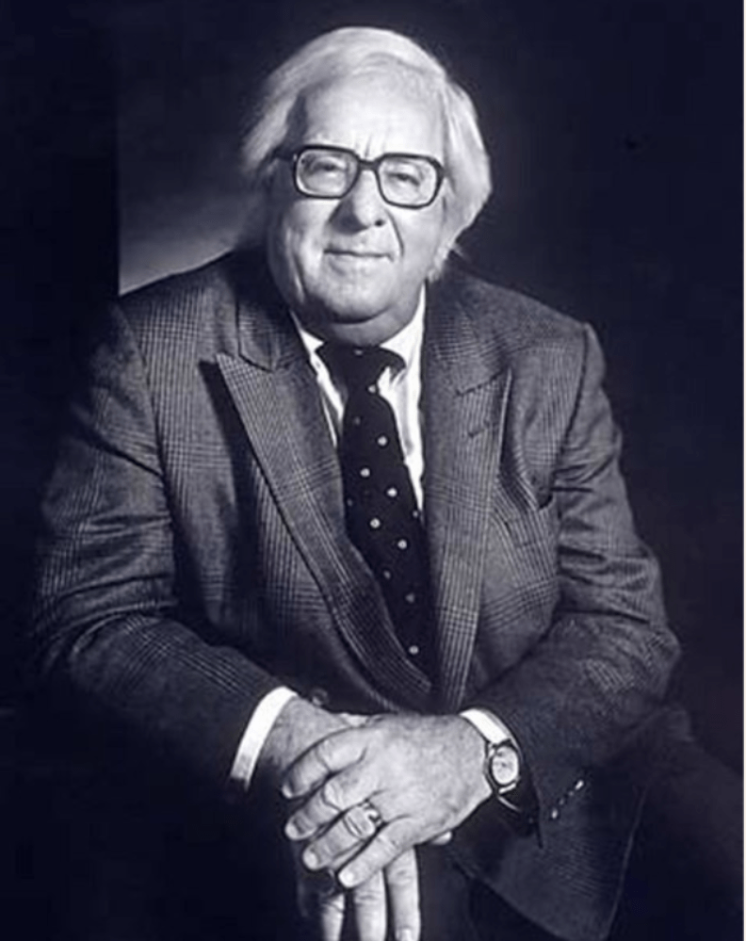

Uncle Einar, Ray Bradbury

Uncle Einar

"It will take only a minute," said Uncle Einar's good wife.

"I refuse," he said. "And that takes me one second!"

"I've worked all morning," she said. "And you refuse to help? It's about to rain."

"Let it rain," he cried. "I'll not be struck by lightning just to air your clothes."

"But you're so quick at it," she said.

"Again, I refuse." His vast tarpaulin wings hummed nervously behind his back.

She gave him a slender rope on which were tied two dozen fresh-washed clothes. He turned it in his fingers with distaste in his eyes. "So it's come to this," he muttered, bitterly. "To this, to this, to this."

After all the days and weeks of Cecy searching the winds and seeing the land and finding the farms that were not quite right, she at last had found an empty farm, with the people gone and the house deserted. Cecy sent him here on a long transit to search for a possible wife and refuge from a disbelieving world, and here he was, stranded.

"Don't cry; you'll wet the clothes down again," she said. "Jump now, run them up and it'll be finished in a jiffy."

"Run them up," he said in mockery, both hollow and terribly wounded. "Let it thunder, let it pour!"

"If it was a nice sunny day I wouldn't ask," she said. "All my washing gone for nothing. They'll hang about the house"

That did it. If it was anything he hated it was clothes flagged and festooned so a man had to creep under them on the way across a room. He boomed his vast wings.

"But only as far as the pasture fence," he said.

"Only!" she cried.

Whirl … and up he jumped, his wings cleaving and loving the cool air, to roar low across the farmland, trailing the line of clothes in a vast fluttering loop, drying them in the pounding concussion and backwash from his wings.

"Catch!"

A minute later, returned, he sailed the clothes, dry as fresh wheat, down on a series of clean blankets she'd laid out.

"Much thanks!" she cried.

"Gahh!" he shouted, and flew off to brood under the sour-apple tree.

Uncle Einar's beautiful silklike wings hung like sea-green sails behind him and whirred and whispered from his shoulders when he sneezed or turned around swiftly.

Did he hate his wings? Far from it. In his youth he'd always flown nights. Nights were the times for winged men. Daylight held dangers, always had, always would, but night, ah, night, he had sailed over far lands and farther seas. With no danger to himself. It had been a rich, full flying and an exhilaration.

But now he could not fly at night.

On his way here to this damnable, luckless farm he had drunk too much rich crimson wine. "I'll be all right," he had told himself, blearily, as he beat his long way under the morning stars, over the moon-dreaming country hills. And then crack out of the sky

God's or the Universe's bolt of blue lightning! A high tension tower, invisible till the last second against the dark bowl of night.

Like a netted duck! A great sizzling! His face was blown black by blazed St. Elmo's fires. He fended off the fire with a terrific back-jumping percussion of his wings, and fell.

His hitting the moonlit meadow made a noise like a huge telephone book dropped from the sky.

Early the next morning, his dew-sodden wings shaking violently, he arose. It was still dark. There was a faint bandage of dawn stretched across the east. Soon the bandage would stain and all flight would be restricted. There was nothing to do but take refuge in the forest and wait out the day in the deepest thicket until another night gave his wings a hid-den movement in the sky.

In this fashion his future wife found him.

During the day, which was warm, young Brunilla Wexley was out to udder a lost cow, for she carried a silver pail in one hand as she sidled through thickets and pleaded cleverly to the unseen cow to please return home or burst her gut with unplucked milk.

The fact that the cow would have most certainly come home when her teats really needed pulling did not concern Brunilla Wexley. It was a sweet excuse for forest-journeying, thistle-blowing, and dandelion-chewing, all of which Brunilla was doing when she stumbled upon Uncle Einar.

Asleep near a bush, he seemed a man under a green shelter.

"Oh," said Brunilla, with a fever. "A man. In a camp-tent."

Uncle Einar awoke. The camp-tent spread like a large green fan behind him.

"Oh," said Brunilla, the cow-searcher. "A man with wings, Yes, yes, at last. Cecy said she would send you! It's Einar, yes?!"

It was a fancy thing to see a winged man and she was proud to meet him. She began to talk to him and in an hour they were old friends, and in two hours she'd quite forgotten his wings were there.

"You look banged around," she said. "That right wing looks very bad. You'd best let me fix it. You won't be able to fly on it, anyway. Did Cecy tell you I live alone with my children? I'm an astrologer of sorts, most peculiar, strange, almost psychic. And, as you see, quite ugly."

He insisted she was not, and he didn't mind the psychic. But wasn't she afraid of him? he asked.

"Jealous would be more near it," she said. "May I?" And she stroked his large, green, membraned veils with careful envy. He shuddered at the touch and put his tongue between his teeth.

So there was nothing for it but that he come to her house and have an ointment on that bruise, and my! what a burn across his face, beneath his eyes.

"Lucky you weren't blinded," she said. "How'd it happen?"

"I dared the heavens!" he said, and they were at her farm, hardly noticing they'd walked a mile, watchful of each other.

Well, a day passed, and another. The day came that he thanked her at her door and said he must be going. After all, Cecy wanted him to meet a number of other possible ladies in the far country before he decided where to tarpaulin-fold his wings and settle in.

It was twilight, and he must travel many miles to a farm farther on.

"Thank you, and goodbye," he said, as he unfurled his wings and started to fly off in the dusk … and crashed straight on into a maple tree.

"Oh!" she cried, and ran to stand over his unconscious body.

That did it. When he waked the next hour he knew he'd fly no nights ever again. His delicate night-perception was gone. The winged telepathy that told him where towers, trees, and wires stood across his path; the fine, clear vision and mentality that guided him 'twixt cliff, pole, and pine all of it was gone. And Cecy's distant voice, no help. That crack across his face, the blue electrical flames, had sloughed off his perceptions, perhaps forever.

"How'm I to fly back to Europe?" he groaned, pitifully. "If I want someday to fly there!"

"Oh," Brunilla Wexley said, studying the floor. "Who wants Europe?"

And so they were married. The ceremony was brief, if a little inverted and dark and mildly different to Brunilla, but it ended well. Uncle Einar stood with his fresh bride thinking that he didn't dare fly back to Europe in the daytime, which was the only time he could safely see now, for fear of being seen and shot; but it didn't matter any more, for with Brunilla beside him, Europe had less and less fascination for him.

He didn't have to see very well to fly straight up, or come down. So it was only natural that on their wedding night he gathered Brunilla and soared straight up in the clouds.

A farmer, five miles over, glanced at the sky about midnight and saw faint glows and crackles.

"Heat lightnin'," he figured.

They didn't come back down until dawn with the dew.

The marriage took. She was so wing-proud of him, it lifted her to think she was the only woman in the world married to a winged man. "Who else could say it?" she asked her mirror. And the answer was: "No one!"

He, on the other hand, found great beauty behind her face, great kindness and understanding. He made some changes in his diet to fit her thinking, and was careful that his wings did not knock porcelains and spill lamps.

He also changed his sleeping habits, since he couldn't fly nights anyhow. And she in turn fixed chairs so they were comfortable for his wings and said things he loved to hear. "We're all in cocoons," she said. "I'm plain bread. But one day I'll break out wings as fine and handsome as yours!"

"You broke out long ago," he said.

"Yes," she had to admit. "I know just which day it was. In the woods when I looked for a cow and found a camp-tent!" And they laughed, and in that moment a hidden beauty slipped her from her homeliness, like a sword from its case.

As for her fatherless children, three boys and a girl, who, for their energy, seemed to have wings, they popped up like toadstools on hot summer days to ask Uncle Einar to sit under the apple tree and fan them with his cooling wings and tell them wild starlit tales of youth and sky excursions. So he told them of the winds and cloud textures, and what a star feels like melting in your mouth, and the taste of high mountain air, and how it feels to be a pebble dropped from Mt. Everest, turning to a green bloom, flowering your wings just before striking the ageless snow!

This was his marriage, then.

And today, here sat Uncle Einar, fostering under the tree, grown impatient and unkind; not because this was his desire, but because after the long wait, his night-flight sense had never returned. Here he sat despondently, resembling a green summer sun-parasol, abandoned for the season by reckless vacationers who once sought refuge under its spread shadow. Was he to sit here forever, afraid to fly, save as a clothes-drier for his good wife, or a fanner of children on hot August noons? Ye gods! Think!

His one occupation, flight, running family errands, quicker than storms, faster than telegraphs. Like a boomerang he'd whickled over hills and valleys and like a thistle landed.

But now? Bitterness! His wings quivered behind him.

"Papa, fan us," said his small daughter.

The children stood before him, looking up at his dark face.

"No," he said.

"Fan us, Papa," said the honorable new son.

"It's a cool day, there'll soon be rain," said Uncle Einar.

"There's a wind blowing, Papa. The wind'll blow the clouds way," said the second, very small son.

"Will you come watch us, Papa?"

"Run on, run on," Einar told them. "Let Papa brood."

Again he thought of old skies, night skies, cloudy skies, all kinds of skies. Was it to be his fate to scull pastures in fear of being seen breaking wing on the silo, or cracking up on a kindling fence? Gah!

"Come watch us, Papa," said the girl.

"We're goin' to the hill," said one boy. "With all the kids from town."

Uncle Einar chewed his knuckles. "What hill's that?"

"The Kite Hill, of course!" they sang together.

Now he examined the three.

They each held large paper kites against their gasping bosoms, their faces bathed with anticipation and animal glowing. In their small fingers were balls of white twine. From the kites, colored red, blue, yellow, and green, hung appendages of cotton and silk strips.

"We'll fly our kites! Come see!"

"No," he said. "I'd be seen!"

"You could hide and watch from the woods. We want you to see."

"The kites?" he said.

"Made 'em ourselves. Just because we know how."

"How do you know how?"

"You're our papa!" was the instant cry. "That's how!"

He looked from one to the second to the third. "A kite festival, is it?"

"Yes, sir!"

"I'm going to win," said the girl.

"No, me!" the boys contradicted. "Me, me!"

"God!" roared Uncle Einar. He leaped up with a deafening kettledrum of wings. "Children! Children, I love you, I love you!"

"What? What's wrong?" The children backed off.

"Nothing!" chanted Einar, flexing his wings to their greatest propulsion and plundering. Whoom! they whammed together like cymbals and the children fell flat in the backwash! "I have it, I have it! I'm free again, free! Fire in the flue! Feather on the wind! Brunilla!" He called to the house. She stuck her head out.

"I'm free!" he cried, flushed and tall. "Listen! I don't need the night! I can fly by day, now! I don't need the night! I'll fly every day and any day of the year from now on, and nobody'll know, and nobody'll shoot me down, and, and but, God, I waste time! Look!"

And as the shocked members of his family watched he seized the cotton tail from one of the kites, tied it to his belt, grabbed the twine ball and gripped one end between his teeth, gave the other end to his children, and up, up into the air he flew, away into the wind!

And across the meadows and over the farms his daughter and sons ran, feeding out string into the daylit sky, shrieking and stumbling, and Brunilla stood out on the farm porch and waved and laughed to know that from now on her family would run and fly in joy.

The children pell-melled to the far Kite Hill and stood, the three of them, holding the ball of twine in their eager, proud fingers, each tugging, directing, pulling.

The children from town came running with their small kites to let up on the wind, and they saw the great green kite dipping and hovering in the sky and they exclaimed:

"Oh, oh, what a kite! Oh, oh! I wish I had a kite like that! Oh, what a kite! Where'd you get it!?"

"Our father made it!" cried the honorable daughter and the two fine sons, and gave an exultant pull on the twine and the humming, thundering kite in the sky flew and soared and wrote a great and magical exclamation mark across a cloud!

The End