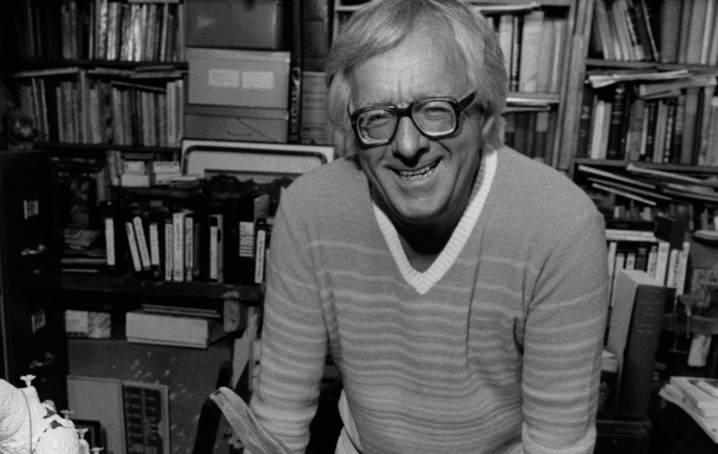

When the Bough Breaks, Ray Bradbury

When the Bough Breaks

The night was cold and there was a slight wind which had begun to rise around two in the morning.

The leaves in all the trees outside began to tremble.

By three o’clock the wind was constant and murmuring outside the window.

She was the first to open her eyes.

And then, for some imperceptible reason, he stirred in his half sleep.

‘You awake?’ he said.

‘Yes,’ she said. ‘There was a sound, something called.’

He half raised his head.

A long way off there was a soft wailing.

‘Hear that?’ she asked.

‘What?’

‘Something’s crying.’

‘Something?’ he said.

‘Someone,’ she said. ‘It sounds like a ghost.’

‘My God, what a thing. What time is it?’

‘Three in the morning. That terrible hour.’

‘Terrible?’ he said.

‘You know Dr Meade told us at the hospital that that’s the one hour when people just give up, they don’t keep trying anymore. That’s when they die. Three in the morning.’

‘I’d rather not think about that,’ he said.

The sound from outside the house grew louder.

‘There it is again,’ she said. ‘That sounds like a ghost.’

‘Oh my God,’ he whispered. ‘What kind of ghost?’

‘A baby,’ she said. ‘A baby crying.’

‘Since when do babies have ghosts? Have we known any babies recently that died?’ He made a soft sound of laughter.

‘No,’ she said, and shook her head back and forth. ‘But maybe it’s not the ghost of a baby that died, but…I don’t know. Listen.’

He listened and the crying came again, a long way off.

‘What if—’ she said.

‘Yes?’

‘What if it’s the ghost of a child—’

‘Go on,’ he said.

‘That hasn’t been born yet.’

‘Are there such ghosts? And can they make sounds? My God, why do I say that? What a strange thing to say.’

‘The ghost of a baby that hasn’t been born yet.’

‘How can it have a voice?’ he said.

‘Maybe it’s not dead, but just wants to live,’ she said. ‘It’s so far off, so sad. How can we answer it?’

They both listened and the quiet cry continued and the wind wailed outside the window.

Listening, tears came into her eyes and, listening, the same thing happened to him.

‘I can’t stand this,’ he said. ‘I’m going to get up and get something to eat.’

‘No, no,’ she said, and took his hand and held it. ‘Be very quiet and listen. Maybe we’ll get answers.’

He lay back and held her hand and tried to shut his eyes, but could not.

They both lay in bed and the wind continued murmuring, and the leaves shook outside the window.

A long way off, a great distance off, the sound of weeping went on and on.

‘Who could that be?’ she said. ‘Whatcould that be? It won’t stop. It makes me so sad. Is it asking to be let in?’

‘Let in?’ he said.

‘To live. It’s not dead, it’s never lived, but it wants to live. Do you think—’ She hesitated.

‘What?’

‘Oh my God,’ she said. ‘Do you think the way we talked a month ago…?’

‘What talk was that?’ he said.

‘About the future. About our not having a family. No family. Nochildren.’

‘I don’t remember,’ he said.

‘Try to,’ she said. ‘We promised each other no family, no children.’ She hesitated and then added, ‘No babies.’

‘No children. No babies?’

‘Do you think—’ She raised her head and listened to the crying outside the window, far away, through the trees, across the country. ‘Can it be that—’

‘What?’ he said.

‘I think,’ she said, ‘that I know a way to stop that crying.’

He waited for her to continue.

‘I think that maybe—’

‘What?’ he said.

‘Maybe you should come over on this side of the bed.’

‘Are you asking me over?’

‘I am, yes, please, come over.’

He turned and looked at her and finally rolled completely over toward her. A long way off the town clock struck three-fifteen, then three-thirty, then three forty-five, then four o’clock.

Then they both lay, listening.

‘Do you hear?’ she said.

‘I’m listening.’

‘The crying.’

‘It’s stopped,’ he said.

‘Yes. That ghost, that child, that baby, that crying, thank God it stopped.’

He held her hand, turned his face toward her, and said, ‘We stopped it.’

‘We did,’ she said. ‘Oh yes, thank God, we stopped it.’

The night was very quiet. The wind began to die. The leaves on the trees outside stopped trembling.

And they lay in the night, hand in hand, listening to the silence, the wonderful silence, and waited for the dawn.

The End