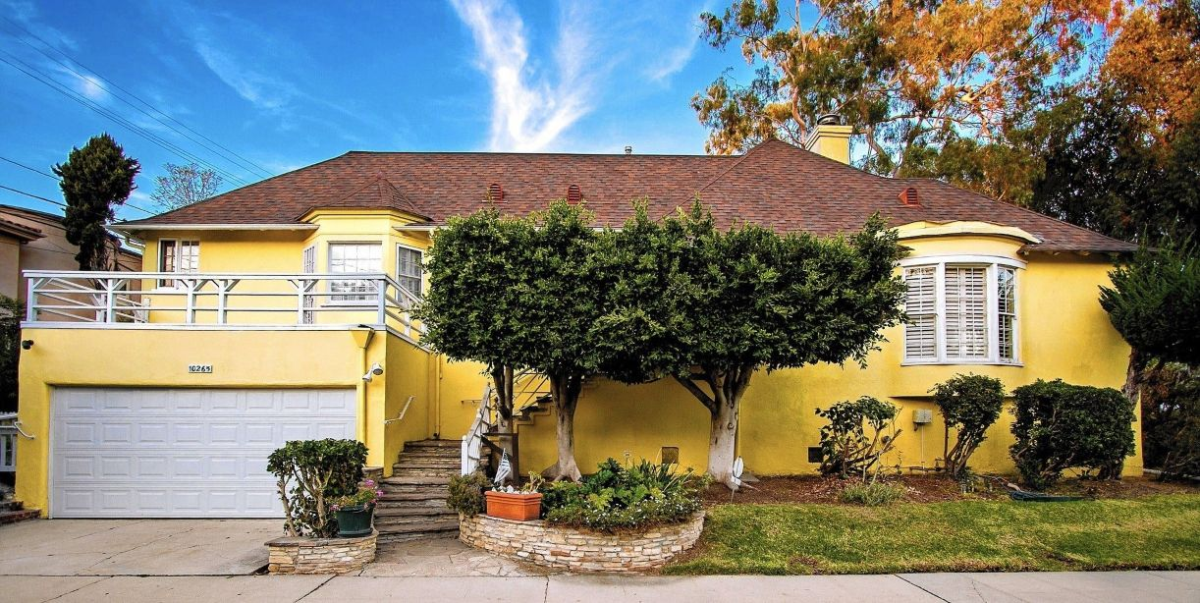

Christus Apollo, Ray Bradbury

Christus Apollo

Cantata Celebrating The Eighth Day Of Creation And The Promise Of The Ninth

A Voice spoke in the dark,

And there was Light.

And summoned up by Light upon the Earth

The creatures swam

And moved unto the land

And lived in garden wilderness;

All this, we know.

The Seven Days are written in our blood

With hand of Fire.

And now we children of the seven eternal days

Inheritors of this, the Eighth Day of God,

The long Eighth Day of Man,

Stand upright in a weather of Time

In downfell snow

And hear the birds of morning

And much want wings

And look upon the beckonings of stars,

And need their fire.

In this time of Christmas,

We celebrate the Eighth Day of Man,

The Eighth Day of God,

Two billion years unending

From the first sunrise on Earth

To the last sunrise at our Going Away.

And the Ninth Day of the History of God

And the flesh of God which names itself Man

Will be spent on wings of fire

Claimed from sun and far burnings of sun starlight.

And the Ninth Day's sunrise

Will show us forth in light and wild surmise

Upon an even further shore.

We seek new Gardens there to know ourselves.

We seek new Wilderness,

And send us forth in wandering search.

Apollo's missions move, and Christus seek,

And wonder as we look among the stars

Did He know these?

In some far universal Deep

Did He tread Space

And visit worlds beyond our blood-warm dreaming?

Did He come down on lonely shore by sea

Not unlike Galilee

And are there Mangers on far worlds that knew His light?

And Virgins?

Sweet Pronouncements?

Annunciations?

Visitations from angelic hosts?

And, shivering vast light among ten billion lights,

Was there some Star much like the star at Bethlehem

That struck the sight with awe and revelation

Upon a cold and most strange morn?

On worlds gone wandering and lost from this

Did Wise Men gather in the dawn

In cloudy steams of Beast

Within a place of straw now quickened to a Shrine

To look upon a stranger Child than ours?

How many stars of Bethlehem burnt bright

Beyond Orion or Centauri's blinding arc?

How many miracles of birth all innocent

Have blessed those worlds?

Does Herod tremble there

In dread facsimile of our dark and murderous King?

Does that mad keeper of an unimaginable realm

Send stranger soldiers forth

To slaughter down the Innocents

Of lands beyond the Horsehead Nebula?

It must be so.

For in this time of Christmas

In the long Day totalling up to Eight,

We see the light, we know the dark;

And creatures lifted, born, thrust free of so much night

No matter what the world or time or circumstance

Must love the light,

So, children of all lost unnumbered suns

Must fear the dark

Which mingles in a shadowing-forth on air.

And swarms the blood.

No matter what the color, shape, or size

Of beings who keep souls like breathing coals

In long midnights,

They must need saving of themselves.

So on far worlds in snowfalls deep and clear

Imagine how the rounding out of some dark year

Might celebrate with birthing one miraculous child!

A child?

Born in Andromeda's out-swept mysteries?

Then count its hands, its fingers,

Eyes, and most incredible holy limbs!

The sum of each?

No matter. Cease.

Let Child be fire as blue as water under Moon.

Let Child sport free in tides with human-seeming fish.

Let ink of octopi inhabit blood

Let skin take acid rains of chemistry

All falling down in nightmare storms of cleansing burn.

Christ wanders in the Universe

A flesh of stars,

He takes on creature shapes

To suit the mildest elements,

He dresses him in flesh beyond our ken.

There He walks, glides, flies, shambling of strangeness.

Here He walks Men.

Among the ten trillion beams

A billion Bible scrolls are scored

In hieroglyphs among God's amplitudes of worlds;

In alphabet multitudinous

Tongues which are not quite tongues

Sigh, sibilate, wonder, cry:

As Christ comes manifest from a thunder-crimsoned sky.

He walks upon the molecules of seas

All boiling stews of beast

All maddened broth and brew and rising up of yeast.

There Christ by many names is known.

We call him thus.

They call him otherwise.

His name on any mouth would be a sweet surprise.

He comes with gifts for all,

Here: wine and bread.

There: nameless foods

At breakfasts where the morsels fall from stars

And Last Suppers are doled forth with stuff of dreams.

So sit they there in times before the Man is crucified.

Here He has long been dead.

There He has not yet died.

Yet, still unsure, and all being doubt,

Much frightened man on Earth does cast about

And clothe himself in steel

And borrow fire

And himself in the great glass of the careless Void admire.

Man builds him rockets

And on thunder strides

In humble goings-forth

And most understandable prides.

Fearing that all else slumbers,

That ten billion worlds lie still,

We, grateful for the Prize and benefit of life,

Go to offer bread and harvest wine;

The blood and flesh of Him we Will

To other stars and worlds about those stars.

We cargo holy flesh

On stranger visitations,

Send forth angelic hosts,

To farflung worlds

To tell our walking on the waters of deep Space,

Arrivals, swift departures

Of most miraculous man

Who, God fuse-locked in every cell

Beats holy blood

And treads the tidal flood

And ocean shore of Universe,

A miracle of fish

We father, gather, build and strew

In metals to the winds

That circle Earth and wander Night beyond till Nights.

We soar, all arch-angelic, fire-sustained

In vast cathedral, aery apse, in domeless vault

Of constellations all blind dazzlement.

Christ is not dead

Nor does God sleep

While waking Man

Goes striding on the Deep

To birth ourselves anew

And love rebirth

From fear of straying long

On outworn Earth.

One harvest in, we broadcast seed for further reaping.

Thus ending Death And Night,

And Time's demise,

And senseless weeping.

We seek for mangers in the Pleides

Where man the god-fleshed wandering babe

May lay him down with such as these

Who once drew round and worshipped innocence.

New Mangers lie waiting!

New Wise men Descry

Our hosts of machineries

Which write immortal life

And sign it God!

Down, down Alien skies.

And flown and gone, arrived and bedded safe to sleep

Upon some winters morning deep

Ten billion years of light

From where we stand us now and sing,

There will be time to cry eternal gratitudes

Time to know and see and love the Gift of Life itself,

Always diminished,

Always restored,

Out of one hand and into the other

Of the Lord.

Then wake we in that far lost

Nightmare keep of Beast

And see our star recelebrated in an East

Beyond all Easts.

Beyond a snowdrift sifting down of stars.

In this time of Christmas

Think on that: Morn ahead!

For this let all your fears, your cries,

Your tears, your blood and prayers be shed!

All numb and wild one day

You shall be reborn

And hear the Trump break forth from rocket-trembled air

All humbled, all shorn O

f pride, but free of despair.

Now listen! Now hear!

It is the Ninth Day's morn!

Christ is risen!

God survives!

Gather, Universe!

Look, ye stars!

In the exultant; countries of Space

In a sudden simple pasture

Far beyond Andromeda!

O Glory, Glory, a New Christmas

Torn

From the very pitch and rim of Death,

Snatched from his universal grip,

His teeth, his most cold breath!

Under a most strange sun

O Christ, O God,

O man breathed out of most incredible stuffs,

You are the Savior's Savior,

God's pulse and heart-companion,

You! The Host He lifts

On high to consecrate;

His dear need to know and touch and cry wonders

At Himself.

In this time of Christmas

Prepare

In this holy time

Know yourself most rare!

Beyond the vast Abyss

See those men grown Wise

Who gather with their gifts

Which are but Life!

And Life that knows no end.

Behold the rockets, more than chaff, on air,

All seed that save a holy seed

And cast it everywhere in mindless Dark.

In this time of Christmas

This holy time of Christmas,

Like Him, you are God's son!

One Son? Many?

All are gathered now to One

And will wake cradled in Beast-summer breath

That warms the sleeping child to life eternal.

You must go there.

In the long winter of Space

And lie you down in grateful innocence

At last to sleep.

O New Christmas,

O God, far-motioning.

O Christ-of-many-fleshed made one,

Leave Earth!

God Himself cries out.

He Goes to Prepare the Way

For your rebirth

In a new time of Christmas,

A holy time of Christmas,

This New Time of Christmas,

From all this stay?

No, Man. You must not linger, wonder.

No, Christ. You must not pause.

Now.

Now.

It is the Time of Going Away.

Arise, and go.

Be born. Be born.

Welcome the morning of the Ninth Day.

It is the Time of Going away.

Praise God for this Annunciation!

Give praise,

Rejoice!

For the time of Christmas

And the Ninth Day,

Which is Forever's Celebration!

The End