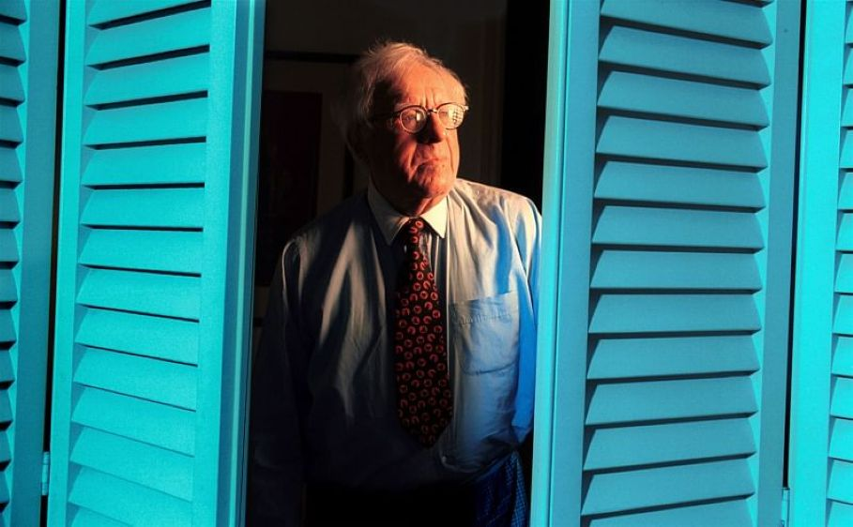

Don't Get Technatal, Ray Bradbury

Don't Get Technatal

Futuria Fantasia (1939)

For several moments Stern had eyed his typewriter ominously, contemplating whether he should utter the unutterable. Finally:

"Damn!" he roared, "I can’t write any more! Look, look at that!" He tore the sheet out of the rollers and crumpled it in his fist. "If I'd known it would be this way," he said, "I wouldn’t have voted for it! Technocracy is ruining everything!"

Bella Stern, preoccupied with her knitting, glanced up in horror. "What a temper," she exclaimed, "Can’t you keep your voice down?" She fussed with her work. "There now," she cried, "you made me drop a stitch!"

"I want to be a writer!" Samuel Stern lamented, turning with grim eyes to his wife. "And the Technate has spoiled my fun."

"The way you talk, Samuel," said his wife, "I actually believe you want to go back to that barbarism prevalent in the DARK THIRTIES!"

"It sounds like one damned good idea!" he said, "At least I'd have something decent, or indecent, to write about!"

"What can you mean?" she asked, tilting her head back and thinking, "Why can’t you write? There are just oodles of things I can think of that are readable."

Something like a tear rolled down Samuel’s cheek, "No more gangsters, no more bank robberies, no more holdups, no more good, old-fashioned burglaries, no more vice gangs!" He voice grew lachrymose as he proceeded down an infinite line of 'no mores’.

"No more sadness," he almost sobbed. "Everybody’s happy, contented. No more strife and hard work. Oh, for the days when a gangland massacre was headline scoop for me!"

"Tush!" sniffed Bella, "Have you been drinking again, Samuel?"

He hiccoughed gently.

"I thought so," she said,

"I had to do something," he declared, "I’m going nuts for want of a plot."

Bella Stern laid her knitting aside and walked to the balcony, looked meditatively down into the yawning canyon of the New York street fifty stories below. She turned back to Sam with a reminiscent smile, "Why not write a love story?"

"WHAT!" Stern shot out of his chair like a hooked eel.

"Why, yes," she concluded, "A nice love story would be very enjoyable."

"LOVE!" Stern’s voice was thick with sarcasm, "Why we don't even have decent love these days. A man can’t marry a woman for her money, and vice-versa. Everyone under Technocracy gets the same amount of credit. No more Reno, no more alimony, no more breach of promise, or law suits!

Everything is cut and dried. The days of society weddings and coming out parties are gone—cause everyone is equal. I can’t write political criticisms about graft in the government, about slums and terrible living conditions, about poor starving mothers and their babies. Everything is okay—okay—okay—" his voice sobbed off into silence.

"Which should make you very happy," countered his wife.

"Which makes me very sick," growled Samuel Stern. "Look, Bell, all my life I wanted to be a writer. Okay. I’m writing for the pulp magazines for a coupla years, Right? Okay. Then I’m writing sea stories, gangsters, political views, first class bump-offs, I’m happy...

I’m in my element, then—bingo! in comes Technocracy, makes everyone happy—bumpo! out goes me! I just can’t stand writing the stuff the people read today. Everything is science and education." He ruffled his thick black hair with his fingers and glared,

"You should be joyful that the population is at work doing what they want to do," Bella beamed.

Sam continued muttering to himself. "They took all the sex magazines off the market first thing, all of the gangster, murder and detective publications. They been educating the children and moving model citizens out of them.”

"Which is as it should be," finished Bella.

"Do you realize," he blazed, whipping, his finger at her, "that for two years there hasn’t been more than dozen murders in the city? Not one suicide or gang war—or—"

"Heavens!" sighed Bella, "Don’t be prehistoric, Sam. There hasn’t been anything really criminal for twenty years now. This is 1975 you know." She came over and patted him gently on the shoulder, "Why don’t you write something science-fictional?"

"I don’t like science," he spat,

"Then your only alternative is love," she declared firmly.

He formed the despicable word with his lips, then: "No, I want something now and different," He got up and strode to the window. In the penthouse below he saw half a dozen robots moving about speedily, working. His face lit up suddenly, like that of a tiger spying his prey, "Jumping Jigwheels!" he cried. "Why didn't I think of it before? Robots! I’ll write a love story about two robots."

Bella squelched him. "Be sensible," she said.

"It might happen some day," he argued, "Just think. Love oiled, welded, built of metal, wired for sound!" He laughed triumphantly, but it was a low laugh, a strange little sound. Bella expected him to beat his chest next. "Robots fall in love at first sight," he announced, "and blow an audio tube!"

Bella smiled tolerantly. "You’re such a child, Sam. I sometimes wonder I married you."

Stern sank down, burning slowly, a crimson flush rising in his face.

Only half a dozen murders in two years, he thought. No more politics, no more to write about. He had to have a story, just had to have one. He’d go crazy if something didn’t happen soon.

His brain was clicking furiously. A calliope of thought was tooting in his subconscious. He had to have a story. He turned and looked at his wife, Bella, who stood watching the air traffic go by the window, bending over the sill, looking down into the street fifty floors below..... .

.....and then he reached slowly and quietly for his atomic gun.

The End