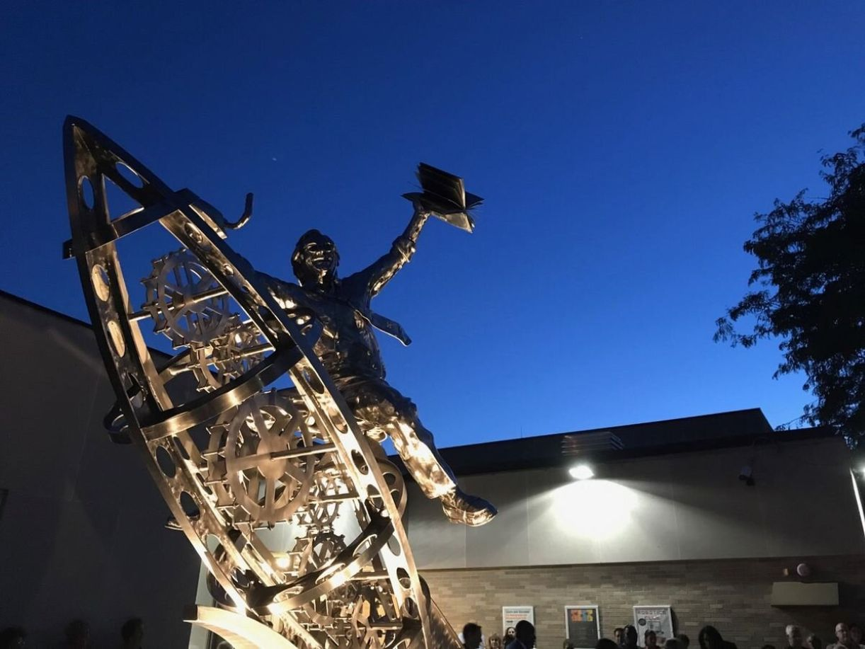

Dorian In Excelsus, Ray Bradbury

Dorian In Excelsus

Good evening. Welcome. I see you have my invitation in your hands. Decided to be brave, did you? Fine. Here we are Grab onto this."

The tall, handsome stranger with the heavenly eyes and the impossibly blond hair handed me a wineglass.

"Clean your palate," he said.

I took the glass and read the label on the bottle he held in his left hand. Bordeaux, it read. St. Emilion.

"Go on," said my host. "It's not poison. May I sit? And might you drink?"

"I might," I sipped, shut my eyes, and smiled. "You're a connoisseur. This is the best I've had in years. But why this wine and why the invitation? What am I doing here at Gray's Anatomy Bar and Grill?"

My host sat and filled his own glass. "I am doing a favor to myself. This is a great night, perhaps for both of us. Greater than Christmas or Halloween." His lizard tongue darted into his wine to vanish back into his contentment. "We celebrate my being honored, at last becoming-"

He exhaled it all out:

"Becoming," he said, "a friend to Dorian! Dorian's friend. Me!"

"Ah." I laughed. "That explains the name of this place, then? Does Dorian own Gray's Anatomy?"

"More! Inspires and rules over it. And deservedly so."

"You make it sound as if being a friend to Dorian is the most important thing in the world."

"No! In life! In all of life." He rocked back and forth, drunk not from the wine but from some inner joy. "Guess."

"At what?"

"How old I am!"

"You look to be twenty-nine at the most."

"Twenty-nine. What a lovely sound. Not thirty, forty, or fifty, but-"

I said, "I hope you're not going to ask what sign I was born under. I usually leave when people ask that. I was born on the cusp, August, 1920." I pretended to half rise. He pressed a gentle hand to my lapel.

"No, no, dear boy-you don't understand. Look here. And here." He touched under his eyes and then around his neck. "Look for wrinkles."

"But you have none," I said.

"How observant. None. And that is why I have become this very night a fresh, new, stunningly handsome friend to Dorian."

"I still don't see the connection."

"Look at the backs of my hands." He showed his wrists. "No liver spots. I am not turning to rust. I repeat the question, how old am I?"

I swirled the wine in my glass and studied his reflection in the swirl.

"Sixty?" I guessed. "Seventy?"

"Good God!" He fell back in his chair, astonished. "How did you know?"

"Word association. You've been rattling on about Dorian. I know my Oscar Wilde, I know my Dorian Gray, which means you, sir, have a portrait of yourself stashed in an attic aging while you yourself, drinking old wine, stay young."

"No, no." The handsome stranger leaned forward. "Not stayed young. Became young. I was old, very old, and it took a year, but the clock went back and after a year of playing at it, I achieved what I set out for."

"Twenty-nine was your target?"

"How clever you are!"

"And once you became twenty-nine you were fully elected as-"

"A Friend to Dorian! Bulls-eye! But there is no portrait, no attic, no staying young. It's becoming young again's the ticket."

"I'm still puzzled!"

"Child of my heart, you might possibly be another Friend. Come along. Before the greatest revelation, let me show you the far end of the room and some doors."

He seized my hand. "Bring your wine. You'll need it!" He hustled me along through the tables in a swiftly filling room of mostly middle-aged and some fairly young men, and a few smoke-exhaling ladies. I jogged along, staring back at the EXIT as if my future life were there.

Before us stood a golden door.

"And behind the door?" I asked.

"What always lies behind any golden door?" my host responded. "Touch."

I reached out to print the door with my thumb.

"What do you feel?" my host inquired.

"Youngness, youth, beauty." I touched again. "All the springtimes that ever were or ever will be."

"Jeez, the man's a poet. Push."

We pushed and the golden door swung soundlessly wide.

"Is this where Dorian is?"

"No, no, only his students, his disciples, his almost Friends. Feast your eyes."

I did as I was told and saw, at the longest bar in the world, a line of men, a lineage of young men, reflecting and re-reflecting each other as in a fabled mirror maze, that illusion seen where mirrors face each other and you find yourself repeated to infinity, large, small, very small, smallest, GONE! The young men were all staring down the long bar at us and then, as if unable to pull their gaze away, at themselves.

You could almost hear their cries of appreciation. And with each cry, they grew younger and younger and more splendid and more beautiful...

I gazed upon a tapestry of beauty, a golden phalanx freshly out of the Elysian fields and hills. The gates of mythology swung wide and Apollo and his demi-Apollos glided forth, each more beautiful than the last.

I must have gasped. I heard my host inhale as if he drank my wine.

"Yes, aren't they," he said.

"Come," whispered my new friend. "Run the gauntlet. Don't linger; you may find tiger-tears on your sleeve and blood rising. Now."

And he glided, he undulated, me along on his soundless tuxedo slippers, his fingers a pale touch on my elbow, his breath a flower scent too near. I heard myself say:

"It's been written that H. G. Wells attracted women with his breath, which smelled of honey. Then I learned that such breath comes with illness."

"How clever. Do I smell of hospitals and medicines?"

"I didn't mean-"

"Quickly. You're rare meat in the zoo. Hup, two, three!"

"Hold on," I said, breathless not from walking fast but from perceiving quickly. "This man, and the next, and the one after that-"

''Yes?!"

"My God," I said, "they're almost all the same, look-alikes!"

"Bull's-eye, half true! And the next and the next after that, as far behind as we have gone, as far ahead as we might go. All twenty-nine years old, all golden tan, all six feet tall, white of teeth, bright of eye. Each different but beautiful, like me!"

I glanced at him and saw what I saw around me. Similar but different beauties. So much youngness I was stunned.

"Isn't it time you told me your name?"

"Dorian."

"But you said you were his Friend."

"I am. They are. But we all share his name. This chap here. And the next. Oh, once we had commoner names. Smith and Jones. Harry and Phil. Jimmy and Jake. But then we signed up to become Friends."

"Is that why I was invited? To sign up?"

"I saw you in a bar across town a year ago, made queries. A year later, you look the proper age-"

"Proper-?"

"Well, aren't you? Just leaving sixty-nine, arriving at seventy?"

''Well.''

"My God! Are you happy being seventy?"

"It'll do.''

"Do? Wouldn't you like to be really happy, steal some wild oats? Sow them?!"

"That time's over."

"It's not. I asked and you came, curious.

"Curious about what?"

"This." He bared me his neck again and flexed his pale white wrists. "And all those!" He waved at the fine faces as we passed. "Dorian's sons. Don't you want to be gloriously wild and young like them?"

"How can I decide?"

"Lord, you've thought of it all night for years. Soon you could be part of this!"

We had reached the far end of the line of men with bronzed faces, white teeth, and breath like H. G. Wells' scent of honey ...

"Aren't you tempted?" he pursued. "Will you refuse-"

"Immortality?"

"No! To live the next twenty years, die at ninety, and look twenty-nine in the damn tomb! In the mirror over there-what do you see?"

"An old goat among ten dozen fauns."

"Yes!"

"Where do I sign up?" I laughed.

"Do you accept?"

"No, I need more facts."

"Damn! Here's the second door. Get in!"

He swung wide a door, more golden than the first, shoved me, followed, and slammed the door. I stared at darkness.

"What's this?" I whispered.

"Dorian's Gym, of course. If you work out here all year, hour by hour, day by day, you get younger."

"That's some gym," I observed, trying to adjust my eyes to the dim areas beyond where shadows tumbled, and voices rustled and whispered. "I've heard of gyms that help keep, not make, you young . . . Now tell me...

"I read your mind. For every old man that became young in there at the bar, is there an attic portrait?"

"Well, is there?"

"No! There's only Dorian."

"A single person? Who grows old for all of you?"

"Touche'! Behold his gym!"

I gazed off into a vast high arena where a hundred shadows stirred and moaned like a tide on a terrible shore.

"I think it's time to leave," I said.

"Nonsense. Come. No one will see you. They're all... busy. I am Moses," said the sweet breath at my elbow. "And I hereby tell the Red Sea to part!"

And we moved along a path between two tides, each shadowed, each more terrifying with its gasps, its cries, its slip-pages of flesh, its slapping like waves, its repeated whispers for more, more, ah, God, more!

I ran, but my host grabbed on. "Look right, left, now right again!"

There must have been a hundred, two hundred animals, beasts, no, men wrestling, leaping, falling, rolling in darkness. It was a sea of flesh, undulant, a writhing of limbs on acres of tumbling mats, a glistening of skin, flashes of teeth where men climbed ropes, spun on leather horses, or flung themselves up crossbars to be seized down in the tidal flux of lamentations and muffled cries. I stared across an ocean of rising and falling shapes. My ears were scorched by their bestial moans.

"What, my God," I exclaimed, "does it all mean?"

"There. See."

And above the wild turbulence of flesh in a far wall was a great window, forty feet wide and ten feet tall, and behind that cold glass Something watching, savoring, alert, one vast stare.

And over all there was the suction of a great breath, a vast inhalation which pulled at the gymnasium air with a constant hungry and invisible need. As the shadows tumbled and writhed, this inhalation tugged at them and the raw air in my nostrils.

Somewhere a huge vacuum machine sucked in darkness but did not exhale. There were long pauses as the shadows flailed and fell, and then another savoring inhalation. It swallowed breath. In, in, always in, devouring the sweaty air, hungering the passions.

And the shadows were pulled, I was pulled, toward that vast glass eye, that immense window behind which a shapeless Something stared to dine on gymnasium airs.

"Dorian?" I guessed.

"Come meet him."

"Yes, but . . ." I watched the wild, convulsive shadows. "What are they doing?"

"Go find out. Afraid? Cowards never live. So!"

He swung wide a third door and whether it was golden hot and alive, I could not feel, for suddenly I lurched into a hothouse as the door slammed and was locked by my blond young friend. "Ready?"

"Lord, I must go home!"

"Not until you meet," said my host, "him."

He pointed. At first I could see nothing. The lights were dim and the place, like the gymnasium, was mostly shadow. I smelled jungle greens. The air stirred on my face with sensuous strokes. I smelled papaya and mango and the wilted odor of orchids mixed with the salt smells of an unseen tide. But the tide was there with that immense inhaled breathing that rose and was quiet and began again.

"I see no one," I said.

"Let your eyes adjust. Wait."

I waited. I watched.

There were no chairs in the room, for there was no need of chairs.

He did not sit, he did not recline, he "prolonged" himself on the largest bed in history. The dimensions might easily have been fifteen feet by twenty. It reminded me of the apartment of a writer I once knew who had completely covered his room with mattresses so that women stumbled on the sill and fell flat out on the springs.

So it was with this nest, with Dorian, immense, a gelatinous skin, a vitreous shape, undulant within that nest.

And if Dorian was male or female, I could not guess. This was a great pudding, an emperor jellyfish, a monstrous heap of sexual gelatin from the exterior of which, on occasion, noxious gases escaped with rubbery sounds; great lips sibilating. That and the sough of that labored pump, that constant inhalation, were the only sounds within the chamber as I stood, anxious, alarmed, but at last impressed by this beached creature, cast up from a dark landfall.

The thing was a gelatinous cripple, an octopus without limbs, an amphibian stranded, unable to undulate and seep back to an ocean sewer from which it had inched itself in monstrous waves and gusts of lungs and eruptions of corrupt gas until now it lay, featureless, with a mere x-ray ghost of legs, arms, wrists, and hands with skeletal fingers. At last I could discern, at the far end of this flesh peninsula, what seemed a half-flat face with a frail phantom of skull beneath, an open fissure for an eye, a ravenous nostril, and a red wound which ripped wide to surprise me as a mouth.

And at last this thing, this Dorian, spoke.

Or whispered, or lisped.

And with each lisp, each sibilance, an odor of decay was expelled as if from a vast night-swamp balloon, sunk on its side, lost in fetid water as its unsavory breath rinsed my cheeks. It expelled but one lingering syllable:

Yessss.

Yes what?

And then it added:

Soooo...

"How long . . . how long," I murmured, "has it . . . has he been here?"

"No one knows. When Victoria was Queen? When Booth emptied his makeup kit to load his pistol? When Napoleon yellow-stained the Moscow snows? Forever's not bad .

What else?"

I swallowed hard. "Is . . . is he?"

"Dorian? Dorian of the attic? He of the Portrait? And somewhere along the line found portraits not enough? Oil, canvas, no depth. The world needed something that could soak in, sponge the midnight rains, breakfast and lunch on loss, depravity's guilt. Something to truly take in, drink, digest; a pustule, imperial intestine. A rheum oesophagus for sin. A laboratory plate to take bacterial snows. Dorian."

The long archipelago of membranous skin flushed some buried tubes and valves, and a semblance of laughter was throttled and drowned in the aqueous gels.

A slit widened to emit gas and again the single word:

Yessss .

"He's welcoming you!" My host smiled.

"I know, I know," I said impatiently. "But why? I don't even want to be here. I'm ill. Why can't we go?"

"Because"-my host laughed-"you were selected.

"Selected?"

"We've had our eye on you."

"You mean you've watched, followed, spied on me? Christ, who gave you permission?"

"Temper, temper. Not everyone is picked."

"Who said I wanted to be picked!?"

"If you could see yourself as we see you, you'd know why."

I turned to stare at the vast mound of priapic gelatin in which faint creeks gleamed as the creature wept its lids wide in holes to let it stare. Then all its apertures sealed: the saber-cut mouth, the slitted nostrils, the cold eyes gummed shut so that its skin was faceless. The sibilance pumped with gaseous suctions.

Yessss, it whispered.

Lisssst, it murmured.

"And list it is!" My host pulled forth a small computer pad which he tapped to screen my name, address, and phone.

He glanced from the pad to reel off such items as wilted me.

"Single," he said.

"Married and divorced."

"Now single! No women in your life?"

"I'm walking wounded."

He tapped his pad. "Visiting strange bars."

"I hadn't noticed."

"Creative blindness. Getting to bed late. Sleeping all day. Drinking heavily three nights a week."

"Twice!"

"Going to the gym, look, every day. Workouts excessive. Prolonged steam baths, overlong massages. Sudden interest in sports. Endless basketball, soccer, tennis matches every night, and half the noons. That's hyperventilation!"

''My business!"

"And ours! You're balanced giddily on the rim. Shove all these facts in that one-armed bandit in your head, yank, and watch the lemons and ripe cherries spin. Yank!"

Jesus God. Yes! Bars. Drinks. Late nights. Gyms. Saunas. Masseurs. Basketball. Tennis. Soccer. Yank. Pull. Spin!

"Well?" My host searched my face, amused. "Three jackpot cherries in a row?"

I shuddered.

"Circumstance. No court would convict me."

"This court elects you. We tell palms to read ravenous groins. Yes?"

Gas steamed up from one shriveled aperture in the restless mound. Yessss.

They say that men in the grip of passion, blind to their own darkness, make love and run mad. Stunned by guilt, they find themselves beasts, having done the very thing they were warned not to do by church, town, parents, life. In explosive outrage they turn to the sinful lure. Seeing her as unholy provocateur, they kill. Women, in similar rages and guilts, overdose. Eve lies self-slain in the Garden. Adam hangs himself with the Snake as noose.

But here was no passionate crime, no woman, no provocateur, only the great mound of siphoning breath and my blond host. And only words which riddled me with fusillades of arrows. Like an Oriental hedgehog, bristled with shafts, my body exploded with No, No, No. Echoed and then real:

"No!"

Yessss, whispered the vapor from the mounded tissue, the skeleton buried in ancient soups.

Yessss.

I gasped to see my games, steams, midnight bars, late-dawn beds: a maniac sum.

I rounded dark corridors to confront a stranger so pockmarked, creased, and oiled by passion, so cobwebbed and smashed by drink, that I tried to avert my gaze. The terror gaped his mouth and reached for my hand.

Stupidly, I reached to shake his and-rapped glass! A mirror. I stared deep into my own life. I had seen myself in shop windows, dim undersea men running in creeks. Mornings, shaving, I saw my mirrored health. But this! This troglodyte trapped in amber. Myself, snapshotted like ten dozen sexual acrobats! And who jammed this mirror at me? My beautiful host, and that corrupt flatulence beyond.

"You are selected," they whispered.

"I refuse!" I shrieked.

And whether I shrieked aloud or merely thought, a great furnace gaped. The oceanic mound erupted thunders of gaseous streams. My beautiful host fell back, stunned that their search beneath my skin, behind my mask, had brought revulsion. Always when Dorian cried, "Friend," raw gymnast teams had mobbed to catapult that armless, legless, featureless Sargasso Sea. Before they had smothered to drown in his miasma, to arise, embrace, and wrestle in the dark gymnasium, then run forth young to assault a world.

And I? What had I dared to do, that quaked that membranous sac into regurgitated whistling and broken winds?

"Idiot!" cried my host, all teeth and fists. "Out! Out!"

"Out," I cried, spun to obey, and tripped.

I do not clearly know what happened as I fell. And if it was a swift reaction to the holocaust erupted like vile spit and vomit from that putrescent mound, I cannot say. I knew no lightning shock of murder, yet knew perhaps some summer heat flash of revenge. Forwhat? I thought. What are you to Dorian or he to you that frees the hydra behind your face, or causes the slightest twitch of leg, arm, hand, or fingernail, as the last fetid air from Dorian burned my hair and stuffed my nostrils.

It was over in a second.

Something shoved me. Did my secret self, insulted, give that push? I was flung as if on wires, knocked to sprawl at Dorian.

He gave two terrible cries, one of warning, one of despair.

I was recovered so in landing, I did not sink my hands deep in that poisonous yeast, into that multiflorid Man of War jelly. I swear that I touched, raked, scarified him with only one thing: the smallest fingernail of my right hand.

My fingernail!

And so this Dorian was shot and foundered. And so the mammoth with screams collapsed. And so the nauseous balloon sank, fold on midnight fold, upon its own boneless sell, fissuring volcanic sulfurs, immense rectal airs, outgassed whistles, and whimpers of self-pitying despair.

"Christ! What have you done!? Murderer! Damn you!" cried my host, riven to stare at Dorian's exhaustions unto death.

He whirled to strike, but ran to reach the door and cry, "Lock this! Lock! Whatever happens, for God's sake, don't open! Now!" The door slammed. I ran to lock it and turn.

Quietly, Dorian was falling away.

He sank down and down, out of sight. Like a great membranous tent with its poles removed, he vanished into the floor, down flues and vents on all sides of his great platform nest. Vents obviously created for such a massive disease-sac melting into viral fluid and sewer gas.

Even as I watched, the last of the noxious clot was sucked into the vents, and I stood abandoned in a room where but a few minutes before an unspeakable strata of discards and half-born fetuses had lain sucking at sins, spoiled bones, and souls to send forth beasts in semblance of beauty. That perverse royalty, that lunatic monarch, gone, all gone. A last choke and throttle from the sewer vent underlined its death.

My God, I thought, even now, that, all that, that terrible miasma, that stuff is on its way to the sea to wash in with bland tides to lie on clean shores where bathers come at dawn ...

Even now ...

I stood, eyes shut, waiting.

For what? There had to be a next thing, yes? It came.

There was a trembling, shivering, and then a quaking of the wall, but especially the golden door behind me.

I spun to see as well as hear.

I saw the door shaken, and then bombarded from the other side. Fists pummeled, struck, hammered. Voices cried out and screamed and then shrieked.

I felt a great mass ram the door to shiver, to slam it on its hinges.

I stared, fearful that the door might explode and let in the flood tide of nightmare-ravening, terrified beasts, the kennel of dying things. For now their shrieks as they mauled and rattled to escape, to beg for mercy, were so terrible that I clamped my fists to my ears.

Dorian was gone, but they remained. Shrieks. Screams. Screams. Shrieks. An avalanche of limbs beyond the door struck and fell, yammering.

What must they look like now? I thought. All those bouquets. All those beauties.

The police will come, I thought, soon. But.

No matter what ...

I would not unlock that door.

The end