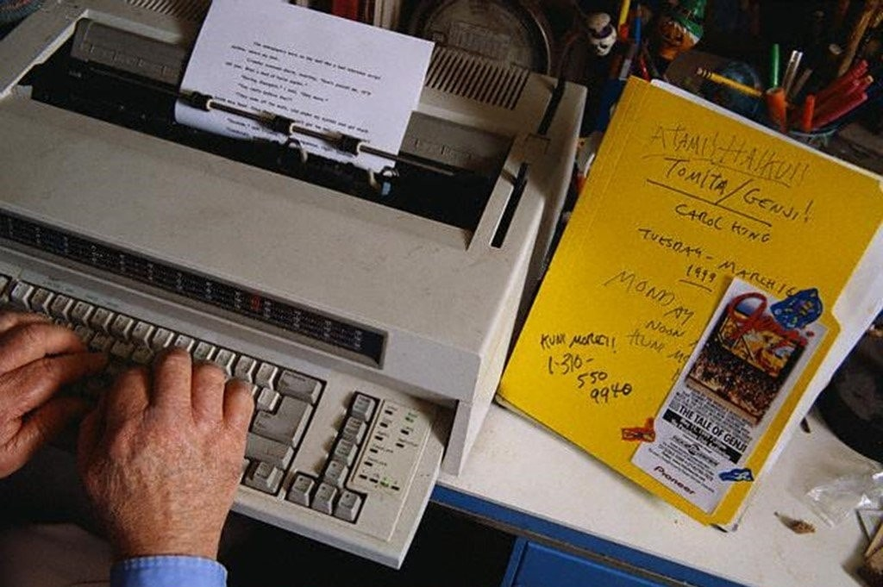

El Dia de Muerte, Ray Bradbury

El Dia de Muerte

Morning.

The little boy, Raimundo, ran across the Avenida Madero. He ran through the early smell of incense from many churches and in the smell of charcoal from ten thousand breakfast cookings. He moved in the thoughts of death.

For Mexico City was cool with death thoughts in the morning. There were shadows of churches and always women in black, in mourning black, and the smoke from the church candles and charcoal braziers made a smell of sweet death in his nostrils as he ran. And he did not think it strange, for all thoughts were death thoughts on this day.

This was El Dia de Muerte, the Day of Death.

On this day in all the far places of the country, the women sat by little wooden slat stands and from these sold the white sugar skulls and candy corpses to be chewed and swallowed. In all of the churches services would be said, and in graveyards tonight candles would be illumined, much wine drunk, and many high man-soprano songs cried forth.

Raimundo ran with a sense of the entire universe in him; all the things his Tio Jorge had told him, all the things he had himself seen in his years. On this day events would be happening in such far places as Guanajuato and Lake Patzcuaro.

Here in the great bull ring of Mexico City even now the trabajandos were raking and smoothing the sands, tickets were selling and the bulls were nervously eliminating themselves, their eyes swiveling, fixing, in their hidden stalls waiting for death.

In the graveyard at Guanajuato the great iron gates were swinging wide to let the turistas step down the spiral cool staircase into the deep earth, there to walk in the dry echoing catacombs and gaze upon mummies rigid as toys, stood against the wall. One hundred and ten mummies stiffly wired to the stones, faces horror-mouthed and shrivel-eyed; bodies that rustled if you touched them.

At Lake Patzcuaro, on the island of Javitzio, the great fishing seines flew down in butterfly swoops to gather silvering fish. The island, with Father Morelos' huge stone statue on top of it, had already begun the tequila drinking that started the celebratory Dia de Muerte.

In Levares, a small town, a truck ran over a dog and did not stop to come back and see.

Christ himself was in each church, with blood upon him, and agony in him.

And Raimundo ran in the November light across the Avenida Madero.

Ah, the sweet terrors! In the windows, the sugar skulls with names on their snowy brows: JOSE, CARLOTTA, RAMONA, LUISA. All the names on chocolate death's-heads and frosted bones.

The sky was glazed blue pottery over him and the grass flamed green as he ran past the glorietas. In his hand he held very tightly fifty centavos, much money for much sweets, for surely he must purchase legs, sockets and ribs to chew. The day of eating of Death. They would show Death, ah, yes, they would! He and madrecita mia, and his brothers, aye, and his sisters!

In his mind he saw a skull with candy lettering: RAIMUNDO. I shall eat my own skull, he thought. And in this way cheat Death who always drips at the window in the rain or squeaks in that hinge of the old door or hangs in our urine like a little pale cloud. Cheat Death who is rolled into tamales by the sick tamale maker, Death wrapped in a fine corn-tortilla shroud.

In his mind, Raimundo heard his old Tio Jorge talking all this. His ancient, adobe-faced uncle who gestured his fingers to each small word and said, "Death is in your nostrils like clock-spring hairs, Death grows in your stomach like a child. Death shines on your eyelids like a lacquer."

From a rickety stand an old woman with a sour mouth and tiny beards in her ears sold shingles on which miniature funerals were conducted. There was a little cardboard coffin and a crepe-paper priest with an infinitesimal Bible, and crepe-paper altar boys with small nuts for heads, and there were attendants holding holy flags, and a candy-white corpse with tiny black eyes inside the tiny coffin, and on the altar behind the coffin was a movie star's picture.

These little shingle funerals could be taken home, where you threw away the movie star’s picture and pasted in a photograph of your own dead in its place on the altar. So you had a small funeral of your loved one over again.

Raimundo put out a twenty-centavo piece. "One," he said and he bought a shingle with a funeral on it.

Tio Jorge said, "Life is a wanting of things, Raimundito. You must always be wanting things in life. You will want frijoles, you will want water, you will desire women, you will desire sleep; most especially sleep.

You will want a burro, you will want a new roof on your house, you will want fine shoes from the glass windows of the zapatera and, again, you will want sleep. You will want rain, you will want jungle fruits, you will want good meat; you will, once more, desire sleep.

You will seek a horse, you will seek children, you will seek the jewels in the great shining store on the avenida and, ah, yes, remember? You will lastly seek sleep. Remember, Raimundo, you will want things. Life is this wanting.

You will want things until you no longer want them, and then it is time to be wanting only sleep and sleep. There is a time for all of us, when sleep is the great and the beautiful thing. And when nothing is wanted but only sleep then it is one thinks of the Day of the Dead and the happy sleeping ones. Remember, Raimundo?"

"Si, Tio Jorge."

"What do you want, Raimundor?"

"I don't know."

"What do all men want, Raimundo?"

"What?"

"What is there to want, Raimundo?"

"Maybe I know. Ah, but I don't know, I don't!"

"I know what you want, Raimundo."

"What?"

"I know what all men in this land want; there is much of it and it is wanted far over and above all other wantings and it is worshiped and wanted, for it is rest and a peacefulness of limb and body ......

Raimundo entered the store and picked up a sugar skull with his name frosted upon it.

"You hold it in your hand, Raimundo," whispered Tio Jorge. "Even at your age you hold it delicately and nibble, swallow it into your blood. In your hands, Raimundo, look!"

The sugar skull.

"In the street I see a dog. I drive my car. Do I pause? Do I unpress my foot from the pedal? No! More speed! Boom! So! The dog is happier, is he not? Out of this world, forever gone?"

Raimundo paid money and proudly inserted his dirty fingers within the sugar skull, giving it a brain of five wriggling parts.

He walked from the store and looked upon the wide, sun-filled boulevard with the cars rushing and roaring through it He squinted his eyes and ...

The barreras were full. In la sombra and el sot, in shadow or in sun, the great round seats of the bull ring were filled to the sky. The band exploded in brass! The gates flung wide! The matadors, the banderilleros, the picadors, all of them came walking or riding across the fresh, smooth sand in the warm sunlight. The band crashed and banged and the crowd stirred and stirred and murmured and cried aloud.

The music finished with a cymbal.

Behind the barrera walls the men in the tight glittery costumes adjusted their birettas upon their greasy black hairdos and felt of their capes and swords and talked, and a man

bent over the wall above with a camera to whirr and click at them.

The band whammed proudly again. A door burst open, the first black giant of a bull rushed out, loins jolting, little Buttery ribbons tacked to his neck. The bull!

Raimundo ran forward, lightly, lightly, on the Avenida Madero. Lightly, lightly he ran between the fast black huge bull cars. One gigantic car roared and homed at him. Lightly, lightly ran Raimundito.

The banderillero ran forward lightly, lightly, like a blue feather blown over the dimpled bull-ring sands, the bull a black cliff rising. The banderillero stood now, poised, and stamped his foot. The banderillas are raised, ah!

So! Softly, softly ran the blue ballet slippers in the quiet sand and the bull ran and the banderillero rose softly in an arc upon the air and the two poles struck down and the bull slammed to a halt, grunting-shrieking as the pikes bit deep in his withers. Now the banderillero, the source of this pain, was gone. The crowd roared!

The Guanajuato cemetery gates swung open.

Raimundo stood frozen and quiet and the car bore down upon him. All of the land smelled of ancient death and dust and everywhere things ran toward death or were in death.

The turistas filled into the cemetery of Guanajuato. A huge wooden door was opened and they walked down the twisting steps into the catacombs where the one hundred and ten dead shrunken people stood horrible against the walls.

The jutting teeth of them, the wide eyes staring into spaces of nothing. The naked bodies of women like so many wire frames with clay clinging all askew to them. "We stand them in the catacombs because their relatives cannot afford the rent on their graves," whispered the little caretaker.

Below the cemetery hill, a juggling act, a man balancing something on his head, a crowd following past the coffin, carpenter's shop, to the music of the carpenter, nails fringing his mouth, bent to beat the coffin like a drum.

Balanced delicately upon his proud dark head the juggler carries a silvery satin-skinned box, which he touches lightly now and again to give it balance. He walks with solemn dignity, his bare feet gliding over the cobbles, behind him the women in black rebozos toothing tangerines. And in the box, hidden away, safe and unseen, is the small child body of his daughter, newly dead.

The procession passes the open coffin shops and the banging of nails and sawing of boards is heard through the land. In the catacomb, the standing dead await the procession.

Raimundo held his body so, like a torero, to make a veronica, for the great hurtling car to pass and the crowd to cry "Ole!" He smiled wildly.

The black car rose over and blotted light from his eyes as it touched him. Blackness ran through him. It was night...

In the churchyard on the island of Janitzio, under the great dark statue of Father Morelos, it is blackness, it is midnight. You hear the high voices of men grown shrill on wine, men with voices like women, but not soft women, no, high, ban and drunken women, quick, savage and melancholy women. On the dark lake little fires glow on Indian boats coming from the mainland, bringing tourists from Mexico City to see the ceremony of Dia de Muerte, sliding across the black foggy lake, all bundled and wrapped against the cold.

Sunlight.

Christ moved.

From the crucifix he took down a hand, lifted it, suddenly waved it.

The hot sun shone in golden explosions from the high church tower in Guadalajara, and in blasts from the high, swaying crucifix. In the street below, if Christ looked down with mellow warm eyes, and he did so now in this moment, he saw two thousand upturned faces: the spectators like so many melons scattered about the market, so many hands raised to shield the uptilted and curious eyes.

A little wind blew and the tower cross sighed very gently and pressed forward under it.

Christ waved his hand. Those in the market below waved back. A small shout trickled through the crowd. Traffic did not move in the street. It was eleven of a hot green Sunday morning. You could smell the fresh clipped grass from the plaza, and the incense from the church door.

Christ took his other hand down also and waved it and suddenly jerked away from the cross and hung by his feet, face down, a small silver medallion jingling in his face, suspended from about his dark neck.

"Ole! Ole!" cried one small boy far below, pointing up at him and then at himself. "You see him, you see? That is Gomez, my brotherly! Gomez who is my brotherly!"

And the small boy walked through the crowd with a hat, collecting money.

Movement. Raimundo, in the street, covered his eyes and screamed. Darkness again.

The tourists from the boats moved in the dream of the island of Janitzio at midnight. In the dim street the great nets hung like fog from the lake and rivers of today's silver minnows lay glittering in cascades upon the slopes. Moonlight struck them like a cymbal striking. Another cymbal; they gave off a silent reverberation.

In the crumbling church at the top of the rough hill is a Christ much drilled by termites, but the blood still congeals, thickly from his artistic wounds and it will be years before the agony is insect-eaten from his suffering mask.

Outside the church, a woman with Tarascan blood lifting and falling in her throat sits fluttering ripped morning-glories through the flames of six candies. The flowers, passing through the flames like moths, give off a gentle sexual odor. Already the moving tourists come and stand about her, looking down, wanting to ask, but not asking, what she is doing, seated there upon her husband's grave.

In the church, like resin from a great beautiful tree, the limbs of Christ, themselves hewn from beautiful limbs of imported trees, give off a sweet sacred resin in little raining droplets that hang but never fall, blood that gives a garment for his nakedness.

"Ole!" roares the crowd.

Bright sunlight again. A pressure on Raimundo's flung body. The car, the daylight, the pain!

The picador jousted his horse forward, the horse with thick mattresses tied to it, and kicked the bull in the shoulder with his boot and at the same time penetrated that shoulder with the long stick and the nail on the end of it. The picador withdrew. Music played. The matador moved slowly forward.

The bull stood with one foot forward in the center of the sun-held ring, his organs nervous. The eyes were dull glazed hypnotic eyes of fear-hate. He kept eliminating nervously, nervously, until he was streaked and foul with a nervous casting out. The greenish matter pulsed from his buttocks and the blood pulsed from his gored shoulder, and the six banderillas bindled and clattered on his spine.

The matador took time to rearrange his red cloth over his blade, just so carefully, while the crowd and the pulsing bull waited.

The bull can see nothing, know nothing. The bull desires not to see of this or that. The world is pain and shadows and light and weariness. The bull stands only to be dispatched. It will welcome an end to confusion, to the racing shapes, the traitorous capes, the lying flourishes and false fronts.

The bull plants out its feet in feeble stances and remains in one position, slowly moving its head back and forth, eyes glazed, the excrement stiff unfelt rivuleting from its flanks, the blood tiredly pumping from the neck. Somewhere off in the glazed distance a man holds out a bright sword. The bull does not move. The sword, held by the smiling man, now cuts three short gashes down the nose of the empty-eyed bull. So!

The crowd shouts.

The bull takes the cutting and does not even flinch. Blood flushes from the snuffling, cut nostrils.

The matador stamps his foot.

The bull runs with feeble obedience toward the enemy. The sword pierces his neck. The bull falls, thuds, kicks, is silent.

"Ole!" shouts the crowd. The band blows out a fanfarria finale!

Raimundo felt the car hit. There were swift intervals of light and darkness.

In the Janitzio churchyard two hundred candles burned atop two hundred rocky graves, men sang, tourists watched fog poured up from the lake.

In Guanajuato, sunlight! Striking down through a slot the catacomb, sunlight showed the brown eyes of a woman mouth wide in rictus, cross-armed. Tourists touched and thumped her like a drum.

"Ole!" The matador circled the ring, his small black biretta in his fingers, high. It rained. Centavo pieces, purses, shoes, hats. The matador stood in this rain with his biretta raised for an umbrella!

A man ran up with a cut-off ear of the slain bull. The matador held it up to the crowd. Everywhere he walked the crowd threw up their hats and money. But thumbs jerked down and though the shouts were glad they were not so glad that he kept the cut-off ear. Thumbs went down. Without a look behind him, shrugging, the matador gave the ear cracking toss.

The bloody ear lay on the sand, while the crowd, glad that he had thrown it away, because he was not that good, cheered. The bucklers came out, chained the slumped bull to a team of high-stamping horses, who whistled fearful sirens in their nostrils at the hot blood odor an bolted like white explosions across the arena when released yanking, bounding the dead slumped bull behind, leaving harrowing of the horns in sand and amulets of blood.

Raimundo felt the sugar skull jolt from his fingers. The funeral on the wooden slat was torn from his other wide flung hand.

Bang! The bull hit, rebounded from the barrera wall as the horses vanished, jangling, screaming, in the tunnel.

A man ran to the barrera of Senior Villalta, poking upward the banderillas, their sharp prongs choked with bull blood and flesh. "Gracias!" Villalta threw down a peso and took the banderillas proudly, the little orange and blue crepe papers fluttering, to hand about like musical instruments to his wife, to cigar-smoking friends.

Christ moved.

The crowd looked up at the swaying cross on the cathedral.

Christ balanced on two hands, logs up in the sky!

The small boy ran through the crowd. "You see my brother? Pay! My brother! Pay!"

Christ now hung by one hand on the swaying cross. Below him was the city of Guadalajara, very sweet and very quiet with Sunday. I will make much money today, he thought.

The cross jolted. His hand slipped. The crowd screamed.

Christ fell.

Christ dies each hour. You see him in carven postures in ten thousand agonized places, eyes lifted to high dusty heavens of ten thousand small churches, and always there is much blood, ah, much blood.

"See!" said Senior Villalta. "See!" He wagged the banderillas in the face of his friends, red and wet.

With children chasing, snatching at him, laughing, the matador circles the ring again to the ever-increasing shower of hats, running and not stopping.

And now the tourist boats cross the dawn-pale lake of Patzcuaro, leaving Janitzio behind, the candles snuffed, the graveyard deserted, the torn flowers strewn and shriveling. The boats pull up and the tourists step out in the new light, and in the hotel on the mainland shore a great silver urn waits, bubbling with fresh coffee; a little whisper of steam, like the last part of the fog from the lake, goes up into the warm air of the hotel dining room, and there is a good sound of chattered plates and tining forks and low converse, and a gentle lidding of eyes and a mouthing of coffee in dreams already begun before the pillow. Doors close. The tourists sleep on fog-damp pillows, in fog-damp sheets, like earth spittled winding clothes.

The coffee smell is as rich as the skin of a Tarascan.

In Guanajuato the gates close, the rigid nightmares are turned from. The spiral stair is taken up in hot November light. A dog barks. A wind stirs the dead morning-glories on the pastry-cake monuments. The big door whams down on the catacomb opening. The withered people are hidden.

The band hoots out its last triumphant hooting and the barreras are empty. Outside, the people walk away between ranks of phlegm-eyed beggars who sing high, high songs, and the blood spoor of the last bull is raked and wiped and raked and wiped by the men with the rakes down in the wide shadowed ring. In the shower, the matador is slapped upon his wet buttocks by a man who has won money because of him this day.

Raimundo fell, Christ fell, in glaring light. A bull rushed, a car rushed, opening a great vault of blackness in the air which slammed, thundered shut and said nothing but sleep. Raimundo touched the earth, Christ touched the earth, but did not know.

The cardboard funeral was shattered to bits. The sugar skull broke in the far gutter in three dozen fragments of blind snow.

The boy, the Christ, lay quiet.

The night bull went away to give other people darkness to teach other people sleep.

Ah, said the crowd.

RAIMUNDO, said the bits of the sugar skull strewn on the earth.

People ran to surround the silence. They looked at the sleep. And the sugar skull with the letters R and A and I and M and U and N and D and O was snatched up and eaten by children who fought over the name.

1957

The end