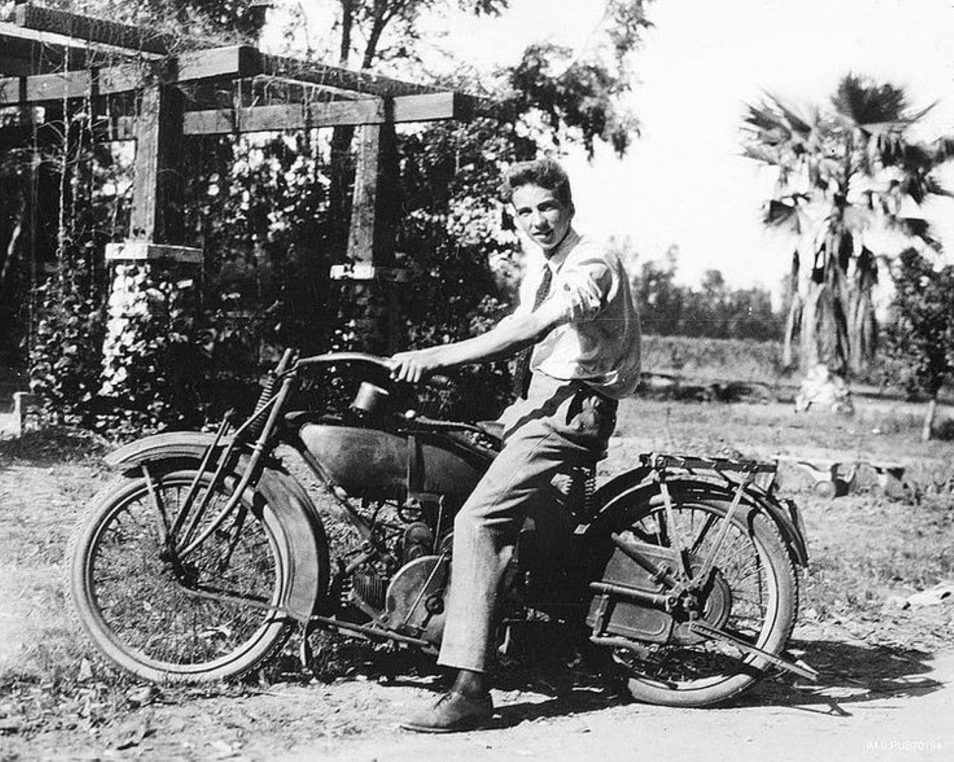

En la noche, Ray Bradbury

En la noche

All night Mrs. Navarrez moaned, and these moans filled the tenement like a light turned on in every room so no one could sleep.

All night she gnashed her white pillow and wrung her thin hands and cried, "My Joe!" The tenement people, at 3 a.m., finally discouraged that she would never shut her painted red mouth, arose, feeling warm and gritty, and dressed to take the trolley downtown to an all-night movie.

There Roy Rogers chased bad men through veils of stale smoke and spoke dialogue above the soft snorings in the dark night theater.

By dawn Mrs. Navarrez was still sobbing and screaming.

During the day it was not so bad. Then the massed choir of babies crying here or there in the house added the saving grace of what was almost a harmony.

There was also the chugging thunder of the washing machines on the tenement porch, and chenille-robed women standing on the flooded, soggy boards of the porch, talking their Mexican gossip rapidly. But now and again, above the shrill talk, the washing, the babies, one could hear Mrs. Navarrez like a radio tuned high. "My Joe, oh, my poor Joe!" she screamed.

Now, at twilight, the men arrived with the sweat of their work under their arms. Lolling in cool bathtubs all through the cooking tenement, they cursed and held their hands to their ears.

"Is she still at it!" they raged helplessly. One man even kicked her door. "Shut up, woman!" But this only made Mrs. Navarrez shriek louder. "Oh, ah! Joe, Joe!"

"Tonight we eat out!" said the men to their wives. All through the house, kitchen utensils were shelved and doors locked as men hurried their perfumed wives down the halls by their pale elbows.

Mr. Villanazul, unlocking his ancient, flaking door at midnight, closed his brown eyes and stood for a moment, swaying. His wife Tina stood beside him with their three sons and two daughters, one in arms.

"Oh God," whispered Mr. Villanazul. "Sweet Jesus, come down off the cross and silence that woman." They entered their dim little room and looked at the blue candlelight flickering under a lonely crucifix. Mr. Villanazul shook his head philosophically. "He is still on the cross."

They lay in their beds like burning barbecues, the summer night basting them with their own liquors. The house flamed with that ill woman's cry.

"I am stifled!" Mr. Villanazul fled through the tenement, downstairs to the front porch with his wife, leaving the children, who had the great and miraculous talent of sleeping through all things.

Dim figures occupied the front porch, a dozen quiet men crouched with cigarettes fuming and glowing in their brown fingers, women in chenille wrappers taking what there was of the summer-night wind. They moved like dream figures, like clothes dummies worked stiffly on wires and rollers. Their eyes were puffed and their tongues thick.

"Let us go to her room and strangle her," said one of the men.

"No, that would not be right," said a woman. "Let us throw her from the window."

Everyone laughed tiredly.

Mr. Villanazul stood blinking bewilderedly at all the people. His wife moved sluggishly beside him.

"You would think Joe was the only man in the world to join the Army," someone said irritably. "Mrs. Navarrez, pah! This Joe-husband of hers will peel potatoes; the safest man in the infantry!"

"Something must be done." Mr. Villanazul had spoken. He was startled at the hard firmness of his own voice. Everyone glanced at him.

"We can't go on another night," Mr. Villanazul continued bluntly.

"The more we pound her door, the more she cries," explained Mr. Gomez.

"The priest came this afternoon," said Mrs. Gutierrez. "We sent for him in desperation. But Mrs. Navarrez would not even let him in the door, no matter how he pleaded. The priest went away. We had Officer Gilvie yell at her, too, but do you think she listened?"

"We must try some other way, then," mused Mr. Villanazul. "Someone must be-sympathetic—with her."

"What other way is there?" asked Mr. Gomez.

"If only," figured Mr. Villanazul after a moment's thought, "if only there was a single man among us."

He dropped that like a cold stone into a deep well. He let the splash occur and the ripples move gently out.

Everybody sighed.

It was like a little summer-night wind arisen. The men straightened up a bit; the women quickened.

"But," replied Mr. Gomez, sinking back, "we are all married. There is no single man."

"Oh," said everyone, and settled down into the hot, empty river bed of night, smoke rising, silent.

"Then," Mr. Villanazul shot back, lifting his shoulders, tightening his mouth, "it must be one of us!"

Again the night wind blew, stirring the people in awe.

"This is no time for selfishness!" declared Villanazul. "One of us must do this thing! That, or roast in hell another night!"

Now the people on the porch separated away from him, blinking. ''You will do it, of course, Mr. Villanazul?" they wished to know.

He stiffened. The cigarette almost fell from his fingers. "Oh, but I—" he objected.

“You," they said. "Yes?"

He waved his hands feverishly. "I have a wife and five children, one in arms!"

"But none of us are single, and it is your idea and you must have the courage of your convictions, Mr. Villanazul!" everyone said.

He was very frightened and silent. He glanced with startled flashes of his eyes at his wife.

She stood wearily weaving on the night air, trying to see him.

"I'm so tired," she grieved.

"Tina," he said.

"I will die if I do not sleep," she said.

"Oh, but, Tina," he said.

"I will die and there will be many flowers and I will be buried if I do not get some rest," she murmured.

"She looks very bad," said everyone.

Mr. Villanazul hesitated only a moment longer. He touched his wife's slack hot fingers. He touched her hot cheek with his lips.

Without a word he walked from the porch.

They could hear his feet climbing the unlit stairs of the house, up and around to the third floor where Mrs. Navarrez wailed and screamed.

They waited on the porch.

The men fit new cigarettes and flicked away the matches, talking like the wind, the women wandering around among them, all of them coming and talking to Mrs. Villanazul, who stood, lines under her tired eyes, leaning against the porch rail.

"Now" whispered one of the men quietly. "Mr. Villanazul is at the top of the house!"

Everybody quieted.

"Now," hissed the man in a stage whisper. "Mr. Villanazul taps at her door! Tap, tap."

Everyone listened, holding his breath.

Far away there was a gentle tapping sound.

"Now, Mrs. Navarrez, at this intrusion, breaks out anew with crying!"

At the top of the house came a scream.

"Now," the man imagined, crouched, his hand delicately weaving on the air, "Mr. Villanazul pleads and pleads, softly, quietly, to the locked door."

The people on the porch lifted their chins tentatively, trying to see through three flights of wood and plaster to the third floor, waiting.

The screaming faded.

"Now, Mr. Villanazul talks quickly, he pleads, he whispers, he promises," cried the man softly.

The screaming settled to a sobbing, the sobbing to a moan, and finally all died away into breathing and the pounding of hearts and listening.

After about two minutes of standing, sweating, waiting, everyone on the porch heard the door far away upstairs rattle its lock, open, and, a second later, with a whisper, close.

The house was silent.

Silence lived in every room like a light turned off. Silence flowed like a cool wine in the tunnel halls. Silence came through the open casements like a cool breath from the cellar. They all stood breathing the coolness of it.

"Ah," they sighed.

Men flicked away cigarettes and moved on tiptoe into the silent tenement. Women followed. Soon the porch was empty. They drifted in cool halls of quietness.

Mrs. Villanazul, in a drugged stupor, unlocked her door.

"We must give Mr. Villanazul a banquet," a voice whispered.

'Tight a candle for him tomorrow." The doors shut.

In her fresh bed Mrs. Villanazul lay. He is a thoughtful man, she dreamed, eyes closed. For such things, I love him. The silence was like a cool hand, stroking her to sleep.

The end