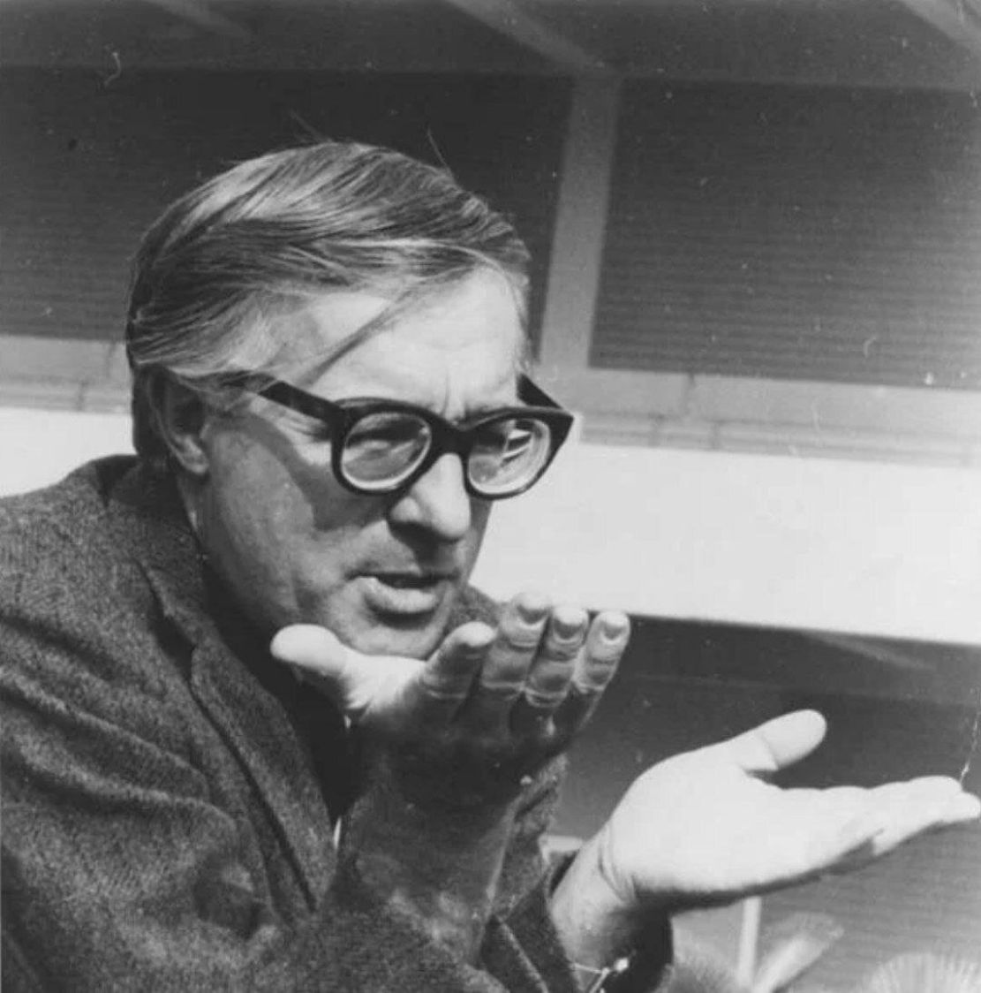

Farewell Summer (short story) Ray Bradbury

Farewell Summer

Farewell summer.

Grandma looked it.

Grandpa said it.

Douglas felt it.

Farewell summer.

The words moved on Grandpa’s lips as he stood at the edge of the porch and surveyed the lake of grass just below and all the dandelions gone and the clover blossoms wilting, and a touch of rust in the trees, and real summer over and a smell of Egypt in the air, blowing from the east.

‘What?’ asked Douglas.

But he had heard.

‘Farewell summer.’ Grandpa leaned on the porch rail, shut one eye, let the other wander on the horizon line. ‘Know what that is, Doug? A flower by the side of the road, named for the way the weather feels today. Look. The whole darn season’s just turned around. Don’t know why summer’s come back. Maybe to find something. Makes you feel kind of sad. And then again, happy. Farewell summer, Doug.’

A fern by the porch rail fell to dust.

Doug moved to stand beside his grandfather, hoping to borrow some of that far sight, some of that look beyond the hills, some of the wanting to cry, some of the ancient joy. The smell of pipe tobacco and Tiger Shaving Tonic had to be sufficient. A top spun in his chest, now light, now dark, now moving his tongue with laughter, now filling his eyes with warm saltwater.

‘Think I’ll go eat me a doughnut and take me a nap,’ he said.

‘Glad we have siestas in northern Illinois. Eat your way to sleep, boy.’

The great warm hand came down on his head in a pressure that spun the top fast until it was all one warm lovely color.

It was a happy journey inside to the doughnuts.

Laid out with a powdered-sugar mustache on his upper lip, Doug contemplated sleep, which came around through the back of his head and gently grabbed him.

Dusk filled his whole twelve-year-old body at three-thirty in the afternoon.

Then, in his sleep, he quickened.

A long way off, a band played a strange slow tune, full of muted brass and muffled drums.

Doug lifted his head, listening.

As if the faraway band had come out of a cave into full sunlight, the music grew louder.

And it was louder because where before it had seemed a brass band of few pieces, now it added instruments as it approached Green Town, as if men were trotting out of empty cornfields brandishing bright pipes of sunny metal or long sticks of licorice over their heads. Somewhere a small moon rose to be beaten, and that was a big bass drum. Somewhere a mob of irritable blackbirds soared to become piccolos and leave the fruitless orchards behind.

‘A parade!’ whispered Doug. ‘But it’s not July Fourth, and Labor Day’s gone! So, how come…?’

And as the music got louder it got slower, deeper, and very sad. It was like an immense storm cloud full of lightning which passed low shadowing hills, darkening rooftops, and now invading the town streets. It was a murmur of thunder.

Douglas shivered and waited.

The parade had stopped just outside his house.

Flashes of sunlit brass shot through the high windows and beat against the walls like the wings of golden birds panicking to escape.

Sidling up to the window, Douglas peered.

And what he saw was familiar people.

Douglas blinked.

For there on the lawn, holding a trombone, was Jack Schmidt who sat across from him in school, and Bill Arno, his best friend, lifting a trumpet, and Mr Wyneski, the town barber, wrapped around by a boa-constrictor tub and—hold on!

Douglas listened.

There was not a sound in the house below.

He spun about and ran downstairs. The kitchen was full of bacon smell but nothing else. The dining room remembered pancakes but only a breeze came in the windows to ghost the curtains.

He ran to the front door and stepped out on the porch. The house was empty, yes, but the yard was full.

Because down among the band stood Grandpa with a French horn, Grandma with a tambourine, Skip with a kazoo.

As soon as Doug reached the edge of the porch, everyone gave a great whooping yell, and while they were yelling Douglas thought how quickly it had all happened. Only an instant before Grandma had put down her kneaded bread dough in the kitchen (it lay with her fingerprints floured in it on the kneading board at this moment), Grandpa had laid aside Dickens in the library, Skip had leaped from the crabapple tree.

Now they stood holding instruments in this assembly of friends, teachers, librarians, and distant cousins from far peach-orchard farms.

The yelling stopped and everyone laughed, forgetting the dirge they had played through town.

‘Hey,’ said Doug at last, ‘what day is this?’

‘Why,’ said Grandma, ‘your day, Doug.’

‘My day?’

‘Yours, Doug. Special. Better than birthdays, greater than Christmas, grander than the Fourth, more amazing than Easter. Your day, Doug, yours!’

That was the Mayor, making a speech.

‘Yes, but…’

‘Doug…’ Grandpa nudged a huge wicker basket. ‘Got strawberry pie here.’

‘Strawberry shortcake,’ added Grandma. ‘Strawberry ice cream.’

Everyone smiled. But Douglas stepped back, waited, feeling like a huge Eskimo pie standing in the sun and not melting.

‘Fireworks at dusk, Doug,’ said Skip, tootling his kazoo. ‘Dusk and fireworks. Also, give you my Mason jar full of fireflies left over from summer.’

‘You never give me anything like that before, Skip. How come you do it now?’

‘It’s Douglas Spaulding Day, Doug. We’ve brought you some flowers.’

People don’t bring flowers to boys, thought Doug, not even in hospitals!

But there were the Ramsey sisters holding out clusters of farewellsummer blossoms, and Grandpa saying: ‘Hurry on, Doug. Lead the parade! The boat’s waiting!’

‘The excursion boat? We going on a picnic trip?’

‘Journey’s more like it.’ Mr Wyneski whipped off his barber’s apron, crammed on his cornflake-cereal straw hat. ‘Listen!’

The sound of a far boat wailed up from the shore of the lake one mile away.

‘Forward march!’ said Grandpa. ‘One, two, Doug, oh, come on now, one, two!’

‘Yes, but—’

Grandma jingled her tambourine, Skip thrummed his kazoo, Grandpa moaned his French horn, and the motion of the mob circling the yard drew Doug down off the porch along the street with a pack of dogs ahead and behind yipping all the way downtown where traffic stopped for them and people waved and someone tore up a telephone book and threw it out the top of the Green Town Hotel but by the time the informational confetti hit the brick street the parade was gone downhill, leaving the sun and town behind.

And by the time they reached the shore of the quiet lake the sun was clouding over and fog moved in across the water so swiftly and completely that it frightened Doug to see it move, as if a great storm cloud from the autumn sky had been cut loose and sank to engulf the shore, the town, the thumping, happy brass band.

The parade stopped. For now far out in the fog, beyond the pier, invisible, they could hear the sound of a vast ship approaching, some sort of boat that mourned with the voice of a fog horn, over and over.

‘Get along, boy, out on the pier,’ said Grandpa, softly.

‘Race you to the end!’ Skip vaulted ahead.

Douglas did not move.

For the boat was now nosing out of the fog, timber by white timber, porthole by porthole, and stood as if held fast by the fog, at the end of the pier, its gangplank let down.

‘How come…’ Douglas stared. ‘How come that boat’s got no name?’

They all looked and it was true, there was no name painted on the bow of the long white boat.

‘Well, you see, Doug—’

The ship’s whistle shrieked and the crowd swarmed pushing Douglas with it along the timbers to the gangplank.

‘You on board first, Doug!’

‘Give him some music to march him aboard!’

And the band lifted up a ton of brass and two hundred pounds of chimes and cymbals and banged out ‘For He’s a Jolly Good Fellow’ triple-time, and before he could tell his legs otherwise, one, two, one, two, they had him up on the deck, people running, slinging down the picnic baskets, then leaping back on the dock…

Wham!

The gangplank fell.

Douglas whirled, cried out.

No one else was on board the ship. His family and friends were trapped on the dock.

‘Hold on, wait!’

The gangplank hadn’t fallen by mistake.

It had been pulled off the boat.

‘Hold on!’ wailed Douglas.

‘Yes,’ said Grandpa, quietly, below, on the dock. ‘Hold on.’

The people weren’t trapped on land at all.

Douglas blinked.

He was trapped on the boat.

Douglas yelled. The steamboat shrieked. It began to edge away from the dock. The band played ‘Columbia, the Gem of the Ocean.’

‘Hold on, now, darn it!’

‘So long, Doug.’

‘Wait!’

‘Good-by, Douglas, good-by,’ cried the two town librarians.

‘So long,’ whispered everyone on the dock.

Douglas looked at the food put by in baskets on the deck and remembered a Chicago museum once, years ago, where he had seen an Egyptian tomb and toys and baskets of withered food placed in that tomb around a small carved boat. It burnt like a flash of gunpowder in his eyes. He spun about wildly and yelled.

‘So long, Doug, so long…‘Ladies lifted white handkerchiefs, men waved their straw hats. Someone lifted a small dog and waved it on the air.

And the boat was pulling way out in the cold water and the fog was wrapping it up and the band was fading and now he could hardly see all the aunts and uncles and his family on the dock.

‘Wait!’ he cried. ‘It’s not too late! Tell ’em to turn back! You can come on the excursion, too! Yeah, sure, you come along, too!’

‘No, Doug, just you,’ called Grandfather’s voice somewhere on the land. ‘Get along, boy.’

And he now knew that the ship was indeed empty. If he ran and looked he would not even find a captain, or a first mate, or any member of a crew. Only he was aboard this ship that moved out into mist, alone, its vast engines groaning and pumping, a mindless life to themselves, under the decks.

Numbly, he moved to the prow. Suddenly, he knew that if he reached his hands down and touched he would find the name of the boat, fresh-painted.

Why had the season changed? Why had the warm weather come back?

The answer was simple.

The name of the boat was Farewell Summer.

And it had come back just for him.

‘Doug…’ the voices faded. ‘Oh, good-by…oh so long…so long…?’

‘Skip, Grandma, Grandpa, Bill, Mr Wyneski, no, no, no, oh Skip, oh Grandma, Grandpa, save me!’

But the shore was empty, the dock lost, the parade gone home and the ship blew its horn a final time and broke his heart so it fell out of his eyes in tears and he wept saying all the names of the ones on shore, and it all ran together into one immense and terrifying word that shook his soul and sneezed forth his heart’s blood in one convulsive shout:

‘Grandpa grandma skip bill mr wyneski help!’

And sat up in bed, hot, cold, and weeping.

He lay there with the tears running down into his ears and he wept, feeling the bed, wept feeling the good sunlight on the fingers of his twitching hands and on the patchwork quilt. Sunset put a quiet supply of lemonade colors through all the air of his room.

His crying ceased.

He got up and went to the mirror to see what sadness looked like and there it was, colored all through his face and in his eyes where it could never be got out now, where it would never go away, and he reached out to touch that other face beyond the glass, and that other hand inside the glass touched back, and it was cold.

Below, bread baked and filled the house with its late afternoon perfume. He walked slowly down the stairs to watch Grandma pull the lovely guts out of a chicken and then pause at a window to see Skip far up in his favorite tree trying to see beyond the sky, and then he strolled out to the porch where the smell of baking bread followed him as if it knew where he was and would not let him go.

Someone stood on the porch, smoking his next-to-last pipe of the day.

‘Gramps, you’re here!’

‘Why, sure, Doug.’

‘Boy. Boy, oh, boy. You’re here. The house is here. The town’s here!’

‘It seems you’re here, too, boy.’

‘Yeah, oh, yeah.’

Grandpa nodded, gazed at the sky, took a deep breath, started to speak when a sudden panic made Doug cry: ‘Don’t!’

‘Don’t what, boy?!’

Don’t, thought Doug, don’t say what you were going to say.

Grandpa waited.

The trees leaned their shadows on the lawn and took on colors of autumn even as they watched. Somewhere, the last lawnmower of summer shaved and cut the years and left them in sweet mounds.

‘Gramps, is—’

‘Is what, Doug?’

Douglas swallowed, closed his eyes, and in self-imposed darkness, got rid of it all in a rush:

‘Is death being on a boat alone and it sailing off and taking you with it and all your folks left back on the shore!?’

Grandpa chewed it over, read a few clouds in the sky, nodded.

‘That’s about it, Doug. Why do you ask?’

‘Just wanted to know.’

Douglas eyed a high cloud passing that had never been that shape before and would never be that way again.

‘Say what you were just about to say, Gramps.’

‘Well, now, let me see. Farewell summer?’

‘Yes, sir,’ whispered Douglas, and leaned against the tall man there and took the old man’s hand and held it hard against his cheek and then placed it to rest on top of his head, like a crown for a young king.

Farewell summer.

The end