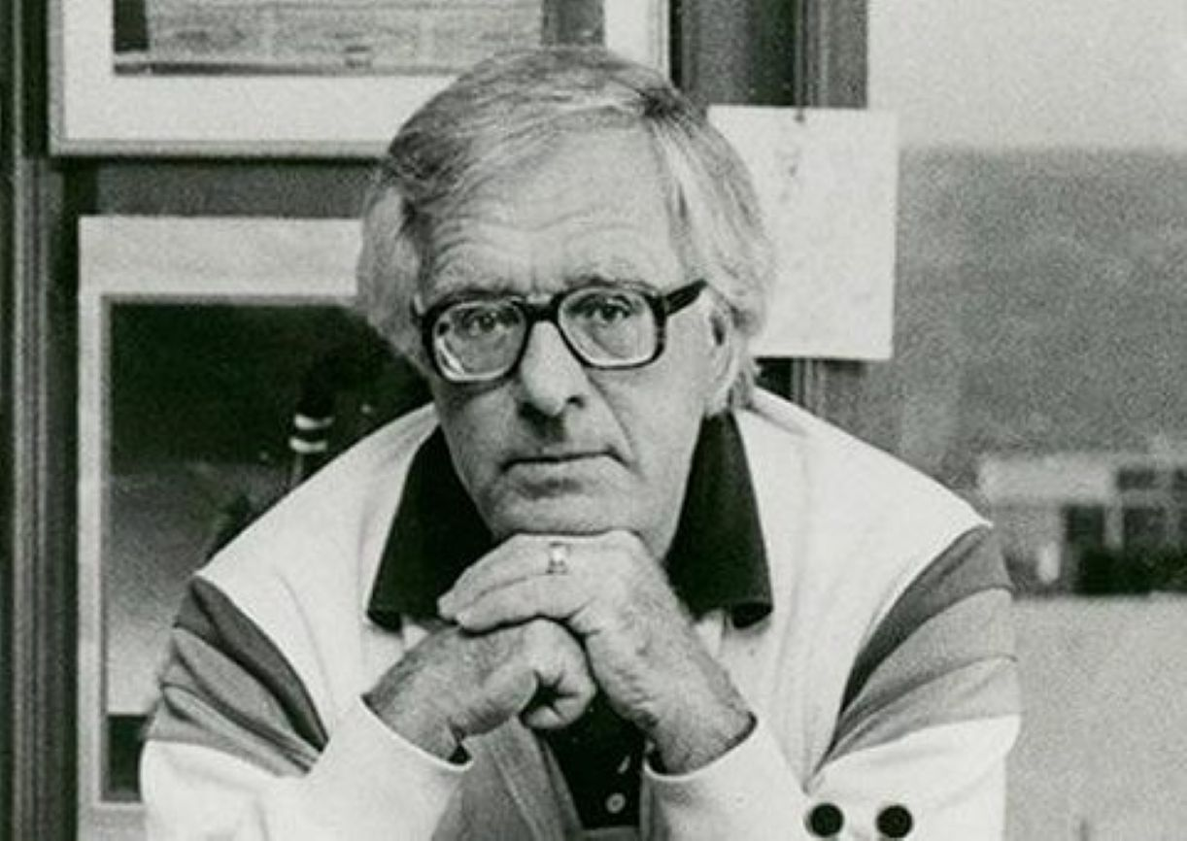

First Day, Ray Bradbury

First Day

It was while he was eating breakfast that Charles Douglas glanced at his newspaper and saw the date. He took another bite of toast and looked again and put the paper down.

“Oh, my God,” he said.

Alice, his wife, startled, looked up. “What?”

“The date. Look at it! September fourteenth.”

“So?” Alice said.

“The first day of school!”

“Say that again,” she said.

“The first day of school, you know, summer vacation’s over, everyone back, the old faces, the old pals.”

Alice studied him carefully, for he was beginning to rise. “Explain that.”

“It is the first day, isn’t it,” he said.

“What’s that got to do with us?” she said. “We don’t have family, we don’t know any teachers, we don’t even have friends anywhere near with kids.”

“Yeah, but …” Charlie said, picking up the newspaper again, his voice gone strange. “I promised.”

“Promised? Who?”

“The old gang,” he said. “Years ago. What time is it?”

“Seven-thirty.”

“We’d better hurry then,” he said, “or we’ll miss it.”

“I’ll get you more coffee. Take it easy. My God, you look terrible.”

“But I just remembered.” He watched her pour his cup full. “I promised. Ross Simpson, Jack Smith, Gordon Haines. We took almost a blood oath. Said we’d meet again, the first day of school, fifty years after graduation.”

His wife sat back and let go of the coffeepot.

“This all has to do with the first day of school, 1938?”

“Yeah,’38.”

“And you stood around with Ross and Jack and what’s his—”

“Gordon! And we didn’t just stand around. We knew we were going out in the world and might not meet again for years, or never, but we took a solemn oath, no matter what, we’d all remember and come back, across the world if we had to, to meet out in front of the school by the flagpole, 1988.”

“You all promised that?”

“Solemn promise, yeah. And here I am sitting here talking when I should be getting the hell out the door.”

“Charlie,” Alice said, “you realize that your old school is forty miles away.”

“Thirty.”

“Thirty. And you’re going to drive over there and—”

“Get there before noon, sure.”

“Do you know how this sounds, Charlie?”

“Nuts,” he said, slowly. “Go ahead, say it.”

“And what if you get there and nobody else shows?”

“What do you mean?” he said, his voice rising.

“I mean what if you’re the only damn fool who’s crazy enough to believe—”

He cut in. “They promised!”

“But that was a lifetime ago!”

“They promised!”

“What if in the meantime they changed their minds, or just forgot?”

“They wouldn’t forget.”

“Why not?”

“Because they were my best pals, best friends forever, no one ever had friends like that.”

“Ohmigod,” she said. “You’re so sad, so naive.”

“Is that what I am? Look, if I remember, why not them?”

“Because you’re a special loony case!”

“Thanks a lot.”

“Well, it’s true, isn’t it? Look at your office upstairs, all those Lionel trains, Mr. Machines, stuffed toys, movie posters.”

“And?”

“Look at your files, full of letters from 1960, 1950, 1940, you can’t throw away.”

“They’re special.”

“To you, yes. But do you really think those friends, or strangers, have saved your letters, the way you’ve saved theirs?”

“I write great letters.”

“Darn right. But call up some of those correspondents, ask for some of your old letters back. How many do you think will return?”

He was silent.

“Zilch,” she said.

“No use using language like that,” he said.

“Is ‘zilch’ a swearword?”

“The way you say it, yes.”

“Charlie!”

“Don’t ‘Charlie’ me!”

“How about the thirtieth anniversary of your drama club group where you ran hoping to see some bubblehead Sally or something or other, and she didn’t remember, didn’t know who you were?”

“Keep it up, keep it up,” he said.

“Oh, God,” she said. “I don’t mean to rain on your picnic, I just don’t want you to get hurt.”

“I’ve got a thick skin.”

“Yes? You talk bull elephants and go hunt dragonflies.”

He was on his feet. With each of her comments he got taller.

“Here goes the great hunter,” he said.

“Yes,” she exhaled, exhausted. “There you go, Charlie.”

“I’m at the door,” he said.

She stared at him.

“I’m gone.”

And the door shut.

My God, he thought, this is like New Year’s Eve.

He hit the gas hard, then released it, and hit it again, and let it slow, depending on the beehive filling his head.

Or it’s like Halloween, late, the fun over, and everyone going home, he thought. Which?

So he moved along at an even pace, constantly glancing at his watch. There was enough time, sure, plenty of time, but he had to be there by noon.

But what in hell is this? he wondered. Was Alice right? A chase for the wild goose, a trip to nowhere for nothing? Why was it so damned important? After all, who were those pals, now unknown, and what had they been up to? No letters, no phone calls, no face-to-face collisions by pure accident, no obituaries. That last, scratch that! Hit the accelerator, lighten up! Lord, he thought, I can hardly wait. He laughed out loud. When was the last time you said that? When you were a kid, could hardly wait, had a list of hard-to-wait-for things. Christmas, my God, was always a billion miles off. Easter? Half a million. Halloween? Dear sweet Halloween, pumpkins, running, yelling, rapping windows, ringing doorbells, and the mask, cardboard smelling hot with breath over your face. All Hallows! The best. But a lifetime away. And July Fourth with great expectations, trying to be first out of bed, first half-dressed, first jumping out on the lawn, first to light six-inchers, first to blow up the town! Hey, listen! First! July Fourth. Can hardly wait. Hardly wait!

But, back then, almost every day was can-hardly-wait day. Birthdays, trips to the cool lake on hot noons, Lon Chaney films, the Hunchback, the Phantom. Can hardly wait. Digging ravine caves. Magicians arriving in the long years. Can’t wait. Hop to it. Light the sparklers. Won’t wait. Won’t.

He let the car slow, staring ahead across Time.

Not far now, not long. Old Ross. Dear Jack. Special Gordon. The gang. The invincibles. Not three but four, counting himself, Musketeers.

He ran the list, and what a list. Ross, the handsome dog, older than the rest though they were all the same age, bright but no show-off, bicycling through classes with no sweat, getting high marks with no care. Reader of books, lover of Fred Allen Wednesdays radio, repeater of all the best jokes next day noon. Meticulous dresser, though poor. One good tie, one good belt, one coat, one pair of pants, always pressed, always clean. Ross. Yeah, sure, Ross.

And Jack, the future writer who was going to conquer the world and be the greatest in history. So he yelled, so he said, with six pens in his jacket and a yellow pad waiting to un-Steinbeck Steinbeck. Jack.

And Gordon, who loped across campus on the bodies of moaning girls, for all he had to do was glance and the females were chopped like trees.

Ross, Jack, Gordon, what a team.

Fast and slow he drove, now slow.

But what will they think of me? Have I done enough, have I done too well? Ninety stories, six novels, one film, five plays—not bad. Hell, he thought, I won’t say, who cares, just shut your mouth, let them talk, you listen, the talk will be great.

What do we say first, I mean as soon as we show up, the old gang, by the flagpole? Hello? Hi. My God, you’re really here! How you been, what’s new, you okay, good health? Marriage, children, grandchildren, pictures, ’fess up. What, what?

Okay, he thought, you’re the writer. Make something up, not just hi, a celebration. Write a poem. Good grief, would they stand still for a poem? How about, would it be too much: I love you, love you all. No. Above and beyond. I love you.

He slowed the car even more, looking through the windshield at shadows.

But what if they don’t show? They will. They must. And if they show, everything will be all right, won’t it? Boys being what they are, if they’ve had a bad life, bad marriages, you name it, they won’t show. But if it’s been good, absolutely incredibly good, they’ll show. That’ll be the proof, won’t it? They’ve done well so it’s okay to remember the date and arrive. True or false? True!

He stepped on the gas, sure that they’d all be there. Then he slowed again, sure that they wouldn’t. Then stepped on the gas again. What the hell, by God, what the hell.

And he pulled up in front of the school. Beyond belief, there was a place to park, and not many students by the flagpole, a handful at most. He wished there were more, to camouflage the arrival of his friends; they wouldn’t want to arrive and be seen right off, would they? He wouldn’t. A slow progression through the noon crowd and then the grand surprise, wouldn’t that be the ticket?

He hesitated getting out of the car until a small crowd emerged from the school, young men and women, all talking at once and pausing by the flagpole, which made him happy, for now there were enough to hide latecomers, no matter what age. He got out of the car and at first did not turn, afraid to look, afraid maybe there’d be no one there, no one would come, no one would have remembered, the whole thing was dumb. He resisted the temptation to jump back in the car and go away.

The flagpole was deserted. There were a lot of students around it, nearby, but nobody right at the flagpole.

He stood staring at it as if by staring someone would move up, go by, perhaps touch it.

His heart slowed, he blinked, and started instinctively to leave.

When, from the edge of the crowd, a man moved.

An old man, hair white, step slow, face pale. An old man.

And then two more old men.

Oh Lord, he thought, is that them? Did they remember? What’s next?

They stood in a wide circle, not speaking, hardly looking, making no move, for the longest time.

Ross, he thought, is that you? And the next one: Jack, now, yes? And the final one. Gordon?

Their expressions were all the same. The same thoughts must have been moving behind each face.

Charlie leaned forward. The others leaned forward. Charlie took the smallest step. The three others took the smallest step. Charlie glanced over at each face. They did the same, trading glances. And then—

Charlie stepped back. After a long moment the other men stepped back. Charlie waited. The three old men waited. The flag blew, softly flapping, on the high pole.

A bell rang somewhere inside the school. Lunchtime over. Time to go in. The students dispersed across the campus.

With the students moving away, with the crowd leaving so there was no camouflage, no more cover, the four men stood in a great circle around the flagpole, some fifty or sixty feet separating them, the four points of a bright autumn day compass.

Perhaps one of them wet his lips, perhaps one of them blinked, perhaps one of them shuffled one shoe forward, took it back. The white hair on their heads blew in the wind. A wind took up the flag on the pole and blew it straight out. Inside the school, another bell rang, with finality.

He felt his mouth shape words but say nothing. He repeated the names, the wondrous names, the loving names, in whispers only he could hear.

He did not make a decision. His lower body did it in a half turn, his legs followed, as did his feet. He stepped back and stood sideways.

Across a great distance, one by one in the blowing noon wind, first one stranger and then the next followed by the next half-turned, stepped a half step away, and waited.

He felt his body hesitate and want to move forward and not off toward his car. Again, he made no decision. His shoes, disembodied, took him quietly away.

As did the bodies, the feet, and the shoes of the strangers.

Now he was on the move, now they were on the move, all walking in different directions, slowly, half-glancing back at the deserted flagpole and the flag, abandoned, high, flapping quietly, and the lawn in front of the school empty and inside the moment of loud talk and laughter and the shove of chairs being put in place.

They were all in motion now, half-glancing back at the empty flagpole.

He halted for a moment, unable to move his feet. He gazed back a final time with a tingling in his right hand, as if it wanted to rise. He half-lifted and looked at it.

And then, across sixty or seventy yards of space, beyond the flagpole, one of the strangers, only half-looking, raised his hand and waved it quietly, once, on the silent air. Over to one side, another old man, seeing this, did the same, as did the third.

He watched as his hand and arm slowly lifted and the tips of his fingers, up in the air, gestured the least small gesture. He looked up at his hand and over at the old men.

My God, he thought, I was wrong. Not the first day of school. The last.

Alice had something frying in the kitchen that smelled good.

He stood in the doorway for a long moment.

“Hey,” she said, “come in, take a load off your feet.”

“Sure,” he said, and went to the dining-room table and saw that it was laid out with the best silver and the best dinnerware and candles lit that were usually lit for a twilight meal, and the best napkins in place, while Alice waited in the kitchen door.

“How did you know I’d be here so soon?” he said.

“I didn’t,” she said. “I saw you pull up out front. Bacon and eggs are quick, be ready in a sec. Sit down?”

“That’s an idea.” He held to the back of one chair and studied the cutlery. “Sit down.”

He sat and she came and kissed him on the brow and went back to the kitchen.

“Well?” she called.

“Well, what?”

“How did it go?” she called.

“How did what go?”

“You know,” she said. “The big day. All those promises. Did anyone show?”

“Sure,” he said. “Everyone showed,” he added.

“Well, spill the beans.”

She was in the kitchen doorway now, bringing the bacon and eggs. She studied him.

“You were saying?”

“Was I?” He leaned forward over the table. “Oh, yeah.”

“Well, was there lots to talk about?”

“We—”

“Yes?”

He saw the waiting and empty plate.

And tears falling on the plate.

“God, yes!” he said, very loud. “We talked our heads off!”

The end