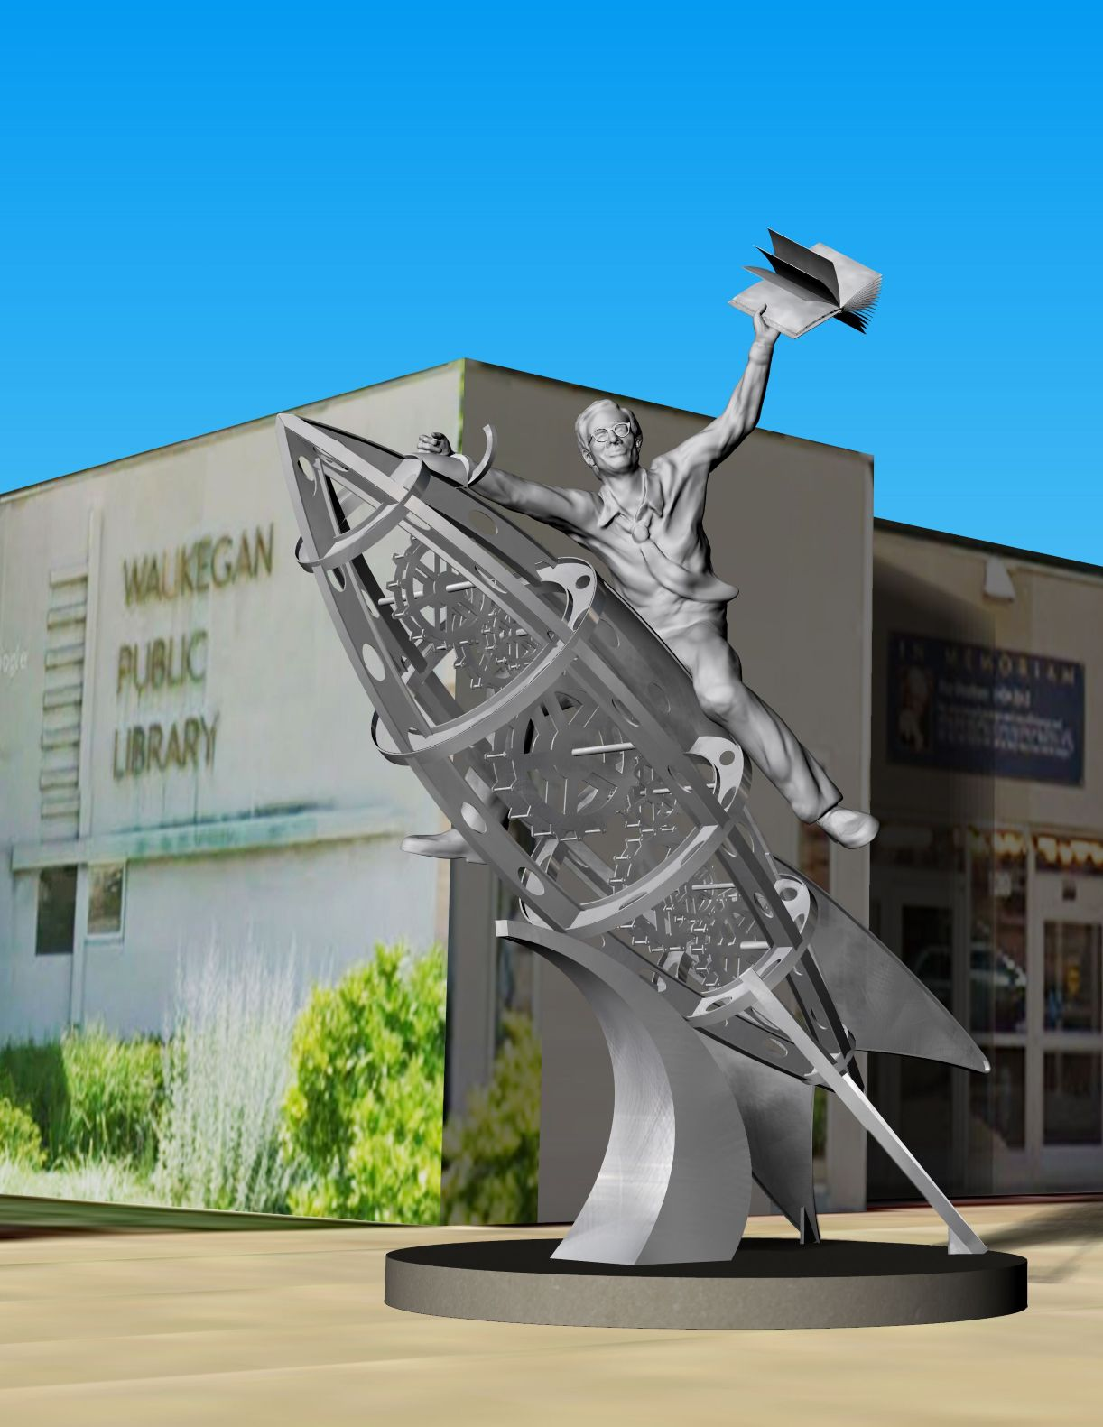

Free Dirt, Ray Bradbury

Free Dirt

The cemetery was in the center of the city. On four sides it was bounded by gliding streetcars on glistening blue tracks and cars with exhaust fumes and sound.

But, once inside the wall, the world was lost. For half a mile in four directions the cemetery raised midnight trees and headstones that grew from the earth, like pale mushrooms, moist and cold. A gravel path led back into darkness and within the gate stood a Gothic Victorian house with six gables and a cupola.

The front-porch light showed an old man there alone, not smoking, not reading, not moving, silent. If you took a deep breath he smelled of the sea, of urine, of papyrus, of kindling, of ivory, and of teak.

His false teeth moved his mouth automatically when it wanted to talk. His tiny yellow seed eyes twitched and his poke-hole nostrils thinned as a stranger crunched up the gravel path and set foot on the porch step.

“Good evening!” said the stranger, a young man, perhaps twenty.

The old man nodded, but his hands lay quietly on his knees "I saw that sign out front," the stranger went on. "FREE DIRT, it said."

The old man almost nodded.

The stranger tried a smile. "Crazy, but that sign caught my eye.

There was a glass fan over the front door. A light shone through this glass fan, colored blue, red, yellow, and touched the old man's face. It seemed not to bother him.

"I wondered, free dirt? Never struck me you'd have much left over. When you dig a hole and put the coffin in and refill the hole, you haven't much dirt left, have you? I should think..."

The old man leaned forward. It was so unexpected that the stranger pulled his foot off the bottom step.

"You want some?" said the old man.

"Why, no, no, I was just curious. Signs like that make you curious."

"Set down," said the old man.

"Thanks." The young man sat uneasily on the steps. "You know how it is, you walk around and never think how it is to own a graveyard."

"And?" said the old man.

"I mean, like how much time it takes to dig graves."

The old man leaned back in his chair. "On a cool day:

two hours. Hot day, four. Very hot day, six. Very cold day, not cold so it freezes, but real cold, a man can dig a grave in one hour so he can head in for hot chocolate, brandy in the chocolate. Then again, you get a good man on a hot day, he's no better than a bad man in the cold. Might take eight hours to open up, but here's easy-digging soil here. All loam, no rocks."

"I'm curious about winter."

"In blizzards we got a icebox mausoleum to stash the dead, undelivered mail, until spring and a whole month of shovels and spades."

"Seeding and planting time, eh?" The stranger laughed.

"You might say that."

"Don't you dig in winter anyhow? For special funerals? Special dead?"

"Some yards got a hose-shovel contraption. Pump hot water through the blade; shape a grave quick, like placer mining, even with the ground an ice-pond. We don't cotton to that. Use picks and shovels."

The young man hesitated. "Does it bother you?"

"You mean, I get scared ever?"

"Well . . . yes."

The old man at last took out and stuffed his pipe with tobacco, tamped it with a callused thumb, lit it, let out a small stream of smoke.

"No," he said at last.

The young man's shoulders sank. "Disappointed?" said the old man. "I thought maybe once .

“Oh, when you're young, maybe. One time ...”

"Then there was a time!" The young man shifted up a step. The old man glanced at him sharply, then resumed smoking. "One time." He stared at the marbled hills and the dark trees. "My grandpa owned this yard. I was born here. A gravedigger' 5 son learns toignore things."

The old man took a number of deep puffs and said:

"I was just eighteen, folks off on vacation, me left to tend things, alone, mow the lawn, dig holes and such. Alone, four graves to dig in October and a cold came hard off the lake, frost on the graves, tombstones like snow, ground froze solid.

"One night I walked out. No moon. Hard grass underfoot, could see my breath, hands in my pockets, walking, listening."

The old man exhaled frail ghosts from his thin nostrils. "Then I heard this sound, deep under. I froze. It was a voice, screaming. Someone woke up buried, heard me walk by, cried out. I just stood. They screamed and screamed. Earth banged. On a cold night, ground's like porcelain, rings, you see?

"Well-" The old man shut his eyes to remember. "I stood like the wind off the lake stopped my blood. A joke? I searched around and thought, Imagination! No, it was underfoot, sharp, clear. A woman's voice.

I knew all the gravestones." The old man's eyelids trembled. "Could recite them alphabetical, year, month, day. Name any year, and I'll tell. How about 1899? Jake Smith departed. And 1923? Betty Dallman lost. And 1933? P. H. Moran! Name a month. August?

August last year, buried Henrietta Wells. August 1918? Grandma Hanlon, whole family! Influenza! Name a day, August fourth? Smith, Burke, Shelby carried off. Williamson? He's on that hill, pink marble. Douglas? By the creek ...”

"The story," the young man urged.

“Eh?”

"The story you were telling."

"Oh, the voice below? Well, I knew all the stones. Standing there, I guessed that voice out of the ground was Henrietta Fremwell, fine girl, twenty-four years, played piano at the Elite Theatre. Tall, graceful, blond. How did I know her voice? I stood where there was only men's graves. Hers was the only woman's. I ran to put my ear on her stone. Yes! Her voice, way down, screaming!

"'Miss Fremwell!' I shouted.

"'Miss Fremwell,' I yelled again.

"Deep down I heard her, only weeping now. Maybe she heard me, maybe not. She just cried. I ran downhill so fast I tripped and split my head on a stone, got up, screamed myself! Got to the tool shed, all blood, dragged out the tools, and just stood there in the moonlight with one shovel.

The ground was ice solid, solid. I fell back against a tree. It would take three minutes to get back to her grave, and eight hours of cold night to dig to her box. The ground was like glass. A coffin is a coffin; only so much space for air.

Henrietta Fremwell had been buried two days before the freeze, been asleep all that time, using up air, and it rained just before the cold spell and the earth over her, soaked with rainwater now, froze. I'd have to dig maybe eight hours. And the way she cried, there wasn't another hour of air left."

The old man's pipe had gone out. He rocked in his chair, back and forth, back and forth, silently.

"But," said the young man, "what did you do?"

"Nothing," said the old man.

"Nothing!?"

"Nothing I could do. That ground was solid. Six men couldn't have dug that grave. No hot water near. And she might've been screaming hours before I heard, so . .

"You did-nothing?"

"Something Put the shovel and pick back in the tool shed, locked it and went back to the house and built a fire and drank some hot chocolate, shivering and shivering. Would you have done different?"

“I-”

"Would you have dug for eight hours in hard ice rock so's to reach her when she was truly dead of exhaustion, cold, smothered, and have to bury her all over again? Then call her folks and tell them?"

The young man was silent. On the porch, the mosquitoes hummed about the naked light bulb.

"I see," said the young man.

The old man sucked his pipe. "I think I cried all night because there was nothing I could do." He opened his eyes and stared about, surprised, as if he had been listening to someone else.

"That's quite a story," said the young man.

"No," said the old man, "God's truth. Want to hear more? See that big stone with the ugly angel? That was Adam Crispin's. Relatives fought, got a writ from a judge, dug him up hoping for poison. Found nothing. Put him back, but by that time the dirt from his grave mixed with other dirts.

We shoveled in stuff from all around. Next plot, the angel with broken wings? Mary-Lou Phipps. Dug her up to lug her off to Elgin, Illinois. More relatives. Where she'd been, the pit stayed open, oh, three weeks. No funerals. Meanwhile, her dirt got cross-shoveled with others.

Six stones over, one stone north, that was Henry Douglas Jones. Became famous sixty years after no one paid attention. Now he's planted under the Civil War monument. His grave lay wide two months, nobody wanted to utilize the hole of a Southerner, all of us leaning North with Grant. So his dirt got scattered. That give you some notion of what that FREE DIRT sign means?"

The young man eyed the cemetery landscape. "Well," he said, "where is that dirt you're handing out?"

The old man pointed with his pipe and the stranger looked and indeed, by a nearby wall was a sizable hillock some ten feet long by about three feet high, loam and grass tufts of many shades of tan, brown, and burnt umber.

"Go look," said the old man.

The young man walked slowly over to stand by the mound.

"Kick it," said the old man. "See if it's real."

The young man kicked and his face paled.

"Did you hear that?" he said.

"What?" said the old man, looking somewhere else.

The stranger listened and shook his head. "Nothing."

"Well, now," said the old man, knocking out the ashes from his pipe. "How much free dirt you need?"

"I hadn't thought."

"Yes, you have," said the old man, "or you wouldn't have driven your lightweight delivery truck up by the cemetery gate. I got cat's ears. Heard your motor just when you stopped. How much?"

"Oh," said the young man uneasily. "My backyard's eighty feet by forty. I could use a good inch of topsoil. So ...?”

"I'd say," said the old man, "half of that mound there. Hell, take it all. Nobody wants it."

"You mean-"

"I mean, that mound has been growing and diminishing, diminishing and growing, mixtures up and down, since Grant took Richmond and Sherman reached the sea. There's Civil dirt there, coffin splinters, satin casket shreds from when Lafayette met the Honor Guard's Edgar Allan Poe.

There's funeral flowers, blossoms from ten hundred obsequies. Condolence-card confetti for Hessian troopers, Parisian gunners who never shipped home. That soil is so laced with bone meal and casket corsages, I should charge you to buy the lot. Grab a spade before I do."

"Stay right there." The young man raised one hand.

"I'm not going anywhere," said the old man. "Nor is anyone else nearby."

The half-truck was pulled up by the dirt mound and the young man was reaching in for a spade when the old man said:

"No, I think not."

The old man went on:

"Graveyard spade's best. Familiar metal, familiar soil. Easy digging when like takes to like. So."

The old man's head indicated a spade half stuck in the dark mound. The young man shrugged and moved.

The cemetery spade came free with a soft whispering. Pellets of ancient mound fell with similar whispers.

He began to dig and shift and fill the back of his half-truck as the old man from the corners of his eyes observed:

“It's more than dirt, as I said. War of 1812, San Juan Hill, Manassas, Gettysburg, October flu epidemic 1918, all strewn from graves filled and evicted to be refilled. Various occupants leavened out to dust, various glories melted to mixtures, rust from metal caskets, coffin handles, shoelaces but no shoes, hairs long and short.

Ever see wreaths made of hair saved to weave crowns to fix on mortal pictures? All that's left of a smile or that funny look in the eyes of someone who knows she's not alive anymore, ever. Hair, epaulettes, not whole ones, but one strand of epaulette, all there along with blood that's gone to silt."

The young man finished, sweating, and started to thrust the spade back in the earth when the old man said:

"Take it. Cemetery dirt, cemetery spade, like takes to like."

"I'll bring it back tomorrow." The young man tossed the spade into the mounded truck.

"No. You got the dirt, so keep the spade. Just don't bring the free dirt back."

"Why would I do that?"

"Just don't," said the old man, but did not move as the young man climbed in his truck to start the engine.

He sat listening to the dirt mound tremble and whisper in the flatbed.

"What're you waiting for?" asked the old man.

The flimsy half-truck ran toward the last of the twilight, pursued by the ever-encroaching dark. Clouds raced overhead, perturbed by the invisible. Back on the horizon, thunder sounded. A few drops of rain fell on the windshield, causing the young man to ram his foot on the gas and swerve into his home street even as the sun truly died, the wind rose, and the trees around his cottage bent and beckoned.

Climbing out, he stared at the sky and then his house and then the empty garden. A few drops of cold rain on his cheeks decided him; he drove the rattling half-truck into the empty garden, unlatched the metal back-flap, opened it just an inch so as to allow a proper flow, and then began motoring back and forth across the garden, letting the dark stuffs whisper down, letting the strange midnight earth sift and murmur, until at last the truck was empty and he stood in the blowing night, watching the wind stir the black soil.

Then he locked the truck in the garage and went to stand on the back porch, thinking, I won't need water. The storm will soak the ground.

He stood for a long while simply staring at the graveyard mulch, waiting for rain, until he thought, what am I waiting for? Jesus! And went in.

At ten o'clock a light rain tapped on the windows and sifted over the dark garden. At eleven it rained so steadily that the gutter drains swallowed and rattled.

At midnight the rain grew heavy. He looked to see if it was eroding the new dark earth but saw only the black muck drinking the downpour like a great black sponge, lit by distant flares of lightning.

Then, at one in the morning, the greatest Niagara of all shuddered the house, rinsed the windows to blindness, and shook the lights.

And then, abruptly, the downpour, the immense Niagara ceased, followed by one great downfell blow of lightning which plowed and pinioned the dark earth close by, near, outside, with explosions of light as if ten thousand flashbulbs had been fired off. Then darkness fell in curtains of thunder, cracking, breaking the bones.

In bed, wishing for the merest dog to hold for lack of human company, hugging the sheets, burying his head, then rising full to the silent air, the dark air, the storm gone, the rain shut, and a silence that spread in whispers as the last drench melted into the trembling soil.

He shuddered and then shivered and then hugged himself to stop the shivering of his cold flesh, and he was thirsty but could not make himself move to find the kitchen and drink water, milk, leftover wine, anything. He lay back, dry-mouthed, with unreasonable tears filling his eyes.

Free dirt, he thought. My God, what a damn-fool night. Free dirt!

At two o'clock he heard his wristwatch ticking softly.

At two-thirty he felt his pulse in his wrists and ankles and neck and then in his temples and inside his head.

The entire house leaned into the wind, listening.

Outside in the still night, the wind failed and the yard lay soaked and waiting.

And at last ... yes. He opened his eyes and turned his head toward the shaded window.

He held his breath. what? Yes? Yes? What?

Beyond the window, beyond the wall, beyond the house, outside somewhere, a whisper, a murmur, growing louder and louder. Grass growing? Blossoms opening? Soil shifting, crumbling?

A great whisper, a mix of shadows and shades. Something rising. Something moving.

Ice froze beneath his skin. His heart ceased.

Outside in the dark, in the yard.

Autumn had arrived.

October was there.

His garden gave him ...

A harvest

The end