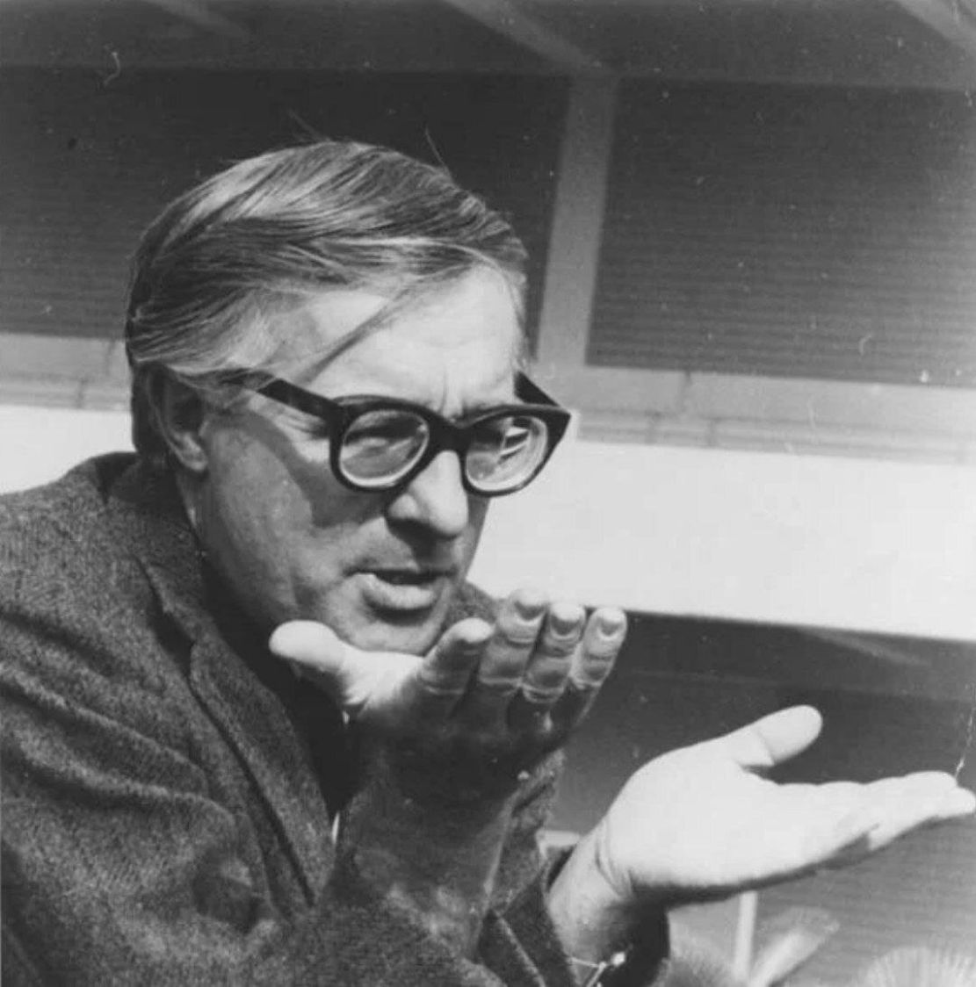

Gotcha! Ray Bradbury

Gotcha!

They were incredibly in love. They said it. They knew it. They lived it. When they weren’t staring at each other they were hugging.

When they weren’t hugging they were kissing. When they weren’t kissing they were a dozen scrambled eggs in bed.

When they were finished with the amazing omelet they went back to staring and making noises.

Theirs, in sum, was a Love Affair. Print it out in capitals. Underline it. Find some italics.

Add exclamation points. Put up the fireworks. Tear down the clouds. Send out for some adrenaline. Roustabout at three A.M. Sleep till noon.

Her name was Beth. His name was Charles.

They had no last names. For that matter, they rarely called each other by their first names. They found new names every day for each other, some of them capable of being said only late at night and only to each other, when they were special and tender and most shockingly unclad.

Anyway, it was Fourth of July every night. New Year’s every dawn. It was the home team winning and the mob on the field. It was a bobsled downhill and everything cold racing by in beauty and two warm people holding tight and yelling with joy.

And then…

Something happened.

At breakfast about one year into the conniption fits Beth said, half under her breath:

‘Gotcha.’

He looked up and said, ‘What?’

‘Gotcha,’ she said. ‘A game. You never played Gotcha?’

‘Never even heard of it.’

‘Oh, I’ve played it for years.’

‘Do you buy it in a store?’ he asked.

‘No, no. It’s a game I made up, or almost made up, based on an old ghost story or scare story. Like to play it?’

‘That all depends.’ He was back shoveling away at his ham and eggs.

‘Maybe we’ll play it tonight—it’s fun. In fact,’ she said, nodding her head once and beginning to go on with her breakfast again, ‘it’s a definite thing. Tonight it is. Oh, bun, you’ll love it.’

‘I love everything we do,’ he said.

‘It’ll scare the hell out of you,’ she said.

‘What’s the name again?’

‘Gotcha,’ she said.

‘Never heard of it.’

They both laughed. But her laughter was louder than his.

It was a long and delicious day of luscious name-callings and rare omelets and a good dinner with a fine wine and then some reading just before midnight, and at midnight he suddenly looked over at her and said:

‘Haven’t we forgotten something?’

‘What?’

‘Gotcha.’

‘Oh, my, yes!’ she said, laughing. ‘I was just waiting for the clock to strike the hour.’

Which it promptly did. She counted to twelve, sighed happily and said. ‘All right—let’s put out most of the lights. Just keep the small lamp lighted by the bed.

Now, there.’ She ran around putting out all the other lights, and came back and plumped up his pillow and made him lie right in the middle of the bed. ‘Now, you stay right there. You don’t move, see. You just…wait. And see what happens—okay?’

‘Okay.’ He smiled indulgently. At times like these she was a ten-yearold Girl Scout rushing about with some poisoned cookies on a grand lark. He was always ready, it seemed, to eat the cookies. ‘Proceed.’

‘Now, be very quiet,’ she said. ‘No talking. Let me talk if I want—okay?’

‘Okay.’

‘Here goes,’ she said, and disappeared.

Which is to say that she sank down like the dark witch, melting, melting, at the foot of the bed. She let her bones collapse softly. Her head and her hair followed her Japanese paper-lantern body down, fold on fold, until the air at the foot of the bed was empty.

‘Well done!’ he cried.

‘You’re not supposed to talk. Sh-h.’

‘I’m sh-h-h-ed.’

Silence. A minute passed. Nothing.

He smiled a lot, waiting.

Another minute passed, Silence. He didn’t know where she was.

‘Are you still at the foot of the bed?’ he asked. ‘Oh, sorry.’ He sh-h-hed himself. ‘Not supposed to talk.’

Five minutes passed. The room seemed to get somewhat darker. He sat up a bit and fixed his pillow and his smile got somewhat less expectant. He peered about the room. He could see the light from the bathroom shining on the wall.

There was a sound like a small mouse in one far corner of the room. He looked there but could see nothing.

Another minute passed. He cleared his throat.

There was a whisper from the bathroom door, down near the floor.

He glanced that way and grinned and waited. Nothing.

He thought he felt something crawling under the bed. The sensation passed. He swallowed and blinked.

The room seemed almost candlelit. The light bulb, one hundred and fifty watts, seemed now to have developed fifty-watt problems.

There was a scurry like a great spider on the floor, but nothing was visible. After a long while her voice murmured to him like an echo, now from this side of the dark room, now that.

‘How do you like it so far?’

‘I…’

‘Don’t speak,’ she whispered.

And was gone again for another two minutes. He was beginning to feel his pulse jump in his wrists. He looked at the left wall, then the right, then the ceiling.

And suddenly a white spider was crawling along the foot of the bed. It was her hand, of course, imitating a spider. No sooner there than gone.

‘Ha!’ He laughed.

‘Sh-h!’ came the whisper.

Something ran into the bathroom. The bathroom light went out. Silence. There was only the small light in the bedroom now. A faint rim of perspiration appeared on his brow. He sat wondering why they were doing this.

A clawing hand snatched up on the far left side of the bed, gesticulated and vanished. The watch ticked on his wrist.

Another five minutes must have gone by. His breathing was long and somewhat painful, though he couldn’t figure why. A small frown gathered in the furrow between his eyes and did not go away. His fingers moved on the quilt all to themselves, as if trying to get away from him.

A claw appeared on the right side. No, it hadn’t been there at all! Or had it?

Something stirred in the closet directly across the room. The door slowly opened upon darkness. Whether something went in at that moment or was already there, waiting to come out, he could not say. The door now opened upon an abyss that was as deep as the spaces between the stars. A few dark shadows of coats hung inside, like disembodied people.

There was a running of feet in the bathroom.

There was a scurry of cat feet by the window.

He sat up. He licked his lips. He almost said something. He shook his head. A full twenty minutes had passed.

There was a faint moan, a distant laugh that hushed itself. Then another groan…where? In the shower?

‘Beth?’ he said at last.

No answer. Water dripped in the sink suddenly, drop by slow drop. Something had turned it on.

‘Beth?’ he called again, and hardly recognized his voice, it was so pale.

A window opened somewhere. A cool wind blew a phantom of curtain out on the air.

‘Beth,’ he called weakly.

No answer.

‘I don’t like this,’ he said.

Silence.

No motion. No whisper. No spider. Nothing.

‘Beth?’ he called, a bit louder.

No breathing, even, anywhere.

‘I don’t like this game.’

Silence.

‘You hear me, Beth?’

Quiet.

‘I don’t like this game.’

Drip in the bathroom sink.

‘Let’s stop the game, Beth.’

Wind from the window.

‘Beth?’ he called again. ‘Answer me. Where are you?’

Silence.

‘You all right?’

The rug lay on the floor. The light grew small in the lamp. Invisible dusts stirred in the air.

‘Beth…you okay?’

Silence.

‘Beth?’

Nothing.

‘Beth!’

‘Oh-h-h-h-h-h…ah-h-h-h-h!’

He heard the shriek, the cry, the scream.

A shadow sprang up. A great darkness leaped upon the bed. It landed on four legs.

‘Ah!’ came the shout.

‘Beth!’ he screamed.

‘Oh-h-h-h!’ came the shriek from the thing.

Another great leap and the dark thing landed on his chest. Cold hands seized his neck. A white face plunged down. A mouth gaped and shrieked:

‘Gotcha!’

‘Beth!’ he cried.

And flailed and wallowed and turned but it clung to him and looked down and the face was white and the eyes raved wide and the nostrils flared. And the big bloom of dark hair in a flurry above fell down in a stormwind.

And the hands clawing at his neck and the air breathed out of that mouth and nostrils as cold as polar wind, and the weight of the thing on his chest light but heavy, thistledown but an anvil crushing, and him thrashing to be free, but his arms pinned by the fragile legs and the face peering down at him so full of evil glee, so brimful of malevolence, so beyond this world and in another, so alien, so strange, so never seen before, that he had to shriek again.

‘No! No! No! Stop! Stop!’

‘Gotcha!’ screamed the mouth.

And it was someone he had never seen before. A woman from some time ahead, some year when age and things had changed everything, when darkness had gathered and boredom had poisoned and words had killed, and everything gone to ice and lostness and nothing, no residues of love, only hate, only death.

‘No! Oh, God! Stop!’

He burst into tears. He began to sob.

She stopped.

Her hands went away cold and came back warm to touch, hold, pet him.

And it was Beth.

‘Oh, God, God, God!’ he wailed. ‘No, no, no!’

‘Oh, Charles, Charlie,’ she cried, all remorse. ‘I’m sorry, I didn’t mean—’

‘You did. Oh God, you did, you did!’

His grief was uncontrollable.

‘No, no. Oh, Charlie,’ she said, and burst into tears herself. She flung herself out of bed and ran around turning on lights.

But none of them were bright enough. He was crying steadily now. She came back and slid in by him and put his grieving face to her breast and held him, hugged him, patted him, kissed his brow and let him weep.

‘I’m sorry. Charlie, listen, sorry. I didn’t—’

‘You did!’

‘It was only a game!’

‘A game! You call that a game, game, game!’ he wailed, and wept again.

And finally, at last, his crying stopped and he lay against her and she was warm and sister/mother/friend/lover again. His heart, which had crashed, now moved to some near-calm. His pulses stopped fluttering. The constric tion around his chest let go.

‘Oh, Beth, Beth,’ he wailed, softly.

‘Charlie,’ she apologized, her eyes shut.

‘Don’t ever do that again.’

‘I won’t.’

‘Promise you’ll never do that again?’ he said, hiccuping.

‘I swear, I promise.’

‘You were gone. Beth—that wasn’t you!’

‘I promise, I swear, Charlie.’

‘All right,’ he said.

‘Am I forgiven, Charlie?’

He lay a long while and at last nodded, as if it had taken some hard thinking.

‘Forgiven.’

‘I’m sorry, Charlie. Let’s get some sleep. Shall I turn the lights off?’

Silence.

‘Shall I turn the lights off, Charlie?’

‘No-no.’

‘We have to have the lights off to sleep, Charlie.’

‘Leave a few on for a little while,’ he said, eyes shut.

‘All right,’ she said, holding him. ‘For a little while.’

He took a shuddering breath and came down with a chill. He shook for five minutes before her holding him and stroking him and kissing him made the shiver and the tremble go away.

An hour later she thought he was asleep and got up and turned off all the lights save the bathroom light, in case he should wake and want at least one on. Getting back into bed, she felt him stir. His voice, very small, very lost, said:

‘Oh, Beth, I loved you so much.’

She weighed his words. ‘Correction. You love me so much.’

‘I love you so much,’ he said.

It took her an hour, staring at the ceiling, to go to sleep.

The next morning at breakfast he buttered his toast and looked at her. She sat calmly munching her bacon. She caught his glance and grinned at him.

‘Beth,’ he said.

‘What?’ she asked.

How could he tell her? Something in him was cold. The bedroom even in the morning sun seemed smaller, darker.

The bacon was burned. The toast was black. The coffee had a strange and alien flavor. She looked very pale. He could feel his heart, like a tired fist, pounding dimly against some locked door somewhere.

‘I…’ he said, ‘we…’

How could he tell her that suddenly he was afraid? Suddenly he sensed that this was the beginning of the end. And beyond the end there would never be anyone to go to anywhere at any time—no one in all the world.

‘Nothing,’ he said.

Five minutes later she asked, looking at her crumpled eggs, ‘Charles, do you want to play the game tonight? But this time it’s me, and this time it’s you who hides and jumps out and says, “Gotcha”?’

He waited because he could not breathe.

‘No.’

He did not want to know that part of himself.

Tears sprang to his eyes.

‘Oh, no,’ he said.

The end