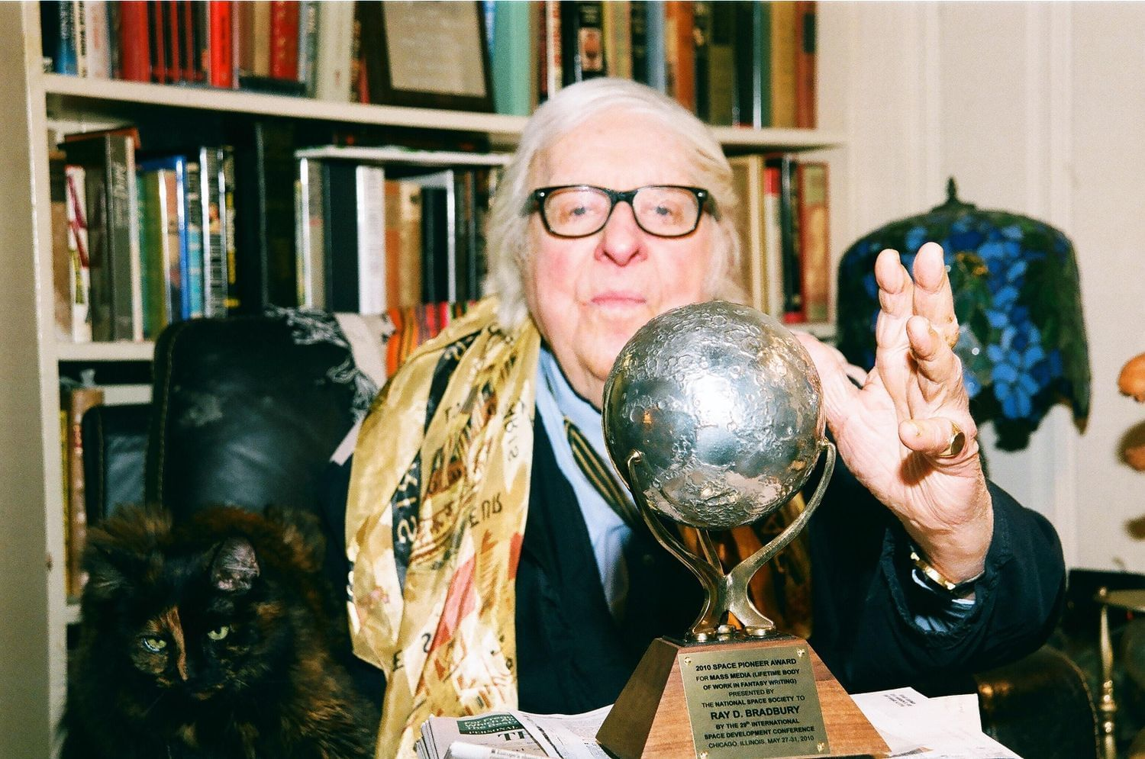

Hail and Farewell, Ray Bradbury

Hail and Farewell

But of course he was going away, there was nothing else to do, the time was up, the clock had run out, and he was going very far away indeed. His suitcase was packed, his shoes were shined, his hair was brushed, he had expressly washed behind his ears, and it remained only for him to go down the stairs, out the front door, and up the street to the small-town station where the train would make a stop for him alone. Then Fox Hill, Illinois, would be left far off in his past.

And he would go on, perhaps to Iowa, perhaps to Kansas, perhaps even to California; a small boy twelve years old with a birth certificate in his valise to show he had been born forty-three years ago.

«Willie!» called a voice downstairs.

«Yes!» He hoisted his suitcase. In his bureau mirror he saw a face made of June dandelions and July apples and warm summer-morning milk. There, as always, was his look of the angel and the innocent, which might never, in the years of his life, change.

«Almost time,» called the woman's voice.

«All right!» And he went down the stairs, grunting and smiling. In the living-room sat Anna and Steve, their clothes painfully neat.

«Here I am!» cried Willie in the parlor door.

Anna looked like she was going to cry. «Oh, good Lord, you can't really be leaving us, can you, Willie?»

«People are beginning to talk,» said Willie quietly. «I've been here three years now. But when people begin to talk, I know it's time to put on my shoes and buy a railway ticket.»

«It's all so strange. I don't understand. It's so sudden,» Anna said. «Willie, we'll miss you.

„I'll write you every Christmas, so help me. Don't you write me.“

„It's been a great pleasure and satisfaction,“ said Steve, sitting there, his words the wrong size in his mouth. „It's a shame“ it had to stop. It's a shame you had to tell us about yourself. It's an awful shame you can't stay on.»

«You're the nicest folks I ever had,» said Willie, four feet high, in no need of a shave, the sunlight on his face.

And then Anna did cry. «Willie, Willie.» And she sat down and looked as if she wanted to hold him but was afraid to hold him now; she looked at him with shock and amazement and her hands empty, not knowing what to do with him now.

«It's not easy to go,» said Willie. «You get used to things. You want to stay. But it doesn't work. I tried to stay on once after people began to suspect. „Flow horrible!“ people said. „All these years, playing with our innocent children,“ they said, „and us not guessing! Awful!“ they said. And finally I had to just leave town one night. It's not easy. You know darned well how much I love both of you. Thanks for three swell years.»

They all went to the front door. «Willie, where're you going?»

«I don't know. I just start traveling. When I see a town that looks green and nice, I settle in.»

«Will you ever come back?»

«Yes,» he said earnestly with his high voice. «In about twenty years it should begin to show in my face. When it does, I'm going to make a grand tour of all the mothers and fathers I've ever had.»

They stood on the cool summer porch, reluctant to say the last words.

Steve was looking steadily at an elm tree. «How many other folks've you stayed with, Willie? How many adoptions?»

Willie figured it, pleasantly enough. «I guess it's about five towns and five couples and over twenty years gone by since I started my tour.»

«Well, we can't holler,» said Steve. «Better to've had a son thirty-six months than none whatever.»

«Well,» said Willie, and kissed Anna quickly, seized at his luggage, and was gone up the street in the green noon light, under the trees, a very young boy indeed, not looking back, running steadily.

he The boys were playing on the green park diamond when came by. He stood a little while among the oak-tree shadows, watching them hurl the white, snowy baseball into the warm summer air, saw the baseball shadow fly like a dark bird over the grass, saw their hands open in mouths to catch this swift piece of summer that now seemed most especially important to hold on to. The boys' voices yelled. The ball lit on the grass near Willie.

Carrying the ball toward from under the shade trees, he thought of the last three years now spent to the penny, and the five years before that, and so on down the line to the year when he was really eleven and twelve and fourteen and the voices saying: «What's wrong with Willie, missus?»

«Mrs. B., is Willie late a-growing?» «Willie, you smokin' cigars lately?» The echoes died in summer light and color. His mother's voice: «Willie's twenty-one today!» And a thousand voices saying: «Come back, son, when you're fifteen; then maybe we'll give you a job.»

l-le stared at the baseball in his trembling hand, as if it were his life, an interminable ball of years strung around and around and around, but always leading back to his twelfth birthday. He heard the kids walking toward him; he felt them blot out the sun, and they were older, standing around him.

«Willie! Where you goin'?» They kicked his suitcase.

How tall they stood in the sun. In the last few months it seemed the sun had passed a hand above their heads, and they were golden toffee pulled by an immense gravity to the sky, thirteen, fourteen years old, looking down upon Willie, smiling, but already beginning to neglect him. It had started four months ago:

«Choose up sides! Who wants Willie?»

«Aw, Willie's too little; we don't play with „kids“.»

And they raced ahead of him, drawn by the moon and the sun and the turning seasons of leaf and wind, and lie was twelve years old and not of them any more. And the other voices beginning again on the old, the dreadfully familiar, the cool refrain: «Better feed that boy vitamins, Steve.» «Anna, does shortness run in your family?» And the cold fist knocking at your heart again and knowing that the roots would have to be pulled up again after so many good years with the «folks».

«Willie, where you goin'?»

He jerked his head. He was back among the towering, shadowing boys who milled around him like giants at a drinking fountain bending down.

«Goin' a few days visitin' a cousin of mine.»

«Oh.» There was a day, a year ago, when they would have cared very much indeed. But now there was only curiosity for his luggage, their enchantment with trains and trips and far places.

«How about a game?» said Willie.

They looked doubtful, but, considering the circumstances, nodded. lie dropped his bag and ran out; the white baseball was up in the sun, away to their burning white figures in the far meadow, up in the sun again, rushing, life coming and going in a pattern. Here,there! Mr. and Mrs. Robert Hanlon, Creek Bend, Wisconsin, 1932, the first couple, the first year!

Here,there! Henry and Alice Boltz, Limeville, Iowa, 1935! The baseball flying. The Smiths, the Eatons, the Robinsons! 1939! 1945! Husband and wife, husband and wife, husband and wife, no children, no children! A knock on this door, a knock on that.

Pardon me. My name is William. I wonder if — «A sandwich? Come in, sit down. Where you from, son?»

The sandwich, a tall glass of cold milk, the smiling, the nodding, the comfort able, leisurely talking.

«Son, you look like you been traveling. You run off from somewhere?»

«No.»

«Boy, are you an orphan?»

Another glass of milk.

«We always wanted kids. It never worked out. Never knew why. One of those things. Well, well. ft's getting late, son. Don't you think you better hit for home?»

«Got no home.»

«A boy like you? Not dry behind the ears? Your mother'll be worried.»

«Got no borne and no folks anywhere in the world. I wonder if — I wonder — could I sleep here tonight?»

«Well, now, son, I don't just know. We never considered taking in —» said the husband.

«We got chicken for supper tonight,» said the wife, «enough for extras, enough for company...»

And the years turning and flying away, the voices, and the faces, and the people, and always the same first conversations. The voice of Emily Robinson, in her rocking chair, in summernight darkness, the last night he stayed with her, the night she discovered his secret, her voice saying:

«I look at all the little children's faces going by.

And I sometimes think. What a shame, what a shame, that all these flowers have to be cut, all these bright fires have to be put out. What a shame these, all of these you see in schools or running by, have to get tall and unsightly and wrinkle and turn gray or get bald, and finally, all bone and wheeze, be dead and buried off away.

When I hear them laugh I can't believe they'll ever go the road I'm going. Yet here they come! I still remember Wordsworth's poem:

„When all at once I saw a crowd, A host of golden daffodils; Beside the lake, beneath the trees, Fluttering and dancing in the breeze.“

That's how I think of children, cruel as they sometimes are, mean as I know they can be, but not yet showing the meanness around their eyes or in their eyes, not yet full of tiredness. They're so eager for everything!

I guess that's what I miss most in older folks, the eagerness gone nine times out of ten, the freshness gone, so much of the drive and life down the drain. I like to watch school let out each day. It's like someone threw a bunch of flowers out of the school front doors. How does it feel, Willie? How does it feel to be young forever? To look like a silver dime new from the mint? Are you happy? Are you as fine as you seem? »

The baseball whizzed from the blue sky, stung his hand like a great pale insect. Nursing it, he hears his memory say:

«I worked with what I had.

After my folks died, after I found I couldn't get man's work anywhere, I tried carnivals, but they only laughed. „Son,“ they said, „you're not a midget, and even if you are, you look like a boy! We want midgets with midgets' laces! Sorry, son, sorry. So I left home, started out, thinking: What was I? A boy. I looked like a boy, sounded like a boy, so I might as well goon being a boy. No use lighting it. No use screaming. So what could I do?

What job was handy? And then one day I saw this man in a restaurant looking at another man's pictures of his children. „Sure wish I had kids,“ he said. „Sure wish I had kids.“ He kept shaking his head. And me sitting a few seats away from him, a hamburger in my hands.

I sat there, frozen. At that very instant I knew what my job would be for all the rest of my life. There was work for me, after all. Making lonely people happy. Keeping myself busy.

Playing forever. I knew I had to play forever. Deliver a few papers, run a few errands, mow a few lawns, maybe. But hard work? No. All I had to do was be a mother's son and a father's pride. I turned to the man down the counter from me. „I beg your pardon,“ I said. I smiled at him ...

„But, Willie,“ said Mrs Emily long ago, „didn't you ever get lonely? Didn't you ever want —things — that grown-ups wanted?“

„I fought that out alone,“ said Willie. „I'm a boy, I told myself, I'll have to live in a boys' world, read boys' books, play boys' games, cut myself off from everything else. I can't be both. I got to be only one thing — young. And so I played that way. Oh, it wasn't easy. There were times —» He lapsed into silence.

«And the family you lived with, they never knew?»

«No. Telling them would have spoiled everything. I told them I was a runaway; I let them cheek through official channels, police. Then, when there was no record, let them put in to adopt me. That was best of all; as long as they never guessed. But then, after three years, or five years, they guessed, or a traveling man came through, or a carnival man saw me, and it was over. It always had to end.»

«And you're very happy and it's nice being a child for over forty years?»

«It's a living, as they say; and when you make other people happy, then you're almost happy too. I got my job to do and I do it.»

He threw the baseball one last time and broke the reverie. Then he was running to seize his luggage. Tom, Bill, Jamie, Bob, Sam — their names moved on his lips. They were embarrassed at his shaking hands.

«After all, Willie, it ain't as if you're going to China or Timbuktu.»

«That's right, isn't it?» Willie did not move.

«So long, Willie. See you next week!»

«So long, so long!»

And he was walking off with his suitcase again, looking at the trees, going away from the boys and the street where he had lived, and as he turned the corner a train whistle screamed, and he began to run.

In the early morning, with the smell of the mist and the cold metal, with the iron smell of the train around him and a ill night of traveling shaking his bones and his body, and a smell of the sun beyond the horizon, he awoke and looked out upon a small town just arising from sleep.

Lights were coming on, soft voices muttered, a red signal bobbed back and forth, back and forth in the cold air. A porter moved by, shadow in shadows.

«Sir,» said Willie.

The porter stopped.

«What town's this?» whispered the boy in the dark.

«Valleyville.»

«How many people?»

«Ten thousand. Why? This your stop?»

«It looks green.» Willie gazed out at the cold morning town for a long time. «It looks nice and quiet,» said Willie.

«Son,» said the porter, «you know where you going? »

«Here,» said Willie, and got up quietly in the still, cool, iron-smelling morning, in the train dark, with a rustling arid stir.

«I hope you know what you're doing, boy,» said the porter.

«Yes, sir,» said Willie. «I know what I'm doing.» And he was down the dark aisle, luggage lifted after him by the porter, and out in the smoking, steaming-cold, beginning-to-lighten morning.

He stood looking tip at the porter arid the black metal train against the few remaining stars. The train gave a great wailing blast of whistle, the porters cried out all along the line, the cars jolted, and his special porter waved and smiled down at the boy there, the small boy there with the big luggage who shouted up to him, even as the whistle screamed again.

«What?» shouted the porter, hand cupped to ear.

«Wish me luck!» cried Millie.

«Best of luck, son,» called the porter, waving, smiling. «Best of luck, boy!»

«Thanks,» said Willie, in the great sound of the train, in the steam and roar.

He watched the black train until it was completely gone away and out of sight. He did not move all the time it was going. He stood quietly, a small boy twelve years old, on the worn wooden platform, and only after three entire minutes did he turn at last to face the empty streets below.

Then, as the sun was rising, he began to walk very fast, so as to keep warm, down into the new town.

1953

The end