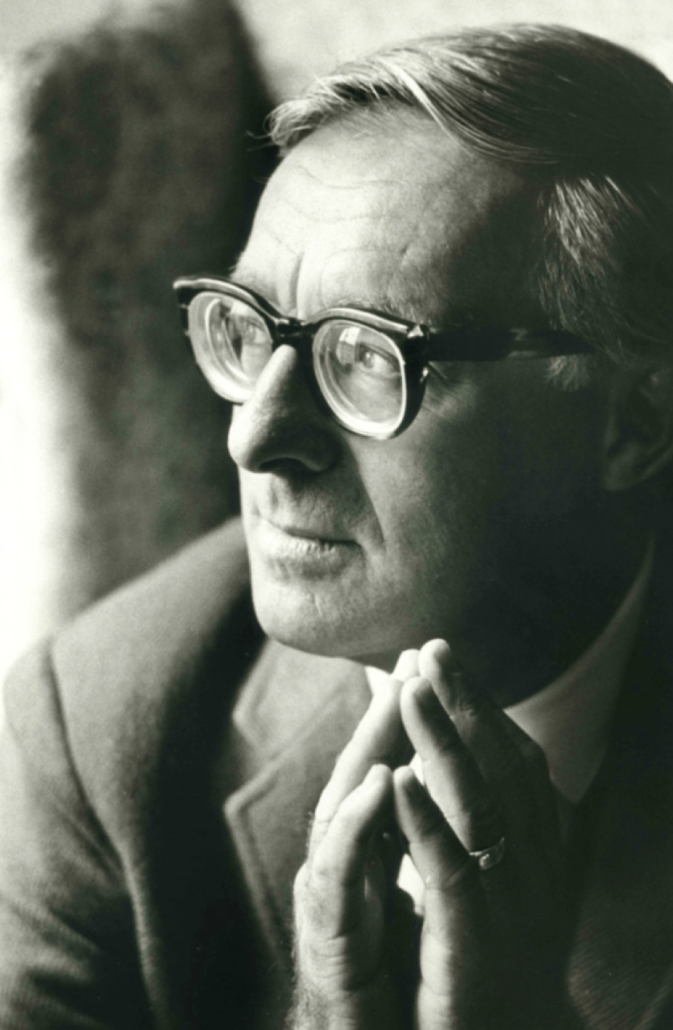

Have I Got a Chocolate Bar for You! Ray Bradbury

Have I Got a Chocolate Bar for You!

It all began with the smell of chocolate.

On a steaming late afternoon of June rain, Father Malley drowsed in his confessional, waiting for penitents.

Where in all the world were they? he wondered. Immense traffics of sin lurked beyond in the warm rains. Then why not immense traffics of confession here?

Father Malley stirred and blinked.

Today’s sinners moved so fast in their cars that this old church was an ecclesiastical blur. And himself? And ancient watercolor priest, tints fading fast, trapped inside.

Let’s give it another five minutes and stop, he thought, not in panic but in the kind of quiet shame and desperation that neglect shoulders on a man.

There was a rustle from beyond the confessional grate next door.

Father Malley sat up, quickly.

A smell of chocolate sifted through the grille.

Ah, God, thought the priest, it’s a lad with his small basket of sins soon laid to rest and him gone. Well…

The old priest leaned to the grate where the candy essence lingered and where the words must come.

But, no words. No ‘Bless me, Father, for I have sinned…’

Only strange small mouse-sounds of…chewing!

The sinner in the next booth, God sew up his mouth, was actually sitting in there devouring a candy bar!

‘No!’ whispered the priest, to himself.

His stomach, gathering data, rumbled, reminding him that he had not eaten since breakfast. For some sin of pride which he could not now recall, he had nailed himself to a saint’s diet all day, and now—this!

Next door, the chewing continued.

Father Malley’s stomach growled. He leaned hard against the grille, shut his eyes, and cried:

‘Stop that!’

The mouse-nibbling stopped.

The smell of chocolate faded.

A young man’s voice said, ‘That’s exactly why I’ve come, Father.’

The priest opened one eye to examine the shadow behind the screen.

‘What’s exactly why you’ve come?’

‘The chocolate, Father.’

‘The what?’

‘Don’t be angry, Father.’

‘Angry, hell, who’s angry?’

‘You are, Father. I’m damned and burnt before I start, by the sound of your voice.’

The priest sank back in the creaking leather and mopped his face and shook his senses.

‘Yes, yes. The day’s hot. I’m out of temper. But then, I never had much.’

‘It will cool off later in the day, Father. You’ll be fine.’

The old priest eyed the screen. ‘Who’s taking and who’s giving confession here?’

‘Why, you are, Father.’

‘Then, get on with it!’

The voice hastened forth the facts:

‘You have smelled the chocolate, Father?’

The priest’s stomach answered for him, faintly.

Both listened to the sad sound. Then:

‘Well, Father, to hit it on the head, I was and still am a…chocolate junkie.’

Old fires stirred in the priest’s eyes. Curiosity became humor, then laughed itself back to curiosity again.

‘And that’s why you’ve come to confession this day?’

‘That’s it, sir, or, Father.’

‘You haven’t come about sweating over your sister or blueprints for fornication or self-battles with the grand war of masturbation?’

‘I have not, Father,’ said the voice in remorse.

The priest caught the tone and said, ‘Tut, tut, it’s all right. You’ll get around to it. For now, you’re a grand relief. I’m full-up with wandering males and lonely females and all the junk they read in books and try in waterbeds and sink from sight with suffocating cries as the damn things spring leaks and all is lost. Get on. You have bruised my antennae alert. Say more.’

‘Well, Father, I have eaten, every day of my life now for ten or twelve years, one or two pounds of chocolate. I cannot leave it alone, Father. It is the end-all and be-all of my life.’

‘Sounds like a fearful affliction of lumps, acne, carbuncles, and pimples.’

‘It was. It is.’

‘And not exactly contributing to a lean figure.’

‘If I leaned, Father, the confessional would fall over.’

The cabinet around them creaked and groaned as the hidden figure beyond demonstrated.

‘Sit still!’ cried the priest.

The groaning stopped.

The priest was wide awake now and feeling splendid. Not in years had he felt so alive and aware of his happily curious and beating heart and fine blood that sought and found, sought and found the far corners of his cloth and body.

The heat of the day was gone.

He felt immensely cool. A kind of excitement pulsed his wrists and lingered in his throat. He leaned almost like a lover to the grille and prompted more spillage.

‘Oh, lad, you’re rare.’

‘And sad, Father, and twenty-two years old and put upon, and hate myself for eating, and need to do something about it.’

‘Have you tried chewing more and swallowing less?’

‘Oh, each night I go to bed saying: Lord, put off the crunchbars and the milk-chocolate kisses and the Hersheys. Each morning I rave out of bed and run to the liquor store not for liquor but for eight Nestlés in a row! I’m in sugar-shock by noon.’

‘That’s not so much confession as medical fact, I can see.’

‘My doctor yells at me, Father.’

‘He should.’

‘I don’t listen, Father.’

‘You should.’

‘My mother’s no help, she’s hog-fat and candy-wild.’

‘I hope you’re not one of those who live at home still?’

‘I loiter about, Father.’

‘God, there should be laws against boys loitering in the round shade of their mas. Is your father surviving the two of you?’

‘Somehow.’

‘And his weight?’

‘Irving Gross, he calls himself. Which is a joke about size and weight and not his name.’

‘With the three of you, the sidewalk’s full?’

‘No bike can pass, Father.’

‘Christ in the wilderness,’ murmured the priest, ‘starving for forty days.’

‘Sounds like a terrible diet, Father.’

‘If I knew the proper wilderness, I’d boot you there.’

‘Boot away, Father. With no help from my mom and dad, a doctor and skinny friends who snort at me. I’m out of pocket from eating and out of mind from the same. I never dreamed I’d wind up with you. Beg pardon, Father, but it took a lot to drive me here. If my friends knew, if my mom, my dad, my crazy doctor knew I was here with you at this minute, oh what the hell!’

There was a fearful stampede of feet, a careening of flesh.

‘Wait!’

But the weight blundered out of the next-door cubby.

With an elephant trample, the young man was gone.

The smell of chocolate alone stayed behind and told all by saying nought.

The heat of the day swarmed in to stifle and depress the old priest.

He had to climb out of the confessional because he knew if he stayed he would begin to curse under his breath and have to run off to have his sins forgiven at some other parish.

I suffer from Peevish, O Lord, he thought. How many Hail Marys for that?

Come to think of it, how many for a thousand tons, give or take a ton, of chocolate?

Come back! he cried silently at the empty church aisle.

No, he won’t, not ever now, he thought, I pressed too hard.

And with that as supreme depression, he went to the parish house to tub himself cool and towel himself to distemper.

A day, two days, a week passed.

The sweltering noons dissolved the old priest back into a stupor of sweat and vinegar-gnat mean. He snoozed in his cubby or shuffled papers in the unlined library, looked out at the untended lawn and reminded himself to caper with the mower one day soon.

But most of all he found himself brambling with irritability. Fornication was the minted coin of the land, and masturbation its handmaiden. Or so it seemed from the few whispers that slid through the confessional grille during the long afternoons.

On the fifteenth day of July, he found himself staring at some boys idling by on their bicycles, mouths full of Hershey bars that they were gulping and chewing.

That night he awoke thinking Power House and Baby Ruth and Love Nest and Crunch.

He stood it as long as he could and then got up, tried to read, tossed the book down, paced the dark night church, and at last, spluttering mildly, went up to the altar and asked one of his rare favors of God.

The next afternoon, the young man who loved chocolate at last came back.

‘Thank you, Lord,’ murmured the priest, as he felt the vast weight creak the other half of the confessional like a ship foundered with wild freight.

‘What?’ whispered the young voice from the far side.

‘Sorry. I wasn’t addressing you,’ said the priest.

He shut his eyes and inhaled.

The gates of the chocolate factory stood wide somewhere and its mild spice moved forth to change the land.

Then, an incredible thing happened.

Sharp words burst from Father Malley’s mouth.

‘You shouldn’t be coming here!’

‘What, what, Father?’

‘Go somewhere else! I can’t help. You need special work. No, no.’

The old priest was stunned to feel his own mind jump out his tongue this way. Was it the heat, the long days and weeks kept waiting by this fiend, what, what? But still his mouth leaped on:

‘No help here! No, no. Go for help—’

‘To the shrinks, you mean?’ the voice cut in, amazingly calm, considering the explosion.

‘Yes, yes, Lord save us, to those people. The—the psychiatrists.’

This last word was even more incredible. He had rarely heard himself say it.

‘Oh, God. Father, what do they know?’ said the young man.

What indeed, thought Father Malley, for he had long been put off by their carnival talk and to-the-rear-march chat and clamor. Good grief, why don’t I turn in my collar and buy me a beard! he thought, but went on more calmly.

‘What do they know, my son? Why, they claim to know everything.’

‘Just like the Church used to claim, Father?’

Silence. Then:

‘There’s a difference between claiming and knowing,’ the old priest replied, as calmly as his beating heart would allow.

‘And the Church knows, is that it, Father?’

‘And if it doesn’t, I do!’

‘Don’t get mad again, Father.’ The young man paused and sighed. ‘I didn’t come to dance angels on the head of a pin with you. Shall I start confession, Father?’

‘It’s about time!’ The priest caught himself, settled back, shut his eyes sweetly, and added. ‘Well?’

And the voice on the other side, with the tongue and the breath of a child, tinctured with silver-foiled kisses, flavored with honeycomb, moved by recent sugars and memories or more immediate Cadbury fetes and galas, began to describe its life of getting up and living with and going to bed with Swiss delights and temptations out of Hershey, Pennsylvania, or how to chew the dark skin off the exterior of a Clark bar and keep the caramel and textured interior for special shocks and celebrations.

Of how the soul asked and the tongue demanded and the stomach accepted and the blood danced to the drive of Power House, the promise of Love Nest, the delivery of Butterfinger, but most of all the sweet African murmuring of dark chocolate between the teeth, tinting the gums, flavoring the palate so you muttered, whispered, murmured, pure Congo, Zambesi, Chad in your sleep.

And the more the voice talked, as the days passed and the weeks, and the old priest listened, the lighter became the burden on the other side of the grille. Father Malley knew, without looking, that the flesh enclosing that voice was raining and falling away. The tread was less heavy.

The confessional did not cry out in such huge alarms when the body entered next door.

For even with the young voice there and the young man, the smell of chocolate was truly fading and almost gone.

And it was the loveliest summer the old priest had ever known.

Once, years before, when he was a very young priest, a thing had happened that was much like this, in its strange and special way.

A girl, no more than sixteen by her voice, had come to whisper each day from the time school let out to the time autumn school renewed.

For all of that long summer he had come as close as a priest might to an alert affection for that whisper and that dear voice. He had heard her through her July attraction, her August madness, and her September disillusion, and as she went away forever in October, in tears, he wanted to cry out; Oh, stay, stay! Marry me!

But I am the groom to the brides of Christ, another voice whispered.

And he had not run forth, that very young priest, into the traffics of the world.

Now, nearing sixty, the young soul within him sighed, stirred, recalled, compared that old and shopworn memory with this new, somehow funny yet withal sad encounter with a lost soul whose love was not summer madness for girls in dire swimsuits, but chocolate unwrapped in secret and devoured in stealth.

‘Father,’ said the voice, late one afternoon. ‘It has been a fine summer.’

‘Strange you would say that,’ said the priest. ‘I have thought so myself.’

‘Father, I have something really awful to confess to you.’

‘I’m beyond shocking, I think.’

‘Father, I am not from your diocese.’

‘That’s all right.’

‘And, Father, forgive me, but, I—’

‘Go on.’

‘I’m not even Catholic.’

‘You’re what!’ cried the old man.

‘I’m not even Catholic, Father. Isn’t that awful?’

‘Awful?’

‘I mean, I’m sorry, truly I am. I’ll join the Church, if you want, Father, to make up.’

‘Join the Church, you idiot?’ shouted the old man. ‘It’s too late for that! Do you know what you’ve done? Do you know the depths of depravity you’ve plumbed? You’ve taken my time, bent my ear, driven me wild, asked advice, needed a psychiatrist, argued religion, criticized the Pope, if I remember correctly, and I do remember, used up three months, eighty or ninety days, and now, now, now you want to join the Church and “make up”?’

‘If you don’t mind, Father.’

‘Mind! Mind!’ yelled the priest, and lapsed into a ten-second apoplexy.

He almost tore the door wide to run around and seize the culprit out into the light. But then:

‘It was not all for nothing, Father,’ said the voice from beyond the grille.

The priest grew quiet.

‘For you see, Father, God bless you, you have helped me.’

The priest grew very quiet.

‘Yes, Father, oh bless you indeed, you have helped me so very much, and I am beholden,’ whispered the voice. ‘You haven’t asked, but don’t you guess? I have lost weight. You wouldn’t believe the weight I have lost. Eighty, eighty-five, ninety pounds. Because of you, Father. I gave it up. I gave it up. Take a deep breath. Inhale.’

The priest, against his wish, did so.

‘What do you smell?’

‘Nothing.’

‘Nothing, Father, nothing! It’s gone. The smell of chocolate and the chocolate with it. Gone. Gone. I’m free.’

The old priest sat, knowing not what to say, and a peculiar itching came about his eyelids.

‘You have done Christ’s work, Father, as you yourself must know. He walked through the world and helped. You walk through the world and help. When I was falling, you put out your hand, Father, and saved me.’

Then a most peculiar thing happened.

Father Malley felt tears burst from his eyes. They brimmed over. They streaked along his cheeks. They gathered at his tight lips and he untightened them and the tears fell from his chin. He could not stop them.

They came, O Lord, they came like a shower of spring rain after the seven lean years and the drought over and himself alone, dancing about, thankful, in the pour.

He heard sounds from the other booth and could not be sure but somehow felt that the other one was crying, too.

So here they sat, while the sinful world rushed by on streets, here in the sweet incense gloom, two men on opposite sides of some fragile board slattings, on a late afternoon at the end of summer, weeping.

And at last they grew very quiet indeed and the voice asked, anxiously, ‘Are you all right, Father?’

The priest replied at last, eyes shut, ‘Fine. Thanks.’

‘Anything I can do, Father?’

‘You have already done it, my son.’

‘About…my joining the Church. I meant it.’

‘No matter.’

‘But it does matter. I’ll join. Even though I’m Jewish.’

Father Malley snorted half a laugh. ‘Wha-what?’

‘Jewish, Father, but an Irish Jew, if that helps.’

‘Oh, yes!’ roared the old priest. ‘It helps, it helps!’

‘What’s so funny, Father?’

‘I don’t know, but it is, it is, funny, funny!’

And here he burst into such paroxysms of laughter as made him cry and such floodings of tears as made him laugh again until all mingled in a grand outrush and uproar. The church slammed back echoes of cleansing laughter.

In the midst of it all he knew that, telling all this to Bishop Kelly, his confessor, tomorrow, he would be let off easy. A church is washed well and good and fine not only by the tears of sorrow but by the clean freshcut meadowbrooms of that self-forgiveness and other-forgiveness which God gave only to man and called it laughter.

It took a long while for their mutual shouts to subside, for now the young man had given up weeping and taken on hilarity, too, and the church rocked with the sounds of two men who one minute had done a sad thing and now did a happy one. The sniffle was gone, Joy banged the walls like wild birds flying to be free.

At last, the sounds weakened. The two men sat, wiping their faces, unseen to each other.

Then, as if the world knew there must be a shift of mood and scene, a wind blew in the church doors far away. Leaves drifted from trees and fell into the aisles. A smell of autumn filled the dusky air. Summer was truly over.

Father Malley looked beyond to that door and the wind and the leaves moving off and gone, and suddenly, as in spring, wanted to go with them. His blood demanded a way out, but there was no way.

‘I’m leaving, Father.’

The old priest sat up.

‘For the time being, you mean.’

‘No, I’m going away, Father. This is my last time with you.’

You can’t do that! thought the priest, and almost said it.

But instead he said, as calmly as he could:

‘Where are you off to, son?’

‘Oh, around the world, Father. Many places. I was always afraid, before. I never went anywhere. But now, with my weight gone, I’m heading out. A new job and so many places to be.’

‘How long will you be gone, lad?’

‘A year, five years, ten. Will you be here ten years from now, Father?’

‘God willing.’

‘Well, somewhere along the way I’ll be in Rome and buy something small but have it blessed by the Pope and when I come back I’ll bring it here and look you up.’

‘Will you do that?’

‘I will. Do you forgive me, Father?’

‘For what?’

‘For everything.’

‘We have forgiven each other, dear boy, which is the finest thing that men can do.’

There was the merest stir of feet from the other side.

‘I’m going now, Father. Is it true that “good-by” means God be with you?’

‘That’s what it means.’

‘Well then, oh truly, good-by, Father.’

‘And good-by in all its original meaning to you, lad.’

And the booth next to his elbow was suddenly empty.

And the young man gone.

Many years later, when Father Malley was a very old man indeed and full of sleep, a final thing happened to fill out his life. Late one afternoon, dozing in the confessional, listening to rain fall out beyond the church, he smelled a strange and familiar smell and opened his eyes.

Gently, from the other side of the grille, the faintest odor of chocolate seeped through.

The confessional creaked. On the other side, someone was trying to find words.

The old priest leaned forward, his heart beating quickly, wild with amazement and surprise. ‘Yes?’ he urged.

‘Thank you,’ said a whisper, at last.

‘Beg pardon…?’

‘A long time ago,’ said the whisper. ‘You helped. Been long away. In town only for today. Saw the church. Thanks. That’s all. Your gift is in the poor box. Thanks.’

Feet ran swiftly.

The priest, for the first time in his life, leaped from the confessional.

‘Wait!’

But the man, unseen, was gone. Short or tall, fat or thin, there was no telling. The church was empty.

At the poor-box, in the dusk, he hesitated, then reached in. There he found a large eighty-nine-cent economy-size bar of chocolate.

Someday, Father, he heard a long-gone voice whisper, I’ll bring you a gift blessed by the Pope.

This? This? The old priest turned the bar in his trembling hands. But why not? What could be more perfect?

He saw it all. At Castel Gandolfo on a summer noon with five thousand tourists jammed in a sweating pack below in the dust and the Pope high up on his balcony there waving out the rare blessings, suddenly among all the tumult, in all the sea of arms and hands, one lone brave hand held high…

And in that hand a silver-wrapped and glorious candy bar.

The old priest nodded, not surprised.

He locked the chocolate bar in a special drawer in his study and sometimes, behind the altar, years later, when the weather smothered the windows and despair leaked in the door hinges, he would, fetch the chocolate out and take the smallest nibble.

It was not the Host, no, it was not the flesh of Christ. But it was a life. And the life was his.

And on those occasions, not often but often enough, when he took a bite, it tasted (O thank you, God), it tasted incredibly sweet.

The end