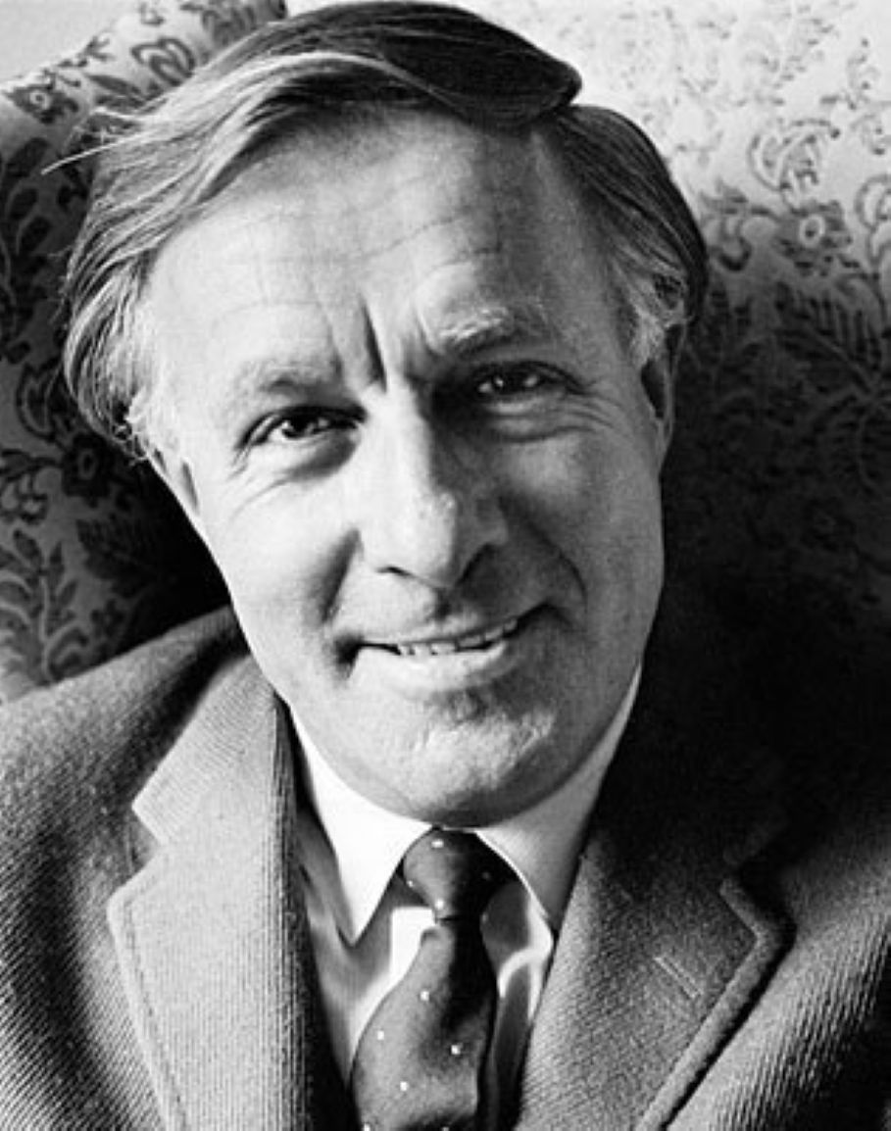

Hello, I Must Be Going, Ray Bradbury

Hello, I Must Be Going

There was a quiet tapping at the door and when Steve Ralphs opened it there stood Henry Grossbock, five foot one inches tall, immaculately dressed, very pale and very perturbed.

"Henry!" Steve Ralphs cried.

"Why do you sound like that?" Henry Grossbock said. "What have I done? Why am I dressed like this? Where am I going?"

"Come in, come in, someone might see you!"

"Why does it matter if someoneseesme?"

"Come in, for God's sake, don't stand there arguing."

"All right, I'll come in, I have things to talk about anyway. Stand aside. There. I'm in."

Steve Ralphs backed off across the room and waved to a chair. "Sit."

"I don't feel welcome." Henry sat. "You have any strong liquor around this place?"

"I was just thinking that." Steve Ralphs jumped, ran into the kitchen, and a minute later returned with a tray, a bottle of whiskey, two glasses, and some ice. His hands were trembling as he poured the liquor.

"You look shaky," said Henry Grossbock. "What's wrong?"

"Don't you know, can't youguess? Here."

Henry took the glass. "You sure poured me a lot."

"You're going to need it. Drink."

They drank and Henry examined his coat front and his sleeves.

"You still haven't told me where I am going," he said, "or have I been there already? I don't usually dress this way except for concerts. When I stand up there before an audience, well, one desires respect. This is very good scotch. Thanks. Well?"

He stared at Steve Ralphs with a steady and penetrating stare.

Steve Ralphs gulped half of his drink and put it down and shut his eyes. "Henry, you've already been to a far place and just come back, for God's sake. And now you'll have to return to that place."

"What place,whatplace, stop the riddles!"

Steve Ralphs opened his eyes and said, "How did you get here? Did you take a bus, hire a taxi, or … walk from the graveyard?"

"Bus, taxi, walk? And what's that about a graveyard?"

"Henry, drink the rest of your drink. Henry, you've been in that graveyard for years."

"Don't be silly. What would I be doingthere? I never applied for any—" Henry stopped and slowly sank back in his chair. "You mean—?"

Steve Ralphs nodded. "Yes, Henry."

"Dead? And in the graveyard? Dead and in the graveyard four years? Why didn't someonetellme?"

"It's hard to tell someone who's dead that heis."

"I see, I see." Henry finished his drink and held the glass out for more. Steve Ralphs refilled.

"Dear, dear," said Henry Grossbock, slowly. "My, my. Sothat'swhy I haven't felt up to snuff lately."

"That's why, Henry. Let me catch up." Steve Ralphs poured more whiskey in his own glass and drank.

"So that's why you looked so peculiar when you opened the door just now—"

"That's why, Henry."

"Sorry. I really didn't mean—"

"Don't get up, Henry. You're here now."

"But under the circumstances—"

"It's all right. I'm under control. And even given the circumstances, you were always my best friend and it's nice, in a way, to see you again."

"Strange.Iwasn't shocked to seeyou."

"There's a difference, Henry. I mean, well—"

"You're alive, and I'm not, eh? Yes, I can see that. Hello, I must be going."

"What?"

"Groucho Marx sang a song with that title."

"Oh, yeah. Sure."

"Marvelous man. Funny. Is he still around? Did he die, too?"

"I'm afraid so."

"Don't be afraid. I'm not. Don't know why. Just now." Henry Grossbock sat up straight. "To business."

"What business?"

"Told you at the front door. Important. Must tell. I am very upset."

"So was I, but this liquor does wonders. Okay, Henry, shoot."

"The thing is—" Henry Grossbock said, finishing his second drink quickly, "my wife is neglecting me."

"But Henry, it's perfectly natural—"

"Let me finish. She used to come visit constantly. Brought me flowers, put a book nearby once, cried a lot. Every day. Then every other day. Now, never. How do you explain that? Refill, please."

Steve Ralphs tipped the bottle.

"Henry, four years is a longtime—"

"You can say that again. How about Eternity, there's arealvaudeville show."

"You didn't really expect to be entertained, did you?"

"Why not? Evelyn always spoiled me. She changed dresses two or three times a day because she knew I loved it. Haunted bookshops, brought me the latest, read me the oldest, picked my ties, shined my shoes, her women's-lib friends joshed her forthat.Spoiled. Yes, I expected to have someone fill the time for me."

"That's not how it works, Henry."

Henry Grossbock thought and nodded, solemnly, and sipped his whiskey. "Yes, I guess you're right. But let me name thebiggestproblem."

"What's that?"

"She's stopped crying. She used to cry every night, every day at breakfast, twice in the afternoon, just before supper. Then, lights out, crying."

"She missed you, Henry."

"And now she doesn't?"

"Time heals all wounds, they say."

"I don't want this wound healed. I liked things just the way they were. A good cry at dawn, a half decent cry before tea, a final one at midnight. But it's over. Now I don't feel wanted or needed."

"Think about it the way you had to think about your honeymoon with Evelyn. It had to end sometime."

"Not entirely. There were stray bits of it for the rest of forty years."

"Yes, but youdosee the resemblance?"

"Honeymoon ended. Life over. I certainly don't much care for the residue." A thought struck Henry Grossbock. He set his glass down, sharply. "Is there someoneelse?"

"Someone … "

"Else! Has she taken up with—?"

"And what if she has?"

"Howdareshe!"

"Four years, Henry, four years. And no, she hasn't taken up with anyone. She'll remain a widow for the rest of her life."

"That's more like it. I'm glad I came to see you first. Set me straight. So she's still single and—hold on. How come no more tears at midnight, crying at breakfast?"

"You didn't really expect that, did you?"

"But damn, I miss it. A man's got to havesomething!"

"Don't you have any friends over at the—" Steve Ralphs stopped, flushed, refilled his glass, refilled Henry's.

"You were going to say graveyard. Bad lot, those. Layabouts. No conversation."

"You were always a great talker, Henry."

"Yes, yes, that's so, wasn't I?Aren'tI? And you were my best listener."

"Talk some more, Henry. Get it all out."

"I think I've hit the high points, the important stuff. She's stopped coming by. That's bad. She's stopped crying. That's the very worst. The lubricant that makes—what I have become—worth the long while. I wonder if I showed up, would she cry again?"

"You'renotgoing to visit?"

"Don't think I should, eh?"

"Nasty shock. Unforgivable."

"Whowouldn't forgive me?"

"Me, Henry.Iwouldn't."

"Yes, yes. Oh dear. My, my. Good advice from my best friend."

"Best, Henry." Steve Ralphs leaned forward. "Youdowant her to get over you, don't you?"

"No! Yes. No! God, I don't know. Yes, I guess so."

"After all shehasmissed you and cried every day for most of four years."

"Yes." Henry Grossbock nursed his glass. "Shehasput in the time. I suppose Ishouldlet her off the hook."

"It would be a kindness, Henry."

"I don'tfeelkind, I don'twantto be kind, but hell, I'll be kind anyhow. I do love the dear girl."

"After all, Henry, she has lots of years ahead."

"True. Damn. Think of it. Men age better but die younger. Women live longer but age badly. Strange arrangement God has made, don't you agree?"

"Why don't you ask Him, now that you're there?"

"Who, God? An upstart like me? Well, well. Ummm." Henry sipped. "Why not? What's she up to? If she's not dashing about in open cars with strange men,what?"

"Dancing, Henry. Taking dance lessons. Sculpting. Painting."

"Always wanted to do that, never could. Concert schedules, cocktail parties for possible sponsors, recitals, lectures, travel. She always saidsomeday."

"Someday is here, Henry."

"Took me by surprise, is all. Dancing, you say? Sculpting? Is she any good?"

"A fair dancer. Averyfine sculptor."

"Bravo. Or is it brava? Yes. Brava. I think I'm glad for that. Yes, Iamglad. Fills the time. And what do I do? Crosswords."

"Crosswords?"

"Dammit, what else is there, considering my circumstances? Fortunately, I recall every single good and bad puzzle ever printed in theNew York Timesor theSaturday Review.Crossword. Short nickname, three letters, for Tutankhamen. Tut! Four letters, one of the Great Lakes.Erie! Easy, that one. Fourteen letters, old Mediterranean capital. Hell. Constantinople!"

"Five letters. Word for best pal, good friend, fine husband, brilliant violinist."

"Henry?"

"Henry. You." Steve Ralphs smiled, lifted his glass, drank.

"That's my cue to grab my hat and leave. Oh, I didn't bring a hat. Well, well."

Steve Ralphs suddenly swallowed very hard.

"What's this?" said Henry, leaning forward, listening.

"A repressed sob, Henry."

"Good! That's better. Warms the old heart,thatdoes. I don't suppose you could—"

"Suppress a few more sobs, once or twice a week for the next year?"

"I hesitate to ask—"

"I'll try, Henry." Another mysterious sound moved up Steve Ralph's throat. He hastened to lid it with whiskey. "Tell you what. I'll call Evelyn, say I'm writing a book about you, need some of your personal books, notes, golf clubs, spectacles, the lot, bring them here, and, well, once a week, anyway, look them over, feel sad. How'sthatsound?"

"That's the ticket, or what are friends for?" Henry

Grossbock beamed. There was color in his cheeks. He drank and stood up.

At the door, Henry turned and peered into Steve Ralph's face.

"Dear me, dear me, are those tears?"

"I think so, Henry."

"Well now, that's more like it. Not Evelyn's of course, and you're not heaving great sobs. But it'll do. Much thanks."

"Don't mention it, Henry."

"Well." Henry opened the door. "See you around."

"Not too soon, Henry."

"Eh? No, of course not. No hurry. Good-bye, friend."

"Oh, good-bye, Henry." Yet another mysterious gulp arose in the younger man's throat.

"Yes, yes." Henry smiled. "Keep that up until I'm down the hall. Well, as Groucho Marx said—"

And he was gone. The door shut.

Turning, slowly, Steve Ralphs walked to the telephone, sat down, and dialed.

After a moment the receiver on the other end clicked and a voice spoke.

Steve Ralphs wiped his eyes with the back of his hand and at last said:

"Evelyn?"

1997

The end