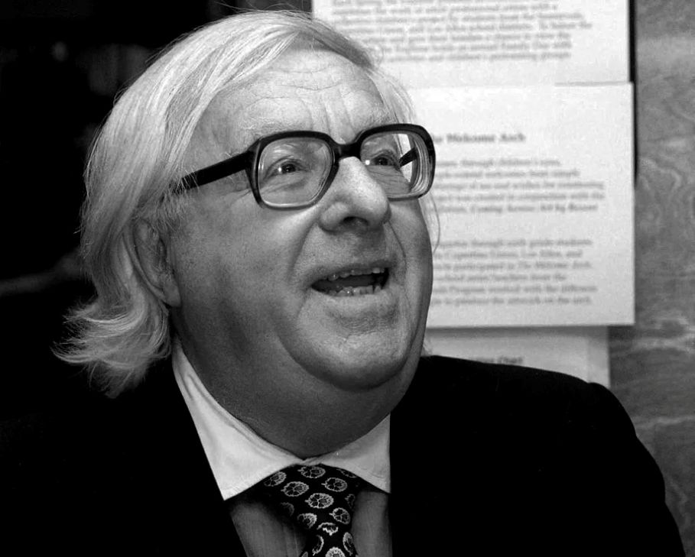

House Divided, Ray Bradbury

House Divided

Small fifteen-year-old fingers plucked at the buttons on Chris' trousers like a moth drawn to a flame. He heard whispered words in the dark room that meant nothing, and could not be remembered a moment after they were spoken.

Vivian's lips were so fresh that it was unbelievable. Chris had the feeling that this was a dream. This was a pantomime carried out in the dark, which he could not see. Vivian herself had switched out every light.

It had started as every evening like it had started. With Chris and his brother Leo climbing upstairs with Vivian and Shirley, their girl cousins. The girls were both blonde and smiling. Leo was sixteen and clumsy.

Chris was twelve and knew nothing of such moths darting in the warm pantomime, or that there was a light shining in him he had never known about, that some girl might want. Shirley was ten, going on eleven, but very curious. Vivian was the ringleader; she was fifteen and beginning to see the world's people.

Chris and Leo had arrived in the family car, acting properly grave, since it was such a grave situation. They walked silently behind Mother and Dad into the Johnsons' house on Buttrick Street, where all the other relatives were gathered in a hushed spell of waiting. Uncle Inar sat by the phone, looking at it, his big hands twitching all by themselves, uneasy animals in his lap.

It was like walking into the hospital itself. Uncle Lester was very badly off. They were waiting for news now from the hospital. Lester had been shot in the stomach on a hunting trip and had lingered half-alive for three days now. So they had come tonight to be together, just in case they received the news of their Uncle Lester's passing. All three sisters and Lester's two brothers were there, with their wives and husbands and children.

After a proper interval of hushed speaking, Vivian had very carefully suggested, "Mama, we'll go upstairs and tell ghost stories, so you grown-ups can talk."

"Ghost stories," said Uncle Inar vaguely. "What a thing to tell tonight. Ghost stories."

Vivian's mama agreed. "You can go upstairs if you're quiet. We don't want any racket."

"Yes, ma'am," said Chris and Leo.

They left the room, walking slowly on the edge of their shoes. Nobody noticed their going. They could have been several phantoms passing for all the attention they got.

Upstairs, Vivian's room had a low couch against one wall, a dressing table with pink-folded silk for a skirt, and flower pictures. There was a green leather diary, fabulously inscribed but securely padlocked on the table, freckles of powder on it. The room smelled sweetly soft and nice.

They sat upon the couch, backs lined neatly against the wall, a row of solemn ramrods, and Vivian, like always, told the first ghost story. They turned out all but one lamp, which was very feeble, and she put her voice low in her rounded breasts and whispered it out.

It was that ancient tale about lying abed late one night, with stars cold in the sky, al alone in a big old house when somethingstarts creeping slowly up the stairs to your room. Some strange and awful visitor from some other world. And as the story advanced, slowly step by step, step by step, your voice got more tense and more whispery and you kept waiting and waiting for that shocking finale.

"Itcrept up to the second step, it stepped up to the third step, it came to the fourth step … "

All four of their hearts had churned to this story a thousand times. Now, again, a cold sweat formed on four anticipatory brows. Chris listened, holding Vivian's hand.

"The strange sounds came on to the sixth step, and rustled to the seventh step, and then to the eighth step … "

Chris had memorized the story, often, and told it often, but no one could tell it quite like Vivian. She was husking it now, like a witch, eyes half shut, body tensed against the wall.

Chris went over the story in his mind, ahead of her. "Ninth, tenth, and eleventh steps. Twelve, thirteen, fourteen steps.Itcame to thetopof the stairs … "

Vivian went on. "Now it's in the hall at the top of the stairs. Outside the door. Now it's coming inside. Now it's closing the door." A pause. "Now it's walking across your room. Now it's passing the bureau. Now it's over your bed. Now it's standing right over you, right over your head … "

A long pause, during which the darkness of the room got darker. Everybody drew in their breath, waiting, waiting.

"I GOTCHA!"

Screaming, then giggling, you burst out! You let the black bat crash into the web. You had built the web of tension and horror so completely inside, minute by minute, step by step, around and around, like a very dainty horrible spider weaving, and in that tumultuous climax when I GOTCHA! flew out at you, like a sickening bat, it shattered the web down in trembling apprehension and laughter. You had to laugh to cover up your old old fear. You shrieked and giggled, all four of you. You hollered and shook the couch and held onto each other.

Oh that familiar old story! You rocked back and forth, shivering, breathing fast. Funny how it still scared you after the hundredth telling.

The giggling subsided quickly. Footsteps, real ones, were hurrying up the steps to Vivian's room. By the sound of them Chris knew it was Auntie. The door opened.

"Vivian," cried Auntie. "I told you about noise! Don't you have any respect!"

"All right, Mama. We're sorry."

"I'm sorry, Auntie," said Chris, meaning it. "We just forgot ourselves. We got scared."

"Vivian, you keep them quiet," directed Auntie, her scowl softening. "And if I hear you again you'll all come downstairs."

"We'll be good," said Leo, quietly, earnestly.

"Well, all right, then."

"Has the hospital called?" asked Shirley.

"No," said Auntie, her face changing, remembering. "We expect to hear soon."

Auntie went downstairs. It took another five minutes to get back into the spell of storytelling.

"Who'll tell a story now?" asked Shirley.

"Tell another one, Vivian," said Leo. "Tell the one about the butter with the evil fungus in it."

"Oh, I tell thateverytime," said Vivian.

"I'll tell one," said Chris. "Anewone."

"Swell," said Vivian. "But let's turn out the other light first. It's too light in here."

She bounced up, switched out the last light. She came back through the utter dark and you could smell her coming and feel her beside you, Chris realized. Her hand grabbed his, rightly. "Go on," she said.

"Well … " Chris wound his story up on a spool, getting it ready in his mind. "Well, once upon a time—"

"Oh, we heardthatone before!" they all laughed. The laughter came back from the unseen wall of the room. Chris cleared his throat and started again.

"Well, once upon a time there was a black castle in the woods—"

He had his audience immediately. A castle was a darn nice thing to start with. It wasn't a bad story he had in mind, and he would have told it all the way through, taking fifteen minutes or more to hang it out on a line in the dark bedroom air. But Vivian's fingers were like an impatient spider inside his palm, and as the story progressed he became more aware of her than of the story people.

"—an old witch lived in this black castle—"

Vivian's lips kissed him on the cheek. It was like all her kisses. It was like kisses before bodies were invented. Bodies are invented around about the age of twelve or thirteen. Before that there are only sweet lips and sweet kisses. There is a sweet something about such kisses you never find again after someone puts a body under your head.

Chris didn't have a body yet. Just his face. And, like every time Vivian had ever kissed him, he responded. After all, it was fun and it was as good as eating and sleeping and playing all kinds of games.

Her lips were like a subtle sugar, and nothing else. For the past four years since he was eight, every time he met Vivian and that was usually once every month, because she lived on the far side of town, there would be ghost stories and kisses and subtle sugar.

"—well, this witch in this castle—"

She kissed him on the lips, momentarily crumbling the castle. About ten seconds later he had to build it up again.

"—this witch in this castle had a beautiful young daughter named Helga. Helga lived in a dungeon and was treated very poorly by her evil old mother. She was very pretty and—"

The lips returned. This time for a longer stay.

"Go on with the story," said Leo.

"Yeah, hurry up," said Shirley, perturbed.

"—Ah," said Chris, breaking away a little, his breath a bit funny. "—One day the girl escaped from the dungeon and ran out into the woods, and the witch shouted after her—"

From there on the story got slower and slower, and wandered off in aimless, vague, and blundering directions. Vivian pressed close to him, kissing and breathing on his cheek as he told the halting tale.

Then, very slowly, and with an architect's wonderful ability, she began to build his body for him! The Lord said ribs and there were ribs. The Lord said stomach and there was stomach! The Lord said legs and there were legs! The Lord said something else and there was something else!

It was funny finding his body under him so suddenly. For twelve years it had never been there. It was a pendulum under a clock, that body, and now Vivian was setting it in motion, touching, urging, rocking it to and fro, until it swung in dizzy warm arcs under the machinery of the head. The clock was now running.

A clock cannot run until the pendulum moves. The clock can be whole, ready, and intact and healthy, but until that pendulum is thrust into motion there is nothing but machinery without use.

"—and the girl ran out into the woods—"

"Hurry up, hurry up, Chris!" criticized Leo.

It was like the story of the thing coming up the stairs, one by one, one by one. This whole evening, here, now, in the dark. But—different.

Vivian's fingers deftly plucked at the belt buckle and drew the metal tongue out, loosening it open.

Now she's at the first button.

Now she's at the second button.

Solikethat old story. But this was arealstory.

"—so this girl ran into the woods—"

"You said that before, Chris," said Leo.

Now she's at the third button.

Now she's moved down to the fourth button, oh God, and now to the fifth button, and now—

The same words that ended thatotherstory, thevery same two words,but this time shouted passionately, inside, silently, silently, to yourself!

The two words!

The same two words used at the end of the story about the thing coming up the stairs. The same two words at the end!

Chris' voice didn't belong to him anymore:

"—and she ran into something, there was something, there was, well, anyway, this, she … well, she tried … er, someone chased her … or … well, she ran, anyway, and she came, down she went and she ran and then, and then, she—"

Vivian moved against him. Her lips sealed up that story inside him and wouldn't let it out. The castle fell thundering for the last time into ruin, in a burst of blazing flame, and there was nothing in the world but this newly invented body of his and the fact that a girl's body is not so much land, like the hills of Wisconsin, pretty to look at. Here was all the beauty and singing and firelight and warmth in the world. Here was the meaning of all change and all movement and all adjustment.

Far away in the dim hushed lands below a phone rang. It was so faint it was like one of those voices crying in a forgotten dungeon. A phone rang and Chris could hear nothing.

It seemed there was a faint, halfhearted criticism from Leo and Shirley, and then a few minutes later, Chris realized that Leo and Shirley were clumsily kissing one another, and nothing else, just clumsily adjusting faces to one another. The room was silent. The stories were told and all of space engulfed the room.

It was so strange. Chris could only lie there and let Vivian tell him all of it with this dark, unbelievable pantomime. You are not told all of your life of things like this, he thought. You are not told at all. Maybe it is too good to tell, too strange and wonderful to give words about.

Footsteps came up the stairs. Very slow, very sad footsteps this time. Very slow and soft.

"Quick!" whispered Vivian. She pulled away, smoothing her dress. Like a blind man, fingerless, Chris fumbled with his belt buckle and buttons. "Quick!" whispered Vivian.

She flicked the light on and the world shocked Chris with its unreality. Blank walls staring, wide and senseless after the dark; lovely, soft, moving, and secretive dark. And as the footsteps advanced up the stairs, the four of them were once again solemn ramrods against the wall, and Vivian was retelling her story:

"—now he's at the top stair—"

The door opened. Auntie stood there, tears on her face. That was enough in itself to tell, to give the message.

"We just received a call from the hospital," she said. "Your Uncle Lester passed away a few minutes ago."

They sat there.

"You'd better come downstairs," said Auntie.

They arose slowly. Chris felt drunk and unsteady and warm. He waited for Auntie to go out and the others to follow. He came last of all, down into the hushed land of weeping and solemn tightened faces.

As he descended the last step he couldn't help but feel a strange thing moving in his mind. Oh, Uncle Lester, they've taken your body away from you, and I've gotmine,and it isn't fair! Oh, it isn't fair, because this is sogood!

In a few minutes they would go home. The silent house would hold their weeping a few days, the radio would be snapped off for a week, and laughter would come and be throttled in birth.

He began to cry.

Mother looked at him. Uncle Inar looked at him and some of the others looked at him. Vivian, too. And Leo, so big and solemn standing there.

Chris was crying and everybody looked.

But only Vivian knew that he was crying for joy, a warm good crying of a child who has found treasure buried deep and warm in his very body.

"Oh, Chris," said Mother, and came to comfort him. "There, there."

1997

The end