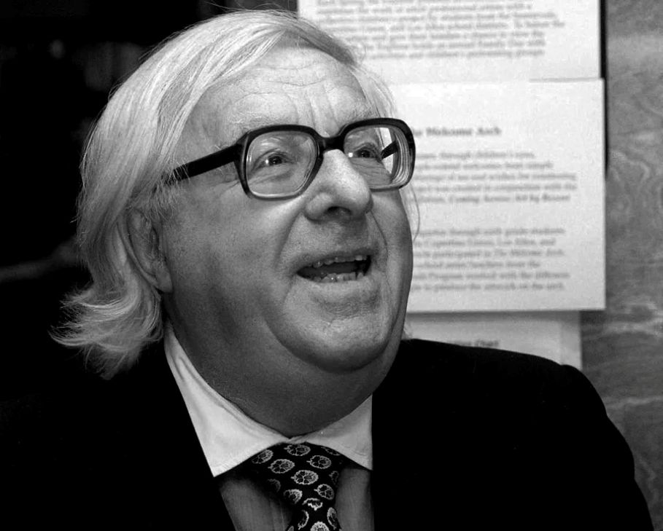

I Wonder What's Become of Sally, Ray Bradbury

I Wonder What's Become of Sally

Somebody started playing the yellow-keyed piano, somebody started singing, and somebody, myself, started thinking. The words of the song were slow, sweet, and sad:

"I wonder what's become of Sally,

That old gal of mine."

I hummed it. I remembered some more words:

"The sunshine's gone from out our alley,

Ever since the day Sally went away."

"I knew a Sally once," I said.

"You did?" said the bartender, not looking at me.

"Sure," I said. "Very first girlfriend. Like the words of that song, makes you wonder, whatever happened to her? Where's she tonight? About all you can do is hope she's happy, married, got five kids, and a husband who isn't late more than once a week, and remembers, or doesn't remember, her birthdays, whichever way she likes it most."

"Why don't you look her up?" said the bartender, still not looking at me, shining a glass.

I drank my drink slowly.

"Wherever she may go,

Wherever she may be,

If no one wants her now,

Please send her back to me."

The people around the piano were finishing the song. I listened, eyes shut.

"I wonder what's become of Sally,

That old gal of mine."

The piano stopped. There was a lot of quiet laughter and talk.

I put the empty glass down on the bar and opened my eyes and looked at it for a minute.

"You know," I said to the bartender, "you just gave me an idea … "

Where do I start? I thought, outside on the rainy street in a cold wind, night coming on, buses and cars moving by, the world suddenly alive with sound. Or do you start at all, which is it?

I'd had ideas like this before; I got them all the time. On Sunday afternoons if I overslept I woke up thinking I had heard someone crying and found tears on my face and wondered what year it was and sometimes had to go off and find a calendar just to be sure.

On those Sundays I felt there was fog outside the house, and had to go open the door to be sure the sun was still slanting across the lawn. It wasn't anything I could control. It just happened while I was half asleep and the old years gathered around and the light changed. Once, on a Sunday like that, I telephoned clear across the United States to an old school chum, Bob Hartmann.

He was glad to hear my voice, or said he was, and we talked for half an hour and it was a nice talk, full of promises. But we never got together, as we had planned; next year, when he came to town, I was in a different mood. But that's how those things go, isn't it? Warm and mellow one second, and the next I looked around and I was gone.

But right now, standing on the street outside of Mike's Bar, I held out my hand and added up my fingers: first, my wife was out of town visiting her mother downstate. Second, tonight was Friday, and a whole free weekend ahead. Third, I remembered Sally very well, if no one else did. Fourth, I just wanted somehow to say, Hello, Sally, how are things? Fifth, why didn't I start?

I did.

I got the phone book and went down the lists. Sally Ames. Ames, Ames. I looked at them all. Of course. She was married. That was the bad thing about women: once married they took aliases, vanishing into the earth, and you were lost.

Well then, her parents, I thought.

They were unlisted. Moved or dead.

What about some of her old friends who were once friends of mine? Joan something-or-other. Bob whatsis-name. I drew blanks, and then remembered someone named Tom Welles.

I found Tom in the book and telephoned him.

"Good God, is that you, Charlie?" he cried. "Good grief, come on over. What's new? Lord, it's been years! Why are you—"

I told him what I was calling about.

"Sally? Haven't seen her in years. Hey, I hear you're doing okay, Charlie. Salary in five figures, right? Pretty good for a guy from across the tracks."

There hadn't been any tracks, really; just an invisible line nobody could see but everyone felt.

"Hey, when can we see you, Charlie?"

"Give you a call soon."

"She was a sweet girl, Sally. I've told my wife about her. Those eyes. And hair color that didn't come out of a bottle. And—"

As Tom talked on, a lot of things came back. The way she listened, or pretended to listen, to all my grand talk about the future. It suddenly seemed she had never talked at all. I wouldn't let her. With the sublime dumb ego of a young man I filled up the nights and days with building tomorrows and tearing them down and building them again, just for her. Looking back, I was embarrassed for myself.

And then I remembered how her eyes used to take fire and her cheeks flush with my talking, as if everything I said was worth her time and life and blood. But in all the talk, I couldn't remember ever saying I loved her.

I should have. I never touched her, save to hold her hand, and never kissed her. That was a sadness now. But I had been afraid that if I ever made one mistake, like kissing, she would dissolve like snow on a summer night, and be gone forever. We went together and talked together, or I talked, rather, for a year. I couldn't remember why we broke up. Suddenly, for no reason, she was gone, around the same time we both left school forever. I shook my head, eyes shut.

"Do you remember, she wanted to be a singer once, she had a swell voice," said Tom. "She—"

"Sure," I said. "It all comes back. So long."

"Wait a minute—" said his voice, being hung back on the receiver hook.

I went back to the old neighborhood and walked around. I went in the grocery stores and asked. I saw a few people who I knew but who didn't remember me. And finally I got a line on her. Yes, she was married. No, they weren't sure of the address. Yes,hisname was Maretti. Somewhere on that street down that way and over a few blocks, or maybe it was the other way.

I checked the name I the phone book. That should have warned me. No phone.

Then by asking questions at some grocery stores down the line, I finally got the Maretti address. Third apartment, fourth floor, rear, number 407.

"Why are you doing this?" I asked myself, going up the stairs, climbing in the dim light in the smell of old food and dust. "Want to show her how well you've done, isthatit?

"No," I told myself. "I just want to see Sally, someone from the old days. I want to get around to telling her what I should have told her years ago, that, in my own way, at one time, I loved her. I never told her that. But I was afraid. I'm not afraid now that it doesn't make any difference.

"You're a fool," I said.

"Yes," I said, "but aren't we all."

I had to stop to rest on the third landing. I had a feeling, suddenly, in the thick smell of ancient cooking, in the close, whispering darkness of TVs playing too loud and distant children crying, that I should walk down out of the house before it was too late.

"But you've come this far. Come on," I said. "One more flight."

I went up the last stairs slowly and stood before an unpainted door. Behind it, people moved and children talked. I hesitated. What would I say? Hello, Sally, remember the old days when we went boating in the park and the trees were green and you were as slender as a blade of grass? Remember the time that—well.

I raised my hand. I knocked on the door.

It opened and a woman answered. I'd say she was about ten years older, maybe fifteen, than me. She was wearing a two-dollar basement dress which didn't fit, and her hair was turning gray. There was a lot of fat in the wrong places, and lines around her tired mouth.

I almost said, "I've got the wrong apartment, I'm looking for Sally Maretti." But I didn't say anything. Sally was a good five years younger than me. But this was she, looking out of the door into the dim light. Behind her was a room with a battered lampshade, a linoleum floor, one table, and some old brown overstuffed furniture.

We stood looking at each other across twenty-five years. What could I say? Hello, Sally, I'm back, here I am, prosperous, on the other side of town now, here I am, a good car, home, married, children through school, here I am president of a company, why didn't you marry me and you wouldn't be here?

I saw her eyes move to my Masonic ring, to the boutonniere in my lapel, to the clean rim of the new hat in my hand, to my gloves, to my shined shoes, to my Florida-tanned face, to my Bronzini tie. Then her eyes came back to my face. She was waiting for me to do one thing or the other. I did the right thing.

"I beg your pardon," I said. "I'm selling insurance."

"I'm sorry," she said. "We don't need any." She held the door open for just a moment as if at any moment she might burst open.

"Sorry to have botheredyou," I said.

"That's all right," she said.

I looked beyond her shoulder. I had been wrong. There were not five children, but six at the dinner table with the husband, a dark man with a scowl stamped on his brow.

"Close the door!" he said. "There's a draft."

"Good night," I said.

"Good night," she said.

I stepped back and she closed, the door, her eyes still on my face.

I turned and went down the street.

I had just stepped off the bottom of the brownstone steps when I heard a voice call out behind me. It was a woman's voice. I kept walking. The voice called again and I slowed, but did not turn. A moment later someone put a hand on my elbow. Only then did I stop and look around.

It was the woman from apartment 407 above, her eyes almost wild, her mouth gasping, on the point of tears.

"I'm sorry," she said, and almost pulled back but then gathered herself to say, "This is crazy. You don't happen to be, I know you're not, you aren't Charlie McGraw,areyou?"

I hesitated while her eyes searched my face, looking for some halfway familiar feature among all the oldness.

My silence made her uneasy. "No, I didn't really think you were," she said.

"I'm sorry," I said. "Who was he?"

"Oh, God," she said, eyes down, stifling something like a laugh. "I don't know. Maybe a boyfriend, a long time ago."

I took her hand and held it for a moment. "I wish I were," I said. "We should have had a lot to talk about."

"Too much, maybe." A single tear fell from her cheek. She backed off. "Well, you can't have everything."

"No," I said, and gave her back her hand, gently.

My gentleness provoked her to a last question.

"You'resureyou're not Charlie?"

"Charlie must've been a nice fellow."

"The best," she said.

"Well," I said, at last. "So long."

"No," she said. "Good-bye." She spun about and ran to the steps and ran up the steps so quickly that she almost tripped. At the top she whirled suddenly, her eyes brimmed, and lifted her hand to wave. I tried not to wave back but my hand went up.

I stood rooted to the sidewalk for a full half minute before I could make myself move. Jesus, I thought, every love affair I ever had I ruined.

I got back to the bar near closing time. The pianist, for some obscure reason, hating to go home was probably it, was still there.

Taking a double shot of brandy and working on a beer, I said,

"Whatever you do, don't play that piece about wherever she may go, wherever she may be, if no one wants her now, please send her back to me … "

"What song is that?" said the pianist, hands on the keys.

"Something," I said. "Something about … what was her name? Oh, yeah. Sally."

1997

The end