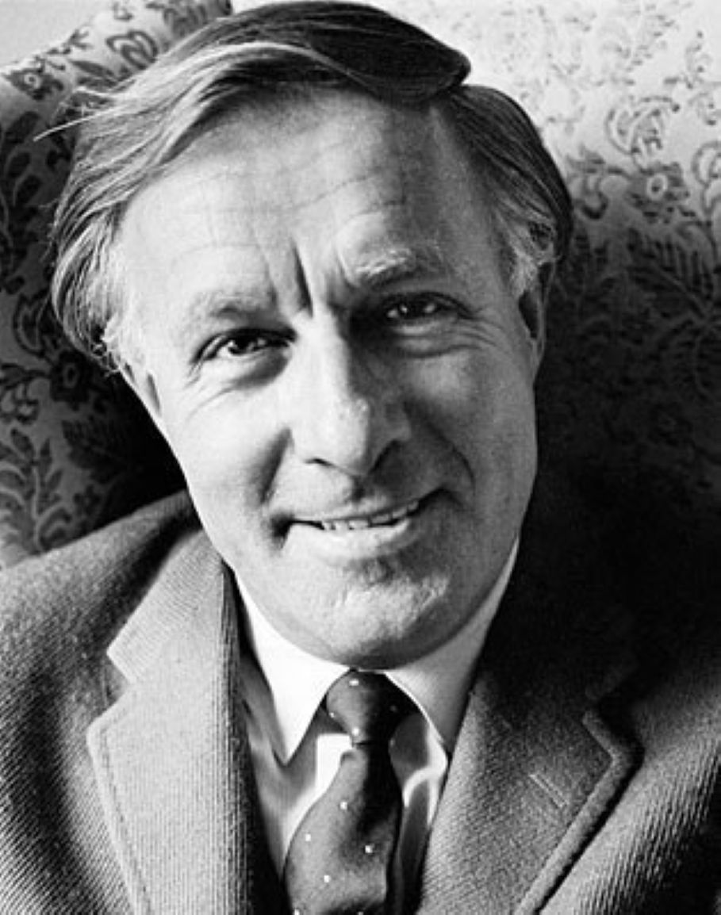

If MGM Is Killed, Who Gets the Lion, Ray Bradbury

If MGM Is Killed, Who Gets the Lion?

"Holy Jeez, damn. Christ off the cross!" said Jerry Would.

"Please," said his typist-secretary, pausing to erase a typo in a screenplay, "I have Christian ears."

"Yeah, but my tongue is Bronx, New York," said Would, staring out the window. "Will you just look, take one long fat look atthat!"

The secretary glanced up and saw what he saw, beyond.

"They're repainting the studio. That's Stage One, isn't it?"

"You're damn right. Stage One, where we built theBountyin '34 and shot the Tara interiors in '39 and Marie Antionette's palace in '34 and now, for God's sake, look what they're doing!"

"Looks like they're changing the number."

"Changing the number, hell, they're wiping itout!"

No more One. Watch those guys with the plastic overlays in the alley, holding up the goddamn pieces, trying them for size."

The typist rose and took off her glasses to see better.

"That looks like UGH. What does 'Ugh' mean?"

"Wait till they fit the first letter. See? Is that or is that not an H?"

"H added to UGH. Say, I bet I know the rest. Hughes! And down there on the ground, in small letters, the stencil? 'Aircraft'?"

"Hughes Aircraft, dammit!"

"Since when are we making planes? I know the war's on, but—"

"We're not making any damn planes," Jerry Would cried, turning from the window.

"We're shooting air combat films, then?"

"No, and we're not shooting no damn air films!"

"I don't see … "

"Put your damn glasses back on and look. Think! Why would those SOBs be changing the number for a name, hey? What's the big idea? We're not making an aircraft carrier flick and we're not in the business of tacking together P-38s and—Jesus,nowlook!"

A shadow hovered over the building and a shape loomed in the noon California sky.

His secretary shielded her eyes. "I'll be damned," she said.

"You ain't the only one. You wanna tell me what that thing is?"

She squinted again. "A balloon?" she said. "A barrage balloon?"

"You can say that again, butdon't!"

She shut her mouth, eyed the gray monster in the sky, and sat back down. "How do you want this letter addressed?" she said.

Jerry Would turned on her with a killing aspect. "Who gives a damn about a stupid letter when the world is going to hell? Don't you get the full aspect, the great significance? Why, I ask you, would MGM have to be protected by a barrage—hell, there goesanother! That makestwobarrage balloons!"

"No reason," she said. "We're not a prime munitions or aircraft target." She typed a few letters and stopped abruptly with a laugh. "I'm slow, right? Wearea prime bombing target?"

She rose again and came to the window as the stencils were hauled up and the painters started blow-gunning paint on the side of Stage One.

"Yep," she said, softly, "there it is. AIRCRAFT COMPANY. HUGHES. When does he movein?"

"What, Howie the nut? Howard the fruitcake? Hughes the billionaire bastard?"

"Thatone, yeah."

"He's going nowhere, he still has his pants glued to an office just three miles away. Think! Add it up. MGM is here, right, two miles from the Pacific coast, two blocks away from where Laurel and Hardy ran their tin lizzie like an accordion between trolley cars in 1928! And three miles north of us andalsotwo miles in from the ocean is—"

He let her fill in the blanks.

"Hughes Aircraft?"

He shut his eyes and laid his brow against the window to let it cool. "Give the lady a five-cent seegar."

"I'll be damned," she breathed with revelatory delight.

"You ain't the only one."

"When the Japs fly over or the subs surface out beyond Culver City, the people painting that building and re-lettering the signs hope that the Japs will think Clark Gable and Spencer Tracy are running around Hughes Aircraft two miles north of here, making pictures. And that MGM,here,has Rosie the Riveters and P-38s flying out of that hangar down there all day!"

Jerry Would opened his eyes and examined the evidence below. "I got to admit, a sound stage does look like a hangar. A hangar looks like a sound stage. Put the right labels on them and invite the Japsin. Banzai!"

"Brilliant," his secretary exclaimed.

"You're fired," he said.

"What?"

"Take a letter," said Jerry Would, his back turned.

"Another letter?"

"To Mr. Sid Goldfarb."

"But he's right upstairs."

"Take a letter, dammit, to Goldfarb, Sidney. Dear Sid. Strike that. Just Sid. I am damned angry. What the hell is going on? I walk in the office at eight a.m. and it's MGM. I walk out to the commissary at noon and Howard Hughes is pinching the waitresses' behinds. Whose bright idea was this?"

"Just whatIwondered," his secretary said.

"You're fired," said Jerry Would.

"Go on," she said.

"Dear Sid. Where was I? Oh, yeah. Sid, why weren't we informed that this camouflage would happen? Remember the old joke? We were all hired to watch for icebergs sailing up Culver Boulevard? Relatives of the studio, uncles, cousins? And now the damned iceberg's here. And it wears tennis shoes, a leather jacket, and a mustache over a dirty smile. I been here twelve years, Sidney, and I refuse—aw, hell, finish typing it. Sincerely. No, not sincerely. Angrily yours. Angrily. Where do I sign?"

He tore the letter from the machine and whipped out a pen.

"Now take this upstairs and throw it over the transom."

"Messengers get killed for messages like this."

"Killed is better than fired."

She sat quietly.

"Well?" he said.

"I'm waiting for you to cool down. You may want to tear this letter up, half an hour from now."

"I will not cool down and I will not tear up. Go."

And still she sat, watching his face until the lines faded and the color paled. Then very quietly she folded the letter and tore it across once and tore it across twice and then a third and fourth time. She let the confetti drift into the trash basket as he watched.

"How many times have I fired you today?" he said.

"Just three."

"Four times and you're out. Call Hughes Aircraft."

"I was wondering when you—"

"Don't wonder. Get."

She flipped through the phone book, underlined a number, and glanced up. "Who do you want to talk to?"

"Mr. Tennis Shoes, Mr. Flying Jacket, the billionaire buttinsky."

"You really think he ever answers the phone?"

"Try."

She tried and talked while he gnawed his thumbnail and watched them finish putting up and spraying the AIRCRAFT stencil below.

"Hell and damn," she said at last, in total surprise. She held out the phone. "He'sthere! And answered the phonehimself!"

"You're putting me on!" cried Jerry Would.

She shoved the phone out in the air and shrugged.

He grabbed it. "Hello, who's this? What? Well, say, Howard, I mean Mr. Hughes. Sure. This is MGM Studios. My name? Would. Jerry Would. Youwhat? You heard me? You sawBack to Broadway? AndGlory Years.But sure, you once owned RKO Studios, right? Sure, sure. Say, Mr. Hughes, I got a little problem here. I'll make this short and sweet."

He paused and winked at his secretary.

She winked back. The voice on the line spoke nice and soft.

"What?" said Jerry Would. "Something's going on over atyourplace,too? So you know why I'm calling, sir. Well, they just put up the aircraft letters and spelled out HUGHES on Stage One. You like that, huh? Looks great. Well, I was wondering, Howard, Mr. Hughes, if you could do me a little favor."

Name it, said the quiet voice a long way off.

"I was thinking if the Japs come with the next tide by air or by sea and no Paul Revere to say which, well, when they see those big letters right outside my window, they're sure going to bomb the hell outta what they think is P-38 country and Hughes territory.

A brilliant concept, sir, brilliant. Iswhat? Is everyone here at MGM happy with the ruse? They're not dancing in the streets but they do congratulate you for coming up with such a world-shaking plan.

Now here's my point. I gotta lot of work to finish. Six films shooting, two films editing, three films starting. What I need is a nice safe place to work, you got the idea? That's it. Yeah. That's it. You got a nice small corner of one of your hangars that—sure! You're way ahead of me. I shouldwhat?

Yeah, I'll send my secretary over right after lunch with some files. You got a typewriter? I'll leave mine here. Boy, How—Mr. Hughes, you're a peach. Now, tit for tat, ifyoushould want to move intomyoffice here? Just joking. Okay. Thanks. Thanks. Okay. She'll be there, pronto."

And he hung up.

His secretary sat stolidly, examining him. He looked away, refused to meet her stare. A slow blush moved up his face.

"You'refired," she said.

"Take it easy," he said.

She rose, gathered a few papers, hunted for her purse, applied a perfect lipstick mouth, and stood at the door.

"Have Joey and Ralph bring all the stuff in that top file," she said. "That'll do for starters. You coining?"

"In a moment," he said, standing by the window, still not looking at her.

"What if the Japs figure out this comedy, and bomb therealHughes Aircraft instead of this fake one?"

"Some days," sighed Jerry Would, "you can't win for losing."

"Shall I write a letter to Goldfarb to tell him where you're going?"

"Don't write, call. That way there's no evidence."

A shadow loomed. They both looked up at the sky over the studio.

"Hey," he said, softly, "there's another. Athirdballoon."

"How come," she said, "it looks like a producer I used to know?"

"You're—" he said.

But she was gone. The door shut.

1997

The end