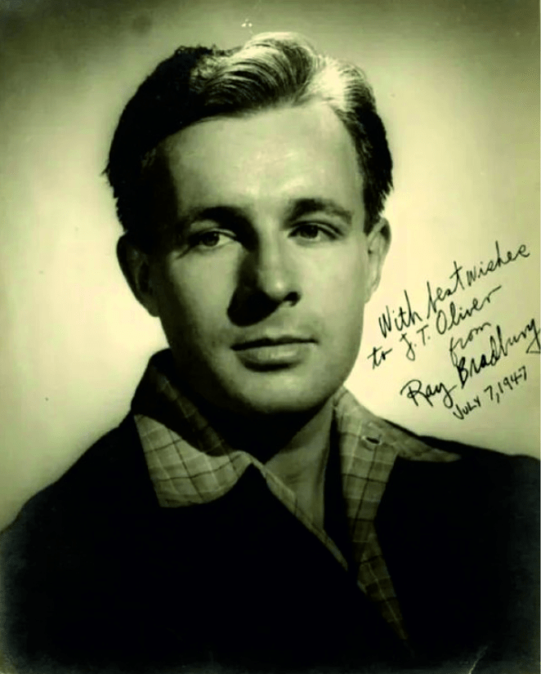

Interim (Time Intervening) Ray Bradbury

Interim (Time Intervening)

Very late on this night, the old man came from his house with a flashlight in his hand and asked of the little boys the object of their frolic. The little boys gave no answer, but tumbled on in the leaves.

The old man went into his house and sat down and worried. It was three in the morning. He saw his own pale, small hands trembling on his knees. He was all joints and angles, and his face, reflected above the mantel, was no more than a pale cloud of breath exhaled upon the mirror.

The children laughed softly outside, in the leaf piles.

He switched out his flashlight quietly and sat in the dark. Why he should be bothered in any way by playing children he could not know. But it was late for them to be out, at three in the morning, playing. He was very cold.

There was a sound of a key in the door and the old man arose to go see who could possibly be coming into his house. The front door opened and a young man entered with a young woman. They were looking at each other softly and tenderly, holding hands, and the old man stared at them and cried, “What are you doing in my house?”

The young man and the young woman replied, “What are you doing in our house?” The young man said, “Here now, get on out.” And he took the old man by the elbow and shoved him out the door and closed and locked it after searching him to see if he had stolen something.

“This is my house. You can’t lock me out!” The old man beat upon the door. He stood in the dark morning air. Looking up he saw the lights illumine the warm inside window and rooms upstairs and then, with a move of shadows, go out.

The old man walked down the street and came back and still the small boys rolled in the icy morning leaves, not looking at him.

He stood before the house and as he watched the lights turned on and turned off more than a thousand times. He counted softly under his breath.

A young boy of about fourteen ran by to the house, a football in his hand. He opened the door without even trying to unlock it, and went in. The door closed.

Half an hour later, with the morning wind rising, the old man saw a car pull up and a plump woman get out with a little boy three years old. They walked across the wet lawn and went into the house after the woman had looked at the old man and said, “Is that you, Mr. Terle?”

“Yes,” said the old man, automatically, for somehow he didn’t wish to frighten her. But it was a lie. He knew he was not Mr. Terle at all. Mr. Terle lived down the street.

The lights glowed on and off a thousand more times.

The children rustled softly in the leaves.

A seventeen year old boy bounded across the street, smelling faintly of the smudged lipstick on his cheek, almost knocked the old man down, cried, “Sorry!” and leaped up the steps. Fitting a key to the lock he went in.

The old man stood there with the town lying asleep on all sides of him; the unlit windows, the breathing rooms, the stars all through the trees, liberally caught and held on winter branches, so much snow suspended glittering on the cold air.

“That’s my house; who are all those people going in it?” cried the old man to the wrestling children.

The wind blew, shaking the empty trees.

In the year which was 1923 the house was dark. A car drove up before it, the mother stepped from the car with her son William, who was three. William looked at the dusky morning world and saw his house and as he felt his mother lead him toward the house he heard her say.

“Is that you, Mr. Terle?” and in the shadows by the great wind-filled oak tree an old man stood and replied, “Yes.” The door closed.

In the year which was 1934 William came running in the summer night, feeling the football cradled in his hands, feeling the murky night street pass under his running feet, along the sidewalk. He smelled, rather than saw, an old man, as he ran past. Neither of them spoke. And so, on into the house.

In the year 1937 William ran with antelope boundings across the street, a smell of lipstick on his face, a smell of someone young and fresh upon his cheeks; all thoughts of love and deep night. He almost knocked the stranger down, cried, “Sorry!” and ran to fit a key to the front door.

In the year 1947 a car drew up before the house, William relaxed, his wife beside him. He wore a fine tweed suit, it was late, he was tired, they both smelled faintly of so many drinks offered and accepted. For a moment they both heard the wind in the trees. They got out of the car and let themselves into the house with a key. An old man came from the living room and cried, “What are you doing in my house?”

“Your house?” said William. “Here now, old man, get on out.” And William, feeling faintly sick in his stomach, for there was something about the old man that made him feel all water and nothing, searched the old man and pushed him out the door and closed and locked it. From outside the old man cried, “This is my house. You can’t lock me out!”

They went up to bed and turned out the lights.

In the year 1928 William and the other small boys wrestled on the lawn, waiting for the time when they would leave to watch the circus come chuffing into the pale-dawn railroad station on the blue metal tracks.

In the leaves they lay and laughed and kicked and fought. An old man with a flashlight came across the lawn. “Why are you playing here on my lawn at this time of morning?” asked the old man.

“Who are you?” replied William, looking up a moment from the tangle.

The old man stood over the tumbling children a long moment. Then he dropped his flash. “Oh, my dear boy, I know now, now I know!” He bent to touch the boy. “I am you and you are me. I love you, my dear boy, with all of my heart! Let me tell you what will happen to you in the years to come!

If you knew! I am you and you were once me! My name is William—so is yours! And all these people going into the house, they are William, they are you, they are me!” The old man shivered. “Oh, all the long years and the passing of time!”

“Go away,” said the boy. “You’re crazy.”

“But—” said the old man.

“You’re crazy. I’ll call my father.”

The old man turned and walked away.

There was a flickering of the house lights, on and off. The boys wrestled quietly and secretly in the rustling leaves. The old man stood on the dark lawn.

Upstairs, in his bed, William Latting did not sleep, in the year 1947. He sat up, lit a cigarette, and looked out the window. His wife was awake. “What’s wrong?” she asked.

“That old man,” said William Latting. “I think he’s still down there, under the oak tree.”

“Oh, he couldn’t be,” she said.

“I can’t see very well, but I think he’s there. I can barely make him out, it’s so dark.”

“He’ll go away,” she said.

William Latting drew quietly on his cigarette. He nodded. “Who are those kids?”

From her bed his wife said, “What kids?”

“Playing on the lawn out there, what a hell of a time of night to be playing in the leaves.”

“Probably the Moran boys.”

“Doesn’t look like them.”

He stood by the window. “You hear something?”

“What?”

“A baby crying. Way off?”

“I don’t hear anything,” she said.

She lay listening. They both thought they heard running footsteps on the street, a key to the door. William Latting went to the hall and looked down the stairs but saw nothing.

In the year 1937, coming to the door, William saw a man in a dressing gown at the top of the stairs, looking down, with a cigarette in his hand. “That you, Dad?” No answer. The man sighed and went back into some room. William went to the kitchen to raid the ice-box.

The children wrestled in the soft, dark leaves of morning.

William Latting said, “Listen.”

He and his wife listened.

“It’s the old man,” said William, “crying.”

“Why should he be crying?”

“I don’t know. Why does anybody cry? Maybe he’s unhappy.”

“If he’s still there in the morning,” said his wife in the dim room, “call the police.”

William Latting went away from the window, put out his cigarette, and lay in the bed, his eyes closed. “No,” he said quietly. “I won’t call the police. Not for him, I won’t.”

“Why not?”

His voice was certain. “I wouldn’t want to do that. I just wouldn’t.”

They both lay there and faintly there was a sound of crying and the wind blew and William Latting knew that all he had to do if he wanted to watch the boys wrestling in the icy leaves of morning would be to reach out with his hand and lift the shade and look, and there they would be, far below, wrestling and wrestling, as dawn came pale in the Eastern sky.

With all his heart, soul, and blood he wanted to go out and lie in the leaves with them, and let the leaves bury him deep as he snuffed them in, eyes wet. He could go out there now . . .

Instead, he turned on his side and could not close his eyes, and could not sleep.

1947

The End