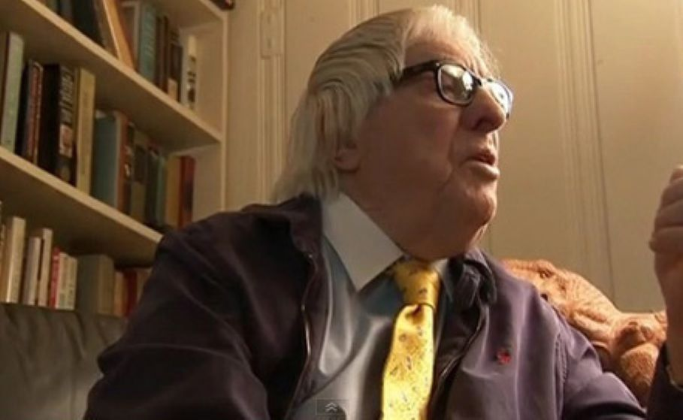

Madame Et Monsieur Shill, Ray Bradbury

Madame Et Monsieur Shill

It was while shuttling his eye down the menu posted in a nineteenth-century silver frame outside Le Restaurant Fondue that Andre Hall felt the merest touch at his elbow.

"Sir," said a man's voice, "you look to be hungry."

Andre turned irritably.

"What makes you think—?" he began, but the older man interrupted, politely.

"It was the way you leaned in to read the menu. I am Monsieur Sault, the proprietor of this restaurant. I know the symptoms."

"My God," said Andre. "Thatmade you come out?"

"Yes!" The older man examined Andre's coat, the worn cuffs, the too-often-cleaned lapels and said, "Areyou hungry?"

"Do I sing for my supper?"

"No, no!Regardezthe window."

Andrew turned and gasped, shot through the heart.

For in the window sat the most beautiful young woman, bent to ladle her soup to a mostdeliciousmouth. Bent, as if in prayer, she seemed not to notice their tracing her profile, her mellow cheeks, her violet eyes, her ears as delicate as seashells.

Andre had never dined on a woman's fingers, but now the urge overwhelmed him as he fought to breathe.

"All you must do," whispered the proprietor, "is sit in that window with the lovely creature and eat and drink during the next hour. And return another night to dine with the same lovely vision."

"Why?" said Andre.

"Regardez." The old man turned Andre's head so he might gaze at himself in the window's reflection.

"What do you see?"

"A hungry art student. Myself! And … not bad-looking?"

"Ah hah! Good. Come!"

And the young man was pulled through the door to sit at the table while the beautiful young woman laughed.

"What?" he cried, as champagne was poured. "What's so funny?"

"You," the beauty smiled. "Hasn't he said why we're here? Behold, our audience."

She pointed her champagne glass at the window where people now lingered outside.

"Who are they?" he protested. "Andwhatdo they see?"

"The actors." She sipped her champagne. "The beautiful people. Us. My fine eyes, nose, fine mouth, andlookat you. Eyes, nose, mouth,allfine. Drink!"

The proprietor's shadow moved between them. "Do you know the magician's theater where a volunteer who is the magician's assistantpretendsinnocence to secretly help the sorcerer, eh? And thenameof such assistants?Shill.So, seated with a proper wine and your audience beyond the window, I now dub thee … " He paused.

"Shill. MadameetMonsieur … Shill." And indeed as the lovely creature across from Andre raised her glass, in the twilight hour beyond the window, passersby hesitated and were pleasured by the incredible beauty and a man as handsome as she was lovely.

With a murmuring and shadowing the couples, lured by more than menus, filled the tables and more candles were lit and more champagne poured as Andre and his love, fascinated with each other's immortal faces, devoured their meal without seeing it.

So the last plates were cleared, the last wine tasted, the last candles extinguished. They sat, staring at one another, until the proprietor, in the shadows, raised his hands. Applause. "Tomorrow night," he said. "Encore?"

Encore and another after that and still another followed with their arrivals and departures, but always they met in silence to cause the room's temperature to change. People entering from the cool night found summer on this hearth where he fed on her warmth.

And it was in the midst of the sixteenth night that Andre felt a ventriloquist's ghost in his throat move his mouth to say:

"I love you."

"Don't!" she said. "People are watching!"

"They've been watching for weeks. They see two lovers."

"Lovers? No. We're not!"

"Yes! Come back to my room or let me come toyours!"

"That would spoil it! This is perfectnow."

"Beingwith you would be perfect."

"Sit! Look at all the people we make happy. Consider Monsieur Sault, whose future we assure. Think: before you arrived last month, what were your plans for next year? Drink the wine. They say it's excellent."

"Because theysayit's excellent?"

"Careful. The people outside might read lips and leave. Give me your hand.Gently! Eat. Smile. Nod your head. There. Better?"

"I love you."

"Stop or I'll go!"

"Where?"

"Somewhere!" She smiled her false smile for the people beyond the window. "Where working conditions are better."

"AmIa bad working condition?"

"You endanger us. See, Monsieur Sault glares! Be still. Pour the wine. Yes?"

"Yes," he said at last.

And so it went for another week until he burst out and said, "Marry me!"

She snatched her hand from his. "No!" Then, because a couple had paused at their window, she laughed.

"Don't you love me a little bit?" he pleaded.

"Why should I? There were no promises."

"Marry me!"

"Monsieur Sault!" she cried. "The check!"

"But there has neverbeena check!"

"Tonight," she said, "thereis."

The next night she vanished.

"You," cried Monsieur Sault. "You fiend! Look what you've done!"

Inside the window there was no beautiful young woman: the last night of spring, the first night of summer.

"My business is ruined!" cried the old man. "Why couldn't you have shut your mouth and eaten your pate or drunk a second bottle and stuck the cork in your teeth?"

"I told the truth as I felt it. She'll come back!"

"So? Readthis!"

Andre took the note the old man gave him and read:Farewell.

"Farewell." Tears leaked from Andre's eyes. "Where's she gone?"

"God knows. We never knew her real name or address. Come!"

Andre followed up through a labyrinth of stairs to the roof. There, swaying as if he might pitch headlong down, Monsieur Sault pointed across the twilight city.

"What do you see?"

"Paris. Thousands of buildings."

"And?"

"Thousands of restaurants?"

"Do you truly know how many there are between here, theTour Eiffel,and there, Notre-Dame? Twenty thousand restaurants. Twenty thousand hiding places for our nameless wonder. Would you find her? Search!"

"All twenty thousand restaurants?"

"Bring her and you'll be my son and partner. Come without her and I will kill you. Escape!"

Andre escaped. He ran to climb the hill to the white splendor of Sacre-Coeur and looked out at the lights of Paris drowned in the blue and gold colors of a vanished sun.

"Twenty thousand hiding places," he murmured.

And went down in search.

In the Latin Quarter across the Seine from Notre-Dame you could wander past forty restaurants in a single block, twenty on each side, some with windows where beauties might sit by candlelight, some with tables and laughing people in the open.

"No, no," Andre muttered. "Too much!" And veered off down an alley that ended at the Boulevard St. Michel where brasseries,tabacs,and restaurants swarmed with tourists; where Renoir women spoke wine as they drank, spoke food as they ate, and ignored this strange, haunted, searching young man as he passed.

My God, Andre thought. Must I cross and recross Paris from the Trocadero to Montmartre to Montparnasse, to find a single small theater-cafe window where candlelight reveals a woman so beautiful that all appetites bud, all joys, culinary and amorous, conjoin?

Madness!

What if I miss that one window, that illumination, that face?

Insane! What if in my confusion I revisit alleys already searched! A map! I must cross out where I've been.

So each night at sundown with the shades of violet and purple and magenta flooding the narrow alleys he set out with bright maps that darkened as he left. Once on the Boulevard de Crenelle he shouted his taxi to a halt and leaped out, furious. The taxi had gone too fast; a dozen cafes had flashed by unseen.

Then suddenly, in despair, he said:

"Honfleur? Deuville? Lyon?"

"What if," he continued, "she isnotin Paris but has fled to Cannes or Bordeaux with their thousands of restaurants! My God!"

That night he woke at three a.m. as a list of names passed through his head. Elizabeth. Michelle. Arielle. Which name to speak if at last he found her? Celia? Helene? Diana? Beth?

Exhausted, he slept.

And so the weeks passed into months and in the fourth month he shouted at his mirror:

"Stop! If you haven't found her special 'theater' this week, burn your maps! No more names or streets at midnight or dawn! Yes!"

His image, in silence, turned away.

On the ninety-seventh night of his search, Andre was moving along the Quai Voltaire when he was suddenly seized by a storm of emotion so powerful it shook his bones and knocked his heart. Voices that he heard but did not hear made him stagger toward an intersection, where he froze.

Across the narrow street under a bower of trembling leaves, there was a small audience staring at a brass-framed menu, and the window beyond. Andre stepped, as in a trance, to stand behind the people.

"Impossible," whispered Andre.

For in the candlelit window sat the most beautiful woman, the most beautiful love of his life. And across from her sat an amazingly handsome man. They were lifting glasses and drinking champagne.

Am I outside or in? Andre wondered. Is that me in there, as before, and in love?What?

He could only swallow his heart as, for an instant, the gaze of the beautiful young woman passed over him like a shadow and did not return. Instead she smiled at her friend across the candlelit table. Stunned, Andre found the entryway and stepped in to move and stand close by the couple who whispered and laughed quietly.

She was more beautiful than in all the nights he had imagined her multitudinous names. Her travels across Paris had colored her cheeks and brightened her incredible eyes. Even her laughter was made rich by a passage of time.

Outside the restaurant window, a new audience watched as Andre said:

"Excuse."

The beautiful young woman and the handsome man looked up. There was no remembrance in her eyes, nor did her lips smile.

"MadameetMonsieur Shill?" Andre asked, numbly.

They held hands and nodded.

"Yes?" they said.

And finished the wine.

1997

The end