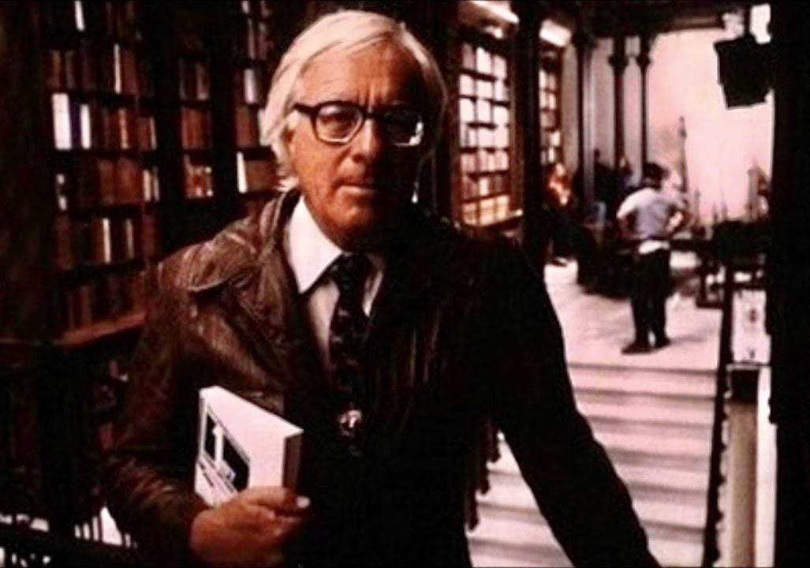

Marionettes, Inc. Ray Bradbury

Marionettes, Inc.

Marionettes, Inc.

They walked slowly down the street at about ten in the evening, talking calmly.

They were both about thirty-five, both eminently sober.

"But why so early?" said Smith.

"Because," said Braling.

"Your first night out in years and you go home at ten o'clock."

"Nerves, I suppose."

"What I wonder is how you ever managed it. I've been trying to get you out for ten years for a quiet drink. And now, on the one night, you insist on turning in early."

"Mustn't crowd my luck," said Braling.

"What did you do, put sleeping powder in your wife's coffee?"

"No, that would be unethical. You'll see soon enough."

They turned a corner. "Honestly, Braling, I hate to say this, but you have been patient with her. You may not admit it to me, but marriage has been awful for you, hasn't it?"

"I wouldn't say that."

"It's got around, anyway, here and there, how she got you to marry her. That time back in 1979 when you were going to Rio…"

"Dear Rio. I never did see it after all my plans."

"And how she tore her clothes and rumpled her hair and threatened to call the police unless you married her."

"She always was nervous, Smith, understand."

"It was more than unfair. You didn't love her. You told her as much, didn't you?"

"I recall that I was quite firm on the subject."

"But you married her anyhow."

"I had my business to think of, as well as my mother and father. A thing like that would have killed them."

"And it's been ten years."

"Yes," said Braling, his gray eyes steady. "But I think perhaps it might change now. I think what I've waited for has come about. Look here."

He drew forth a long blue ticket.

"Why, it's a ticket for Rio on the Thursday rocket!"

"Yes, I'm finally going to make it."

"But how wonderful! You do deserve it! But won't she object? Cause trouble?"

Braling smiled nervously. "She won't know I'm gone. I'll be back in a month and no one the wiser, except you.

Smith sighed. "I wish I were going with you."

"Poor Smith, your marriage hasn't exactly been roses, has it?"

"Not exactly, married to a woman who overdoes it. I mean, after all, when you've been married ten years, you don't expect a woman to sit on your lap for two hours every evening, call you at work twelve times a day and talk baby talk. And it seems to me that in the last month she's gotten worse. I wonder if perhaps she isn't just a little simple-minded?"

"Ah, Smith, always the conservative. Well, here's my house. Now, would you like to know my secret? How I made it out this evening?"

"Will you really tell?"

"Look up, there!" said Braling.

They both stared up through the dark air.

In the window above them, on the second floor, a shade was raised. A man about thirty-five years old, with a touch of gray at either temple, sad gray eyes, and a small thin mustache looked down at them.

"Why, that's you!" cried Smith.

"Sh-h-h, not so loud!" Braling waved upward.

The man in the window gestured significantly and vanished.

"I must be insane," said Smith.

"Hold on a moment." They waited.

The street door of the apartment opened and the tall spare gentleman with the mustache and the grieved eyes came out to meet them.

"Hello, Braling," he said.

"Hello, Braling," said Braling.

They were identical.

Smith stared. "Is this your twin brother? I never knew…"

"No, no," said Braling quietly. "Bend close. Put your ear to Braling Two's chest."

Smith hesitated and then leaned forward to place his head against the uncomplaining ribs.

Tick - tick - tick - tick - tick - tick - tick - tick.

"Oh no! It can't be!"

"It is."

"Let me listen again."

Tick - tick - tick - tick - tick - tick - tick - tick.

Smith staggered back and fluttered his eyelids, appalled. He reached out and touched the warm hands and the cheeks of the thing.

"Where'd you get him?"

"Isn't he excellently fashioned?"

"Incredible. Where?"

"Give the man your card, Braling Two."

Braling Two did a magic trick and produced a white card:

MARIONETTES, INC.

Duplicate self or friends;

new humanoid plastic 1990 models,

guaranteed against all physical wear.

From $7,600 to our $15,000 de luxe model.

"No," said Smith.

"Yes," said Braling.

"Naturally," said Braling Two.

"How long has this gone on?"

"I've had him for a month. I keep him in the cellar in a toolbox. My wife never goes downstairs, and I have the only lock and key to that box. Tonight I said I wished to take a walk to buy a cigar. I went down cellar and took Braling Two out of his box and sent him back up to sit with my wife while I came on out to see you, Smith."

"Wonderful! He even smells like you: Bond Street and Melachrinos!"

"It may be splitting hairs, but I think it highly ethical. After all, what my wife wants most of all is me. This marionette is me to the hairiest detail. I've been home all evening. I shall be home with her for the next month. In the meantime another gentleman will be in Rio after ten years of waiting. When I return from Rio, Braling Two here will go back in his box."

Smith thought that over a minute or two.

"Will he walk around without sustenance for a month?" he finally asked.

"For six months if necessary. And he's built to do everything - eat, sleep, perspire - everything, natural as natural is. You'll take good care of my wife, won't you, Braling Two?"

"Your wife is rather nice," said Braling Two. "I've grown rather fond of her."

Smith was beginning to tremble. "How long has Marionettes, Inc., been in business?"

"Secretly, for two years."

"Could I - I mean, is there a possibility…"

Smith took his friend's elbow earnestly.

"Can you tell me where I can get one, a robot, a marionette, for myself? You will give me the address, won't you?"

"Here you are."

Smith took the card and turned it round and round.

"Thank you," he said. "You don't know what this means. Just a little respite. A night or so, once a month even. My wife loves me so much she can't bear to have me gone an hour. I love her dearly, you know, but remember the old poem: 'Love will fly if held too lightly, love will die if held too tightly.' I just want her to relax her grip a little bit."

"You're lucky, at least, that your wife loves you. Hate's my problem. Not so easy."

"Oh, Nettie loves me madly. It will be my task to make her love me comfortably."

"Good luck to you, Smith. Do drop around while I'm in Rio. It will seem strange, if you suddenly stop calling by, to my wife. You're to treat Braling Two, here, just like me."

"Right! Good - by. And thank you."

Smith went smiling down the street. Braling and Braling Two turned and walked into the apartment hall.

On the crosstown bus Smith whistled softly, turning the white card in his fingers:

Clients must be pledged to secrecy, for while an act is pending in Congress to legalize Marionettes, Inc., it is still a felony, if caught, to use one.

"Well," said Smith.

Clients must have a mold made of their body and a color index check of their eyes, lips, hair, skin, etc. Clients must expect to wait for two months until their model is finished.

Not so long, thought Smith. Two months from now my ribs will have a chance to mend from the crushing they've taken. Two months from now my hand will heal from being so constantly held. Two months from now my bruised underlip will begin to reshape itself. I don't mean to sound ungrateful...

He flipped the card over.

Marionettes, Inc.,

is two years old and has a fine record of satisfied customers behind it.

Our motto is "No Strings Attached."

Address: 43 South Wesley Drive.

The bus pulled to his stop; he alighted, and while humming up the stairs he thought, Nettie and I have fifteen thousand in our joint bank account. I'll just slip eight thousand out as a business venture, you might say. The marionette will probably pay back my money, with interest, in many ways. Nettie needn't know. He unlocked the door and in a minute was in the bedroom. There lay Nettie, pale, huge, and piously asleep.

"Dear Nettie."

He was almost overwhelmed with remorse at her innocent face there in the semidarkness.

"If you were awake you would smother me with kisses and coo in my ear. Really, you make me feel like a criminal. You have been such a good, loving wife. Sometimes it is impossible for me to believe you married me instead of that Bud Chapman you once liked. It seems that in the last month you have loved me more wildly than ever before."

Tears came to his eyes. Suddenly he wished to kiss her, confess his love, tear up the card, forget the whole business. But as he moved to do this, his hand ached and his ribs cracked and groaned. He stopped, with a pained look in his eyes, and turned away. He moved out into the hall and through the dark rooms. Humming, he opened the kidney desk in the library and filched the bankbook.

"Just take eight thousand dollars is all," he said. "No more than that." He stopped. "Wait a minute."

He rechecked the bankbook frantically.

"Hold on here!" he cried. "Ten thousand dollars is missing!" He leaped up. "There's only five thousand left! What's she done? What's Nettie done with it? More hats, more clothes, more perfume! Or, wait - I know! She bought that little house on the Hudson she's been talking about for months, without so much as a by your leave!"

He stormed into the bedroom, righteous and indignant. What did she mean, taking their money like this? He bent over her.

"Nettie!" he shouted. "Nettie, wake up!"

She did not stir. "What've you done with my money!" he bellowed.

She stirred fitfully. The light from the street flushed over her beautiful cheeks.

There was something about her. His heart throbbed violently. His tongue dried. He shivered. His knees suddenly turned to water. He collapsed.

"Nettie, Nettie!" he cried. "What've you done with my money!"

And then, the horrid thought. And then the terror and the loneliness engulfed him. And then the fever and disillusionment. For, without desiring to do so, he bent forward and yet forward again until his fevered ear was resting firmly and irrevocably upon her round pink bosom.

"Nettie!" he cried.

Tick - tick - tick - tick - tick - tick - tick - tick - tick - tick - tick.

As Smith walked away down the avenue in the night, Braling and Braling Two turned in at the door to the apartment.

"I'm glad he'll be happy too," said Braling.

"Yes," said Braling Two abstractedly.

"Well, it's the cellar box for you, B-Two."

Braling guided the other creature's elbow down the stairs to the cellar.

"That's what I want to talk to you about," said Braling Two, as they reached the concrete floor and walked across it. "The cellar. I don't like it. I don't like that toolbox."

"I'll try and fix up something more comfortable."

"Marionettes are made to move, not lie still. How would you like to lie in a box most of the time?"

"Well…"

"You wouldn't like it at all. I keep running. There's no way to shut me off. I'm perfectly alive and I have feelings."

"It'll only be a few days now. I'll be off to Rio and you won't have to stay in the box. You can live upstairs."

Braling Two gestured irritably. "And when you come back from having a good time, back in the box I go."

Braling said, "They didn't tell me at the marionette shop that I'd get a difficult specimen."

"There's a lot they don't know about us," said Braling Two. "We're pretty new. And we're sensitive. I hate the idea of you going off and laughing and lying in the sun in Rio while we're stuck here in the cold."

"But I've wanted that trip all my life," said Braling quietly.

He squinted his eyes and could see the sea and the mountains and the yellow sand. The sound of the waves was good to his inward mind. The sun was fine on his bared shoulders. The wine was most excellent.

"I'll never get to go to Rio," said the other man. "Have you thought of that?"

"No, I…"

"And another thing. Your wife."

"What about her?" asked Braling, beginning to edge toward the door.

"I've grown quite fond of her."

"I'm glad you're enjoying your employment." Braling licked his lips nervously. "I'm afraid you don't understand. I think - I'm in love with her."

Braling took another step and froze. "You're what?"

"And I've been thinking," said Braling Two, "how nice it is in Rio and how I'll never get there, and I've thought about your wife and - I think we could be very happy."

"T… that's nice." Braling strolled as casually as he could to the cellar door. "You won't mind waiting a moment, will you? I have to make a phone call."

"To whom?" Braling Two frowned.

"No one important."

"To Marionettes, Incorporated? To tell them to come get me?"

"No, no - nothing like that!" He tried to rush out the door.

A metal-firm grip seized his wrists. "Don't run!"

"Take your hands off!"

"No."

"Did my wife put you up to this?"

"No."

"Did she guess? Did she talk to you? Does she know? Is that it?" He screamed.

A hand clapped over his mouth.

"You'll never know, will you?" Braling Two smiled delicately. "You'll never know."

Braling struggled. "She must have guessed; she must have affected you!"

Braling Two said, "I'm going to put you in the box, lock it, and lose the key. Then I'll buy another Rio ticket for your wife."

"Now, now, wait a minute. Hold on. Don't be rash. Let's talk this over!"

"Good-bye, Braling."

Braling stiffened. "What do you mean, 'good-bye'?"

Ten minutes later Mrs. Braling awoke. She put her hand to her cheek. Someone had just kissed it. She shivered and looked up.

"Why - you haven't done that in years," she murmured.

"We'll see what we can do about that," someone said.

The End