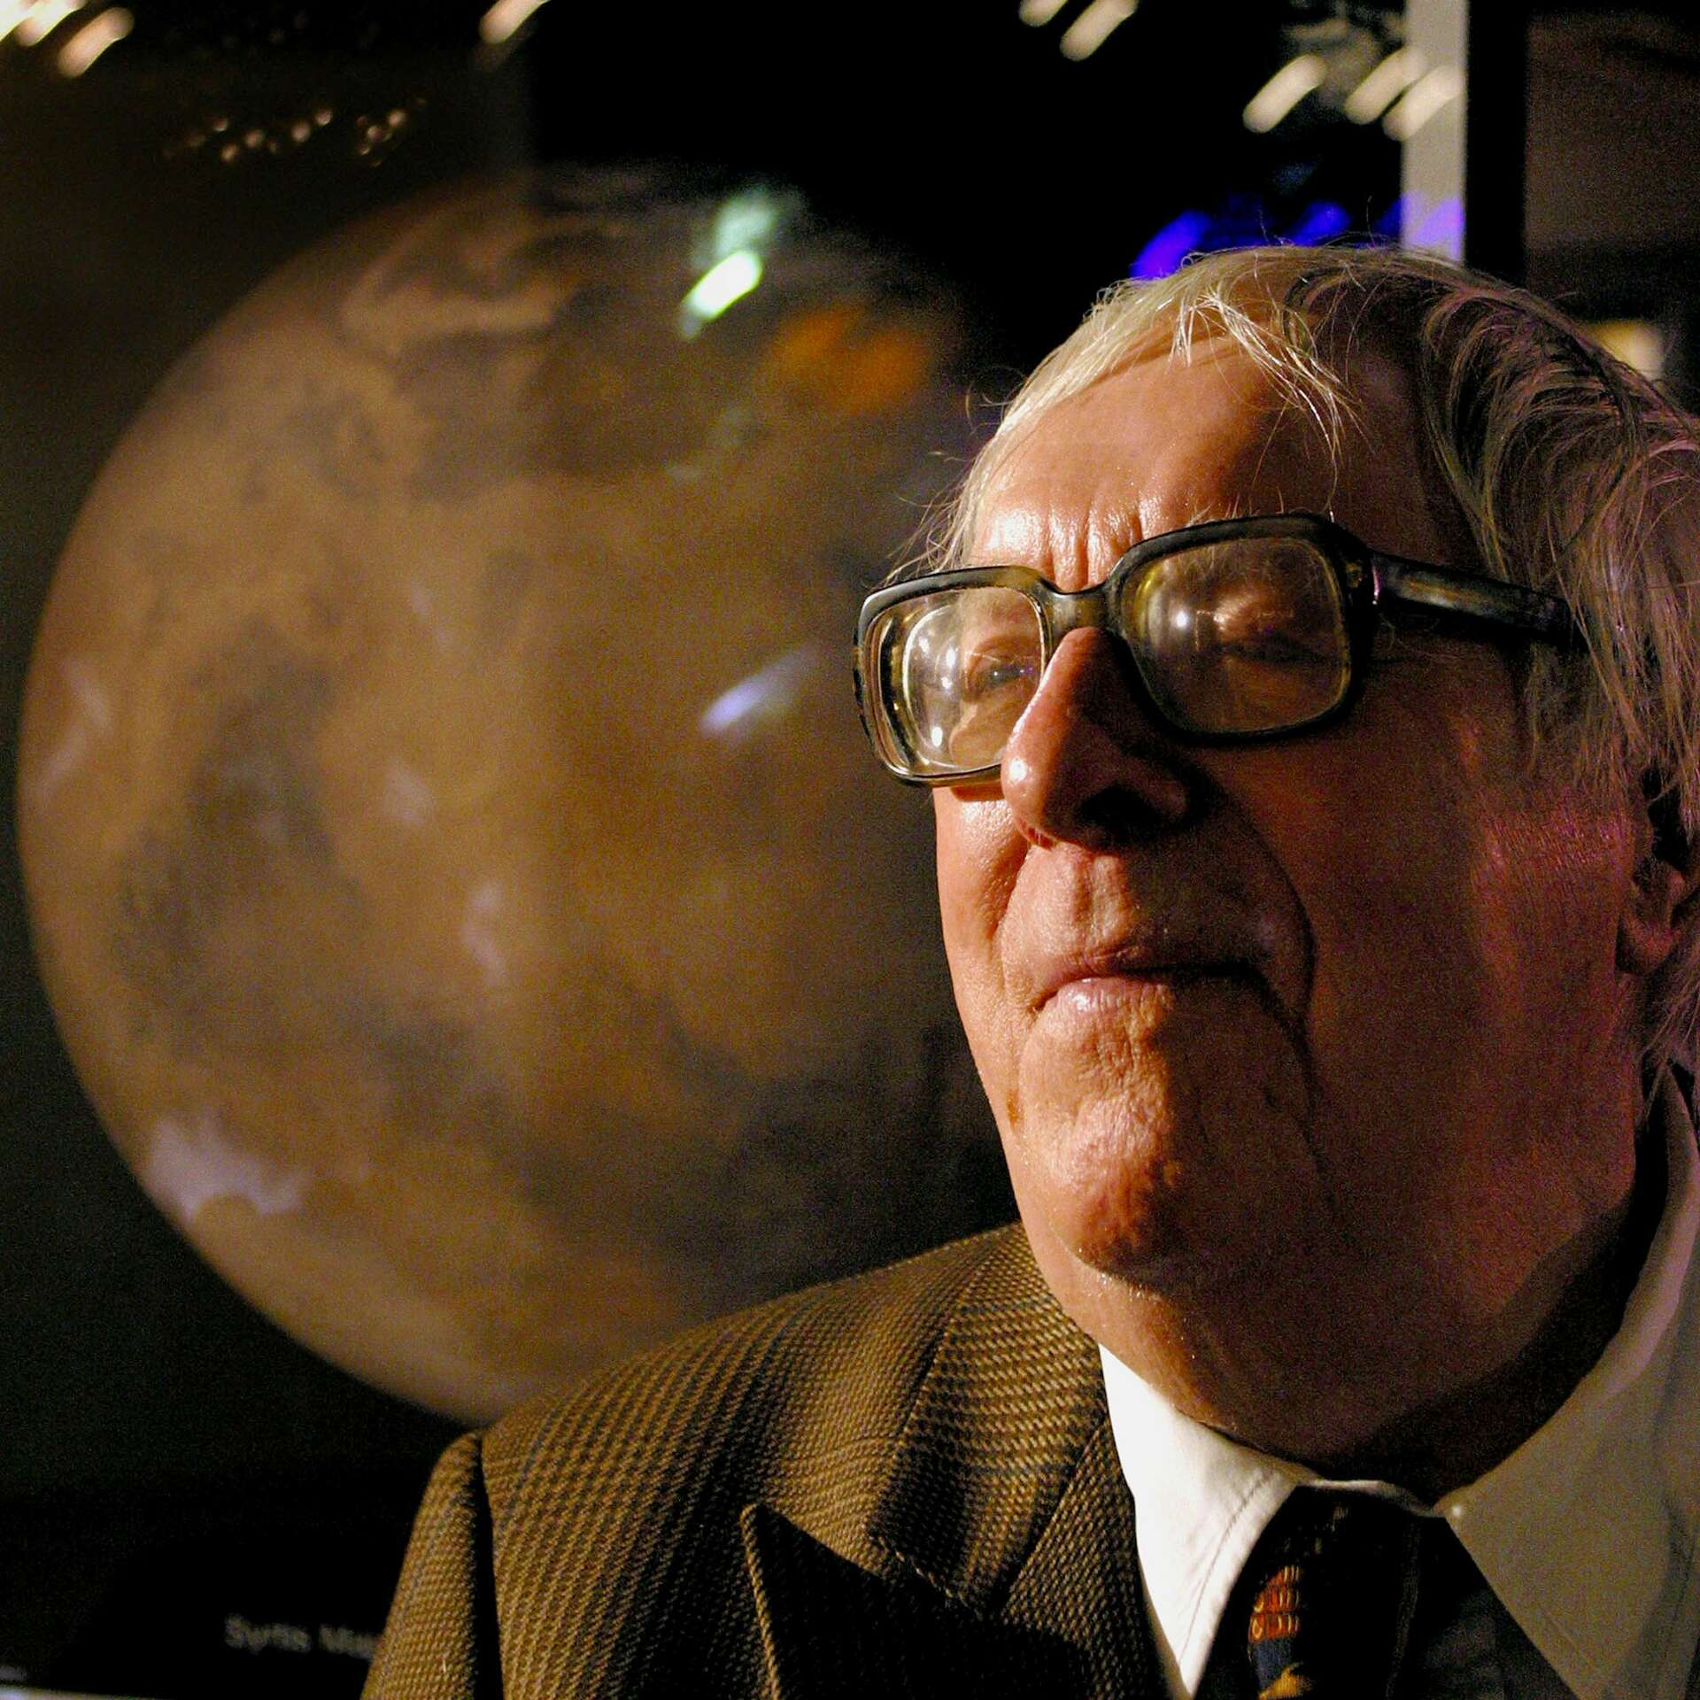

McGillahee’s Brat, Ray Bradbury

McGillahee’s Brat

In 1953 I had spent six months in Dublin, writing a screenplay. I had not been back since.

Now, fifteen years later, I had returned by boat, train, and taxi, and here we pulled up in front of the Royal Hibernian Hotel and here we got out and were going up the front hotel steps when a beggar woman shoved her filthy baby in our faces and cried:

‘Ah, God, pity! It’s pity we’re in need of! Have you some?!’

I had some somewhere on my person, and slapped my pockets and fetched it out, and was on the point of handing it over when I gave a small cry, or exclamation. The coins spilled from my hand.

In that instant, the babe was eying me, and I the babe.

Then it was snatched away. The woman bent to paw after the coins, glancing up at me in some sort of panic.

‘What on earth?’ My wife guided me up into the lobby where, stunned, standing at the register, I forgot my name. ‘What’s wrong? What happened out there?’

‘Did you see the baby?’ I asked.

‘The beggar’s child—?’

‘It’s the same.’

‘The same what?’

‘The same baby,’ I said, my lips numb, ‘that the woman used to shove in our faces fifteen years ago.’

‘Oh, come, now.’

‘Yes, come.’ And I went back to the door and opened it to look out.

But the street was empty. The beggar woman and her bundle had run off to some other street, some other hotel, some other arrival or departure.

I shut the door and went back to the register.

‘What?’ I said.

And suddenly remembering my name, wrote it down.

The child would not go away.

The memory, that is.

The recollection of other years and days in rains and fogs, the mother and her small creature, and the soot on that tiny face, and the cry of the woman herself which was like a shrieking of brakes put on to fend off damnation.

Sometimes, late at night, I heard her wailing as she went off the cliff of Ireland’s weather and down upon rocks where the sea never stopped coming or going, but stayed forever in tumult.

But the child stayed, too.

My wife would catch me brooding at tea or after supper over the Irish coffee and say, ‘That again?’

‘That.’

‘It’s silly.’

‘Oh, it’s silly, all right.’

‘You’ve always made fun of metaphysics, astrology, palmistry—’

‘This is genetics.’

‘You’ll spoil your whole vacation.’ My wife passed the apricot tarts and refilled my cup. ‘For the first time in years, we’re traveling without a load of screenplays or novels. But out in Galway this morning you kept looking over your shoulder as if she were trotting in the road behind with her spitting image.’

‘Did I do that?’

‘You know you did. You say genetics? That’s good enough for me. That is the same woman begged out front of the hotel fifteen years ago, yes, but she has twenty children at home, each one inch shorter than the next, and all as alike as a bag of potatoes.

Some families run like that. A gang of father’s kids, or a gang of mother’s absolute twins, and nothing in between. Yes, that child looks like the one we saw years back. But you look like your brother, don’t you, and there’s twelve years difference?’

‘Keep talking,’ I said. ‘I feel better.’

But that was a lie.

I went out to search the Dublin streets.

Oh, I didn’t tell myself this, no. But, search I did.

From Trinity College on up O’Connell Street and way around back to St Stephen’s Green I pretended a vast interest in fine architecture, but secretly watched for her and her dire burden.

I bumped into the usual haggle of banjo-pluckers and shuffle-dancers and hymn-singers and tenors gargling in their sinuses and baritones remembering a buried love or fitting a stone on their mother’s grave, but nowhere did I surprise my quarry.

At last I approached the doorman at the Royal Hibernian Hotel.

‘Mike,’ I said.

‘Sir,’ said he.

‘That woman who used to lurk about at the foot of the steps there—’

‘Ah, the one with the babe, do you mean?’

‘Do you know her!?’

‘Know her! Sweet Jesus, she’s been the plague of my years since I was thirty, and look at the gray in my hair now!’

‘She’s been begging that long?’

‘And forever beyond.’

‘Her name—’

‘Molly’s as good as any, McGillahee, I think. Sure. McGillahee’s it. Beg pardon, sir, why do you ask?’

‘Have you looked at her baby, Mike?’

His nose winced at a sour smell. ‘Years back, I gave it up. These beggar women keep their kids in a dread style, sir, a condition roughly equivalent to the bubonic. They neither wipe nor bathe nor mend. Neatness would work against beggary, do you see? The fouler the better, that’s the motto, eh?’

‘Right, Mike, so you’ve never really examined that infant?’

‘Aesthetics being a secret part of my life, I’m a great one for averting the gaze. It’s blind I am to help you, sir. Forgive.’

‘Forgiven, Mike,’ I passed him two shillings. ‘Oh…have you seen those two, lately?’

‘Strange. Come to think, sir. They have not come here in…’ he counted on his fingers and showed surprise, ‘why it must be ten days! They never done that before. Ten!’

‘Ten,’ I said, and did some secret counting of my own. ‘Why, that would make it ever since the first day I arrived at the hotel.’

‘Do you say that now?’

‘I say it, Mike.’

And I wandered down the steps, wondering what I said and what I meant.

It was obvious she was hiding out.

I did not for a moment believe she or the child was sick.

Our collision in front of the hotel, the baby’s eyes and mine striking flint, had startled her like a fox and shunted her off God-knows-where, to some other alley, some other road, some other town.

I smelled her evasion. She was a vixen, yes, but I felt myself, day by day, a better hound.

I took to walking earlier, later, in the strangest locales. I would leap off busses in Ballsbridge and prowl the fog or taxi half out to Kilcock and hide in pubs. I even knelt in Dean Swift’s church to hear the echoes of his Houyhnhnm voice, but stiffened alert at the merest whimper of a child carried through.

It was all madness, to pursue such a brute idea. Yet on I went, itching where the damned thing scratched.

And then by sheer and wondrous accident in a dousing downpour that smoked the gutters and fringed my hat with a million raindrops per second, while taking my nightly swim, it happened…

Coming out of a Wally Beery 1930 vintage movie, some Cadbury’s chocolate still in my mouth, I turned a corner…

And this woman shoved a bundle in my face and cried a familiar cry:

‘If there’s mercy in your soul—!’

She stopped, riven. She spun about. She ran.

For in the instant, she knew. And the babe in her arms, with the shocked small face, and the swift bright eyes, he knew me, too! Both let out some kind of fearful cry.

God, how that woman could race.

I mean she put a block between her backside and me while I gathered breath to yell: ‘Stop, thief!’

It seemed an appropriate yell. The baby was a mystery I wished to solve. And there she vaulted off with it. I mean, she seemed a thief.

So I dashed after, crying, ‘Stop! Help! You, there!’

She kept a hundred yards between us for the first half mile, up over bridges across the Liffey and finally up Grafton Street where I jogged into St Stephen’s Green to find it…empty.

She had absolutely vanished.

Unless, of course, I thought, turning in all directions, letting my gaze idle, it’s into the Four Provinces pub she’s gone…

There is where I went.

It was a good guess.

I shut the door quietly.

There, at the bar, was the beggar woman, putting a pint of Guinness to her own face, and giving a shot of gin to the babe for happy sucking.

I let my heart pound down to a slower pace, then took my place at the bar and said, ‘Bombay Gin, please.’

At my voice, the baby gave one kick. The gin sprayed from his mouth. He fell into a spasm of choked coughing.

The woman turned him over and thumped his back to stop the convulsion. In so doing, the red face of the child faced me, eyes squeezed shut, mouth wide, and at last the seizure stopped, the cheeks grew less red, and I said:

‘You there, baby.’

There was a hush. Everyone in the bar waited.

I finished:

‘You need a shave.’

The babe flailed about in his mother’s arms with a loud strange wounded cry, which I cut off with a simple:

‘It’s all right. I’m not the police.’

The woman relaxed as if all her bones had gone to porridge.

‘Put me down,’ said the babe.

She put him down on the floor.

‘Give me my gin.’

She handed him his little glass of gin.

‘Let’s go in the saloon bar where we can talk.’

The babe led the way with some sort of small dignity, holding his swaddling clothes about him with one hand, and the gin glass in the other.

The saloon bar was empty, as he had guessed. The babe, without my help, climbed up into a chair at a table and finished his gin.

‘Ah, Christ, I need another,’ he said in a tiny voice.

While his mother went to fetch a refill, I sat down and the babe and I eyed each other for a long moment.

‘Well,’ he said at last, ‘what do ya think?’

‘I don’t know. I’m waiting and watching my own reactions,’ I said. ‘I may explode into laughter or tears at any moment.’

‘Let it be laughter. I couldn’t stand the other.’

On impulse, he stuck out his hand. I took it.

‘The name is McGillahee. Better known as McGillahee’s Brat. Brat, for short.’

‘Brat,’ I said. ‘Smith.’

He gripped my hand hard with his tiny fingers.

‘Smith? Your name fits nothing. But Brat, well, don’t a name like that go ten thousand leagues under? And what, you may ask, am I doing down here? And you up there so tall and fine and breathing the high air? Ah, but here’s your drink, the same as mine. Put it in you, and listen.’

The woman was back with shots for both. I drank, watched her, and said, ‘Are you the mother—?’

‘It’s me sister she is,’ said the babe. ‘Our mother’s long since gone to her reward; a ha’penny a day for the next thousand years, nuppence dole from there on, and cold summers for a million years.’

‘Your sister?!’ I must have sounded my disbelief, for she turned away to nibble her ale.

‘You’d never guess, would you? She looks ten times my age. But if winter don’t age you, Poor will. And winter and Poor is the whole tale. Porcelain cracks in this weather. And once she was the loveliest porcelain out of the summer oven.’ He gave her a gentle nudge. ‘But Mother she is now, for thirty years—’

‘Thirty years you’ve been—!’

‘Out front of the Royal Hibernian Hotel? And more! And our mother before that, and our father, too, and his father, the whole tribe! The day I was born, no sooner sacked in diapers, than I was on the street and my mother crying Pity and the world deaf, stone-dumb-blind and deaf.

Thirty years with my sister, ten years with my mother, McGillahee’s brat has been on display!’

‘Forty?’ I cried, and drank my gin to straighten my logic. ‘You’re really forty? And all those years—how?’

‘How did I get into this line of work?’ said the babe. ‘You do not get, you are, as we say, born in. It’s been nine hours a night, no Sundays off, no time-clocks, no paychecks, and mostly dust and lint fresh paid out of the pockets of the rambling rich.’

‘But I still don’t understand.’ I said, gesturing to his size, his shape, his complexion.

‘Nor will I, ever,’ said McGillahee’s brat. ‘Am I a midget born to the blight? Some kind of dwarf shaped by glands? Or did someone warn me to play it safe, stay small?’

‘That could hardly—’

‘Couldn’t it!? It could! Listen. A thousand times I heard it, and a thousand times more my father came home from his beggary route and I remember him jabbing his finger in my crib, pointing at me, and saying, ‘Brat, whatever you do, don’t grow, not a muscle, not a hair! The Real Thing’s out there; the World. You hear me, Brat? Dublin’s beyond, and Ireland on top of that and England hard-assed above us all.

It’s not worth the consideration, the bother, the planning, the growing-up to try and make do, so listen here, Brat, we’ll stunt your growth with stories, with truth, with warnings and predictions, we’ll wean you on gin, and smoke you with Spanish cigarettes until you’re a cured Irish ham, pink, sweet, and small, small, do you hear, Brat?

I did not want you in this world. But now you’re in it, lie low, don’t walk, creep; don’t talk, wail; don’t work, loll; and when the world is too much for you, Brat, give it back your opinion: wet yourself! Here, Brat, here’s your evening poteen; fire it down. The Four Horsemen of the Apocalypse wait down by the Liffey. Would you see their like? Hang on. Here we go!’

‘And out we’d duck for the evening rounds, my dad banging a banjo with me at his feet holding the cup, or him doing a tap-dance, me under one arm, the musical instrument under the other, both making discord.

‘Then, home late, we’d lie four in a bed, a crop of failed potatoes, discards of an ancient famine.

‘And sometimes in the midst of the night, for lack of something to do, my father would jump out of bed in the cold and run outdoors and fist his knuckles at the sky, I remember, I remember.

I heard, I saw, daring God to lay hands on him, for so help him, Jesus, if he could lay hands on God, there would be torn feathers, ripped beards, lights put out, and the grand theater of Creation shut tight for Eternity! do ya hear, God, ya dumb brute with your perpetual rain-clouds turning their black behinds on me, do ya care!?

‘For answer the sky wept, and my mother did the same all night, all night.

‘And the next morn out I’d go again, this time in her arms and back and forth between the two, day on day, and her grieving for the million dead from the famine of fifty-one and him saying good-by to the four million who sailed off to Boston…

‘Then one night, Dad vanished, too. Perhaps he sailed off on some mad boat like the rest, to forget us all. I forgive him. The poor beast was wild with hunger and nutty for want of something to give us and no giving.

‘So then my mother simply washed away in her own tears, dissolved, you might say, like a sugar-crystal saint, and was gone before the morning fog rolled back, and the grass took her, and my sister, aged twelve, overnight grew tall, but I, me, oh, me? I grew small. Each decided, you see, long before that, of course, on going his or her way.

‘But then part of my decision happened early on. I knew, I swear I did! the quality of my own Thespian performance!

‘I heard it from every decent beggar in Dublin when I was nine days old. ‘What a beggar’s babe that is!’ they cried.

‘And my mother, standing outside the Abbey Theater in the rain when I was twenty and thirty days old, and the actors and directors coming out tuning their ears to my Gaelic laments, they said I should be signed up and trained!

So the stage would have been mine with size, but size never came. And there’s no brat’s roles in Shakespeare. Puck, maybe; what else? So meanwhile at forty days and fifty nights after being born my performance made hackles rise and beggars yammer to borrow my hide, flesh, soul and voice for an hour here, an hour there.

The old lady rented me out by the half day when she was sick abed. And not a one bought and bundled me off did not return with praise. ‘My God,’ they cried, “his yell would suck money from the Pope’s poorbox!”

‘And outside the Cathedral one Sunday morn, an American cardinal was riven to the spot by the yowl I gave when I saw his fancy skirt and bright cloth. Said he: “That cry is the first cry of Christ at his birth, mixed with the dire yell of Lucifer churned out of Heaven and spilled in fiery muck down the landslide slops of Hell!”

‘That’s what the dear Cardinal said. Me, eh? Christ and the Devil in one lump, the gabble screaming out my mouth half lost, half found, can you top that?’

‘I cannot,’ I said.

‘Then, later on, many years further, there was this wild American film director who chased White Whales? The first time he spied me, he took a quick look and…winked! And took out a pound note and did not put it in my sister’s hand, no, but took my own scabby fist and tucked the pound in and gave it a squeeze and another wink, and him gone.

‘I seen his picture later in the paper, him stabbing the White Whale with a dread harpoon, and him proper mad, and I always figured, whenever we passed, he had my number, but I never winked back. I played the part dumb. And there was always a good pound in it for me, and him proud of my not giving in and letting him know that I knew that he knew.

‘Of all the thousands who’ve gone by in the grand Ta-Ta! he was the only one ever looked me right in the eye, save you! The rest were all too embarrassed by life to so much as gaze as they put out the dole.

‘Well, I mean now, what with that film director, and the Abbey Players, and the cardinals and beggars telling me to go with my own natural self and talent and the genius busy in my baby fat, all that must have turned my head.

‘Added to which, my having the famines tolled in my ears, and not a day passed we did not see a funeral go by, or watch the unemployed march up and down in strikes, well, don’t you see? Battered by rains and storms of people and knowing so much, I must have been driven down, driven back, don’t you think?

‘You cannot starve a babe and have a man; or do miracles run different than of old?

‘My mind, with all the drear stuff dripped in my ears, was it likely to want to run around free in all that guile and sin and being put upon by natural nature and unnatural man? No. No! I just wanted my little cubby, and since I was long out of that, and no squeezing back, I just squinched myself small against the rains. I flaunted the torments.

‘And, do you know? I won.’

You did, Brat, I thought. You did.

‘Well, I guess that’s my story,’ said the small creature there perched on a chair in the empty saloon bar.

He looked at me for the first time since he had begun his tale.

The woman who was his sister, but seemed his gray mother, now dared to lift her gaze, also.

‘Do,’ I said, ‘do the people of Dublin know about you?’

‘Some. And envy me. And hate me, I guess, for getting off easy from God, and his plagues and Fates.’

‘Do the police know?’

‘Who would tell them?’

There was a long pause.

Rain beat on the windows.

Somewhere a door-hinge shrieked like a soul in torment as someone went out and someone else came in.

Silence.

‘Not me.’ I said.

‘Ah, Christ, Christ…’

And tears rolled down the sister’s cheeks.

And tears rolled down the sooty strange face of the babe.

Both of them let the tears go, did not try to wipe them off, and at last they stopped, and we drank up the rest of our gin and sat a moment longer and then I said: ‘The best hotel in town is the Royal Hibernian, the best for beggars, that is,’

‘True,’ they said.

‘And for fear of meeting me, you’ve kept away from the richest territory?’

‘We have.’

‘The night’s young,’ I said. ‘There’s a flight of rich ones coming in from Shannon just before midnight.’

I stood up.

‘If you’ll let…I’ll be happy to walk you there, now.’

‘The Saints’ calendar is full,’ said the woman, ‘but somehow we’ll find room for you.’

Then I walked the woman McGillahee and her brat back through the rain toward the Royal Hibernian Hotel, and us talking along the way of the mobs of people coming in from the airport just before twelve, drinking and registering at that late hour, that fine hour for begging, and with the cold rain and all, not to be missed.

I carried the babe for some part of the way, she looking tired, and when we got in sight of the hotel, I handed him back, saying:

‘Is this the first time, ever?’

‘We was found out by a tourist? Aye,’ said the babe. ‘You have an otter’s eye.’

‘I’m a writer.’

‘Nail me to the Cross,’ said he. ‘I might have known! You won’t—’

‘No,’ I said. ‘I won’t write a single word about this, about you, for another fifteen years or more.’

‘Mum’s the word?’

‘Mum.’

We were a hundred feet from the hotel steps.

‘I must shut up here,’ said Brat, lying there in his old sister’s arms, fresh as peppermint candy from the gin, round-eyed, wild-haired, swathed in dirty linens and wools, small fists gently gesticulant. ‘We’ve a rule, Molly and me, no chat while at work. Grab my hand.’

I grabbed the small fist, the little fingers. It was like holding a sea anemone.

‘God bless you,’ he said.

‘And God,’ I said, ‘take care of you.’

‘Ah,’ said the babe, ‘in another year we’ll have enough saved for the New York boat.’

‘We will,’ she said.

‘And no more begging, and no more being the dirty babe crying by night in the storms, but some decent work in the open, do you know, do you see, will you light a candle to that?’

‘It’s lit.’ I squeezed his hand.

‘Go on ahead.’

‘I’m gone,’ I said.

And walked quickly to the front of the hotel where airport taxis were starting to arrive.

Behind, I heard the woman trot forward, I saw her arms lift, with the Holy Child held out in the rain.

‘If there’s mercy in you!’ she cried. ‘Pity—!’

And heard the coins ring in the cup and heard the sour babe wailing, and more cars coming and the woman crying Mercy and Thanks and Pity and God Bless and Praise Him and wiping tears from my own eyes, feeling eighteen inches tall, somehow made it up the high steps and into the hotel and to bed where rains fell cold on the rattled windows all the night and where, in the dawn, when I woke and looked out, the street was empty save for the steady falling storm…

The end