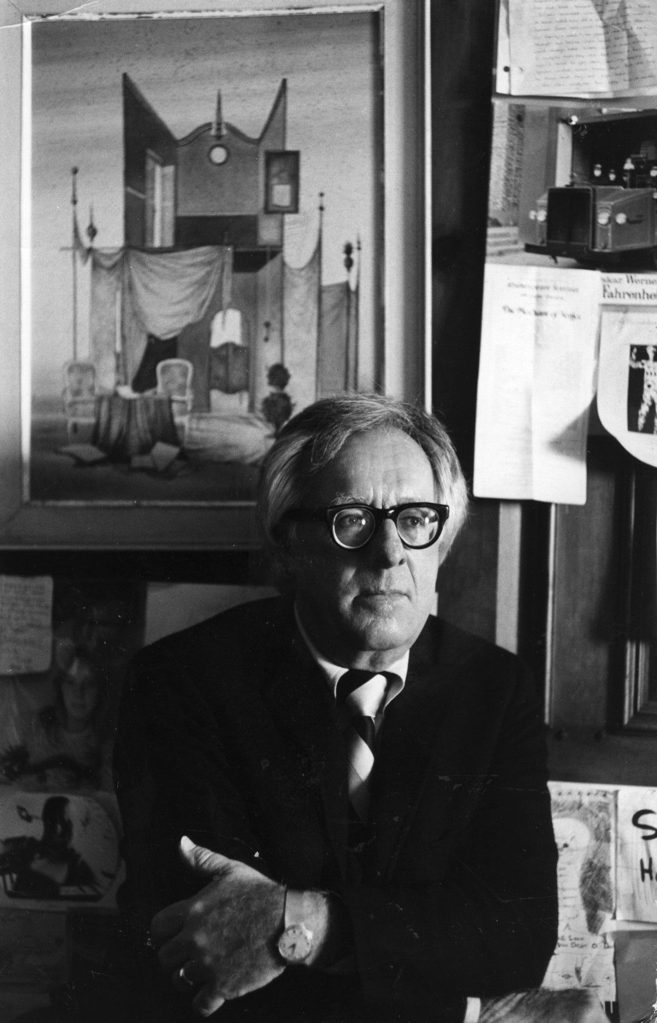

Mr. Pale, Ray Bradbury

Mr Pale

"He's a very sick man."

"Where is he?"

"Up above on Deck C. I got him to bed."

The doctor sighed. "I came on this trip for a vacation. All right, all right. Excuse me," he said to his wife. He followed the private up through the ramps of the spaceship and the ship, in the few minutes while he did this, pushed itself on in red and yellow fire across space, a thousand miles a second.

"Here we are," said the orderly.

The doctor turned in at the portway and saw the man lying on the bunk, and the man was tall and his flesh was sewed tight to his skull. The man was sick, and his lips fluted back in pain from his large, discolored teeth. His eyes were shadowed cups from which flickers of light peered, and his body was as thin as a skeleton. The color of his hands was that of snow. The doctor pulled up a magnetic chair and took the sick man's wrist.

"What seems to be the trouble?"

The sick man didn't speak for a moment, but only licked a colorless tongue over his sharp lips.

"I'm dying," he said, at last, and seemed to laugh.

"Nonsense, we'll fix you up, Mr … ?"

"Pale, to fit my complexion. Pale will do."

"Mr. Pale." This wrist was the coldest wrist he had ever touched in his life. It was like the hand of a body you pick up and tag in the hospital morgue. The pulse was gone from the cold wrist already. If it was there at all, it was so faint that the doctor's own fingertips, pulsing, covered it.

"It's bad, isn't it?" asked Mr. Pale.

The doctor said nothing but probed the bared chest of the dying man with his silver stethoscope.

There was a faint far clamor, a sigh, a musing upon distant things, heard in the stethoscope. It seemed almost to be a regretful wailing, a muted screaming of a million voices, instead of a heartbeat, a dark wind blowing in a dark space and the chest cold and the sound cold to the doctor's ears and to his own heart, which gave pause in hearing it.

"I was right, wasn't I?" said Mr. Pale.

The doctor nodded. "Perhaps you can tell me … "

"What caused it?" Mr. Pale closed his eyes smilingly over his colorlessness. "I haven't any food. I'm starving."

"We can fix that."

"No, no, you don't understand," whispered the man. "I barely made it to this rocket in time to get aboard. Oh, I was really healthy there for awhile, a few minutes ago."

The doctor turned to the orderly. "Delirious."

"No," said Mr. Pale, "no."

"What's going on here?" said a voice, and the captain stepped into the room. "Hello, who's this? I don't recall … "

"I'll save you the trouble," said Mr. Pale. "I'm not on the passenger list. I just came aboard."

"You couldn't have. We're ten million miles away from Earth."

Mr. Pale sighed. "I almost didn't make it. It took all my energy to catch you. If you'd been a little farther out … "

"A stowaway, pure and simple," said the captain. "And drunk, too, no doubt."

"A very sick man," said the doctor. "He can't be moved. I'll make a thorough examination … "

"You'll find nothing," said Mr. Pale, faintly, lying white and long and alone in the cot, "except I'm in need of food."

"We'll see about that," said the doctor, rolling up his sleeves.

An hour passed. The doctor sat back down on his magnetic chair. He was perspiring. "You're right. There's nothing wrong with you, except you're starved. How could you do this to yourself in a rich civilization like ours?"

"Oh, you'd be surprised," said the cold, thin, white man. His voice was a little breeze blowing ice through the room. "They took all my food away an hour or so ago. It was my own fault. You'll understand in a few minutes now. You see, I'm very very old. Some say a million years, some say a billion. I've lost count. I've been too busy to count."

Mad, thought the doctor, utterly mad.

Mr. Pale smiled weakly as if he had heard this thought. He shook his tired head and the dark pits of his eyes flickered. "No, no. No, no. Old, very old. And foolish. Earth was mine. I owned it. I kept it for myself.

It nurtured me, even as I nurtured it. I lived well there, for a billion years, I lived high. And now here I am, in the name of all that's darkest, dying too. I never thought I could die. I never thought I could be killed, like everyone else. And nowIknow what the fear is, what it will be like to die. After a billion years I know, and it is frightening, for what will the universe be without me?"

"Just rest easily, now, we'll fix you up."

"No, no. No, no, there's nothing you can do. I overplayed my hand. I lived as I pleased. I started wars and stopped wars. But this time I went too far, and committed suicide, yes, I did. Go to the port there and look out." Mr. Pale was trembling, the trembling moved in his fingers and his lips. "Look out. Tell me what you see."

"Earth. The planet Earth, behind us."

"Wait just a moment, then," said Mr. Pale.

The doctor waited.

"Now," said Mr. Pale, softly. "It should happen aboutnow."

A blind fire filled the sky.

The doctor cried out. "My God, my God, this is terrible!"

"What do you see?"

"Earth! It's caught fire. It's burning!"

"Yes," said Mr. Pale.

The fire crowded the universe with a dripping blue yellow flare. Earth blew itself into a thousand pieces and fell away into sparks and nothingness.

"Did you see?" said Mr. Pale.

"My God, my God." The doctor staggered and fell against the port, clawing at his heart and his face. He began to cry like a child.

"You see," said Mr. Pale, "what a fool I was. Too far. I went too far. I thought, What a feast. What a banquet. And now, and now, it's over."

The doctor slid down and sat on the floor, weeping. The ship moved in space. Down the corridors, faintly, you could hear running feet and stunned voices, and much weeping.

The sick man lay on his cot, saying nothing, shaking his head slowly back and forth, swallowing convulsively. After five minutes of trembling and weeping, the doctor gathered himself and crawled and then got to his feet and sat on the chair and looked at Mr. Pale who lay gaunt and long there, almost phosphorescent, and from the dying man came a thick smell of something very old and chilled and dead.

"Now do you see?" said Mr. Pale. "I didn't want it this way."

"Shut up."

"I wanted it to go on for another billion years, the high life, the picking and choosing. Oh, I was king."

"You're mad!"

"Everyone feared me. And nowI'mafraid. For there's no one left to die. A handful on this ship. A few thousand left on Mars. That's why I'm trying to get there, to Mars, where I can live, if I make it.

For in order for me to live, to be talked about, to have an existence, others must be alive to die, and when all the living ones are dead and no one is left to die, then Mr. Pale himself must die, and he most assuredly does not want that. For you see, life is a rare thing in the universe. Only Earth lived, and only I lived there because of the living men. But now I'm so weak, so weak. I can't move. You must help me."

"Mad, mad!"

"It's another two days to Mars," said Mr. Pale, thinking it through, his hands collapsed at his sides. "In that time you must feed me. I can't move or I would tend myself. Oh, an hour ago, I had great power, think of the power I took from so much and so many dying at once.

But the effort of reaching this ship dispersed the power, and the power is self-limiting. For now I have no reason to live, except you, and your wife, and the twenty other passengers and crew, and those few on Mars.

My incentive, you see, weakens, weakens … " His voice trailed off into a sigh. And then, after swallowing, he went on, "Have you wondered, Doctor, why the death rate on Mars in the six months since you established bases there has been nil? I can't be everywhere.

I was born on Earth on the same day as life was born. And I've waited all these years to move on out into the star system. I should have gone months ago, but I put it off, and now, I'm sorry. What a fool, what a greedy fool."

The doctor stood up, stiffening and pulling back. He clawed at the wall. "You're out of your head."

"Am I? Look out the port again at what's left of Earth."

"I won't listen to you."

"You must help me. You must decide quickly. I want the captain. He must come to me first. A transfusion, you might call it. And then the various passengers, one by one, just to keep me on the edge, to keep me alive. And then, of course, perhaps even you, or your wife. You don't want to live forever, do you? That's what would happen if you let me die."

"You're raving."

"Do you dare believe I am raving? Can you take that chance? If I die, all of you would be immortal. That's what man's always wanted, isn't it? To live forever. But I tell you, it would be insanity, one day like another, and think of the immense burden of memory! Think! Consider."

The doctor stood across the room with his back to the wall, in shadow.

Mr. Pale whispered, "Better take me up on this. Better die when you have the chance than live on for a million billion years. Believe me. Iknow.I'm almost glad to die. Almost, but not quite. Self-preservation.

Well?"

The doctor was at the door. "I don't believe you."

"Don't go," murmured Mr. Pale. "You'll regret it."

"You're lying."

"Don't let me die … " The voice was so far away now, the lips barely moved. "Please don't let me die. You need me. All life needs me to make life worthwhile, to give it value, to give it contrast. Don't … "

Mr. Pale was thinner and smaller and now the flesh seemed to melt faster. "No," he sighed. "No … " said the wind behind the hard yellowed teeth. "Please … " The deep-socketed eyes fixed themselves in a stare at the ceiling.

The doctor crashed out the door and slammed it and bolted it tight. He lay against it, weeping again, and through the ship he could see the people standing in groups staring back at the empty space where Earth had been. He heard cursing and wailing. He walked unsteadily and in great unreality for an hour through the ship's corridors until he reached the captain.

"Captain, no one is to enter that room where the dying man is. He has a plague. Incurable. Quite insane. He'll be dead within the hour. Have the room welded shut."

"What?" said the captain. "Oh, yes, yes. I'll attend to it. I will. Did you see? See Earth go?"

"I saw it."

They walked numbly away from each other. The doctor sat down beside his wife who did not recognize him for a moment until he put his arm around her.

"Don't cry," he said. "Don't cry. Please don't cry."

Her shoulders shook. He held her very tightly, his eyes clenched in on the trembling in his own body. They sat this way for several hours.

"Don't cry," he said. "Think of something else. Forget Earth. Think about Mars, think about the future."

They sat back in their seats with vacant faces. He lit a cigarette and could not taste it, and passed it to her and lit another for himself. "How would you like to be married to me for another ten million years?" he asked.

"Oh, I'd like that," she cried out, turning to him and seizing his arm in her own, fiercely wrapping it to her. "I'd like that very much!"

"Wouldyou?" he said.

1997

The end