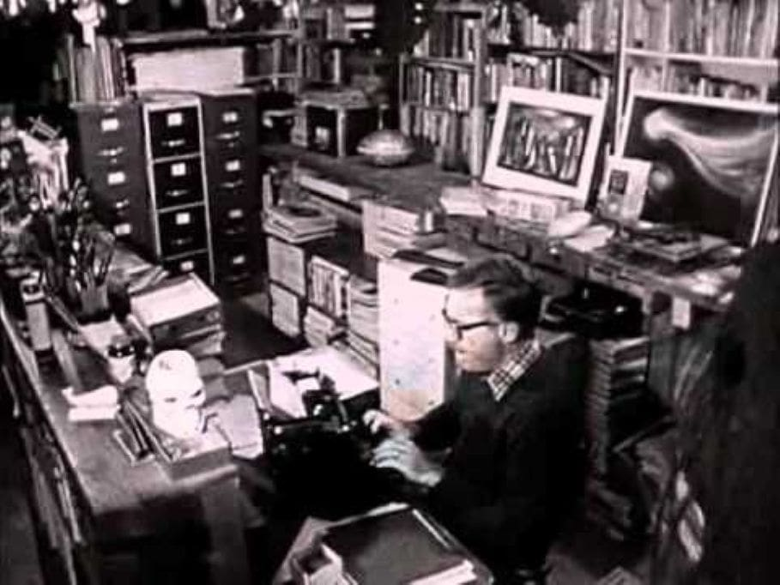

Night Meeting, Ray Bradbury

Night Meeting

IT WAS AN evening unlike any he could remember in all of his life. Very early, after the sun went down, and the air was incredibly fresh, he began to tremble, an inner, hidden trembling, of excitement, almost of waiting. He arrived at the depot amid the dispersal of buses, the routine, the pattern, the gas, acceleration, the brakes, and then he was out, in his own bus, the tremor still in him.

There were no accidents, it was a clear night, little traffic, few passengers. He drove through the ocean-quiet streets, smelling the salt air and feeling that certain thing in the wind that spelled spring no matter where you were, no matter what you were doing.

He was thirty-eight or thirty-nine, the first faint recession of hair beginning on his brow, the first quilled pricklings of silver touching his temples, the first criss-crossed leather creases starting to fold the back of his neck.

He rotated the driver’s wheel now this way, now that, automatically, and it was eleven at night, a sultry hour, warm, a spring night, and the trembling all through his body. He found himself looking and searching everything with his eyes, taking a special pleasure in the lemon ice neon signs and the green mint neon signs, glad to be out of his small apartment, glad of this night routine.

At the end of his first run he walked down to the edge of the sea for a cigarette and a nervous moment of looking at the phosphorescence in the water.

Looking at the ocean, he remembered a night long ago when someone explained the phosphorescence to him; millions upon billions of tiny animal lives were boiling there, seething, reproducing, bringing others like themselves into myriad life, and dying. And the glow of this love in spring caused the shoreline to burn green, and in places like red coals, along the beach as far north as San Francisco, they said, as far south as Acapulco, or Peru, who could say, who could tell?

With his cigarette finished he stood a moment more by the sea wall feeling the wind blow the smell of the old apartment house off his clothes. His hands, though he had washed them, still felt greasy from the deck of solitaire cards he had used most of the afternoon in his room.

He went back to his bus, started the motor and let it idle, humming to himself. The bus was empty, this run was an empty run through sleeping avenues. He talked and sang to himself, to spin out the hours, alone, passing through shadowed moon streets toward the hour when he could go home, fall into a lonely bed, sleep late, and start all over again tomorrow afternoon at four.

At the fourth stop he paused long enough to open all the windows on the empty bus and turn out all but a few lights. Then he let the night wind run like a summer river, sluicing through every lifted pane, making the bus roar like a blown sea-shell. And there was only moonlight to ride on, silver asphalt to float over on boulevards of milk and black-velvet shadow.

He almost went past the young woman at the seventeenth stop.

She was standing in the open, but he was so preoccupied with breathing and smiling to himself, that he ran the bus a good twenty yards beyond her and she had to run quietly to get on when he opened the door. He apologized, she dropped her money in the silver-sounding box and sat in the seat across from him where he could see her from the corner of his eyes, and in the overhead mirror. She sat quietly, in the dim light, her hands folded upon her lap, her knees and feet together, her head up, her hair blowing.

And he was in love with her.

It was as immensely simple as that. He fell in love with this woman, very young, sitting in the seat across from him, her face pale as a milk-flower, everything about her folded and pressed and cleanly neat. Her hair was dark and blew like smoke in the wind and she sat so calmly and complacently there, not knowing she was beautiful or very young.

She had used some light perfume early in the evening and the night had blown a good deal of it away, but some still remained faintly on the air. She looked very happy, as if some great news had come into her life tonight, her face shone, her eyes sparkled, and she rode, swaying gently, occasionally putting out her hand to hold when he slowed for a corner.

“I love her,” he thought, and was surprised. “It’s ridiculous, but I love her.”

He knew how her voice must be, very gentle and kind, and how she would be and act, anywhere, at any time. It was in her dark eyes and in the way her hands touched everything, with a careful consideration. And then the pale light in her face glowed out upon things, it did not burn in upon herself and feed upon herself. It nourished others. It illumined the bus. It reflected the world and himself.

“Do you know?” he thought to her image in the mirror. “I love you? Do you suspect?”

They rode in the summer streets, toward midnight.

AND THEN he knew. Inside each man, though he did not know it, nor ever considered it, was the image of the woman he someday must love. Whether she was composed of all the music he had ever heard or all the trees he had ever seen or all the friends of his childhood, certainly no one could tell. Whether the eyes were his mother’s, and the chin that of a girl cousin swimming in a summer lake twenty-five years ago, this was unknowable also.

But most men carried this image, like a locket, like a pearl-cameo, in their head a lifetime, taking it out only rarely, taking it out never, after marriage, afraid then to compare it to the reality. And most men never saw the woman they would love anywhere, in the dark theatre, in a book, or passing on the street.

They saw her only after midnight when the city was asleep and the pillow was cool under their heads. And she was a composite of all dreams and all women and every moonlit night since the calendar began.

“SHALL I tell you now?” he thought. “Do I dare?”

Now she had closed her eyes and leaned back to think of how this evening had been to her.

“If only you knew,” he thought, and then the panic grew in him. There were only nine more stops. Somewhere along the way she would ring the buzzer and step out into the night and be gone. Somewhere ahead he would have to cry out suddenly, or be silent,

“My name is William Becket, what’s yours? Where do you live? Can I see you again?”

Eight stops. She was shifting in her seat and watching the streets. “My name is William Becket, and I love you,” he thought.

She raised her hand to the cord.

“No,” he thought.

THE BUZZER rang. She arose as he slowed the bus toward its stop. He could come back in the morning, of course, to this stop. He could stand here and wait for her to come by, and say to her...and say to her...

His face was jerking now, a bit, up toward the mirror, down toward the avenue and the moon was very lovely in the trees. He knew he could not come here in the morning.

He stopped the bus and she was waiting at the door. Waiting for him to open it. He paused a moment and said, “I—”

She half-turned and looked at him with her beautiful face, the face that was everything he had ever thought about at night walking by the sea, in his free time.

He pressed the air-release, the door hissed open, she stepped out and was walking in the leafy moonlight.

I don’t even know her name, he thought, I never even heard her voice. He kept the door open and watched her move off down the dark street. I didn’t even see if she was married, he thought.

He closed the door and started the bus off and away, very cold now, his hands trembling on the wheel, not quite able to see where he was driving. After a moment he had to stop again and put down all the windows, there was too much draught.

Half an hour later, coming back along this same street, he was rushing his bus too fast, for the avenues were empty and there was only the moon and the empty bus behind his back, and he was hurrying, hurrying, thinking to himself, if I hurry I’ll reach the sea and if I’m lucky, it all depends, there may be some phosphorescence left, and there’ll be time for a smoke and a walk before I turn the bus around and come back empty through the empty town.

The end