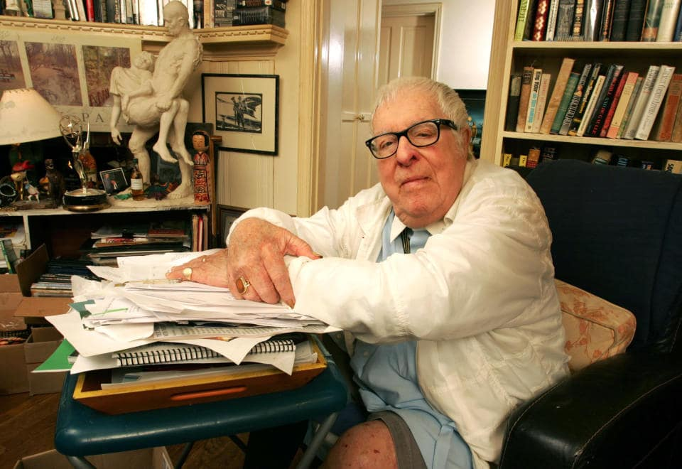

Night Train to Babylon, Ray Bradbury

Night Train to Babylon

James Cruesoe was in the club car of a train plummeting out of Chicago, rocking and swaying as if it were drunk, when the conductor, lurching by, glanced at the bar, gave Cruesoe a wink, and lurched on. Cruesoe listened.

Uproars, shouts and cries.

That is the sound, he thought, of sheep in panic, glad to be fleeced, or hang gliders, flung off cliffs with no wings.

He blinked.

For there at the bar, drawn to a blind source of joyous consternation, stood a cluster of men glad for highway robbery, pleased to have wallets and wits purloined.

That is to say: gamblers.

Amateur gamblers, Cruesoe thought, and rose to stagger down the aisle to peer over the shoulders of businessmen behaving like high school juniors in full stampede.

"Hey, watch! The Queencomes!Shegoes. Presto! Where?"

"There!" came the cry.

"Gosh," cried the dealer. "Lost my shirt! Again! Queen up, Queen gone! Where?"

He'll let them win twice, Cruesoe thought. Then spring the trap.

"There!" cried all.

"Good gravy!" shouted the unseen gambler. "I'm sunk!"

Cruesoe had to look, heyearnedto see this agile vaudeville magician.

On tiptoe, he parted a few squirming shoulders, not knowing what to expect.

But there sat a man with no fuzzy caterpillar brows or waxed mustaches. No black hair sprouted from his ears or nostrils. His skull did not poke through his skin. He wore an ordinary dove-gray suit with a dark gray tie tied with a proper knot. His fingernails were clean but unmanicured. Stunning! An ordinary citizen, with the serene look of a chap about to lose at cribbage.

Ah, yes, Cruesoe thought, as the gambler shuffled his cards slowly. That carefulness revealed the imp under the angel's mask. A calliope salesman's ghost lay like a pale epidermis below the man's vest.

"Careful, gents!" He fluttered the cards. "Don't bet too much!"

Challenged, the men shoveled cash into the furnace.

"Whoa! No bets above four bits! Judiciously, sirs!"

The cards leapfrogged as he gazed about, oblivious of his deal.

"Where's my left thumb, my right? Or are therethree thumbs?"

They laughed. What a jokester!

"Confused, chums? Baffled? Must I loseagain?"

"Yes!" all babbled.

"Damn," he said, crippling his hands. '"Damn! Where's the Red Queen? Start over!"

"No! Themiddleone!Flipit!"

The card was flipped.

"Ohmigod," someone gasped.

"Can't look." The gambler's eyes were shut. "How much did I losethistime?"

"Nothing," someone whispered.

"Nothing?" The gambler, aghast, popped open his eyes.

They all stared at a black card.

"Gosh," said the gambler. "I thought youhadme!"

His fingers spidered to the right, another black card, then to the far left. The Queen!

"Hell," he exhaled, "why's shethere? Christ, guys, keep your cash!"

"No! No!" A shaking of heads. "You won. You couldn't help it. It was just—"

"Okay. If you insist! Watch out!"

Cruesoe shut his eyes. This, he thought, is the end. From here on they'll lose and bet and lose again. Their fever's up.

"Sorry, gents. Nice try.There!"

Cruesoe felt his hands become fists. He was twelve again, a fake mustache glued to his lip and his school chums at a party and the three-card monte laid out. "Watch the Red Queenvanish!" And the kids shout and laugh as his hands blurred to win their candy but hand it back to show his love.

"One, two,three! Where can shebe?"

He felt his mouth whisper the old words, but the voice was the voice of this wizard stealing wallets, counting cash on a late-night train.

"Lost again? God, fellas, quit before your wife shoots you! Okay, Ace of spades, King of clubs, Red Queen. You won't seeheragain!"

"No!There!"

Cruesoe turned, muttering.Don't listen!Sit! Drink! Forget your twelfth birthday, your friends. Quick!

He took one step when:

"That'sthreetimes lost, pals. Imustfold my tent and … "

"No, no, don't leavenow! We got to win the damn stuff back. Deal!"

And as if struck, Cruesoe spun about and returned to the madness.

"The Queen wasalwaysthere on the left," he said.

Heads turned.

'"It was there all thetime,"Cruesoe said, louder.

"And who are you, sir?" The gambler raked in the cards, not glancing up.

"A boy magician."

"Christ, a boy magician!" The gambler riffled the deck.

The men backed off.

Cruesoe exhaled. "I know how to do the three-card monte."

"Congratulations."

"I won't cut in, I just wanted these good men—"

There was a muted rumble from the good men.

"—to knowanyonecan win at the three-card monte."

Looking away, the gambler gave the cards a toss.

"Okay, wisenheimer, deal! Gents, your bets. Our friend here takes over. Watch his hands."

Cruesoe trembled with cold. The cards lay waiting.

"Okay, son. Grab on!"

"I can'tdothe trick well, I just knowhowit'sdone."

"Ha!" The gambler stared around. "Hear that, chums? Knows how itworks,but can'tdo. Right?"

Cruesoe swallowed. "Right. But—"

"But? Does a cripple show an athlete? A dragfoot pace the sprinter? Gents, you want to change horses out here—" He glanced at the window. Lights flashed by. "—halfway to Cincinnati?"

The gents glared and muttered.

"Deal! Show us how you can steal from the poor."

Cruesoe's hands jerked back from the cards as if burnt.

"You prefer not to cheat these idiots in my presence?" the gambler asked.

Clever beast! Hearing themselves so named, the idiots roared assent.

"Can't you see what he'sdoing?" Cruesoe said.

"Yeah, yeah, we see," they babbled. "Even-steven. Lose some, win some. Why don't you go back where you came from?"

Cruesoe glanced out at a darkness rushing into the past, towns vanishing in night.

"Do you, sir," said the Straight-Arrow gambler, "in front of all these men, accuse me of raping their daughters, molesting their wives?"

"No," Cruesoe said, above the uproar. "Just cheating," he whispered, "at cards!"

Bombardments, concussions, eruptions of outrage as the gambler leaned forward.

"Show us, sir, where these cards are inked, marked, or stamped!"

"Thereareno marks, inks, or stamps," Cruesoe said. "It's all prestidigitation."

Jesus! He might as well have criedProstitution!

A dozen eyeballs rolled in their sockets.

Cruesoe fussed with the cards.

"Not marked," he said. "But your hands aren't connected to your wrists or elbows and finally all of it's not connected to … "

"Towhat,sir?"

"Your heart," Cruesoe said, dismally.

The gambler smirked. "This, sir, is not a romantic excursion to Niagara Falls."

"Yah!" came the shout.

A great wall of faces confronted him.

"I," Cruesoe said, "am very tired."

He felt himself turn and stagger off, drunk with the sway of the train, left, right, left, right. The conductor saw him coming and punched a drift of confetti out of an already punched ticket.

"Sir," Cruesoe said.

The conductor examined the night fleeing by the window.

"Sir," Cruesoe said. "Lookthere."

The conductor reluctantly fastened his gaze on the mob at the bar, shouting as the cardsharp raised their hopes but to dash them again.

"Sounds like a good time," the conductor said.

"No, sir! Those men are being cheated, fleeced, buggy-whipped—"

"Wait," said the conductor. "Are they disturbing the peace? Looks more like a birthday party."

Cruesoe shot his gaze down the corridor.

A herd of buffalo humped there, angry at the Fates, eager to be shorn.

"Well?" said the conductor.

"I want that man thrown off the train! Don't you see what he's up to? That trick's in every dime-store magic book!"

The conductor leaned in to smell Cruesoe's breath.

"Do youknowthat gambler, sir? Any of his pals your friends?"

"No, I—" Cruesoe gasped and stopped. "My God, I just realized." He stared at the conductor's bland face.

"You," he said, but could not go on. You are in cohoots, he thought. You share the moola at the end of the line!

"Holdon," said the conductor. He took out a little black book, licked his fingers, turned pages. "Uh-huh," he said. "Lookit all the biblical/Egyptian names.Memphis,Tennessee.Cairo,Illinois? Yep! And here's one just ahead. Babylon."

"Where you throw that cheatoff?"

"No. Someoneelse."

"You wouldn't do that," Cruesoe said.

"No?" said the conductor.

Cruesoe turned and lurched away. "Damn idiot stupid fool," he muttered. "Keep your smart-ass mouthshut!"

"Ready, gentlemen," the insidious cardsharp was shouting. "Annie over.Flea-hop! Oh,no! The bad-news boy isback!"

Jeez, hell, damn, was the general response. "Who do you think you are?" Cruesoe blurted.

"Glad you asked." The gambler settled back, leaving the cards to be stared at by the wolf pack. "Can you guess where I'm going tomorrow?"

"South America," Cruesoe said, "to back a tin-pot dictator."

"Not bad." The sharpster nodded. "Go on."

"Or you are on your way to a small European state where some nut keeps a witch doctor to suck the economy into a Swiss bank."

"The boy's a poet! I have a letter here, from Castro."

His gambler's hand touched his heart. "And one from Bothelesa, another from Mandela in South Africa. Which do I choose? Well." The gambler glanced at the rushing storm outside the window. "Choose any pocket, right, left, inside, out." He touched his coat.

"Right," Cruesoe said.

The man shoved his hand in his right coat pocket, pulled out a fresh pack of cards, gave it a toss.

"Open it. That's it. Now riffle and spread.Seeanything?"

"Well … "

"Gimme." He took it. "The next monte will be from the deckyouchoose."

Cruesoe shook his head. "That's not how the trick works. It's how youlay downandpick upthe cards.Anydeck would do."

"Pick!"

Cruesoe picked two tens and a red Queen.

"Okay!" The gambler humped the cards over each other. "Where's the Queen?"

"Middle."

He flipped it over. "Hey, you're good." He smiled.

"You're better. That's the trouble," Cruesoe said.

"Now, see this pile of ten-dollar bills? That's the stake, just put by these gents. You've stopped the game too long. Do you join or be the skeleton at the feast?"

"Skeleton."

"Okay. They're off! There she goes. Queen here, Queen there. Lost!Where? You ready to risk all your cash, fellows? Want to pullout?Allof a singlemind?"

Fierce whispers.

"All," someone said.

"No!" Cruesoe said.

A dozen curses lit the air.

"Smart-ass," said the cardsharp, his voice deadly calm, "do you realize that your static may cause these gentlemen to loseeverything?"

"No," Cruesoe said. "It's not my static.Yourhands deal the cards."

Such jeers. Such hoots. "Move! My God, move!"

"Well." With the three cards still under his clean fingers the gambler stared at the rushing storm beyond the window. "You've ruined it. Because of you, their choice is doomed. You and only you have intruded to burst the ambience, the aura, the bubble that enclosed this game. When I turn the card over my friends may hurl you off the train."

"They wouldn't do that," Cruesoe said.

The card was turned over.

With a roar the train pulled away in a downpour of rain and lightning and thunder. Just before the car door slammed, the gambler thrust a fistful of cards out on the sulfurous air and tossed. They took flight: an aviary of bleeding pigeons, to pelt Cruesoe's chest and face.

The club car rattle-banged by, a dozen volcanic faces with fiery eyes crushed close to the windows, fists hammering the glass.

His suitcase stopped tumbling.

The train was gone.

He waited a long while and then slowly bent and began to pick up fifty-two cards. One by one. One by one.

A Queen of hearts. Another Queen. Another Queen of hearts. And one more.

A Queen ...

Queen.

Lightning struck. If it had hit him, he would never have known.

1997

The end