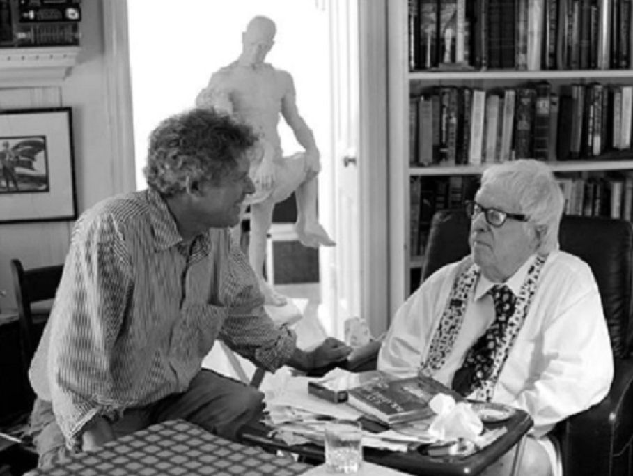

Nothing Changes, Ray Bradbury

Nothing Changes

There is this truly wonderful bookstore by the ocean where you can hear the tide under the pier, shaking the shop, the books on the shelves, and you.

The shop is dark and has a tin roof above the ten thousand books from which you blow dust in order to turn pages.

And it is not just the tide below but the tide above that I love when storm rains shatter that tin roof, banging it like orchestras of machine-gun-cymbal-and-drum. Whenever it is a dark midnight at noon, if not in my soul, like Ishmael, I head for the storm beneath and the storm above, tambourining the tin and knocking silverfish off forgotten authors, row on row. With my smile for a flashlight, I linger all day.

Pure hyperventilation in storms, I arrived one noon at White Whale Books, where I walked, slowly, to the entrance. My anxious taxi driver pursued with his umbrella. I held him off. "Please," I said. "Iwantto get wet!"

"Nut!" cried the cabbie and left.

Gloriously damp, I ducked inside, shook myself like a dog, and froze, eyes shut, hearing the rain bang that high tin roof.

"Which way?" I said to the darkness.

Intuition said left.

I turned and found, in the tintinnabulation of downpour (what a great word: tintinnabulation!) stacks of shelves of old high school annuals which I usually avoid like funerals.

For bookshops are, by their nature, graveyards where old elephants drop their bones.

Uneasily, then, I prowled the high school yearbooks to read the spines: Burlington, Vermont, Orange, New Jersey, Roswell, New Mexico, big sandwiches of memorabilia from fifty states. I did not touch my own godforsaken yearbook, which lay buried with its scribbled time-capsule insults from the Great Depression: "Get lost, sappo. Jim." "Have a great life, you should live so long. Sam." "To a fine writer, lousy lover. Fay."

I blew the dust off Remington High, Pennsylvania, to thumb through scores of baseball, basketball, football braves no longer brave.

1912.

I scanned ten dozen bright faces.

You, you, and you, I thought. Was your life good? Did you marry well? Did your kids like you? Was there a great first love and another later? How, how did itgo?

Too many flowers here from too many biers. All those eager eyes staring above their wondrous smiles.

I almost shut the book but ...

My finger stayed on the pictures of the 1912 graduating class, with World War I not yet, unimagined and unknown, when I blinked at one snapshot and gasped:

"My God! Charles! Old CharlieNesbitt!"

Yes! Framed there in a far year, with his freckles, roostercomb hair, big ears, flared nostrils, and corncob teeth. Charles Woodley Nesbitt!

"Charlie!" I cried.

The rain buckshot the tin roof above. The cold blew down my neck.

"Charlie," I whispered. "What're you doinghere?"

I carried the book out to a better light, heart thumping, and stared.

The name under the picture was Reynolds. Winton Reynolds.

Destined for Harvard.

Wants to make a million.

Likes golf.

But thepicture?

"Charlie,dammit!"

Charlie Nesbitt was god-awful homely, a tennis pro, top gymnast, speed swimmer, girl collector. How come? Did those ears, teeth, and nostrils make girls swarm? Tobelike him, we would have signed up for lessons.

And now here he was on a wrong page of an old book in a lost year with his berserk smile and crazed ears.

Could there once have beentwoCharlie Nesbitts alive? Identical twins, separated at birth? Hell. My Charlie was born in 1920, same as me. Wait!

I dodged back in the stacks to grab my 1938 yearbook and riffle the graduate photos until I found:

Wants to be a golf pro.

Heads for Princeton.

Hopes to be rich.

Charles Woodley Nesbitt.

The same goofy teeth, ears, and multitudinous freckles!

I placed the two annuals to study these seeming "twins."

Seemed? No! Absolutely the same!

Rain drummed the high tin roof.

"Hell, Charlie, hell, Winton!"

I carried the books up front where Mr. Lemley, as old as his books, peered at me over his Ben Franklin specs.

"Foundthose,did you? Take 'em. Free."

"Mr. Lemley, look … "

I showed him the pictures and the names.

"I'll be damned." He snorted. "Same family? Brothers? Naw. Same fella, though. How'd you find this?"

"Just did."

"Give me the collywobbles. Coincidence. One in a million births, right?"

"Yeah." I turned the pages back and forth, over and over. "But what if all the faces inallthe annuals in all the towns in all the states, hell, what if theyall lookalike!

"What'd I justsay?" I cried, hearing myself.

What ifallthe faces in all the annuals were thesame!

"Outta the way!" I shouted.

Tearing up the cabbage patch is how Mr. Lemley told it later. If the God of Vengeance and Terror was Shiva with many arms, I was a small but louder god, with a dozen hands seizing books, cursing at revelations, frights, and elations, alone, as witness to a big parade marching nowhere, with separate bands and different choirs in towns strewn across a blind world. From time to time as I leaped through the stacks, Mr. Lemley brought coffee and whispered: "Rest up."

"You don't understand!" I cried.

"No, I don't. Howoldare you?"

"Forty-nine!"

"Act like a nine-year-old running up the aisle at a bad movie, peeing."

"Good advice!" I ran and came back.

Mr. Lemley checked the linoleum for wet spots. "Continue."

I seized more annuals:

"Ella, there's Ellaagain.Tom, there's Tom who looks like Joe, and Frank, a dead ringer for Ralph. Ringer, hell, spittin'image! And Helen who's a twin to Cora!

And Ed and Phil and Morris to fit Roger and Alan and Pat. Christ!"

I had two dozen books butterflied, some torn in my haste. "I'll pay, Mr. Lemley, I'llpay!"

In the mist of the storm-fever I stopped on page 47 of the Cheyenne 1911Book of High School Remembrances.

For there was the sap, the simpleton, the ignoramus, the shy wimp, the lost soul.

His name, in that lost year?

Douglas Driscoll.

His message to the future?

Admired as a thespian.

Will soon join the unemployed.

Headed for literary distinction.

Poor fool, lost dreamer, final achiever.

Douglas Driscoll, Cheyenne, 1911.

Me.

My eyes streaming tears, I bumped my way out of the twilight stacks to show my melancholy gift to Mr. Lemley.

"Gosh." He touched the picture. "Thatcan'tbe someone named Driscoll.

"That's got to be," he said, "you."

"Yes, sir."

"Damn," he said, softly. "Youknowthis boy?"

"No."

"Got any relatives in … Wyoming?"

"No, sir."

"How'd you come on this?"

"Wild hunch."

"Yeah, you really tore up the tundra." He studied my identical twin, half a century ago. "What will you do? Look this fellaup?"

"If graveyards count for looking."

"Itisa long time back. How about his kids, orgrandkids?"

"What would I tell them? They wouldn't necessarily look like him anyway."

"Hell," said Mr. Lemley. "If one kid looks like you, 1911, why not someoneclose.Twenty years ago, or, hot damn,thisyear?"

"Repeat that!" I cried.

"Thisyear?"

"Yougotsome?Thisyear's yearbooks?"

"God, I dunno. Hey, why are youdoingthis?"

"You ever feel," I shouted, "you're on the verge of a bombshell annihilating discovery?"

"Swimming once I found a big chunk of something awful. Ambergris! I thought. Sell it to a perfume factory for thousands! I ran to show the damned stuff to the lifeguard. Ambergris? Horseflies! I flung it back in the sea.Thatkind of annihilating discovery?"

"Maybe. Genealogies. Genetics."

"From what year?"

"Lincoln," I said. "Washington, Henry the Eighth. God, I feel as if I found all Creation, some obvious truth that's been sitting right in front of us forever and we didn't see. This could change history!"

"Or spoil it," said Mr. Lemley. "You sure you ain't been drinking back there in the stacks? Don't stand there. Go!"

"One side or a leg-off," I said.

I read and tossed, tossed and read, but there were no really new annuals. Phone calls and airmail was the answer.

"Jeez Christopher," observed Mr. Lemley. "Can you afford todothat?"

"I'll die if I don't."

"And die if you do. Closing time. Lights out."

The annuals streamed in during the week before graduations all across the country.

I stayed up two nights, sleepless, riffling, Xeroxing pages, tallying lists, twinning pasteups of ten dozen new faces against ten dozen old.

Christ, I thought, you damn stupid blind idiot on a runaway train. How do you steer? Where the hell is it going? And, oh God,why?

I had no answers. Gone mad, I mailed and phoned, sent and got back, like a blind man in a closet sorting clothes, trying inanities, discarding reason.

The mail was an avalanche.

It could not be, and yet it was. All biological rules? Out the window. The history of flesh was what? Darwinian "Sport." Genetic accidents that birthed new species. Derailed genes which spun the world afresh. But what if there were freak/sport replays? What if Nature hiccuped, and its needle jumpedback? Then, having lost its genetic mind, wouldn't it clone generation after generation of Williamses, Browns, and Smiths? Not related by family, no. But mindless rebirths, blind matter trapped in a mirror maze? Impossible.

Yet there it was. Dozens of faces repeated in hundreds of faces across the world! Twin upon twin,in excelsis.And where did that leave room for new flesh, a history of progress and survival?

Shut up, I thought, and drink your gin.

The cascade of high school annuals continued.

I flipped their pages like decks of cards until, at last ...

There it was.

Its arrival blew a hole in my stomach.

There was a name on page 124 of the Roswell High annual, published this week and just arrived. The name was:

William Clark Henderson.

I stared at his picture and saw:

Me.

Alive and graduating this week!

The other me.

An exact replica of every eyelash, eyebrow, small pore and large, ear fuzz and nostril hair.

Me. Myself. I.

No! I thought. I looked again.Yes!

I jumped. I ran.

Lugging a folder of pictures, I flew to Roswell and, sweating, grabbed a cab to reach Roswell High at twelve noon straight up.

The graduation procession had begun. I panicked. But then as the young men and women passed an immense calmness touched me. Destiny and Providence whispered as my gaze wandered over two hundred young faces in line and at some late-arriving wild smiles, manic with joy now that the long haul was over.

And still the young moved on their way to good or unborn wars, bad marriages, fine or awful employments.

And therehewas. William Clark Henderson.

The other me.

As he walked, laughing, with a pretty dark-haired girl, I traced my own profile in my high school annual long ago. I saw the soft line under his chin, the unshaven cheeks, the unfocused half-blind eyes that would never understand life but hide out in libraries, duck behind typewriters.

As he passed, he glanced up and froze.

I almost waved, but stopped for he could not make himself move.

He staggered as if struck in the chest. His face grew pale as he groped toward me and gasped.

"Dad! What're you doinghere?"

I felt my heart stop.

"Youcan'tbe here!" the young man cried, tears brimming his eyes. "You'redead! Died two years ago! Can't be. What? How?"

"No." I said at last. "I'm not … "

"Dad!" He seized my arms. "Oh, God! God!"

"Don't!" I said. "Not me!"

"Thenwho?" he pleaded and crushed his head against my chest. "What's goingon? Christ!"

"Please." I broke his grip. "They'rewaiting!"

He fell back. "I don't understand," he said, the tears flowing.

"Idon't understand," I said.

He lurched forward. I raised my hand swiftly. "No. Don't."

"Will you," he mourned, "be here … after?"

"Yes," I said, agonized. "No. I don'tknow."

"At leastwatch," he said.

I was silent.

"Please," he said.

At last I nodded and saw color in his face.

"What's goingon?" he asked again, bewildered.

They say that drowning victims' lives flash through their heads. Here, with William Clark Henderson frozen in the processional, my thoughts, sunk in revelations, sought answers, found none.

Were there families worldwide with similar thoughts, plans, dreams locked in mirror-image flesh? Was there a genetic plot to seize the future? Would a day dawn when these unseen, unrecognized fathers, brothers, nephews, cousins rose as rulers? Or was this just God's ghost and spirit, his Providence, his unfathomable Will? Were we all identical seeds hurled forth in wide broadcasts so as not to collide?

Were we then in some broad and incalculable fashion, brother to wolves, birds, and antelope, all inked, spotted, colored the same, year on year and generation on generation back as far as minds could see? To what purpose? To economize on genes and chromosomes? Why?

Would the faces of this Family, grown apart, vanish by 2001? Or would the replicas increase to envelop all cousined flesh? Or was it just a miracle of mere existence, misunderstood by two stunned fools shouting across blind generations on a summer's graduation day?

All this, all this exploded light dark, light dark across my gaze.

"What's going on?" the other me repeated.

For the line of young men and women was almost gone, quitting a scene where two idiots raved with two similar voices.

I said something, quietly, which he could not hear. When this is done, I thought, I must tear up the pictures, burn the notes. To continue this way, with old annuals, lost faces:madness! Trash it all, I thought.Now.

The young man's mouth trembled. I read his lips.

"Whatdid you just say?" he asked.

"Nothing changes," I whispered.

Then, louder:

"Nothing changes!"

I waited to hear Kipling's words to that song of great sadness: "Lord God of old, be with us yet. Lest we forget."

Lest we forget.

When I saw the diploma go into the hands of William Clark Henderson—

I backed off, weeping, and ran.

1997

The end