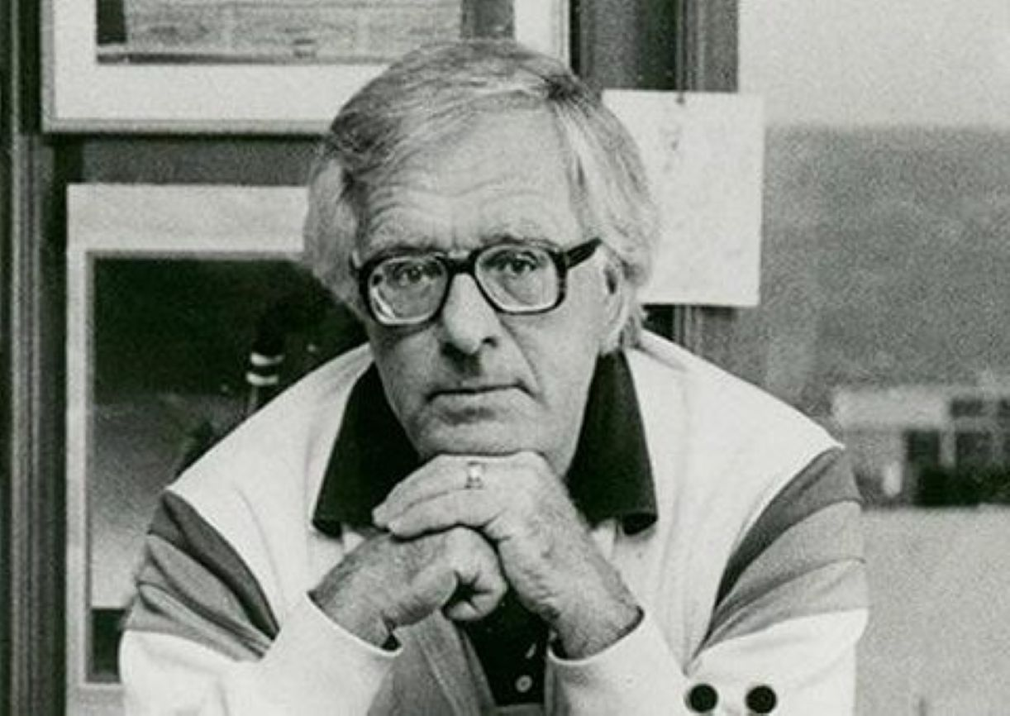

One More for the Road (short story) Ray Bradbury

One More for the Road (short story)

My secretary stuck her head in my office and talked over my barricade of letters and books.

“You in there?” she called.

“You know I am, and overworked,” I said. “What?”

“There’s a maniac out here needs publishing and claims he has written or will write the World’s Longest Novel.”

“I thought Thomas Wolfe was dead,” I said.

“This chap is carrying four shopping bags of what looks like kindling,” Elsa said, “but there’s letters and words on each chunk. ‘It was a dark and stormy night,’ one said. ‘People were dead everywhere,’ said another.”

That did it. I rose behind my fortress of literature and marched to the door to peer out at the maniac. He sat across the reception area with several white bags containing lumps. I could see words in both.

“Bring him in,” I heard myself say.

“You don’t really—”

“I do,” I said, wide awake. “Talk about Narrative Hooks!”

“Hooks?”

“The way you start a novel that’s so wild your reader is hooked and plunges in. Go, Elsa.”

Elsa went.

She brought the little man in, for he was a little less than five feet tall, earnestly dragging his white bags full of words. When he had placed two, he hurried out to fetch two more. Then he sat quietly amongst his collection as Elsa, rolling her eyeballs, shut the door.

“Well, Mr....?” I said.

“G. F. Follette, author of what some call Follette’s Folly. Here is my amazing novel!”

He stirred the bags with his shoe.

“I’m intrigued, Mr. Folly,” I said.

He ignored my slip and smiled down at his creations.

“Thanks. Most editors are busy or run off. Sir, I’m here because …” He paused to scan me head to foot. “I see you’re my age and might recall that grand time, in the thirties, when tourists crossed the United States by car …” He paused to let me remember. I did. I nodded.

“This.” He touched his bags full of words. “Is an old idea whose time has returned. Remember those trips, Route 66, heading west with your parents? On the way, how did you entertain yourself and bug the hell out of your folks?”

“Bug? Hell!” My mind whirled its Rolodex to three wins in a row.

“Burma Shave!” I cried, and calmed down. Editors must not enthuse; it jacks up the price. “Burma Shave,” I murmured.

“Bull Durham Bull’s-eye!” said Folly. “Though you didn’t shave: Burma! America’s highways were studded with B.S. signs, some called them, so you could chant couplets between Paducah and Potawatomi, Tonopah and Tombstone, Gila Gulch and Grass—”

“Yes, yes,” I said, impatiently.

“Looking for a perfect shave,

Buy our product, then you’ll rave,

Yesterday you were a slave,

Free yourself with Burma Shave.”

“I remember,” I cried, beaming.

“Of course you do!” said Folly.

I then recited:

“Bearded brute, jump from your cave.

Freshen up with Burma Shave!”

“What a memory!” Folly praised.

I stared at his mystery bags. “But what has that got to do with—”

“Glad you asked.” He spilled two bags. Adjectives, nouns, and verbs scattered as he intoned: “Burma Shave, 1999. Dickens, 2000. Shakespeare, 2001.”

“All of those?” I gasped. “On those small wooden signs?”

“No, not dead authors. Live ones. Me!”

He knelt and slid the phrases across the carpet.

“How would you like to publish the first and longest cross-country novel, spanning counties, circling small towns, skirting big cities, finishing in Seattle, where you never wanted to go but you had to find out how the Novel of the Century ended? And here it is! What say?”

I leaned to read the phrases that ran by my desk, ended at the wall.

“My secretary mentioned ‘A Dark and Stormy Night—’?”

“Oh, that was a come-on.” Folly laughed. “Narrative Hook! You know Narrative Hooks?”

I bit my tongue.

“This,” he said, “is the wild true start of my magnum opus.”

I read: “The world was coming to an end …” on the first plinth. The second read: “Alec Jones had six hours in which to save Earth!”

“Those are the eye-opener words of your vast best-seller?” I said.

“Can you do better?” he said.

“Well …”

“Wait!” he interrupted. “It gets wilder. Get ready to cut a deal.”

He arranged more long kindling sticks until there were some sixty words underfoot, barring the door.

“You may well ask,” he said, “why has this book’s time come? When the Burma Shave verse was yanked like teeth from America’s roads it left a vacuum, right?”

“We missed them, yes.”

“Cross-country today there’s little to see, cars go fast, billboards are verboten, so how to cope? Something small, low-profile on the soft shoulder, mainly side roads, from Maine to Missoula, Des Plaines to Denver. Plant these mini-metaphors to take root in the American psyche.

Provoke TV chat news bites. Tourists, crazy, start reading in Kankakee, Kenosha, and Kansas. Find the finales in Sauk Center and Seattle. Then, sir, by God, we publish the whole bounteous batch in one Book-of-the-Month, leather-bound, to reap the travel tour storm winds. Think!”

“I’m overwhelmed, Folly!”

“As you should be. Quick, now! I must race to the next publisher, unless you sign and nail these revolutionary placards to promote literacy in the dumbest continental backwaters!”

“You think teachers will—”

“Devour them for breakfast, lunch, dinner! Menu them on computers. We skirt library lawns interstate advertising those drop-ins as intellectual water holes. Professors will beg to hammer my stakes near English I. Ad agencies will bribe entry to our far-traveling lingo, but no! My novel will race on, tossing characters and mad excursions right and left. Its time has come, sir. The old renewed. The untried tried again. So long!”

And he was on his feet, cudgeling his nouns and verbs, when I cried: “Wait!” I stared at the ample phrases. “These phrases are for starters, but … how does it end?”

“Fabulously! Once launched on the great road run, folks won’t be able to stop. Crackerjack, pure crackerjack. Fritos; I dare you to eat just one!”

“How do I know—?”

“In God we trust, sir, and his man Folly’s intuitive precognition. I’ll weigh plot lines, hour by hour, day by day, from Schenectady to Saskatchewan. Even as I drive stakes and paint letters my secret self will dot the is, cross the ts. I will know fevers like yours, eager to find what in hell waits beyond the 66 horizon, up early, down late, a tipped beehive of words sizzling in my wake. So?”

He snatched a dozen sticks and scanned them with relish.

“Hot diggety,” he cried.

“That does it. Elsa!” I called.

“Sir?” Her head thrust in to scan the littered floor.

“God help me,” I gasped. “Bring contracts. For books, I think, yes, books!”

And while she was bringing and Folly was signing I tugged his sleeve:

“Why me? Why here?”

“Sir,” said Folly, “you have the mien of a librarian book-selling English major spelling-bee champ, lugged ten books from the adult stacks when you were twelve, came next noon for ten more!”

“How did you guess?”

“If I knew otherwise I wouldn’t be making you grammarian editor of my movable feast! Now, how do we finance this Tolstoy-enhanced journey?”

“I don’t doubt—”

“You must. We nudge lumberyards to donate plaques and stakes, gratis. Publicity! Lasso librarians for photo ops wielding mallets, or painting text. Boy Scouts eager to plant and pound. Expenses? Zilch to zero.”

“Brilliant!”

“Yes? Grab your boxer shorts. Along the King’s Highway, as ’twere, we flag blue-haired ladies’ wedding, birth, and death card shops, hideouts for budding critics ripe to ride this Vesuvial eruption.”

“Bingo!”

“Win every time! En route, traps laid by universities to bar our way.”

“Why?”

“Hotbeds of unpublished authors, unfinished novels asleep in their desks, will leap out to advise punctuation, characterization, lively plot lines, dying falls.”

“And …?”

“Outskirts to inskirts, Philadelphia, Frisco, L.A. Antique car parades to plow us through the ’burbs. Classic cars flagging our rear. Governors at state lines, popping corks.”

“Genius!”

“The squeal of my pig is not lost, sir. More details? you say. It will take some twenty thousand tent pegs flourishing twenty thousand demi-haiku fortune-cookie shingles, one every hundred yards on fast roads, every fifty yards on slow. There’s your nutshell. Here’s your contract. Here’s mine. Now, ready cash?”

“Take this!”

“A bundle of U.S. Grants? Lincoln’s pal! I’m off to the lumberyard paint shop. Premiere stake-driving-celebrity-mix tomorrow noon, old 66. You hammer the first peg!”

“I don’t deserve—”

“Be there!”

And like a dust devil vacuuming the rug, he was gone, whistling to my ready cash, his kindling words ajolt in the hall.

Elsa stared. “What made you do that?” she cried.

“Teenage madness.” I touched my ribs, elbows, and face. “There was a moment there when I felt thirteen, twelve, ten, the road whizzing by, the B.S. epithets in flight, me chanting, my brother echoing, my dad mad to drive off cliffs, and all of a sudden the land empty, the B.S. signs gone, when the state law dentists yanked and chopped words, and nothing to quote from Tularemia to Taos. When we pit-stopped full of soda pop, I watered Burma, my brother watered Shave.”

“Nuts!” said Elsa.

“Yeah.” I heard the echoes of the bags full of verbs fade. “But I can hardly wait, can you?” I whispered. “For that dark and stormy night?”

“If you say so,” said Elsa.

Not with a bang but a whimper, as the saying goes. What exploded as a Cecil B. DeMille rocket fizzled like a damp July Fourth squib.

I, of course, launched Folly’s wild road-race epic, On Our Way to Everywhere. I banged the first stake to fire off the longest novel since Appomattox. Subsequent chapters would be revealed via Council Bluffs and Gila Bend! Suspense promised! Sequels at a boil. Exclamation point.

First, no one cared. Soon: everyone!

Mobs of Folly travelers tidal-waved him cross-country, chanting phrases, reenacting scenes ere his dust settled. Letters poured in to get some characters shot, others promoted.

A Chicago Times critic chatted up a Folly interview, killed by his editor, an historian of Yeats and Pope. Route 66 regained its old prominence. Air travel fell. Bus travel soared. Gas stations mushroomed.

Motels upped rates. Motor homes jam packed with greeting-card-ravenous readers snaked from Omaha to Oogalooga. There were Cliffs Notes digests of this brakeless ride from hell to high water.

And then, oblivion! Half out of Donner Pass, half into Death Valley, the literary freshet died.

The waterfall ran alkali dust.

The landscape was littered with white kindlings of nouns, verbs, and adjectives.

I was ready to ticket a plane or jump-start a road van when my office door banged wide. There stood Folly, truly defoliated, face pale, teeth clenched, two huge shopping bags in his downslung arms.

“Folly!” I cried.

“You can say that again,” he replied.

“Come in, come in. My God, what’s wrong?”

“You name it.”

“Is that your sequel?”

“Residue,” he murmured and spilled the bags wide.

Sawdust littered the floor. Thirty pounds of finely granulated sawdust.

“Tried, but couldn’t finish,” he said.

“Inspiration pooped out? Mind block?”

“Roadblock,” he said.

He dumped what was left of one sack in a pile of shavings and pollen on my desk. I saw a flaked g, t, or h and one large the in the dust. The burden of this light stuff sank in my chair.

“Roadblock?” I bleated.

“I never figured folks might not want my bright wildflowers along the road,” Folly mourned. “I had to skip acres of farms, sometimes entire counties. Sheriffs said: Move it! Ladies’ social clubs claimed my opus was ipso facto flagrant delicti. Sex with tea! One hump or two! they yelled. Weed-pulling censors yanked my stakes, stole my stuff, as did plagiarists!”

“Plagiarists!?”

“Plot thieves, novel snatchers! Five-mile episodes vanished in Tulsa one night, showed next noon, Tallahassee to charm the alligators. Tallahassee sheriff pulled the snatch, now’s a nova, Oprah celeb! How do I prove he stole my stuff!? Tried to snatch back my pick-up-sticks, but some book-burning tea party shot my tires. I told them to shove my shingles, hoping for slivers!”

He stopped, breathless.

“Roadkill,” he whispered.

“Roadkill?” I cried.

“To top everything, Internet roadkill. Fast as I gardened my dears, Internet harvested and rebroadcast, galloping ahead, they the Roadrunner, I the Coyote trying to cut the electronic smog.

Their fireworks blazed night and noon, firing my words on a billion screens, wiping clean, firing more, like Kasparov playing Big Blue. ‘Computer Wins Chess Match!’ they cried. Hell, with two dozen high-IQ minds stuffed in the IBM circuits?

A wasps’ nest of genius against a hopeless Russian. Same for me. This little bitty Hemingway dropout against the Internet storm. That’s when I pulled up stakes and vamoosed.

“Well, that’s it,” said Folly. “Maybe you can rustle someone to finish the finale, kill the worst, bury the best. I failed. What can I say?”

“I hope you find a new job,” I offered.

“As an adjunct carpenter running a sawmill? Good for Jesus, bad for me. I’ll mail you some monthly checks, pay back the loan.”

“What’ll I do with this?” I said, my nose tickled by the fine wood pollen in the air.

“Stuff a pillow, start an ant farm.”

“It was a fine long exciting terrific novel,” I said.

“Yeah. I wonder how it would have ended.”

“If you wake some night with the answer, call.”

“Don’t wait. So long.”

And leaving the twin bags of granulated opus magnum, he left.

Elsa peered in. “What will you do with all that?” she said.

I sneezed once, twice, three times.

The desktop lay empty. Sawdust bloomed.

Elsa stared at the airborne opus.

“Gone With the Wind?” she said.

“No. Could be: Jack Kerouac On the Road.”

I blew my nose.

“Fetch the broom.”

The end