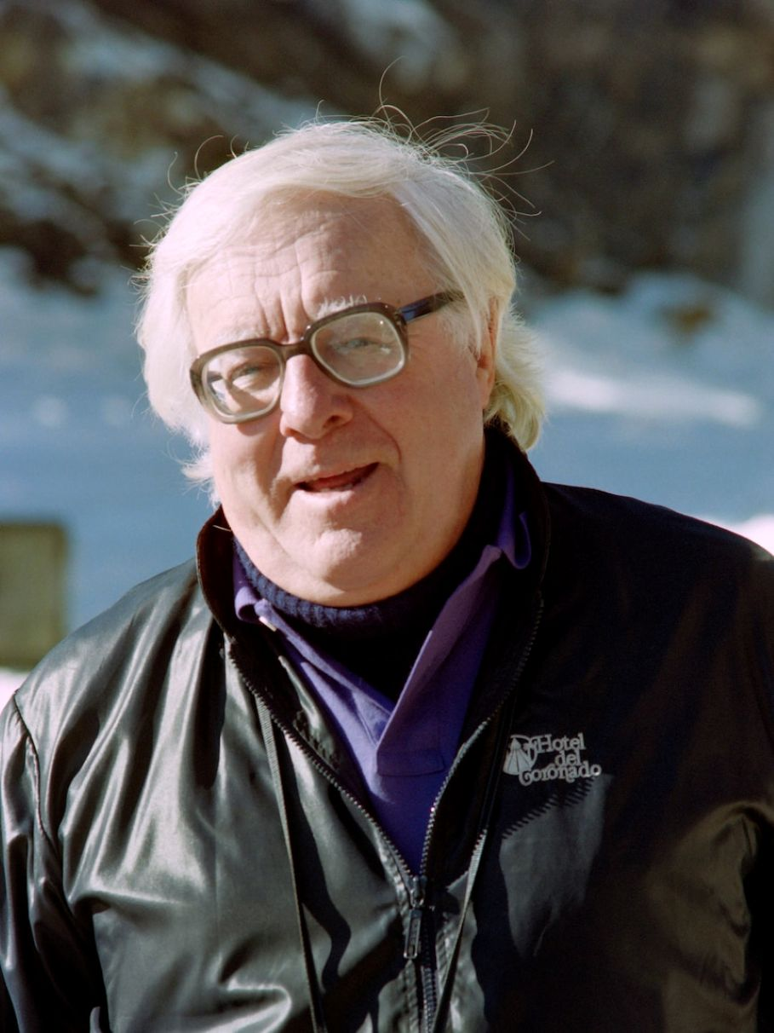

Powerhouse, Ray Bradbury

Powerhouse

The horses moved gently to a stop, and the man and his wife gazed down into a dry, sandy valley. The woman sat lost in her saddle; she hadn’t spoken for hours, didn’t know a good word to speak.

She was trapped somewhere between the hot, dark pressure of the storm-clouded Arizona sky and the hard, granite pressure of the wind-blasted mountains. A few drops of cool rain fell on her trembling hands.

She looked over at her husband wearily. He sat his dusty horse easily, with a firm quietness. She closed her eyes and thought of how she had been all of these mild years until today.

She wanted to laugh at the mirror she was holding up to herself, but there was no way of doing even that; it would be somewhat insane.

After all, it might just be the pushing of this dark weather, or the telegram they had taken from the messenger on horseback this morning, or the long journey now to town.

There was still an empty world to cross, and she was cold.

‘I’m the lady who was never going to need religion,’ she said quietly, her eyes shut.

‘What?’ Berty, her husband, glanced over at her.

‘Nothing,’ she whispered, shaking her head. In all the years, how certain she had been. Never, never would she have need of a church. She had heard fine people talk on and on of religion and waxed pews and calla lilies in great bronze buckets and vast bells of churches in which the preacher rang like a clapper.

She had heard the shouting kind and the fervent, whispery kind, and they were all the same. Hers was simply not a pew-shaped spine.

‘I just never had a reason ever to sit in a church,’ she had told people. She wasn’t vehement about it. She just walked around and lived and moved her hands that were pebble-smooth and pebble-small.

Work had polished the nails of those hands with a polish you could never buy in a bottle. The touching of children had made them soft, and the raising of children had made them temperately stern, and the loving of a husband had made them gentle.

And now, death made them tremble.

‘Here,’ said her husband. And the horses dusted down the trail to where an odd brick building stood beside a dry wash. The building was all glazed green windows, blue machinery, red tile, and wires.

The wires ran off on high-tension towers to the farthest directions of the desert. She watched them go, silently, and, still held by her thoughts, turned her gaze back to the strange storm-green windows and the burning-colored bricks.

She had never slipped a ribbon in a Bible at a certain significant verse, because though her life in this desert was a life of granite, sun, and the steaming away of the waters of her flesh, there had never been a threat in it to her. Always things had worked out before the necessity had come for sleepless dawns and wrinkles in the forehead. Somehow, the very poisonous things of life had passed her by. Death was a remote stormrumor beyond the farthest range.

Twenty years had blown in tumbleweeds, away, since she’d come West, worn this lonely trapping man’s gold ring, and taken the desert as a third, and constant, partner to their living. None of their four children had ever been fearfully sick or near death. She had never had to get down on her knees except for the scrubbing of an already well-scrubbed floor.

Now all that was ended. Here they were riding toward a remote town because a simple piece of yellow paper had come and said very plainly that her mother was dying.

And she could not imagine it—no matter how she turned her head to see or turned her mind to look in on itself. There were no rungs anywhere to hold to, going either up or down, and her mind, like a compass left out in a sudden storm of sand, was suddenly blown free of all its once-clear directions, all points of reference worn away, the needle spinning without purpose, around, around. Even with Berty’s arms on her back it wasn’t enough. It was like the end of a good play and the beginning of an evil one. Someone she loved was actually going to die. This was impossible!

‘I’ve got to stop,’ she said, not trusting her voice at all, so she made it sound irritated to cover her fear.

Berty knew her as no irritated woman, so the irritation did not carry over and fill him up. He was a capped jug: the contents there for sure. Rain on the outside didn’t stir the brew. He side-ran his horse to her and took her hand gently. ‘Sure,’ he said. He squinted at the eastern sky. ‘Some clouds piling up black there. We’ll wait a bit. It might rain. I wouldn’t want to get caught in it.’

Now she was irritated at her own irritation, one fed upon the other, and she was helpless. But rather than speak and risk the cycle’s commencing again, she slumped forward and began to sob, allowing her horse to be led until it stood and tramped its feet softly beside the red brick building.

She slid down like a parcel into his arms, and he held her as she turned in on his shoulder; then he set her down and said. ‘Don’t look like there’s people here.’ He called, ‘Hey, there!’ and looked at the sign on the door: DANGER, BUREAU OF ELECTRIC POWER.

There was a great insect humming all through the air. It sang in a ceaseless, bumbling tone, rising a bit, perhaps falling just a bit, but keeping the same pitch. Like a woman humming between pressed lips as she makes a meal in the warm twilight over a hot stove. They could see no movement within the building: there was only the gigantic humming.

It was the sort of noise you would expect the sun-shimmer to make rising from hot railroad ties on a blazing summer day, when there is that flurried silence and you see the air eddy and whorl and ribbon, and expect a sound from the process but get nothing but an arched tautness of the eardrums and the tense quiet.

The humming came up through her heels, into her medium-slim legs, and thence to her body. It moved to her heart and touched it, as the sight of Berty just sitting on a top rail of the corral often did. And then it moved on to her head and slenderest niches in the skull and set up a singing, as love songs and good books had done once on a time.

The humming was everywhere. It was as much a part of the soil as the cactus. It was as much a part of the air as the heat.

‘What is it?’ she asked, vaguely perplexed, looking at the building.

‘I don’t know much about it except it’s a powerhouse,’ said Berty. He tried the door. ‘It’s open,’ he said, surprised. ‘I wish someone was around.’ The door swung wide and the pulsing hum came out like a breath of air over them, louder.

They entered together into the solemn, singing place. She held him tightly, arm in arm.

It was a dim undersea place, smooth and clean and polished, as if something or other was always coming through and coming through and nothing ever stayed, but always there was motion and motion, invisible and stirring and never settling. On each side of them as they advanced were what first appeared to be people standing quietly, one after the other, in a double line.

But these resolved into round, shell-like machines from which the humming sprang.

Each black and gray and green machine gave forth golden cables and lime-colored wires, and there were silver metal pouches with crimson tabs and white lettering, and a pit like a washtub in which something whirled as if rinsing unseen materials at invisible speeds. The centrifuge raced so fast it stood still.

Immense snakes of copper looped down from the twilight ceiling, and vertical pipes webbed up from cement floor to fiery brick wall. And the whole of it was as clean as a bolt of green lightning and smelled similarly.

There was a crackling, eating sound, a dry rustling as of paper; flickers of blue fire shuttled, snapped, sparked, hissed where wires joined procelain bobbins and green glass insulation.

Outside, in the real world, it began to rain.

She didn’t want to stay in this place; it was no place to stay, with its people that were not people but dim machines and its music like an organ caught and pressed on a low note and a high note. But the rain washed every window and Berty said, ‘Looks like it’ll last. Might have to stay the night here. It’s late anyhow. I’d better get the stuff in.’

She said nothing. She wanted to be getting on. Getting on to what thing in what place, there was really no way of knowing.

But at least in town she would hold on to the money and buy the tickets and hold them tight in her hand and hold on to a train which would rush and make a great noise, and get off the train, and get on another horse, or get into a car hundreds of miles away and ride again, and stand at last by her dead or alive mother.

It all depended on time and breath. There were many places she would pass through, but none of them would offer a thing to her except ground for her feet, air for her nostrils, food for her numb mouth. And these were worse than nothing. Why go to her mother at all, say words, and make gestures? she wondered. What would be the use?

The floor was clean as a solid river under her. When she moved forward on it, it sent echoes cracking back and forth like small, faint gunshots through the room. Any word that was spoken came back as from a granite cavern.

Behind her, she heard Berty setting down the equipment. He spread two gray blankets and put out a little collection of tinned foods.

It was night. The rain still streamed on the high green-glazed windows, rinsing and making patterns of silk that flowed and intermingled in soft clear curtains. There were occasional thunderclaps which fell and broke upon themselves in avalanches of cold rain and wind hitting sand and stone.

Her head lay upon a folded cloth, and no matter how she turned it, the humming of the immense powerhouse worked up through the cloth into her head. She shifted, shut her eyes, and adjusted herself, but it went on and on. She sat up, patted the cloth, lay back down.

But the humming was there.

She knew without looking, by some sense deep in herself, that her husband was awake. There was no year she could remember when she hadn’t known. It was some subtle difference in his breathing.

It was the absence of sound, rather; no sound of breathing at all, save at long, carefully thought-out intervals. She knew then that he was looking at her in the rainy darkness, concerned with her, taking great care of his breath.

She turned in the darkness. ‘Berty?’

‘Yes?’

‘I’m awake too,’ she said.

‘I know,’ he said.

They lay, she very straight, very rigid, he in a half curl, like a hand relaxed, half bent inward. She traced this dark, easy curve and was filled with incomprehensible wonder.

‘Berty,’ she asked, and paused a long while, ‘how…how are you like you are?’

He waited a moment. ‘How do you mean?’ he said.

‘How do you rest?’ She stopped. It sounded very bad. It sounded so much like an accusation, but it was not, really. She knew him to be a man concerned with all things, a man who could see in darknesses and who was not conceited because of his ability. He was worried for her now, and for her mother’s life or death, but he had a way of worrying that seemed indifferent and irresponsible.

It was neither of the two. His concern was all in him, deep; but it lay side by side with some faith, some belief that accepted it, made it welcome, and did not fight it. Something in him took hold of the sorrow first, got acquainted with it, knew each of its traceries before passing the message on to all of his waiting body.

His body held a faith like a maze, and the sorrow that struck into him was lost and gone before it finally reached where it wanted to hurt him. Sometimes this faith drove her into a senseless anger, from which she recovered quickly, knowing how useless it was to criticize something as contained as a stone in a peach.

‘Why didn’t I ever catch it from you?’ she said at last.

He laughed a little bit, softly. ‘Catch what?’

‘I caught everything else. You shook me up and down in other ways. I didn’t know anything but what you taught me.’ She stopped. It was hard to explain. Their life had been like the warm blood in a person passing through tissues quietly, both ways.

‘Everything but religion,’ she said. ‘I never caught that from you.’

‘It’s not a catching thing,’ he said. ‘Someday you just relax. And there it is.’

Relax, she thought. Relax what? The body. But how to relax the mind? Her fingers twitched beside her. Her eyes wandered idly about the vast interior of the powerhouse. The machines stood over her in dark silhouettes with little sparkles crawling on them. The humming-humming-humming crept along her limbs.

Sleepy. Tired. She drowsed. Her eyes lidded and opened and lidded and opened. The humming-humming filled her marrow as if small hummingbirds were suspended in her body and in her head.

She traced the half-seen tubing up and up into the ceiling, and she saw the machines and heard the invisible whirlings.

She suddenly became very alert in her drowsiness. Her eyes moved swiftly up and up and then down and across, and the humming-singing of the machines grew louder and louder, and her eyes moved, and her body relaxed; and on the tall, green windows she saw the shadows of the high-tension wires rushing off into the raining night.

Now the humming was in her, her eyes jerked, she felt herself yanked violently upright. She felt seized by a whirling dynamo, around, around in a whirl, out, out, into the heart of whirling invisibilities, fed into, accepted by a thousand copper wires, and shot, in an instant, over the earth!

She was everywhere at once!

Streaking along high monster towers in instants, sizzling between high poles where small glass knobs sat like crystal-green birds holding the wires in their non-conductive beaks, branching in four directions, eight secondary directions, finding towns, hamlets, cities, racing on to farms, ranches, haciendas, she descended gently like a widely filamented spider web upon a thousand square miles of desert!

The earth was suddenly more than many separate things, more than houses, rocks, concrete roads, a horse here or there, a human in a shallow, boulder-topped grave, a prickling of cactus, a town invested with its own light surrounded by night, a million apart things. Suddenly it all had one pattern encompassed and held by the pulsing electric web.

She spilled out swiftly into rooms where life was rising from a slap on a naked child’s back, into rooms where life was leaving bodies like the light fading from an electric bulb—the filament glowing, fading, finally colorless.

She was in every town, every house, every room, making lightpatterns over hundreds of miles of land; seeing, hearing everything, not alone any more, but one of thousands of people, each with his ideas and his faiths.

Her body lay, a lifeless reed, pale and trembling. Her mind, in all its electric tensity, was flung about this way, that, down vast networks of powerhouse tributary.

Everything balanced. In one room she saw life wither; in another, a mile away, she saw wineglasses lifted to the newborn, cigars passed, smiles, handshakes, laughter.

She saw the pale, drawn faces of people at white deathbeds, heard how they understood and accepted death, saw their gestures, felt their feelings, and saw that they, too, were lonely in themselves, with no way to get to the world to see the balance, see it as she was seeing it now.

She swallowed. Her eyelids flickered and her throat burned under her upraised fingers.

She was not alone.

The dynamo had whirled and flung her with centrifugal force out along a thousand lines into a million glass capsules screwed into ceilings, plucked into light by a pull of a cord or a twist of a knob or a flick of a switch.

The light could be in any room: all that was needed was to touch the switch. All rooms were dark until light came. And here she was, in all of them at once. And she was not alone. Her grief was but one part of a vast grief, her fear only one of countless others.

And this grief was only a half thing. There was the other half; of things born, of comfort in the shape of a new child, of food in the warmed body, of colors for the eye and sounds in the awakened ear, and spring wild flowers for the smelling.

Whenever a light blinked out, life threw another switch; rooms were illumined afresh.

She was with those named Clark and those named Gray and the Shaws and Martins and Hanfords, the Fentons, the Drakes, the Shattucks, the Hubbells, and the Smiths. Being alone was not alone, except in the mind.

You had all sorts of peekholes in your head. A silly, strange way to put it, perhaps, but there were the holes; the ones to see through and see that the world was there and people in it, as hard put to and uneasy as yourself; and there were the holes for hearing, and the one for speaking out your grief and getting rid of it, and the holes for knowing the changes of season through the scents of summer grain or winter ice or autumn fires.

They were there to be used so that one was not alone. Loneliness was a shutting of the eyes. Faith was a simple opening.

The light-net fell upon all the world she had known for twenty years, herself blended with every line. She glowed and pulsed and was gentled in the great easy fabric. It lay across the land, covering each mile like a gentle, warm, and humming blanket. She was everywhere.

In the powerhouse the turbines whirled and hummed and the electric sparks, like little votive candles, jumped and clustered upon bent elbows of electric piping and glass.

And the machines stood like saints and choruses, haloed now yellow, now red, now green, and a massed singing beat along the roof hollows and echoed down in endless hymns and chants.

Outside, the wind clamored at the brick walls and drenched the glazed windows with rain; inside, she lay upon her small pillow and suddenly began to cry.

Whether it was with understanding, acceptance, joy, resignation, she couldn’t know. The singing went on, higher and higher, and she was everywhere. She put out her hand, caught hold of her husband, who was still awake, his eyes fixed at the ceiling.

Perhaps he had run everywhere, too, in this instant, through the network of light and power.

But then, he had always been everywhere at once. He felt himself a unit of a whole and therefore he was stable; to her, unity was new and shaking. She felt his arms suddenly around her and she pressed her face into his shoulder for a long while, hard, while the humming and the humming climbed higher, and she cried freely, achingly, against him…

In the morning the desert sky was very clear. They walked from the powerhouse quietly, saddled their horses, cinched on all of the equipment, and mounted.

She settled herself and sat there under the blue sky. And slowly she was aware of her back, and her back was straight, and she looked at her alien hands on the reins, and they had ceased trembling.

And she could see the far mountains; there was no blur nor a running-of-color to things.

All was solid stone touching stone, and stone touching sand, and sand touching wild flower, and wild flower touching the sky in one continuous clear flow, everything definite and of a piece.

‘Wope!’ cried Berty, and the horses walked slowly off, away from the brick building, through the cool sweet morning air.

She rode handsomely and she rode well, and in her, like a stone in a peach, was a peacefulness. She called to her husband as they slowed on a rise, ‘Berty!’

‘Yes?’

‘Can we…’ she asked.

‘Can we what?’ he said, not hearing the first time.

‘Can we come here again sometime?’ she asked, nodding back toward the powerhouse. ‘Once in a while? Some Sunday?’

He looked at her and nodded slowly. ‘I reckon. Yes. Sure. I reckon so.’

And as they rode on into town she was humming, humming a strange soft tune, and he glanced over and listened to it, and it was the sound you would expect to hear from sun-warmed railroad ties on a hot summer day when the air rises in a shimmer, flurried and whorling; a sound in one key, one pitch, rising a little, falling a little, humming, humming, but constant, peaceful, and wondrous to hear.

The end