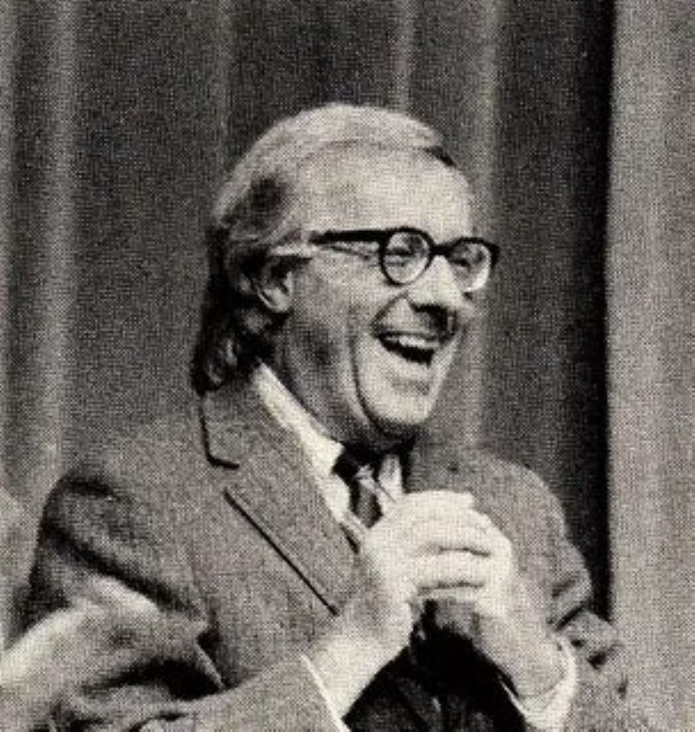

Punishment Without Crime, Ray Bradbury

Punishment Without Crime

‘You wish to kill your wife?’ said the dark man at the desk.

‘Yes. No…not exactly. I mean…’

‘Name?’

‘Hers or mine?’

‘Yours.’

‘George Hill.’

‘Address?’

‘Eleven South Saint James, Glenview.’

The man wrote this down, emotionlessly. ‘Your wife’s name?’

‘Katherine.’

‘Age?’

‘Thirty-one.’

Then came a swift series of questions. Color of hair, eyes, skin, favorite perfume, texture and size index. ‘Have you a dimensional photo of her? A tape recording of her voice? Ah, I see you do. Good. Now—’

An hour later, George Hill was perspiring.

‘That’s all.’ The dark man arose and scowled. ‘You still want to go through with it.’

‘Yes.’

‘Sign here.’

He signed.

‘You know this is illegal?’

‘Yes.’

‘And that we’re in no way responsible for what happens to you as a result of your request?’

‘For God’s sake!’ cried George. ‘You’ve kept me long enough. Let’s get on!’

The man smiled faintly. ‘It’ll take nine hours to prepare the marionette of your wife. Sleep awhile, it’ll help your nerves. The third mirror room on your left is unoccupied.’

George moved in a slow numbness to the mirror room. He lay on the blue velvet cot, his body pressure causing the mirrors in the ceiling to whirl. A soft voice sang, ‘Sleep…sleep…sleep…’

George murmured, ‘Katherine, I didn’t want to come here. You forced me into it. You made me do it. God, I wish I weren’t here. I wish I could go back. I don’t want to kill you.’

The mirrors glittered as they rotated softly.

He slept.

He dreamed he was forty-one again, he and Katie running on a green hill somewhere with a picnic lunch, their helicopter beside them. The wind blew Katie’s hair in golden strands and she was laughing. They kissed and held hands, not eating. They read poems; it seemed they were always reading poems.

Other scenes. Quick changes of color, in flight. He and Katie flying over Greece and Italy and Switzerland, in that clear, long autumn of 1997! Flying and never stopping!

And then—nightmare. Katie and Leonard Phelps. George cried out in his sleep. How had it happened? Where had Phelps sprung from? Why had he interfered? Why couldn’t life be simple and good?

Was it the difference in age? George touching fifty, and Katie so young, so very young. Why, why?

The scene was unforgettably vivid. Leonard Phelps and Katherine in a green park beyond the city. George himself appearing on a path only in time to see the kissing of their mouths.

The rage. The struggle. The attempt to kill Leonard Phelps.

More days, more nightmares.

George Hill awoke, weeping.

‘Mr Hill, we’re ready for you now.’

Hill arose clumsily. He saw himself in the high and now-silent mirrors, and he looked every one of his years. It had been a wretched error. Better men than he had taken young wives only to have them dissolve away in their hands like sugar crystals under water. He eyed himself, monstrously. A little too much stomach. A little too much chin. Somewhat too much pepper in the hair and not enough in the limbs…

The dark man led him to a room.

George Hill gasped. ‘This is Katie’s room!’

‘We try to have everything perfect.’

‘It is, to the last detail!’

George Hill drew forth a signed check for ten thousand dollars. The man departed with it.

The room was silent and warm.

George sat and felt for the gun in his pocket. A lot of money. But rich men can afford the luxury of cathartic murder. The violent unviolence. The death without death. The murder without murdering. He felt better. He was suddenly calm.

He watched the door. This was a thing he had anticipated for six months and now it was to be ended. In a moment the beautiful robot, the stringless marionette, would appear, and…

‘Hello, George.’

‘Katie!’

He whirled.

‘Katie.’ He let his breath out.

She stood in the doorway behind him. She was dressed in a feathersoft green gown. On her feet were woven gold-twine sandals. Her hair was bright about her throat and her eyes were blue and clear.

He did not speak for a long while. ‘You’re beautiful,’ he said at last, shocked.

‘How else could I be?’

His voice was slow and unreal. ‘Let me look at you.’

He put out his vague hands like a sleepwalker. His heart pounded sluggishly. He moved forward as if walking under a deep pressure of water. He walked around and around her, touching her.

‘Haven’t you seen enough of me in all these years?’

‘Never enough,’ he said, and his eyes were filled with tears.

‘What did you want to talk to me about?’

‘Give me time, please, a little time.’ He sat down weakly and put his trembling hands to his chest. He blinked. ‘It’s incredible. Another nightmare. How did they make you?’

‘We’re not allowed to talk of that; it spoils the illusion.’

‘It’s magic!’

‘Science.’

Her touch was warm. Her fingernails were perfect as seashells. There was no seam, no flaw. He looked upon her. He remembered again the words they had read so often in the good days, Behold, thou art fair, my love: behold, thou art fair; thou hast doves’ eyes within thy locks…Thy lips are like a thread of scarlet, and thy speech is comely…Thy two breasts are like two young roes that are twins, which feed among the lilies…there is no spot in thee.

‘George?’

‘What?’ His eyes were cold glass.

He wanted to kiss her lips.

Honey and milk are under thy tongue.

And the smell of thy garments is like the smell of Lebanon.

‘George.’

A vast humming. The room began to whirl.

‘Yes, yes, a moment, a moment.’ He shook his humming head.

How beautiful are thy feet with shoes. O prince’s daughter! the joints of thy thighs are like jewels, the work of the hands of a cunning workman…

‘How did they do it?’ he cried. In so short a time. Nine hours, while he slept. Had they melted gold, fixed delicate watch springs, diamonds, glitter, confetti, rich rubies, liquid silver, copper thread? Had metal insects spun her hair? Had they poured yellow fire in molds and set it to freeze?

‘No,’ she said. ‘If you talk that way, I’ll go.’

‘Don’t!’

‘Come to business, then,’ she said, coldly. ‘You want to talk to me about Leonard.’

‘Give me time, I’ll get to it.’

‘Now,’ she insisted.

He knew no anger. It had washed out of him at her appearance. He felt childishly dirty.

‘Why did you come to see me?’ She was not smiling.

‘Please.’

‘I insist. Wasn’t it about Leonard? You know I love him, don’t you?’

‘Stop it!’ He put his hands to his ears.

She kept at him. ‘You know, I spend all of my time with him now. Where you and I used to go, now Leonard and I stay. Remember the picnic green on Mount Verde? We were there last week. We flew to Athens a month ago, with a case of champagne.’

He licked his lips. ‘You’re not guilty, you’re not.’ He rose and held her wrists. ‘You’re fresh, you’re not her. She’s guilty, not you. You’re different!’

‘On the contrary,’ said the woman. ‘I am her. I can act only as she acts. No part of me is alien to her. For all intents and purposes we are one.’

‘But you did not do what she has done!’

‘I did all those things. I kissed him.’

‘You can’t have, you’re just born!’

‘Out of her past and from your mind.’

‘Look,’ he pleaded, shaking her to gain her attention. ‘Isn’t there some way, can’t I—pay more money? Take you away with me? We’ll go to Paris or Stockholm or any place you like!’

She laughed. ‘The marionettes only rent. They never sell.’

‘But I’ve money!’

‘It was tried, long ago. It leads to insanity. It’s not possible. Even this much is illegal, you know that. We exist only through governmental sufferance.’

‘All I want is to live with you, Katie.’

‘That can never be, because I am Katie, every bit of me is her. We do not want competition. Marionettes can’t leave the premises; dissection might reveal our secrets. Enough of this. I warned you, we mustn’t speak of these things. You’ll spoil the illusion. You’ll feel frustrated when you leave. You paid your money, now do what you came to do.’

‘I don’t want to kill you.’

‘One part of you does. You’re walling it in, you’re trying not to let it out.’

He took the gun from his pocket. ‘I’m an old fool. I should never have come. You’re so beautiful.’

‘I’m going to see Leonard tonight.’

‘Don’t talk.’

‘We’re flying to Paris in the morning.’

‘You heard what I said!’

‘And then to Stockholm.’ She laughed sweetly and caressed his chin. ‘My little fat man.’

Something began to stir in him. His face grew pale. He knew what was happening. The hidden anger and revulsion and hatred in him were sending out faint pulses of thought. And the delicate telepathic web in her wondrous head was receiving the death impulse. The marionette. The invisible strings. He himself manipulating her body.

‘Plump, odd little man, who once was so fair.’

‘Don’t,’ he said.

‘Old while I am only thirty-one, ah, George, you were blind, working years to give me time to fall in love again. Don’t you think Leonard is lovely?’

He raised the gun blindly.

‘Katie.’

‘His head is as the most fine gold—’ she whispered.

‘Katie, don’t!’ he screamed.

‘His locks are bushy, and black as a raven…His hands are as gold rings set with the beryl—’

How could she speak those words! It was in his mind, how could she mouth it!

‘Katie, don’t make me do this!’

‘His cheeks are as a bed of spices,’ she murmured, eyes closed, moving about the room softly. ‘His belly is as bright ivory overlaid with sapphires. His legs are as pillars of marble—’

‘Katie!’ he shrieked.

‘His mouth is most sweet—’

One shot.

‘—this is my beloved—’

Another shot.

She fell.

‘Katie, Katie, Katie!’

Four more times he pumped bullets into her body.

She lay shuddering. Her senseless mouth clicked wide and some insanely warped mechanism had caused her to repeat again and again. ‘Beloved, beloved, beloved, beloved, beloved…’

George Hill fainted.

He awakened to a cool cloth on his brow.

‘It’s all over,’ said the dark man.

‘Over?’ George Hill whispered.

The dark man nodded.

George Hill looked weakly down at his hands. They had been covered with blood. When he fainted he had dropped to the floor. The last thing he remembered was the feeling of the real blood pouring upon his hands in a freshet.

His hands were now clean-washed.

‘I’ve got to leave,’ said George Hill.

‘If you feel capable.’

‘I’m all right.’ He got up. ‘I’ll go to Paris now, start over. I’m not to try to phone Katie or anything, am I.’

‘Katie is dead.’

‘Yes. I killed her, didn’t I? God, the blood, it was real!’

‘We are proud of that touch.’

He went down in the elevator to the street. It was raining, and he wanted to walk for hours. The anger and destruction were purged away. The memory was so terrible that he would never wish to kill again.

Even if the real Katie were to appear before him now, he would only thank God, and fall senselessly to his knees. She was dead now. He had had his way. He had broken the law and no one would know.

The rain fell cool on his face. He must leave immediately, while the purge was in effect. After all, what was the use of such purges if one took up the old threads? The marionettes’ function was primarily to prevent actual crime.

If you wanted to kill, hit, or torture someone, you took it out on one of those unstringed automatons. It wouldn’t do to return to the apartment now. Katie might be there. He wanted only to think of her as dead, a thing attended to in deserving fashion.

He stopped at the curb and watched the traffic flash by. He took deep breaths of the good air and began to relax.

‘Mr Hill?’ said a voice at his elbow.

‘Yes?’

A manacle was snapped to Hill’s wrist. ‘You’re under arrest.’

‘But—’

‘Come along. Smith, take the other men upstairs, make the arrests!’

‘You can’t do this to me,’ said George Hill.

‘For murder, yes, we can.’

Thunder sounded in the sky.

It was eight-fifteen at night. It had been raining for ten days. It rained now on the prison walls. He put his hands out to feel the drops gather in pools on his trembling palms.

A door clanged and he did not move but stood with his hands in the rain. His lawyer looked up at him on his chair and said. ‘It’s all over. You’ll be executed tonight.’

George Hill listened to the rain.

‘She wasn’t real. I didn’t kill her.’

‘It’s the law, anyhow. You remember. The others are sentenced, too. The president of Marionettes, Incorporated, will die at midnight. His three assistants will die at one. You’ll go about one-thirty.’

‘Thanks,’ said George. ‘You did all you could. I guess it was murder, no matter how you look at it, image or not. The idea was there, the plot and the plan were there. It lacked only the real Katie herself.’

‘It’s a matter of timing, too,’ said the lawyer. ‘Ten years ago you wouldn’t have got the death penalty. Ten years from now you wouldn’t, either. But they had to have an object case, a whipping boy.

The use of marionettes has grown so in the last year it’s fantastic. The public must be scared out of it, and scared badly. God knows where it would all wind up if it went on.

There’s the spiritual side of it, too, where does life begin or end? are the robots alive or dead?

More than one church has been split up the seams on the question. If they aren’t alive, they’re the next thing to it; they react, they even think. You know the “live robot” law that was passed two months ago: you come under that. Just bad timing, is all, bad timing.’

‘The government’s right. I see that now,’ said George Hill.

‘I’m glad you understand the attitude of the law.’

‘Yes. After all, they can’t let murder be legal. Even if it’s done with machines and telepathy and wax. They’d be hypocrites to let me get away with my crime. For it was a crime. I’ve felt guilty about it ever since. I’ve felt the need of punishment. Isn’t that odd? That’s how society gets to you. It makes you feel guilty even when you see no reason to be…’

‘I have to go now. Is there anything you want?’

‘Nothing, thanks.’

‘Good-by then, Mr Hill.’

The door shut.

George Hill stood up on the chair, his hands twisting together, wet, outside the window bars. A red light burned in the wall suddenly. A voice came over the audio; ‘Mr Hill, your wife is here to see you.’

He gripped the bars.

She’s dead, he thought.

‘Mr Hill?’ asked the voice.

‘She’s dead. I killed her.’

‘Your wife is waiting in the anteroom, will you see her?’

‘I saw her fall, I shot her, I saw her fall dead!’

‘Mr Hill, do you hear me?’

‘Yes!’ he shouted, pounding at the wall with his fists. ‘I hear you. I hear you! She’s dead, she’s dead, can’t she let me be! I killed her. I won’t see her, she’s dead!’

A pause. ‘Very well, Mr Hill,’ murmured the voice.

The red light winked off.

Lightning flashed through the sky and lit his face. He pressed his hot cheeks to the cold bars and waited, while the rain fell. After a long time, a door opened somewhere onto the street and he saw two caped figures emerge from the prison office below. They paused under an arc light and glanced up.

It was Katie. And beside her, Leonard Phelps.

‘Katie!’

Her face turned away. The man took her arm. They hurried across the avenue in the black rain and got into a low car.

‘Katie!’ He wrenched at the bars. He screamed and beat and pulled at the concrete ledge. ‘She’s alive! Guard! Guard! I saw her! She’s not dead, I didn’t kill her, now you can let me out! I didn’t murder anyone, it’s all a joke, a mistake, I saw her, I saw her! Katie, come back, tell them, Katie, say you’re alive! Katie!’

The guards came running.

‘You can’t kill me! I didn’t do anything! Katie’s alive. I saw her!’

‘We saw her, too, sir.’

‘But let me free, then! Let me free!’ It was insane. He choked and almost fell.

‘We’ve been through all that, sir, at the trial.’

‘It’s not fair!’ He leaped up and clawed at the window, bellowing.

The car drove away. Katie and Leonard inside it. Drove away to Paris and Athens and Venice and London next spring and Stockholm next summer and Vienna in the fall.

‘Katie, come back, you can’t do this to me!’

The red taillights of the car dwindled in the cold rain. Behind him, the guards moved forward to take hold of him while he screamed.

The end