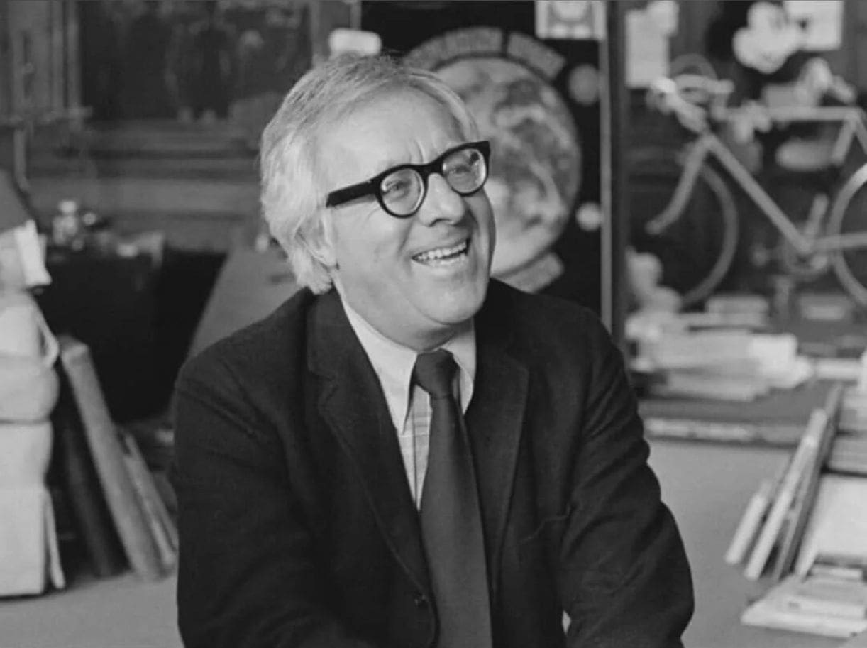

Quid Pro Quo, Ray Bradbury

Quid Pro Quo

You do not build a Time Machine unless you know where you are going. Destinations. Cairo after Christ? Macedonia before Methuselah? Hiroshima just before? Destinations, places, happenings.

But I built my Time Machine, all unknowingly, with no destination in mind, no happening about to arrive or, just this second, depart.

I built my Far Traveling Device with fragments of wired-together ganglion, the seat of invisible perception, of intuitive awareness.

An accessory to this inner side of the medulla oblongata and the brain shelves behind the optic nerve.

Between the hidden senses of the brain and the probing but invisible radar of the ganglion I ram-shackled together a perceptor of future beings or past behaviors far different than name-places and mind-shaking events.

My Tin Lizzie watch, my dust invention, had microwave antennae with which to touch, find, and make moral judgments beyond my own intelligence.

The Machine, in sum, would add up integers of human rise and fall and mail itself there to shape destinies, taking me along as blind baggage.

Did I know this as I pasted and screwed and welded my seemingly hapless mechanical child? I did not. I simply tossed forth notions and needs, opinions and predictions based on successes and failures, and at the end stood back to stare at my useless creation.

For there it stood in my attic, a bright object, all angles and elbows, purring, anxious for travel but going nowhere unless I begged “go” instead of “sit” or “stay.” I would not give it directions; I would simply at the right time shed my “ambiance,” my soul’s light, upon it.

Then it would rear up and gallop off in all directions. Arriving where, only God knew.

But we would know when we arrived.

So there is the start of it all.

A strange dream lurking in a dim attic, with two seats for Tourists, a bated breath and a bright hum of its spidery nerves.

Why had I built it in my attic?

After all, it wouldn’t sky-dive midair, but only hang-glide Time.

The Machine. Attic. Waiting. For what?

Santa Barbara. A small bookshop, and my signing a small novel for an even smaller group when the explosion occurred. Which hardly describes the force with which it slammed me back on my inner wall.

It began when I glanced up and saw this old, old man swaying in the doorway, dreading to enter. He was incredibly wrinkled. His eyes were broken crystal. Saliva brimmed his trembling lips. He shook as if lightning struck him when he gaped his mouth and gasped.

I went back to signing books until an intuitive cog slipped in my head. I glanced up again.

The old, old man still hung there like a scarecrow, framed against the light, his head thrust forward, eyes aching for recognition.

My body froze. I felt the blood run cold along my neck and down my arms. The pen fell from my fingers as the old, old man lurched forward, giggling, hands groping.

“Remember me?” he cried, laughing.

I searched the long frazzled gray hair that blew about his cheeks, noted the white chin stubble, the sun-bleached shirt, the half-soiled denims, the sandals on his bony feet, then up again to his demon eyes.

“Do you?” he smiled.

“I don’t think—”

“Simon Cross!” he exploded.

“Who?”

“Cross!” he bleated. “I am Simon Cross!”

“Son of a bitch!” I reared back.

My chair fell. The small crowd fell back, too, as if struck. The old, old man, riven, shut his eyes, flinching.

“Bastard!” Tears leaped to my eyes. “Simon Cross? What have you done with your life!?”

Eyes clenched, he lifted his gnarled and shivering hands, palms out, horribly empty to wait for my further cry.

“Sweet Jesus,” I said. “Your life. What did you do to it?”

With a great thunderclap my memory reversed to forty years lost, forty years gone, and myself, thirty-three, at the start of my own career.

And Simon Cross stood before me, nineteen years old and handsome to the point of beauty with a bright face, clear and innocent eyes, an amiable demeanor, his bones relaxed within his flesh, and a bundle of story manuscripts under his arm.

“My sister said—” he began.

“I know, I know,” I interrupted. “I read your stories last night, the ones she gave me. You’re a genius.”

“I wouldn’t say that,” said Simon Cross.

“I would. Bring more stories. Without looking I can sell every one of them. Not as an agent, but a friend to genius.”

“Don’t say that,” said Simon Cross.

“I can’t help myself. Someone like you lives once in a lifetime.”

I riffled through his new stories.

“Oh, God, yes, yes. Beautiful. Sell them all, and take no commission.”

“I’ll be damned,” he said.

“No, blessed. Genetically blessed, by God.”

“I don’t go to church.”

“You don’t need to,” I said. “Now, get out of here. Let me get my breath. Your genius is blasphemy to plain dogs like me. I admire, envy, and almost hate you. Go!”

And he smiled a bewildered smile and got out, left me with his white-hot pages burning my hand, and within two weeks I had sold every one of these tales by a nineteen-year-old man-child whose words walked him on water and flew him midair.

The response quaked the earth across country.

“Where did you find this writer?” some said. “He reads like the bastard son of Emily Dickinson out of Scott Fitzgerald. You his agent?”

“No. He’ll need no agent.”

And Simon Cross wrote a dozen more stories that leaped from his machine into print and acclaim.

Simon Cross. Simon Cross. Simon Cross.

And I was his honorary father, visionary discoverer, and envious but forgiving friend.

Simon Cross. And then, Korea.

And him standing on my front porch in a pure salt-white sailor’s suit, his face still unshaven, his cheeks sunburned, his eyes drinking the world, a last story in his hands.

“Come back, dear boy,” I said.

“I’m not a boy.”

“No? God’s forever child then, burning bright! Stay alive. Don’t become too famous.”

“I won’t.” He hugged me and ran.

Simon Cross. Simon Cross.

And the war over and the time lost and him vanished. Spend ten years here, thirty there, and just rumors of my wandering genius child. Some said he had landed in Spain, married a castle, and championed dove shooting.

Others swore they had seen him in Morocco, perhaps Marrakech. Spend another swift decade and jump the sill into 1998 with a Travel Machine treading useless waters in your attic and all Time on your hands, and book-signing fans pressed close when cracking the silence of forty years, what?!

Simon Cross. Simon Cross.

“Damn you to hell!” I shouted.

The old, old man railed back, frightened, hands shielding his face.

“Damn you!” I cried. “Where have you been? How have you used yourself? Christ, what a waste! Look at you! Straighten up! Are you who you say you are?”

“I—”

“Shut up! God, you stupid nerveless monster, what have you done to that fine young man?”

“What fine young man?” the old, old one babbled.

“You. You. You were the genius. You had the world by the tail. You wrote upside down backwards and it all came right! The world was your oyster. You made pearls. Christ, do you know what you’ve done?”

“Nothing.”

“Yes! Nothing! And all you had to do was whistle, blink, and it was yours!”

“Don’t hit me!” he cried.

“Hit you? Kill you, maybe! Hit you! My God!”

I looked around for a blunt instrument. I had only my fists, which I stared at and dropped in despair.

“Don’t you know what life is, you damned idiot fool?” I said at last.

“Life?” gasped the old, old man.

“It’s a deal. A deal you make with God. He gives you life, and you pay back. No, not a gift, a loan. You don’t just take, you give. Quid pro quo!”

“Quid—?”

“Pro quo! One hand washes the other. Borrow and repay, give and take. And you! What a waste! My God, there are ten thousand people out there who’d kill for your talent, who’d die to be what you were and now aren’t.

Lend me your body, give me your brain, if you don’t want it, give it back, but my God, run it to ruin? Lose it forever? How could you? What made you? Suicide and murder, murder and suicide! Oh damn, damn, damn you to hell!”

“Me?” gasped the old, old man.

“Look!” I cried, and spun him to face a shop mirror and see his own shipwreck. “Who is that?”

“Me,” he bleated.

“No, that’s the young man you lost! Damn!”

I raised my fists and it was a moment of stunned release. Images knocked my mind: Suddenly the attic loomed and the useless Machine waiting for no purpose. The Machine I had dreamed wondering why, for what? The Machine with two chairs waiting for occupants going where?

My fists, midair, froze. The attic flashed in my mind and I lowered my fists. I saw the wine on the signing table and took it up.

“Were you going to hit me?” the old, old man cried.

“No. Drink this.”

He opened his eyes to the glass in his hand.

“Does it make me larger or smaller?” he said inanely.

Alice down the rabbit hole with the DRINK ME bottle that grew her outsize or dwarf-small.

“Which?” he said.

“Drink!”

He drank. I refilled the glass. Astounded at this gift confounding my fury, he drank and drank a third and his eyes wet with surprise.

“What?”

“This,” I said, and dragged him half-crippled out to the car and slung him in like a scarecrow and was off down the road, myself grimly silent, Simon Cross, the lost son of a bitch, babbling.

“Where?”

“Here!”

We swerved into my front drive. I yanked him inside and up into the attic without breaking his neck.

We stood, imbalanced, by my Time Machine.

“Now I know why I built it,” I said.

“Built what?” cried Simon Cross.

“Shut up. In!”

“An electric chair?”

“Maybe. Jump!”

He jumped and I locked him in place and took the second seat and threw the control lever.

“What?” said Simon Cross.

“No,” I said. “Where!”

Swiftly, I hit the tabs: year/month/day/hour/ minute; and just as swiftly: state/town/street/block/ number; and yanked the backward/turn/backward bar.

And we were off, dials spinning, unspinning suns, moons, and years until the Machine melted to silence.

Simon Cross, stunned, glanced around.

“Why,” he said, “this is my place.”

“Your home, yes.”

I dragged him up the front walk.

“And there, yes, there, do you see?” I said.

On the front porch, in his sunbright sailor’s suit, stood the beautiful young man with a clutch of story pages in his hands.

“That’s me!” cried the old, old man.

“You. Simon Cross.”

“Hello,” said the young man in the fresh white sailor’s suit. He scowled at me, curious, then puzzled. “Hold on. Why do you look—different?” He nodded at his older self. “And who’s this?”

“Simon Cross,” I said.

In silence, youth looked at age, age looked at youth.

“That’s not Simon Cross,” said the young man.

“That can’t be me,” said the old one.

“Yes.”

Slowly, both turned to look at me.

“I don’t understand,” said Simon Cross, nineteen years old.

“Take me back!” the old man exclaimed.

“Where?”

“To where we were, wherever that was,” he gasped wildly.

“Go away.” The young man backed off.

“I can’t,” I said. “Look close. This is what you will become after you’ve lost yourself. Simon Cross, yes, forty years on.”

The young sailor stood for a long moment, his eyes searching up and down the old man’s body and fixing on his eyes. The young sailor’s face reddened. His hands became fists, relaxed, became fists again. Words did not convince, but some intuition, some power unseen, an invisible vibration between the old man and himself.

“Who are you really?” he said at last.

The old, old man’s voice broke.

“Simon Cross.”

“Son of a bitch!” cried the young man. “Damn you!”

And struck a blow to the older man’s face, and then another and another and the old, old man stood in the rain, the downpour of blows, eyes shut, drinking the violence, until he fell on the pavement with his young self astride him staring at the body.

“Is he dead?” he wondered.

“You killed him.”

“I had to.”

“Yes.”

The young man looked at me. “Am I dead, too?”

“Not if you want to live.”

“Oh God, I do, I do!”

“Then get away from here. I’ll take him with me, back to where we came from.”

“Why are you doing this?” said Simon Cross, only nineteen.

“Because you’re a genius.”

“You keep saying that.”

“True. Run, now. Go.”

He took a few steps and stopped.

“Second chance?” he said.

“Oh, God, I hope so,” I said.

And then added, “Remember this. Don’t live in Spain or become the champion dove shooter in Madrid.”

“I would never be a champion dove shooter anywhere!”

“No?”

“No!”

“And never become the old, old man I must drag through Time to meet himself.”

“Never.”

“You’ll remember all this and live by it?”

“It’s remembered.”

He turned and ran down the street.

“Come,” I said to the body, the scarecrow, the silent thing. “Let’s get you in the Machine and find you an unmarked grave.”

In the Machine, I stared up the now empty street.

“Simon Cross,” I whispered. “Godspeed.”

And threw the switch and vanished in the future.

The end