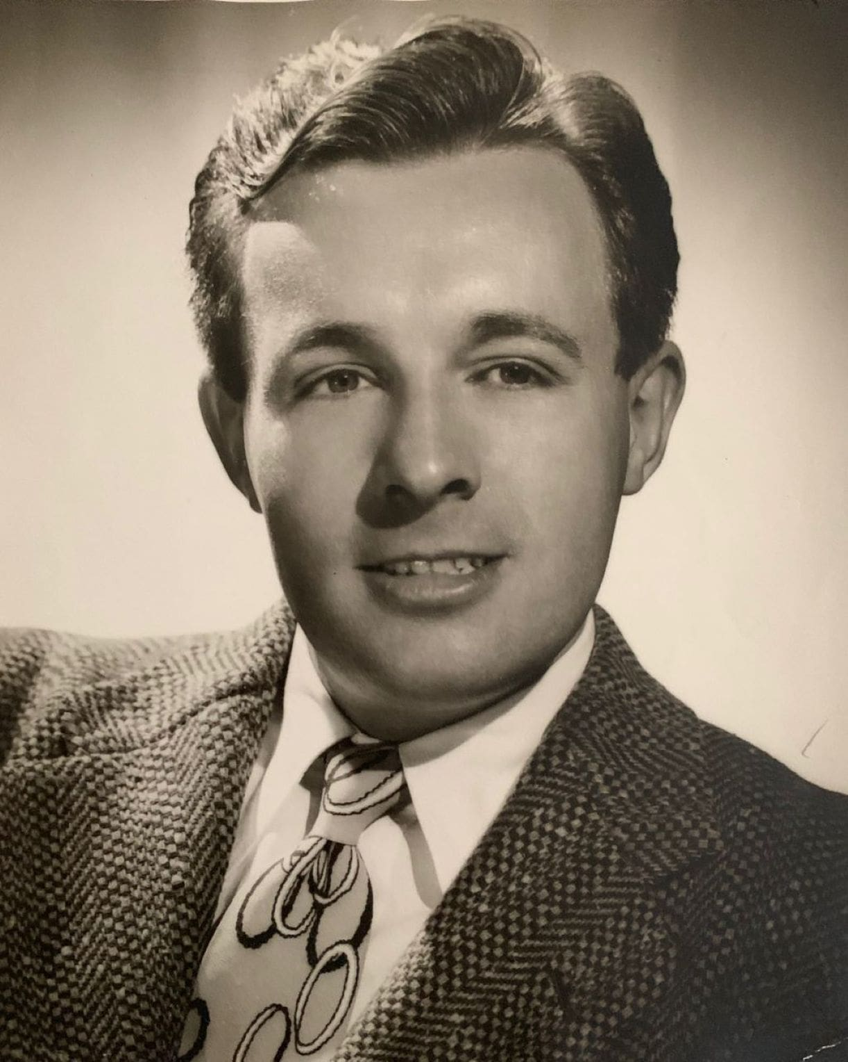

Referent, Ray Bradbury

Referent

ROBY MORRISON fidgeted. Walking in the tropical heat he heard the wet thunder of waves on the shore. There was a green silence on Orthopaedic Island.

It was the year 1997, but Roby did not care.

All around him was the garden where he prowled, all ten years of him. This was Meditation Hour. Beyond the garden wall, to the north, were the High I.Q. Cubicles where he and the other boys slept in special beds.

With morning they popped up like bottle-corks, dashed into showers, gulped food, and were sucked down vacuum-tubes half across the island to Semantics School. Then to Physiology. After Physiology he was blown back underground and released through a seal in the great garden wall to spend this silly hour of meditative frustration, as prescribed by the island Psychologists.

Roby had his opinion of it. ‘Damned silly.’

Today, he was in furious rebellion. He glared at the sea, wishing he had the sea’s freedom to come and go. His eyes were dark, his cheeks flushed, his small hands twitched nervously.

Somewhere in the garden a chime vibrated softly. Fifteen more minutes of meditation. Huh! And then to the Robot Commissionary to stuff his dead hunger as taxidermists stuff birds.

And, after the scientifically pure lunch, through the tube again to Sociology. Of course, late in the warm green afternoon, games would be played in the Main Garden. Games some tremble-brained Psychologist had evolved from a nightmare-haunted sleep.

This was the future! You must live, my lad, as the people of the past, of the year 1920, 1930, and 1942 predicted you would live! Everything fresh, brisk, sanitary, too, too fresh! No nasty old parents about to give one complexes. Everything controlled, dear boy!

Roby should have been in a perfect mood for something unique.

He wasn’t.

When the star fell from the sky a moment later he was only more irritated.

The star was a spheroid. It crashed and rolled to a stop on the hot green grass. A small door popped open in it.

Faintly, this incident recalled a dream to the child. A dream which with superior stubbornness he had refused to record in his Freud Book this morning. The dream-thought was in his mind at the exact instant that the star-door popped wide and some ‘thing’ emerged.

Some ‘thing’.

Young eyes, seeing an object for the first time, have to make a familiar thing of it. Roby didn’t know what this ‘thing’ was, stepping from the sphere. So, scowling, Roby thought of what it most resembled.

Instantly the ‘something’ became a certain thing.

Warm air ran cold. Light flickered, form changed, melted, shifted as the thing evolved into certainty.

Startled, a tall, thin, pale man stood beside the metal star.

The man had pink, terrified eyes. He trembled.

‘Oh, I know you.’ Roby was disappointed. ‘You’re only the Sandman.’

‘Sand – man?’

The stranger quivered like heat rising from boiling metal. His shaking hands went wildly up to touch his long coppery hair as if he’d never seen or felt of it before. The Sandman gazed in horror at his own hands, legs, feet, body, as if they were all new. ‘Sand-man?’

The word was difficult. Talking was new to him, also. He seemed about to flee, but something stopped him.

‘Yeah,’ said Roby. ‘I dream about you every night. Oh, I know what you think. Semantically, our teachers say that ghosts, goblins and fairies, and sandmen are labels, only names for which there aren’t any actual referents, no actual objects or things. But to heck with that. We kids know more than teachers about it. You being here proves the teachers wrong. There are Sandmen after all, aren’t there?’

‘Don’t give me a label!’ cried the Sandman, suddenly. He seemed to understand now. For some reason he was unutterably frightened. He kept pinching, tugging, and feeling his own long new body as if it was a thing of terror. ‘Don’t name me, don’t label me!’

‘Huh?’

‘I’m a referent!’ screamed the Sandman. ‘I’m not a label! I’m just a referent! Let me go!’

Roby’s little green cat-eyes slitted. ‘Say –’ He put his hands on his hips. ‘Did Mr Grill send you? I bet he did! I bet this is another of those psychological tests!’

Roby flushed with dark anger. Always and for ever they were at him. They sorted his games, food, education, took away his friends and his mother, his father, and now – played tricks on him!

‘I’m not from Mr Grill,’ pleaded the Sandman. ‘Listen, before anyone else comes and sees me this way and makes it worse!’

Roby kicked violently. The Sandman danced back, gasping:

‘Listen. I’m not human! You are!’ he shouted. ‘Thought has moulded the flesh of all you here on this world! You’re all dictated to by labels. But I – I am a pure referent!’

‘Liar!’ More kicking from Roby.

The Sandman gibbered with frustration. ‘The truth, child! Centuries of thought have moulded your atoms to your present form; if you could undermine and destroy that belief, the beliefs of your friends, teachers, and parents, you could change form, be a pure referent, too! Like Freedom, Liberty, Humanity, or Time, Space, and Justice!’

‘Grill sent you; he’s always pestering me!’

‘No, no! Atoms are malleable. You’ve accepted certain labels on Earth, called Man, Woman, Child, Head, Hands, Fingers, Feet. You’ve changed from anything into something.’

‘Leave me alone,’ protested Roby. ‘I’ve a test today, I have to think.’ He sat on a rock, hands over his ears.

The Sandman glanced fearfully about, as if expecting disaster. Standing over Roby, he was beginning to tremble and cry. ‘Earth could have been a thousand other ways. Thought, using labels, went round tidying up a disordered cosmos. Now no one bothers trying to think things into other different shapes!’

‘Go away,’ sniffed Roby.

‘I landed near you, not suspecting the danger. I was curious. Inside my spheriod spaceship, thoughts cannot change my shape. I’ve travelled from world to world, over the centuries, and never been trapped like this !’ Tears sprang down his face. ‘And now, by the gods, you’ve labelled me, caught me, imprisoned me with thought!

This Sandman idea. Horrible! I can’t fight it, I can’t change back! And if I can’t change back I’ll never fit into my ship again, I’m much too large. I’ll be stranded on Earth for ever. Release me!’

The Sandman screamed, wept, shouted. Roby’s mind wandered. He debated quietly with himself. What did he want most of all? Escape from this island. Silly. They always caught you. What then? Games, maybe. Like to play regular games, minus psycho-supervision. Yeah, that’d be nice. Kick-the-can, or spin-the-bottle, or even just a rubber ball to bounce on the garden wall and catch, all to himself. Yeah. A red ball.

The Sandman cried, ‘Don’t –’

Silence.

A red rubber ball bounced on the ground.

Up and down bounced the red rubber ball.

‘Hey!’ It took Roby a moment to realize the ball was there. ‘Where’d this come from?’ He hurled it against the wall, caught it. ‘Gee!’

He didn’t notice the absence of a certain stranger who had been shouting at him a few moments before.

The Sandman was gone.

Way off in the hot distance of the garden a bonging noise sounded. A cylinder was rushing up the tube to the wall’s circular door. The door peeled open with a faint hiss. Footsteps rustled measuredly along the path. Mr Grill stepped through a a lush frame of tiger-lilies.

‘Morning, Roby. Oh!’ Mr Grill stopped, his chubby pink face looked as if it had been kicked. ‘What have you there, boy?’ he cried.

Roby bounced the object against the wall.

‘This? A rubber ball.’

‘Eh?’ Grill’s small blue eyes blinked, narrowing. Then he relaxed. ‘Why, of course. For a moment I thought I saw – uh – er –’

Roby bounced the ball some more.

Grill cleared his throat. ‘Lunch time. Meditation Hour is over. And I’m not certain that Minister Locke would enjoy your playing unorthodox games.’

Roby swore under his breath.

‘Oh, well, then, go on. Play. I won’t tattle.’ Mr Grill was in a generous mood.

‘Don’t feel like playing.’ Roby sulked, shoving his sandal-tip into the dirt. Teachers spoiled everything. You couldn’t vomit without permission.

Grill tried to interest the boy. ‘If you come to lunch now, I’ll let you televise your mother in Chicago afterwards.’

‘Time limit, two minutes, ten seconds, no more, no less,’ was Roby’s acid reply.

‘I gather you don’t approve of things, boy.’

‘I’ll run away some day, wait and see!’

‘Tut, lad. We’ll always bring you back, you know.’

‘I didn’t ask to be brought here in the first place.’ Roby bit his lip, staring at his new red rubber ball. He thought he had seen it kind of, sort of, well – move. Funny. He held the ball in his hand. The ball shivered.

Grill patted his shoulder. ‘Your mother is neurotic. Bad environment. You’re better off here on the island. You have a high I.Q. and it is an honour for you to be here with the other little boy geniuses. You’re unstable and unhappy and we’re trying to change that. Eventually you’ll be the exact antithesis of your mother.’

‘I love Mother!’

‘You like her,’ corrected Grill, quietly.

‘I like Mother,’ replied Roby, disquieted. The red ball twitched in his hands, without his touching it. He looked at it with wonder.

‘You’ll only make it harder for yourself if you love her,’ said Grill.

‘You’re a goddam silly,’ said Roby.

Grill stiffened. ‘Don’t swear. Besides, you don’t really mean god and you don’t mean damn. There’s very little of either in the world. Semantics Book Seven, page 418. Labels and Referents.’

‘Now I remember!’ shouted Roby, looking around. ‘There was a Sandman here just now and he said –’

‘Come along,’ said Mr Grill. ‘Lunch time.’

Commissary food emerged from robot-servers on extension springs. Roby accepted the ovoid plate and milk-globe silently. Where he had hidden it, the red rubber ball pulsed and beat like a heart under his belt.

A gong rang. He gulped food swiftly. The tumble for the tube began. They were blown like feathers across the island to Sociology and then, later, in the afternoon, back again for games. Hours passed.

Roby slipped away to the garden to be alone. Hatred for this insane, never-stopping routine, for his teachers and his fellow-students flashed through him in a scouring torrent. He sat alone and thought of his mother, a great distance away.

In great detail he recalled how she looked and what she smelled like and how her voice was and how she touched and held and kissed him. He put his head down into his hands and began to fill the palms of his hands with small tears.

He dropped the red rubber ball.

He didn’t care. He only thought of his mother.

The jungle shivered. Something shifted, quickly.

A woman ran through the deep grass!

She ran away from Roby, slipped, cried out, and fell.

Something glittered in the sunlight. The woman was running towards that silvery glittering thing. The spheroid. The silver star ship! And where had she come from? And why was she running towards the sphere?

And why had she fallen as he looked up? She didn’t seem to be able to get up. Roby leaped from his rock, gave chase. He caught up with her and stood over the woman.

‘Mother!’ he screamed.

Her face shivered and changed, like melting snow, then took on a hard cast, became definite and handsome.

‘I’m not your mother,’ she said.

He didn’t hear. He only heard his own breath moving over his shaking lips. He was so weak with shock he could hardly stand. He put out his hands towards her.

‘Can’t you understand?’ Her face was cold. ‘I’m not your mother. Don’t label me! Why must I have a name! Let me get back to my ship! I’ll kill you if you don’t!’

Roby swayed. ‘Mother, don’t you know me? I’m Roby, your son!’ He wanted only to cry against her, tell her of the long months of imprisonment. ‘Please, remember me!’

Sobbing, he moved forward and fell against her.

Her fingers tightened on his throat.

She strangled him.

He tried to scream. The scream was caught, pressed back into his bursting lungs. He flailed his legs.

Deep in her cold, hard, angry face, Roby found the answer even as her fingers tightened and things grew dark.

Deep in her face he saw a vestige of the Sandman.

The Sandman. The star falling on the summer sky. The silver sphere, the ship towards which this ‘woman’ had been running. The disappearance of the Sandman, the appearance of the red ball, the vanishing of the red ball and now the appearance of his mother. It all fitted.

Matrixes. Moulds. Thought habits. Patterns. Matter. The history of man, his body, all things in the universe.

She was killing him.

She would make him stop thinking, then she would be free.

Thoughts. Darkness. He could barely move, now. Weak, weak. He had thought ‘it’ was his mother. It wasn’t. Nevertheless ‘it’ was killing him. What if Roby thought something else? Try, anyway. Try it. He kicked. In the wild darkness he thought hard, hard.

With a wail, his ‘mother’ withered before him.

He concentrated.

Her fingers dwindled from his throat. Her bright face crumbled. Her body shrank to another size.

He was free. He rose up, gasping.

Through the jungle he saw the silver sphere lying in the sun. He staggered towards it, then cried out with the sharp thrill of the plan that formed in his mind.

He laughed triumphantly. He stared once more at ‘it’. What was left of the woman form changed before his eyes, like melting wax. He reshaped it into something new.

The garden wall trembled. A vacuum cylinder was hissing up through the tube. Mr Grill was coming. Roby would have to hurry or his plan would be ruined.

Roby ran to the spheroid, peered in. Simple controls. Just enough room for his small body – if the plan worked. It had to to work. It would work!

The garden trembled with the approaching thunder of the cylinder. Roby laughed. To hell with Mr Grill. To hell with this island.

He thrust himself into the ship. There was much he could learn, it would come in time. He was just on the skirt of knowledge now, but that little knowledge had saved his life, and now it would do even more.

A voice cried out behind him. A familiar voice. So familiar that it made Roby shudder. Roby heard small-boy feet crash the underbrush. Small feet on a small body. A small voice pleading.

Roby grasped the ship controls. Escape. Complete and unsuspected. Simple. Wonderful. Grill would never know.

The sphere door slammed. Motion.

The star, Roby inside, rose on the summer sky.

Mr Grill stepped out of the seal in the garden wall. He looked around for Roby. Sunlight struck him warmly in the face as he hurried down the path.

There! There was Roby. In the clearing ahead of him. Little Roby Morrison staring at the sky, making fists, crying out to nobody. At least Grill could see nobody about.

‘Hello, Roby,’ called Grill.

The boy jerked at the sound. He wavered – in colour, density, and quality. Grill blinked, decided it was only the sun.

‘I’m not Roby!’ cried the child. ‘Roby escaped! He left me to take his place, to fool you so you wouldn’t hunt for him! He fooled me, too!’ screamed the child, nastily, sobbing. ‘No, no, don’t look at me!

Don’t think that I’m Roby, you’ll make it worse! You came expecting to find him, and you found me and made me into Roby! You’re moulding me and I’ll never, never change, now! Oh, God!’

‘Come now, Roby –’

‘Roby’ll never come back. I’ll always be him. I was a rubber ball, a woman, a Sandman. But, believe me, I’m only malleable atoms, that’s all. Let me go!’

Grill backed up slowly. His smile was sick.

‘I’m a referent. I’m not a label!’ cried the child.

‘Yes, yes, I understand. Now, now, Roby, Roby, you just wait right there, right there now, while I, while I, while I call the Psycho-Ward.’

Moments later, a corps of assistants ran through the garden.

‘Damn you all!’ screamed the child, kicking. ‘God damn you!’

‘Tut,’ declared Grill quietly, as they forced the child into the vac-cylinder. ‘You’re using a label for which there is no referent!’

The cylinder sucked them away.

A star blinked on the summer sky and vanished.

The end