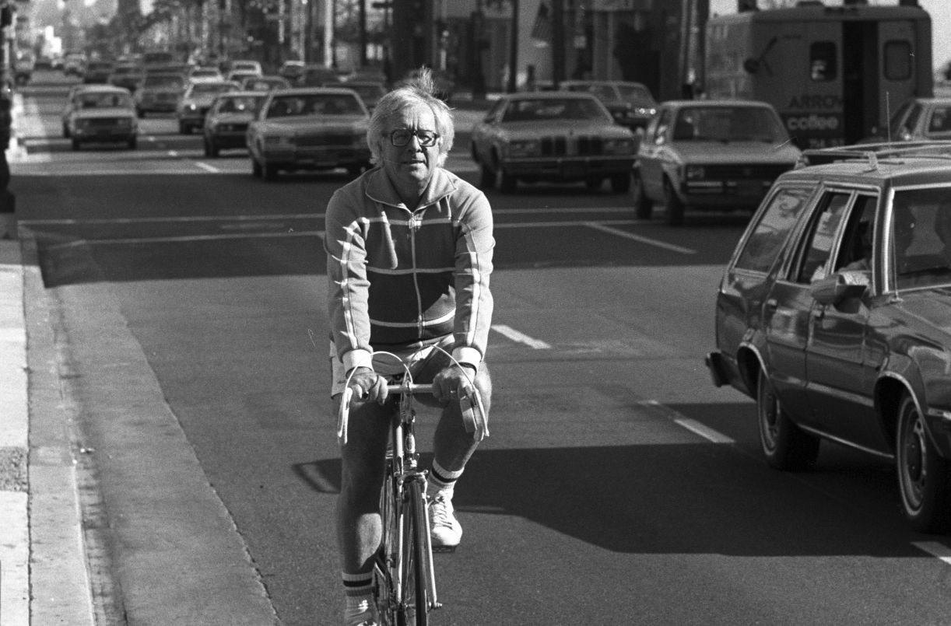

Remember Me? Ray Bradbury

Remember Me?

"Remember me? Of course, surely youdo!"

His hand extended, the stranger waited.

"Why, yes," I said. "You're—"

I, stopped and searched around for help. We were in middle-street in Florence, Italy, at high noon. He had been rushing one way, I the other, and almost collided. Now he waited to hear his name off my lips. Panicking, I rummaged my brain which ran on empty.

"You're—" I said again.

He seized my hand as if fearing I might bolt and run. His face was a sunburst. Heknewme! Shouldn't I return the honor? There's a good dog, he thought,speak!

"I'm Harry!" he cried.

"Harry … ?"

"Stadler!" he barked with a laugh. "Your butcher!"

"Jesus, of course. Harry, you old son of a bitch!" I pumped his hand with relief.

He almost danced with joy. "Thatson of a bitch, yes! Nine thousand miles from home. No wonder you didn't know me! Hey, we'll get killed out here. I'm at the Grand Hotel. The lobby parquetry floor, amazing! Dinner tonight? Florentine steaks—listen to your butcher, eh? Seven tonight! Yes!"

I opened my mouth to suck and blow out in a great refusal, but—

"Tonight!" he cried.

He spun about and ran, almost plowed under by a bumblebee motorbike. At the far curb he yelled:

"Harry Stadler!"

"Leonard Douglas," I shouted, inanely.

"I know." He waved and vanished in the mob. "I know … "

My God! I thought, staring at my massaged and abandoned hand. Whowasthat?

My butcher.

Now I saw him at his counter grinding hamburger, a tiny white toy-boat cap capsizing on his thin blond hair, Germanic, imperturbable, his cheeks all pork sausage as he pounded a steak into submission.

My butcher,yes!

"Jesus!" I muttered for the rest of the day. "Christ! What made me accept? Why in hell did heask? We don't evenknoweach other, except when he says, That's five bucks sixty, and I say, So long! Hell!"

I rang his hotel room every half hour all afternoon. No answer.

"Will you leave a message, sir?"

"No thanks."

Coward, I thought. Leave a message: sick. Leave a message: died!

I stared at the phone, helpless. Of course I hadn't recognized him. Whoever recognizes anyone away from their counter, desk, car, piano, or wherever someone stands, sits, sells, speaks, provides, or dispenses?

The mechanic free of his grease-monkey jumpsuit, the lawyer devoid of his pinstripes and wearing a fiery hibiscus sport shirt, the club woman released from her corset and crammed in an explosive bikini—all, all unfamiliar, strange, easily insulted if unrecognized! We all expect that no matter where we go or dress, we will be instantly recognized. Like disguised MacArthurs we stride ashore in far countries crying: "Ihave returned!"

But does anyonegivea damn? This butcher, now—minus his cap, without the blood-fingerprinted smock, without the fan whirling above his head to drive off flies, without bright knives, sharp tenterhooks, whirled bologna slicers, mounds of pink flesh or spreads of marbled beef, he was the masked avenger.

Besides, travel had freshened him. Travel does that. Two weeks of luscious foods, rare wines, long sleeps, wondrous architectures and a man wakes ten years younger to hate going home to be old.

Myself? I was at the absolute peak of losing years in gaining miles. My butcher and I had become quasi-teenagers reborn to collide in Florentine traffic to gibber and paw each other's memories.

"Damn it to hell!" I jabbed his number on the touch-phone, viciously. Five o'clock: silence. Six: no answer. Seven: the same. Christ!

"Stop!" I yelled out the window.

All of Florence's church bells sounded, sealing my doom.

Bang! Someone slammed a door, on their way out.

Me.

When we met at five minutes after seven, we were like two angry lovers who hadn't seen each other for days and now rushed in a turmoil of self-pity toward a supper with killed appetites.

Eat and run, no, eat and flee, was in our faces as we swayed in mid-lobby, at the last moment seized each other's hands. Might we arm-wrestle? From somewhere crept false smiles and tepid laughter.

"Leonard Douglas," he cried, "you old son of a bitch!"

He stopped, red-faced. Butchers, after all, do not swear at old customers!

"I mean," he said, "comeon!"

He shoved me into the elevator and babbled all the way up to the penthouse restaurant.

"What a coincidence. Middle of the street. Fine food here. Here's our floor. Out!"

We sat to dine.

"Wine for me." The butcher eyed the wine list, like an old friend. "Here's a swell one. 1970, St. Emilion. Yes?"

"Thanks. A very dry vodka martini."

My butcher scowled.

"But," I said, quickly, "Iwillhave some wine, of course!"

I ordered salad to start. He scowled again.

"The salad and the martini will ruin your taste for the wine. Beg pardon."

"Well then," I said, hastily, "the salad,later."

We ordered our steaks, his rare, mine well-done.

"Sorry," said my butcher, "but youshouldtreat your meat more kindly."

"Not like St. Joan, eh?" I said, and laughed.

"That's a good one. Not like St. Joan."

At which moment the wine arrived to be uncorked. I offered my glass quickly and, glad that my martini had been delayed, or might never come, made the next minute easier by sniffing, whirling, and sipping the St. Emilion. My butcher watched, as a cat might watch a rather strange dog.

I swallowed the merest sip, eyes closed, and nodded.

The stranger across the table also sipped and nodded.

A he.

We stared at the twilight horizon of Florence.

"Well … " I said, frantic for conversation " … what do you think of Florence's art?"

"Paintings make me nervous," he admitted. "What Ireallylike is walking around. Italian women! I'd like to ice-pack and ship them home!"

"Er, yes … " I cleared my throat. "But Giotto … ?"

"Giotto bores me. Sorry. He's too soon in art history for me. Stick figures. Masaccio's better. Raphael's best. AndRubens! I have a butcher's taste for flesh."

"Rubens?"

"Rubens!" Harry Stadler forked some neat little salami slices, popped them in his mouth, and chewed opinions. "Rubens! All bosom and bum, big cumulus clouds of pink flesh, eh? You can feel the heart beating like a kettledrum in a ton of that stuff. Every woman a bed; throw yourself on them, sink from sight. To hell with the boy David, all that cold white marble and no fig leaf! No, no, I like color, life, and meat that covers the bone. You're noteating!"

"Watch." I ate my bloody salami and pink bologna and my dead white provolone, wondering if I should ask his opinion of the cold white colorless cheeses of the world.

The headwaiter delivered our steaks.

Stadler's was so rare you could run blood tests on it. Mine resembled a withered black man's head left to smoke and char my plate.

My butcher growled at my burnt offering.

"My God," he cried, "they treated Joan of Arc better than that! Will you puff it or chew it?"

"But yours," I laughed, "is stillbreathing!"

My steak sounded like crunched autumn leaves, every time I chewed.

Stadler, like W. C. Fields, hacked his way through a wall of living flesh, dragging his canoe behind him.

He killed his dinner. I buried mine.

We ate swiftly. All too soon, in a shared panic, we sensed that we must talk once more.

We ate in a terrible silence like an old married couple, angry at lost arguments, the reasons for which were also lost, leaving irritability and muted rage.

We buttered bread to fill the silence. We ordered coffee, which filled more time and at last settled back, watching that other stranger across a snowfield of linen, napery, and silver.

Then, abomination of abominations, I heard myself say:

"When we get home, we must have dinner some night to talk about our time here, yes? Florence, the weather, the paintings."

"Yes." He downed his drink. "No/"

"What?"

"No," he said, simply. "Let's face it, Leonard, when we were home we had nothing in common. Even here we have nothing except time, distance, and travel to share. We have no talk, no interests. Hell, it's a shame, but there it is.

This whole thing was impulsive, for the best, or at the worst, mysterious reasons. You're alone, I'm alone in a strange city at noon, and here tonight. But we're like a couple of gravediggers who meet and try to shake hands, but their ectoplasm falls right through each other, hmm? We've kidded ourselves all day."

I sat there stunned. I shut my eyes, felt as if I might be angry, then gave a great gusting exhalation.

"You're the most honest man I've ever known."

"I hate being honest and realistic." Then he laughed. "I tried to call you all afternoon."

"I tried to callyou!"

"Iwanted to cancel dinner."

"Me, too!"

"I never got through."

"I missedyou."

"My God!"

"Jesus Christ!"

We both began to laugh, threw our heads back, and almost fell from our chairs.

"This isrich!"

"It most certainlyis!"Isaid, imitating Oliver Hardy's way of speaking.

"God, order another bottle of champagne!"

"Waiter!"

We hardly stopped laughing as the waiter poured the second bottle.

"Well, we haveonething in common," said Harry

Stadler.

"What's that?"

"This whole cockamamie silly stupid wonderful day, starting at noon, ending here. We'll tell this story to friends the rest of our lives. How I invited you, and you fell in with it not wanting to, and how we both tried to call it off before it started, and how we both came to dinner hating it, and how we blurted it out, silly, silly, and how suddenly—" He stopped.

His eyes watered and his voice softened. "How suddenly it wasn't so silly anymore. But okay. Suddenly we liked each other in our foolishness. And if we don't try to make the rest of the evening too long, it won't be so bad, after all."

I tapped my champagne glass to his. The tenderness had reached me, too, along with the stupid and silly.

"We won't ever have any dinners back home."

"No."

"And we don't have to be afraid of long talks about nothing."

"Just the weather for a few seconds, now and then."

"And we won't meet socially."

"Here's to that."

"But suddenly it's a nice night, old Leonard Douglas, customer of mine."

"Here's to Harry Stadler." I raised my glass. "Wherever he goes from here."

"Bless me. Bless you."

We drank and simply sat there for another five minutes, warm and comfortable as old friends who had suddenly found that a long long time ago we had loved the same beautiful librarian who had touched our books and touched our cheeks. But the memory was fading.

"It's going to rain." I arose with my wallet.

Stadler stared until I put the wallet back in my jacket.

"Thanks and good night."

"Thanks to you," he said, "I'm not so lonely now, no matter what."

I gulped the rest of my wine, gasped with pleasure, ruffled Stadler's hair with a quick hand, and ran.

At the door I turned. He saw this and shouted across the room.

"Rememberme?"

I pretended to pause, scratch my head, cudgel my memory. Then I pointed at him and cried:

"The butcher!"

He lifted his drink.

"Yes!" he called. "The butcher!"

I hurried downstairs and across the parquetry floor which was too beautiful to walk on, and out into a storm.

I walked in the rain for a long while, face up.

Hell, I thought, I don't feel so lonelymyself!

Then, soaked through, and laughing, I ducked and ran all the way back to my hotel.

1997

The end