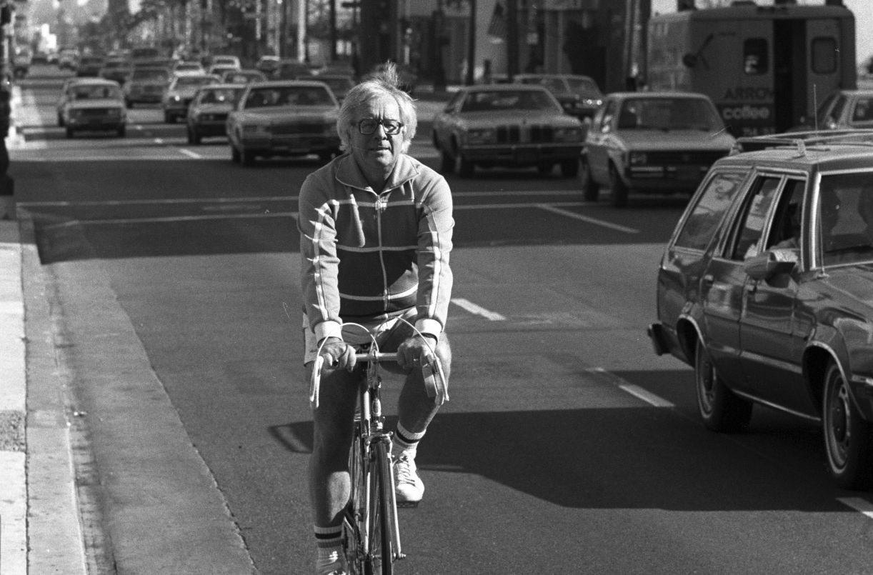

Some Live Like Lazarus, Ray Bradbury

Some Live Like Lazarus

You won’t believe it when I tell you I waited more than sixty years for a murder, hoped as only a woman can hope that it might happen, and didn't move a finger to stop it when it finally drew near. Anna Marie, I thought, you can't stand guard forever. Murder, when ten thousand days have passed, is more than a surprise, it is a miracle.

"Hold on!" Don't let me fall!"

Mrs. Harrison's voice.

Did I ever, in half a century, hear it whisper? Was it always screaming, shrieking, demanding, threatening?

Yes, always.

"Come along, Mother. There you are, Mother." Her son Roger's voice. Did I ever in all the years hear it rise above a murmur, protest, or, even faintly birdlike, argue?

No. Always the loving monotone.

This morning, no different than any other of their first mornings, they arrived in their great black hearse for their annual Green Bay summer. There he was, thrusting his hand in to hoist the window dummy after him, an ancient sachet of bones and talcum dust that was named, surely for some terrible practical joke, Mother.

"Easy does it, Mother."

"You’re bruising my arm!"

"Sorry, Mother."

I watched from a window of the lake pavilion as he trundled her off down the path in her wheel chair, she pushing her cane like a musket ahead to blast any Fates or Furies they might meet out of the way.

"Careful, don't run me into the flowers, thank God we’d sense not to go to Paris after all. You'd've had me in that nasty traffic. You’re not disappointed?"

"No, Mother."

"We'll see Paris next year."

Next year . . .next year . . . no year at all, I heard someone murmur.

Myself, gripping the window sill. For almost seventy years I had heard her promise this to the boy, boy-man, man, man-grasshopper and the now livid male praying mantis that he was, pushing his eternally cold and fur-wrapped woman past the hotel verandas where, in another age, paper fans had Buttered like Oriental butterflies in the hands of basking ladies.

"There, Mother, inside the cottage.." His faint voice fading still more, forever young when he was old, forever old when he was very young.

How old is she now? I wondered. Ninety eight, yes, ninety eight wicked years old. She seemed like a horror film repeated each year bemuse the hotel entertainment fund could not afford to buy a new one to run in the moth-flaked evenings.

So, through all the repetitions of arrivals and departures, my mind ran back to when the foundations of the Green Bay Hotel were freshly poured and the parasols were new leaf green and lemon Sold, that summer of 1890 when I first saw Roger, who was five, but whose eyes already were old and wise and tired.

He stood on the pavilion grass looking at the sun and the bright pennants as I came up to him.

"Hello," I said.

He simply looked at me.

I hesitated, tagged him and ran.

He did not move. I came back and tagged him again.

He looked at the place where I had touched him, on the shoulder, and was about to run after me when her voice came from a distance.

"Roger, don't dirty your clothes!"

And he walked slowly away toward his cottage, not looking back.

That was the day I started to hate him.

Parasols have come and gone in a thousand summer colors, whole flights of butterfly fans have blown away on August winds, the pavilion has burned and been built again in the selfsame size and shape, the lake has dried like a plum in its basin, and my hatred, like these things, came and went, grew very large, stopped still for love, returned, then diminished with the years.

I remember when he was seven, them driving by in their horse carriage, his hair long, brushing his loutish shoulders. They were holding hands and she was saying, "If you're very good this summer, next year we'll go to London. Or the year after that, at the latest."

And my watching their faces, comparing their eyes, their ears, their mouths, so when he came in for a soda pop one noon that summer I walked straight up to him and cried, "She's not your mother!"

"What!" He looked around in panic, as if she might be near.

"She's not your aunt or your grandma, either!" I cried. "She's a witch that stole you when you were a baby. You don't know who your mama is or your pa. You don't look anything like her. She's holding you for a million ransom which comes due when you're twenty-one from some duke or king!"

"Don't say that!" he shouted, jumping up.

"Why not?" I said angrily. "Why do you come around here? You can't play this, can't play that, can't do nothing, what good are you? She says, she does. I know her! She hangs upside down from the ceiling in her black clothes in her bedroom at midnight!"

"Don't say that!" His face was frightened and pale.

"Why not say it?"

"Because," he bleated, "it's true."

And he was out the door and running.

I didn't see him again until the next summer. And then only once, briefly, when I took some clean linen down to their cottage.

The summer when we were both twelve was the summer that for a time I didn't hate him.

He called my name outside the pavilion screen door and when I looked out he said, very quietly, "Anna Marie, when I am twenty and you are twenty, I'm going to marry you."

"Who's going to let you?" I asked.

"I'm going to let you," he said. "You just remember, Ann-Marie. You wait for me. Promise?"

I could only nod.

"But what about--"

"She'll be dead by then," he said, very gravely. "She's old. She's old."

And then he turned and went away.

The next summer they did not come to the resort at all. I heard she was sick. I prayed every night that she would die.

But two years later they were back, and the year after the year after that until Roger was nineteen and I was nineteen, and then at last we had reached and touched twenty, and for one of the few times in all the years, they came into the pavilion together, she in her wheel chair now, deeper in her furs than ever before, her face a gathering of white dust and folded parchment.

She eyed me as I set her ice-cream sundae down before her, and eyed Roger as he said, "Mother, I want you to meet-"

"I do not meet girls who wait on public tables," she said. "I acknowledge they exist, work, and are paid. I immediately forget their names."

She touched and nibbled her ice cream, touched and nibbled her ice cream, while Roger sat not touching his at all.

They left a day earlier than usual that year. I saw Roger as he paid the bill, in the hotel lobby. He shook my hand to say goodbye and I could not help but say, "You’ve forgotten."

He took a half step back, then turned around, patting his coat pockets.

"Luggage, bills paid, wallet, no, I seem to have everything," he said.

"A long time ago," I said, "you made a promise."

He was silent.

"Roger," I said, "I'm twenty now. And so are you."

He seized my hand again, swiftly, as if he were falling over the side of a ship and it was me going away, leaving him to drown forever beyond help.

"One more year, Anna! Two, three, at the most"

"Oh, no," I said, forlornly.

"Four years at the outside! The doctors say-----"

"The doctors don't know what I know, Roger. She’ll live forever. She’ll bury you and me and drink wine at our funeral."

"She's a sick woman, Anna! My God, she can't survive!"

"She will, because we give her strength. She knows we want her dead. That really gives her the power to go on."

"I can't talk this way, I can’t!" Seizing his luggage, he started down the hall.

"I won't wait, Roger," I said.

He turned at the door and looked at me so helplessly, so palely, like a moth pinned to the wall, that I could not say it again.

The door slammed shut.

The summer was over.

The next year Roger came directly to the soda fountain, where he said, "Is it true? Who is

he?"

"Paul," I said. "You know Paul. He’ll manage the hotel someday. We’ll marry this fall."

"That doesn't give me much time," said Roger.

"It's too late," I said. "I've already promised."

"Promised, hell! You don't love him!"

"I think I do."

"Think, hell! Thinking's one thing, knowing's another. You know you love me!"

"Do I, Roger?"

"Stop relishing the damn business so much! You know you do!" Oh, Anna, you'll be miserable!"

"I’m miserable now," I said.

"Oh, Anna, Anna, wait!"

"I have waited, most of my life. But I know what will happen."

"Anna!" He blurted it out as if it had come to him suddenly. "What if-what if she died this summer?"

"She won't."

"But if she did, if she took a turn for the worse, I mean, in the next two months--" He searched my face. He shortened it. "The next month, Anna, two weeks, listen, if she died in two short weeks, would you wait that long, would you marry me then?"

I began to cry. "Oh, Roger, we've never even kissed. This is ridiculous."

"Answer me, if she died one week, seven days from now..." He grabbed my arms.

"But how can you be sure?"

"I'll make myself sure! I swear she’ll be dead a week from now, or I'll never bother you again with this!"

And he flung the screen doors wide, hurrying off into the day that was suddenly too bright.

"Roger, don't---", I cried.

But my mind thought, Roger, do, do something, anything, to start it all or end it all.

That night in bed I thought, what ways are there for murder that no one could know? Is Roger, a hundred yards away this moment, thinking the same? Will he search the woods tomorrow for toadstools resembling mushrooms, or drive the car too fast and fling her door wide on a curve?

I saw the wax dummy witch fly through the air in a lovely soaring arc, to break like ridiculous peanut brittle on an oak, an elm, a maple. I sat up in bed. I laughed until I wept. I wept until I laughed again. No, no, I thought, he'll find a better way. A night burglar will shock her heart into her throat. Once in her throat, he will not let it go down again, she'll choke on her own panic.

And then the oldest, the darkest, most childish thought of all. There's only one way to finish a woman whose mouth is the color of blood. Being what she is, no relative, not an aunt or a great grandmother, surprise her with a stake driven through her heart!

I heard her scream. It was so loud, all the night birds jumped from the trees to cover the stars.

I lay back down. Dear Christian Anna Marie, I thought, what's this? Do you want to kill? Yes, for why not kill a killer, a woman who strangled her child in his crib and has not loosened the throttling cord since? He is so pale, poor man, because he has not breathed free air, all of his life.

And then, unbidden, the lines of an old poem stood up in my head. Where I had read them or who had put them down, or if I had written them myself, within my head over the years, I could not say. But the lines were there and I read them in the dark:

Some live like Lazarus

In a tomb of life

And come forth curious late to twilight hospitals

And mortuary rooms.

The lines vanished. For a while I could recall no more and then, unable to fend it off, for it came of itself, a last fragment appeared in the dark:

Better cold skies seen bitter to the North

Than stillborn stay, all blind and gone to ghost.

Oh if Rio is lost, well, love the Arctic Coast!

Oh ancient Lazarus

Come ye forth.

There the poem stopped and let me be. At last I slept restless, hoping for dawn, and good and final news.

The next day I saw him pushing her along the pier and thought, Yes, that's it! She’ll vanish and be found a week from now, on the shore, like a sea monster floating, all face and no body.

The day passed. Well, surely, I thought, tomorrow ...

The second day of the week, the third, the fourth and then the fifth and sixth passed, and on the seventh day one of the maids came running up the path, shrieking. "Oh, it's terrible, terrible!"

"Mrs. Harrison?" I cried. I felt a terrible and quite unwilled smile on my face.

"No, no, her son! He's hung himseff!"

"Hung himself?" I said ridiculously, and found myself, stunned, explaining to her. "Oh, no, it wasn't him was going to die, it was-" I babbled.

I stopped, for the maid was clutching, pulling my arm. "We cut him down, oh, God, he's still alive, quick!"

Still alive? He still breathed, yes, and walked around through the other years, yes, but alive? No.

It was she who gained strength and lived through his attempt to escape her. She never forgave his trying to run.

"What do you mean by that, what do you mean?" I remember her screaming at him as he lay feeling his throat, in the cottage, his eyes shut, wilted, and I hurried in the door. "What do you mean doing that, what, what?"

And looking at him there I knew he had tried to run away from both of us, we were both impossible to him. I did not forgive him that either, for a while. But I did feel my old hatred of him become something else, a kind of dull pain, as I turned and went back for a doctor. "What do you mean, you silly boy?" she cried.

I married Paul that autumn.

After that, the years poured through the glass swiftly. Once each year, Roger led himself into the pavilion to sit eating mint ice with his limp empty-gloved hands, but he never called me by my name again, nor did he mention the old promise.

Here and there in the hundreds of months that passed I thought, for his own sake now, for no one else, sometime, somehow he must simply up and destroy the dragon with the hideous bellows face and the rust-scaled hands. For Roger and only for Roger, Roger must do it.

Surely this year, I thought, when he was fifty, fifty-one, fifty-two.

Between seasons I caught myself examining occasional Chicago papers, hoping to find a picture of her lying alit like a monstrous yellow chicken. But no, but no, but no....

I'd almost forgotten them when they returned this morning. He's very old now, more like a doddering husband than a son. Baked gray clay he is, with milky blue eyes, a toothless mouth, and manicured fingernails which seem stronger because the flesh has baked away.

At noon today, after a moment of standing out, a lone gray wingless hawk staring at a sky in which he had never soared or flown, he came inside and spoke to me, his voice rising.

"Why didn't you tell me?"

"Tell you what?" I said, scooping out his ice cream before he asked for it.

"One of the maids just mentioned, your husband died five years ago! You should have told me!"

"Well, now you know," I said.

He sat down slowly.

"Lord," he said, tasting the ice cream and savoring it, eyes shut, "this is bitter--"

Then, a long time later, he said, "Anna, I never asked. Were there ever any children?"

"No," I said. "And I don't know why. I guess I'll never know why."

I left him sitting there and went to wash the dishes.

At nine tonight I heard someone laughing by the lake. I hadn't heard Roger laugh since he was a child, so I didn’t think it was him until the doors burst wide and he entered flinging his arms about, unable to control his almost weeping hilarity.

"Roger!" I asked. "What's wrong?"

"Nothing! Oh, nothing!" he cried. "Everything's lovely! A root beer, Anna! Take one yourself! Drink with me!"

We drank together, he laughed, winked, then got immensely calm. Still smiling, though, he looked suddenly, beautifully young.

"Anna," he whispered intensely, leaning forward, "guess what? I'm flying to China tomorrow! Then India! Then London, Madrid, Paris, Berlin, Rome, Mexico City!"

"You are, Roger?"

"I am," he said. "I, I, I, not we, we, we, but I Roger Bidwell Harrison, I, I!"

I stared at him and he gazed quietly back at me, and I must have gasped. For then I knew what he had finally done tonight this hour, within the last few minutes.

"Oh, no," my lips must have murmured.

Oh, but yes, yes, his eyes upon me replied, incredible miracle of miracles, after all these waiting years. Tonight at last. Tonight.

I let him talk. After Rome it was Vienna and Stockholm, he'd saved thousands of schedules, flight charts and hotel bulletins for forty years; he knew the moons and tides, the goings and comings of everything on the sea and in the sky. "But best of all," he said at last, "Anna, Anna, will you come along with me? I've lots of money put away, don't let me run on! Anna, tell me, will you?"

I came around the counter slowly and saw myself in the mirror, a woman in her seventieth year going to a party half a century late.

I sat down beside him and shook my head.

"Oh.. But, Anna, why not, there's no reason why!"

"There is a reason," I said. "You."

"Me, but I don't count!"

"That's just it, Roger, you do."

"Anna, we could have a wonderful time-"

"Undoubtedly. But, Roger, you've been married for seventy years. Now, for the first time, you're not married. You don't want to turn around and get married again right off, do you?"

"Don't I?" he asked, blinking.

"You don't, you really don't. You deserve a little while, at least, off by yourself, to see the world, to know who Roger Harrison is. A little while away from women. Then, when you've gone around the world and come back, is time to think of other things."

"If you say so---"

"No. It mustn't be anything I say or know or tell you to do. Right now it must be you telling yourself what to know and see and do. Go have a grand time. If you can, be happy."

"Will you be here waiting for me when I come back?"

"I haven't it in me any more to wait, but I'll be here."

He moved toward the door, then stopped and looked at me as if surprised by some new question that had come into his mind. "Anna," he said, "if all this had happened forty, fifty years ago, would you have gone away with me then? Would you really have me?"

I did not answer.

"Anna?" he asked. After a long while I said, "There are some questions that should never be asked."

Because, I went on, thinking, there can be no answers. Looking down the years toward the lake, I could not remember, so I could not say, whether we could have ever been happy. Perhaps even as a child, sensing the impossible in Roger, I had clenched the impossible, and therefore the rare, to my heart, simply because it was impossible and rare. He was a sprig of farewell summer pressed in an old book, to be taken out, turned over, admired, once a year, but more than that? Who could say? Surely not I, so long, so late in the day. Life is questions, not answers.

Roger had come very close to read my face, my mind, while I thought all this. What he saw there made him look away, close his eyes, then take my hand and press it to his cheek. "I'll be back. I swear I will!"

Outside the door he stood bewildered for a moment in the moonlight, looking at the world and all its directions, east, west, north, south, like a child out of school for his first summer not knowing which way to go first, just breathing, just listening, just seeing.

"Don't hurry!" I said fervently. "Oh, God, whatever you do, please, enjoy yourself, don't hurry!"

I saw him run off toward the limousine near the cottage where I was supposed to rap in the morning and where I would get no answer. But I knew that I would not go to the cottage and that I'd keep the maids from going there because the old lady had given orders not to be bothered. That would give Roger the chance, the start he needed. In a week or two or three, I might call the police. Then if they met Roger coming back on the boat from all those wild places, it wouldn't matter.

Police? Perhaps not even them. Perhaps she died of a heart attack and poor Roger only thinks he killed her and now proudly sails off into the world, his pride not allowing him to know that only her own self-made death released him.

But then again, if at last all the murder he had put away for seventy years had forced him tonight to lay hands on and kill the hideous turkey, I could not find it in my heart to weep for her but only for the great time it had taken to act out the sentence.

The road is silent. An hour has passed since the limousine roared away down the road.

Now I have just put out the lights and stand alone in the pavilion looking out at the shining lake where in another century, under another sun, a small boy with an old face was first touched to play tag with me and now, very late, had tagged me back, had kissed my hand and run away, and this time myself, stunned, not following.

Many things I do not know, tonight. But one thing I'm sure of. I do not hate Roger Harrison any more.

1960

The end