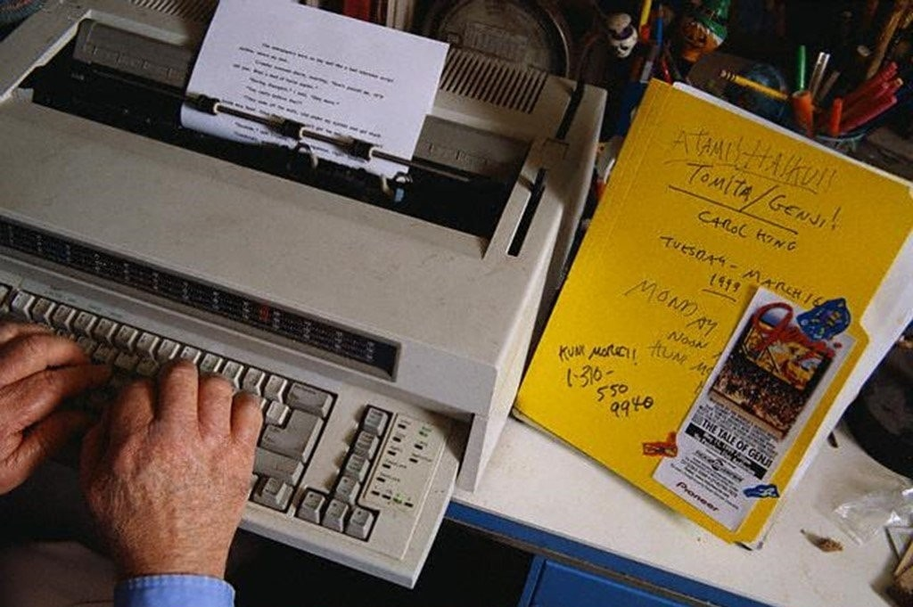

Someone in the Rain, Ray Bradbury

Someone in the Rain

Everything was almost the same. Now that the luggage was brought into the echoing damp cottage, with the raindrops still shining on it, and he had drawn the canvas over the car which was still warm and smelling of the drive two hundred miles north into Wisconsin from Chicago, he had time to think.

First of all, he had been very lucky to get this same cabin, the one he and his brother Skip and his folks had rented twenty years ago, in 1927. It sounded just the same, there was the empty echo of your voice and your feet.

Now, for some unaccountable reason, he was walking about barefoot, because it felt good, perhaps. He closed his eyes as he sat on the bed and listened to the rain on the thin roof. You had to take a lot of things into account. First of all, the trees were larger.

You looked out of your streaming car window in the rain and you saw the Lake Lawn sign looming up and something was different and it was only now, as he heard the wind outside, that he realized what the real change was.

The trees, of course. Twenty years of growing lush and high. The grass, too; if you wanted to get particular, it was the same grass, perhaps, he had lain in that long time ago, after the jump in the lake, his swimsuit still cold around his loins and around his thin small chest. He wondered, idly, if the latrine still smelled the way it did: of brass and disinfectant and old shuffling fumbling men and soap.

The rain stopped. It tapped occasionally on the house from the washing trees above, and the sky was the color and had the feel and expectancy of gunpowder. Now and again it cracked down the middle, all light; and then the crack was mended.

Linda was over in the ladies' rest room, which was just a run between the bushes and the trees and the small white cottages, a run through puddles now, he supposed, and bushes that shook like startled dogs when you passed, showering you with a fresh burst of cool and odorous rain.

It was good that she was gone for awhile. He wanted to look for certain things. First there was the initial he had carved on the windowsill fifteen years ago on their last trip up for the late summer of 1932. It was a thing he would never have done with anyone about, but now, alone, he walked to the window and ran his hand over the surface. It was perfectly smooth.

Well then, he thought, it must have been another window. No. It was this room. And this cottage, no doubt of it. He felt a sudden resentment at the carpenter who had come in here some time ago and smoothed and sandpapered surfaces and taken away the immortality he had promised himself that rainy night when, locked into the house by the storm, he had busied himself with the careful initialing. Then he had said to himself, People will come by, years from now, and see this.

He rubbed his hand on the empty sill.

Linda arrived through the front door. "Oh, what a place," she cried, and she was almost soaked, her blonde hair was full of rain, and her face was wet. She looked at him with half an accusation. "So this is Wonderland. When did they build it? You'd think each house would have a toilet, but oh no! It's just a stone's throw to the toilet, where I spent two minutes trying to find the light switch, and five minutes after that batting off a big moth while I tried to wash up!"

A large moth. He straightened up and smiled. "Here." He gave her a towel. "Dry off. You'll be all right."

"I ran into a bush, look at my dress, drenched. God." She submerged into the towel, talking.

"I've got to go over to the men's room myself," he said, looking out the door, smiling at a thing that had come into his mind. "I'll be back."

"If you're not back in ten minutes, I'll send the Coast Guard—"

The door banged.

He walked very slowly, taking deep breaths. He just let the rain fall on him and he felt the wind tugging at the cuffs of his pants. That cottage there was where Marion, his cousin, had stayed with her mother and father.

God, how many nights had they crept off to the woods and sat on damp grass to tell ghost stories while looking at the lake. And get so scared that Marion would want to hold hands and then maybe kiss, just those small innocent kisses of ten- and eleven-year-old cousins, only touches, only gestures against loneliness.

He could smell her now, Marion, the way she was before the nicotine got to her and the bottled perfumes got to her. She hadn't been his cousin, really now, for ten years or so, never really, since growing up.

The really natural creature had been back here somewhere. Oh, Marion was mature now, and so was he to a certain degree. But all the same, the smell of maturity wasn't quite as pleasant.

He reached the men's washroom, and Christ, it wasn't changed a bit.

The moth was waiting for him.

It was a big soft fluttery white ghost of a moth, batting and whispering against the single filament bulb. It had been there twenty years, sighing and beating in the moist night air of the rest room, waiting for him to come back. He remembered his first encounter with it. He had been only eight and the moth had come at him like a powdery phantom, dusting down its horrible wings, screaming silently at him.

He had run, shrieking, out of the latrine, across the dark August grass, into his cottage. And, rather than go back to the latrine, he watered himself free of his bursting pain behind the cottage. After that, he had been sure to go to the toilet many times during the day, so he would not have to go back to the latrine to face the powdering terror.

Now he looked at the Moth.

"Hello," he said. "Been waiting long?"

It was a silly thing to say, but it was good being silly. He didn't like the look on Linda's face. He knew that the more excuses he could make in the next day or so to be out of her sight, the better for himself. He would save money on cigarettes by not being too near her.

He would be very solicitous. "What if I run up for a bottle of whiskey, darling?" "Darling, I'm going down to the boat dock to pick up some bait." "Darling, Sam wants me to golf this afternoon." Linda didn't keep well in this kind of weather. There was something a little sour about her already.

The moth beat gently at his face. "You're pretty damned big," he said, suddenly feeling a return of the cool chill to his spine, where it had used to be. He hadn't been afraid in years, now he let himself be just a little, enjoyably, afraid of the white, whispering moth.

It tinkled against the light bulb. He washed up, and for the hell of it looked into a booth to see if there was some of that mysterious writing he had once read as a boy. Magic words then, incomprehensible, strange. Now—nothing. "I know what you mean, now," he said. "Words. Limericks. All the magic gone."

Somehow, he caught himself in the mirror, the blurred,fuzzymirror, and his face was disappointed. All the words had not turned out to be half as grand as he had conjured them to seem. Once they had been golden pronouncements of mystery. Now they were vulgar, short, shocks against accumulated taste.

He lingered to finish out a cigarette, not wanting quite yet to return to Linda.

When he entered the cottage, Linda looked at his shirt.

"That's your good shirt, and why didn't you put on your coat, it's all wet."

"I'll be all right," he said.

"You'll catch cold," she said. She was unpacking some things on the bed. "Boy, the bed's hard," she said.

"I used to sleep the sleep of the innocent on it," he said.

"Frankly," she said, "I'm getting old. When they put out a bed made of whipped cream, I'm bait."

"Lie down for awhile," he suggested. "We've got three hours before dinner—"

"How long will this rain go on?" she said.

"I don't know, probably just today, and then tomorrow, everything green. Boy, does it smell good after a rain."

But he was lying. Sometimes it rained for a week. And he hadn't minded it. He had run down to the gray choppy lake in the needling rain, while the sky over him, like a great gray crock overturned and storming, from time to time took on a crackle glaze of electric blue. Then the thunder knocked him off his feet.

And he had swum in the lake, his head out, the lake feeling warm and comfortable, just because the air was filled with cold needles and he looked out at the pavilion where people danced nights, and the hotels with the warm long dim corridors hushed and quiet with running porters, and he looked at the cottage under the August thunder, him in the lake, paddling dog-fashion, the air like winter above. And he never wanted to come out of the lake, he wanted only to remain suspended in the warm water, until he turned purple with enjoyment.

Linda lay down on the bed. "God, what a mattress," she said.

He lay down beside her, not touching her.

The rain started again, gently, upon the cottage. It was as dark as night, but a very special feeling, because you knew it was four in the afternoon, though black, and the sun was above all the blackness, oh, very special.

At six o'clock, Linda painted a fresh mouth on. "Well, I hope the food's good," she said. It was still raining, a thumping, pounding, never-ending drop of storm upon the house. "What do we do this evening?" she wanted to know.

"Dance? There's a pavilion, cost a million dollars, built in 1929 just before the crash," he said, tying his tie. And again he was out of the room, in thought, and under the raining trees, eighteen years ago.

Him and Marion and Skip, running in their rustling slickers, making a noise like cellophane, with the rain patting them all over, their faces greased with it, past the playground and the slides, along the posted road, and to the pavilion. Children were not allowed inside.

They had stood outside with their faces pressed to the screen, watching the people inside, buying drinks, laughing, sitting at the tables, getting up and going out to dance on the dance floor to music that was muted and enclosed. Marion had stood there, enchanted, the light on her face. "Someday," she had said, "I'm going to be inside, and dance."

They had stood, with the rain touching around them, in the dark wet night, the rain dripping from the eaves of the pavilion. And the music had played "I Found My Love in Avalon" and things like "In Old Monterrey."

Then, after half an hour of the rain seeping into their shoes, and their noses chilling, and rain slipping into their raincoat collars, they had turned from the warm pavilion light and walked off, silently, the music fading, down the road back to their cabins.

Someone knocked on the front door. "Sam!" called a voice.

"Hey, you two! Ready? Time for dinner!"

They let Sam in. '"How do we get up to the hotel?" asked Linda. "Walk?" She looked at the rain outside the door.

"Why not," said her husband. "It'd be fun. God, we never do anything anymore, you know what I mean, we never walk anywhere, if we have to go anyplace past a block we get in the car. Hell, let's put on our raincoats and march up, eh, Sam?"

"Okay with me, how about you, Linda?" cried Sam.

"Oh, walk?" she complained. "All that way? And in this rain?"

"Come off it," the husband said. "What's a little rain."

"All right," she said.

There was a rustling as they got into raincoats. He laughed a lot and whacked her on the backside and helped her buckle it up tight. "I smell like a rubber walrus," she said. And then they were out in the lane of green trees, slipping on the squelching grass, in the lane, sinking their rubbered feet into sludge mud furrows where cars came splashing by, whining in the thick wet dark.

"Oh, boy, this is swell!" he shouted.

"Not so fast," she said.

The wind blew, bending the trees, and by the look of it, it would last a week. The hotel was up the hill and they walked now, with less laughing, though he tried starting it again. It was after Linda slipped and fell that nobody said a thing, though Sam, when helping her up, tried to make a joke.

"If nobody minds, I'm hitching a ride," she said.

"Oh, be a sport," he said.

She thumbed the next car going up the hill. When the car stopped, the man in it shouted, "You all want a ride to the hotel?" But he walked on without saying a word, so Sam had to follow.

"That wasn't polite," said Sam.

Lightning stood on the sky, like a naked and newborn tree.

Supper was warm, but not of much taste, the coffee was thin and unpalatable and there were not many people in the dining room. It had that end-of-the-season feel, as if everybody had taken their clothes out of storage for the last time, tomorrow the world was ending, the lights would go out, and it was no use trying too hard to please anybody. The lights seemed dim, there was too much forced talk and bad cigar smoke.

"My feet are soaked," said Linda.

They went down to the pavilion at eight o'clock, and it was big and empty and echoing, with an empty bandstand, which filled slowly until at nine o'clock there were a lot of people seated at the tables, and the orchestra, a nine-piece band (hadn't it been a twenty-piece band in 1929, wondered the husband), broke into a medley of old tunes.

His cigarettes tasted damp, his suit was moist, his shoes were sopping, but he said nothing. When the orchestra played its third number, he asked Linda out on the floor. There were about seven couples out there, in the rainbow changing lights, in the vast echoing emptiness. His socks squeaked water as he walked, they were very cold.

He held Linda and they danced to "I Found My Love in Avalon," just because he had telephoned earlier to have it played. They moved quietly around the floor, not speaking.

"My feet are soaking wet," said Linda, finally.

He held on to her and kept moving. The place was dim and dark and cool and the windows were washed with fresh rain still pouring.

"After this dance," said Linda, "we'll go to the cabin."

He didn't say yes or no.

He looked across the shining floor, to the empty tables, with a few couples spotted here and there, beyond them, to the watery windows. As he moved Linda across the floor, nearer to the window, he squinted, and there they were.

Outside the window, a few child faces, peering in. One or two. Perhaps three. The light on their faces. The light shining in their eyes. Just for a minute or so.

He said something.

"What'd you say?" asked Linda.

"I said I wish I were outside the window now, looking in," he said. She looked at him. The music was ending. When he looked at the window again, the faces were gone.

1997

The end