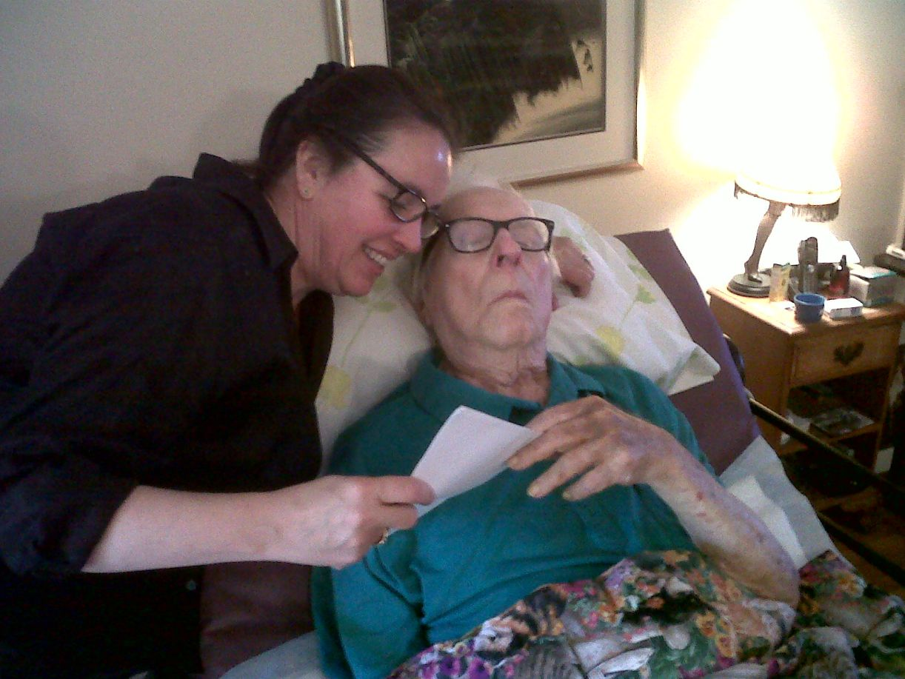

Sun and Shadow, Ray Bradbury

Sun and Shadow

The camera clicked like an insect. It was blue and metallic, like a great fat beetle held in the man's precious and tenderly exploiting hands. It winked in the flashing sunlight.

"Hsst, Ricardo, come away!"

"You down there!" cried Ricardo out the window.

"Ricardo, stop!"

He turned to his wife. "Don't tell me to stop, tell them to stop. Go down and tell them, or are you afraid?"

"They aren't hurting anything," said his wife patiently.

He shook her off and leaned out the window and looked down into the alley. "You there!" he cried.

The man with the black camera in the alley glanced up, then went on focusing his machine at the lady in the salt-white beach pants, the white bra, and the green checkered scarf. She leaned against the cracked plaster of the building. Behind her a dark boy smiled, his hand to his mouth.

"Tomas!" yelled Ricardo. He turned to his wife. "Oh, Jesus the Blessed, Tomas is in the street, my own son laughing there." Ricardo started out the door.

"Don't do anything!" said his wife.

"I'll cut off their heads!" said Ricardo, and was gone.

In the street the lazy woman was lounging now against the peeling blue paint of a banister. Ricardo emerged in time to see her doing this. "That's my banister!" he said.

The cameraman hurried up. "No, no, we're taking pictures. Everything's all right. We'll be moving on."

"Everything's not all right," said Ricardo, his brown eyes flashing. He waved a wrinkled hand. "She's on my house."

"We're taking fashion pictures," smiled the photographer,

"Now what am I to do?" said Ricardo to the blue sky. "Go mad with this news? Dance around like an epileptic saint?"

"If it's money, well, here's a five-peso bill," smiled the photographer.

Ricardo pushed the hand away. "I work for my money. You don't understand. Please go."

The photographer was bewildered. "Wait . . ."

“Tomas, get in the house!"

''But, Papa . . ."

"Gahh!" bellowed Ricardo.

The boy vanished.

"This has never happened before," said the photographer.

"It is long past time! What are we? Cowards?" Ricardo asked the world.

A crowd was gathering. They murmured and smiled and nudged each other's elbows. The photographer with irritable good will snapped his camera shut, said over his shoulder to the model, "All right, we'll use that other street. I saw a nice cracked wall there and some nice deep shadows. If we hurry . . ."

The girl, who had stood during this exchange nervously twisting her scarf, now seized her make-up kit and darted by Ricardo, but not before he touched at her arm. “Do not misunderstand," he said quickly. She stopped, blinked at him. He went on. "It is not you I am mad at. Or you." He addressed the photographer.

"Then why—" said the photographer,

Ricardo waved his hand. "You are employed; I am employed. We are all people employed. We must understand each other.

But when you come to my house with your camera that looks like the complex eye of a black horsefly, then the understanding is over. I will not have my alley used because of its pretty shadows, or my sky used because of its sun, or my house used because there is an interesting crack in the wall, here!

You see! Ah, how beautiful! Lean here! Stand there! Sit here! Crouch there! Hold it! Oh, I heard you. Do you think I am stupid? I have books up in my room. You see that window? Maria!"

His wife's head popped out. "Show them my books!" he cried.

She fussed and muttered, but a moment later she held out one, then two, then half a dozen books, eyes shut, head turned away, as if they were old fish.

"And two dozen more like them upstairs!" cried Ricardo. "You're not talking to some cow in the forest, you're talking to a man!"

"Look," said the photographer, packing his plates swiftly. "We're going. Thanks for nothing."

"Before you go, you must see what I am getting at," said Ricardo. "I am not a mean man. But I can be a very angry man. Do I look like a cardboard cutout?"

"Nobody said anybody looked like anything." The photographer hefted his case and started off.

"There is a photographer two blocks over," said Ricardo, pacing him. "They have cutouts. You stand in front of them. It says 'grand hotel.' They take a picture of you and it looks like you are in the Grand Hotel. Do you see what I mean?

My alley is my alley, my life is my life, my son is my son. My son is not cardboard! I saw you putting my son against the wall, so, and thus, in the background. What do you call it—for the correct air? To make the whole attractive, and the lovely lady in front of him?"

"It's getting late," said the photographer, sweating. The model trotted along on the other side of him.

"We are poor people," said Ricardo. "Our doors peel paint, our walls are chipped and cracked, our gutters fume in the street, the alleys are all cobbles. But it fills me with a terrible rage when I see you make over these things as if I had planned it this way, as if I had years ago induced the wall to crack.

Did you think 1 knew you were coming and aged the paint? Or that I knew you were coming and put my boy in his dirtiest clothes? We are not a studio! We are people and must be given attention as people. Have I made it clear?"

"With abundant detail," said the photographer, not looking at him, hurrying.

\*\*Now that you know my wishes and my reasoning, you will do the friendly thing and go home?"

"You are a hilarious man," said the photographer. "Hey!" They had joined a group of five other models and a second photographer at the base of a vast stone stairway which in layers, like a bridal cake, led up to the white town square. "How you doing, Joe?"

"We got some beautiful shots near the Church of the Virgin, some statuary without any noses, lovely stuff," said Joe. "What's the commotion?"

"Pancho here got in an uproar. Seems we leaned against his house and knocked it down."

"My name is Ricardo. My house is completely intact."

"We'll shoot it here, dear," said the first photographer. "Stand by the archway of that store. There's a nice antique wall going up there." He peered into the mysteries of his camera.

"So!" A dreadful quiet came upon Ricardo. He watched them prepare. When they were ready to take the picture he hurried forward, calling to a man in a doorway "Jorge! What are you doing?"

"I'm standing here," said the man.

"Well," said Ricardo, "isn't that your archway? Are you going to let them use it?"

"I'm not bothered," said Jorge.

Ricardo shook his arm. "They're treating your property like a movie actor's place. Aren't you insulted?"

"I haven't thought about it." Jorge picked his nose.

"Jesus upon earth, man, think!"

"I can't see any harm," said Jorge.

"Am I the only one in the world with a tongue in my mouth?" said Ricardo to his empty hands. "And taste on my tongue? Is this a town of backdrops and picture sets? Won't anyone do something about this except me?"

The crowd had followed them down the street, gathering others to it as it came; now it was of a fair size and more were coming, drawn by Ricardo's bullish shouts. He stomped his feet. He made fists. He spat.

The cameraman and the models watched him nervously. "Do you want a quaint man in the background?" he said wildly to the cameraman. "I'll pose back here. Do you want me near this wall, my hat so, my feet so, the light so and thus on my sandals which I made myself? Do you want me to rip this hole in my shirt a bit larger, eh, like this? So! Is my face smeared with enough perspiration? Is my hair long enough, kind sir?"

"Stand there if you want," said the photographer.

"I won't look in the camera," Ricardo assured him.

The photographer smiled and lifted his machine. "Over to your left one step, dear." The model moved. "Now turn your right leg. That's fine. Fine, fine. Hold it!"

The model froze, chin tilted up.

Ricardo dropped his pants.

"Oh, my God!" said the photographer.

Some of the models squealed. The crowd laughed and pummeled each other a bit. Ricardo quietly raised his pants and leaned against the wall.

"Was that quaint enough?" he said.

"Oh, my God!" muttered the photographer.

"Let's go down to the docks," said his assistant.

"I think I'll go there too." Ricardo smiled.

"Good God, what can we do with the idiot?" whispered the photographer.

"Buy him off!"

"I tried that!"

"You didn't go high enough."

"Listen, you run get a policeman. I'll put a stop to this."

The assistant ran. Everyone stood around smoking cigarettes nervously, eying Ricardo. A dog came by and briefly made water against the wall.

"Look at that!" cried Ricardo. "What art! What a pattern! Quick, before the sun dries it!"

The cameraman turned his back and looked out to sea.

The assistant came rushing along the street. Behind him, a native policeman strolled quietly. The assistant had to stop and run back to urge the policeman to hurry. The policeman assured him with a gesture, at a distance, that the day was not yet over and in time they would arrive at the scene of whatever disaster lay ahead.

The policeman took up a position behind the two cameramen. "What seems to be the trouble?"

"That man up there. We want him removed."

"That man up there seems only to be leaning against a wall," said the officer.

"No, no, it's not the leaning, he— Oh hell," said the cameraman. "The only way to explain is to show you. Take your pose dear."

The girl posed. Ricardo posed, smiling casually.

"Hold it!"

The girl froze.

Ricardo dropped his pants.

Click went the camera.

"Ah," said the policeman.

"Got the evidence right in this old camera if you need it!" said the cameraman.

"Ah," said the policeman, not moving, hand to chin. "So." He surveyed the scene like an amateur photographer himself. He saw the model with the flushed, nervous marble face, the cobbles, the wall, and Ricardo. Ricardo magnificently smoking a cigarette there in the noon sunlight under the blue sky, his pants where a man's pants rarely are.

"Well, officer?" said the cameraman, waiting.

"Just what," said the policeman, taking off his cap and wiping his dark brow, "do you want me to do?"

"Arrest that man! Indecent exposure!"

"Ah," said the policeman.

"Well?" said the cameraman.

The crowd murmured. All the nice lady models were looking out at the sea gulls and the ocean.

"That man up there against the wall," said the officer, "I know him. His name is Ricardo Reyes."

"Hello, Esteban!" called Ricardo.

The officer called back at him, "Hello, Ricardo."

They waved at each other.

"He's not doing anything I can see," said the officer.

"What do you mean?" asked the cameraman. "He's as naked as a rock. It's immoral!"

"That man is doing nothing immoral. He's just standing there," said the policeman. "Now if he were doing something with his hands or body, something terrible to view, I would act upon the instant. However, since he is simply leaning against the wall, not moving a single limb or muscle, there is nothing wrong."

"He's naked, naked!" screamed the cameraman.

"I don't understand." The officer blinked.

"You just don't go around naked, that's all!"

"There are naked people and naked people," said the officer. "Good and bad. Sober and with drink in them. I judge this one to be a man with no drink in him, a good man by reputation; naked, yes, but doing nothing with this nakedness in any way to offend the community."

"What are you, his brother? What are you, his confederate?" said the cameraman. It seemed that at any moment he might snap and bite and bark and woof and race around in circles under the blazing sun. "Where's the justice? What's going on here? Come on, girls, we'll go somewhere else!"

"France," said Ricardo.

"What!" The photographer whirled.

"I said France, or Spain," suggested Ricardo. "Or Sweden. I have seen some nice pictures of walls in Sweden. But not many cracks in them. Forgive my suggestion."

'We'll get pictures in spite of you!" The cameraman shook his camera, his fist.

"I will be there," said Ricardo. "Tomorrow, the next day, at the bullfights, at the market, anywhere, everywhere you go I go, quietly, with grace. With dignity, to perform my necessary task."

Looking at him, they knew it was true.

"Who are you—who in hell do you think you are?" cried the photographer.

"I have been waiting for you to ask me," said Ricardo. "Consider me. Go home and think of me. As long as there is one man like me in a town of ten thousand, the world will go on. Without me, all would be chaos."

"Good night, nurse," said the photographer, and the entire swarm of ladies, hatboxes, cameras, and make-up kits retreated down the street toward the docks. "Time out for lunch, dears. We'll figure something later!"

Ricardo watched them go, quietly. He had not moved from his position. The crowd still looked upon him and smiled.

Now, Ricardo thought, I will walk up the street to my house, which has paint peeling from the door where I have brushed it a thousand times in passing, and I shall walk over the stones I have worn down in forty-six years of walking, and I shall run my hand over the crack in the wall of my own house, which is the crack made by the earthquake in 1930.

I remember well the night, us all in bed, Tomas as yet unborn, and Maria and I much in love, and thinking it was our love which moved the house, warm and great in the night; but it was the earth trembling, and in the morning, that crack in the wall.

And I shall climb the steps to the lacework-grille balcony of my father's house, which grillwork he made with his own hands, and I shall eat the food my wife serves me on the balcony, with the books near at hand.

And my son Tomas, whom I created out of whole cloth, yes, bed sheets, let us admit it, with my good wife. And we shall sit eating and talking, not photographs, not backdrops, not paintings, not stage furniture, any of us. But actors, all of us, very fine actors indeed.

As if to second this last thought, a sound startled his ear. He was in the midst of solemnly, with great dignity and grace, lifting his pants to belt them around his waist, when he heard this lovely sound. It was like the winging of soft doves in the air. It was applause.

The small crowd, looking up at him, enacting the final scene of the play before the intermission for lunch, saw with what beauty and gentlemanly decorum he was elevating his trousers. The applause broke like a brief wave upon the shore of the nearby sea.

Ricardo gestured and smiled to them all.

On his way home up the hill he shook hands with the dog that had watered the wall.

The end