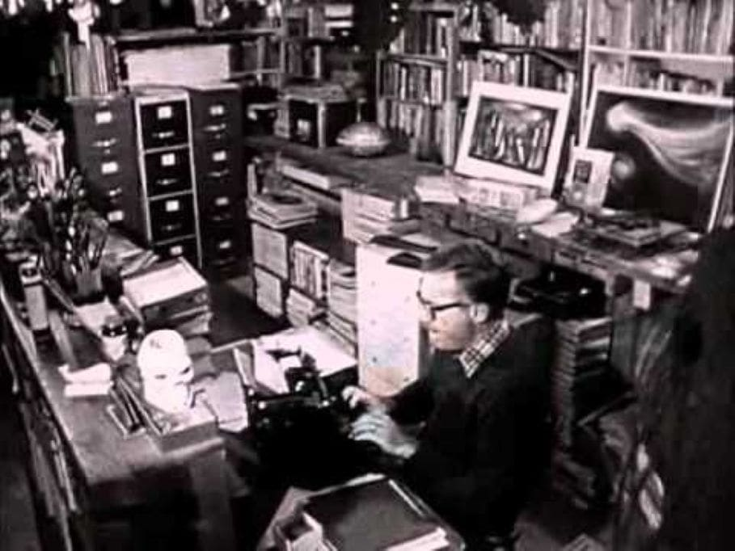

The Beautiful Lady, Ray Bradbury

The Beautiful Lady

IT SEEMED THERE was never a time when someone did not say, “There was the Rose of Sharon, there was the lilies of the valley.” “She walked like a princess. She could walk across the sands by the lake and the smallest breeze would blow the footprints away, she made so little mark in passing.”

The voices moved with the calendar through his life. “Have you ever put your head down in a bed of mint-leaves in May?” “In the middle of the hottest summer night you ever knew, have you felt the curtains blow out into your room, cool and white, suddenly.

And the first rain falling on the hot night roof over your head?” They went all around and over and about the beautiful lady, trying to describe what it was about her. “It’s like trying to tell you what red looks like, or blue, with your eyes shut.” But they never gave up trying.

“She couldn’t have been as beautiful as all that,” cried George Gray. “Show us a picture of her!”

“That’s fifty years ago,” they said. “I suppose if you search around town you’ll find one, but it’s doubtful. She died young. It seems the whole town turned out for her, she was only nineteen and unmarried, when she died. I think everyone was in love with the girl, she was that special.”

George Gray was alternately enchanted and in a rage with his elders. “Well, is she like Helen there, passing?” He pointed.

They only shook their heads with the faintest allowable degree of smugness. They had been to London, they had seen the queen. He had only been to Chicago, poor boy, and to Kankakee.

“Now there’s a lovely girl, really lovely,” said George, and he nodded to someone named Susanna passing in a car.

“That’s a flower without scent,” observed the old people. “So many girls today are flowers like that. When you touch them you find they’re made of paper, to last. Alice wasn’t made to last; she was like the first snow. You look out one December morning and it’s falling but you never see it touch. It never covers the grass, it never has and never will.”

“Oh, my God!” said George. “Shut up with this talk!”

He was only twenty, and hopelessly involved with every woman who sat rocking on a porch as he passed, or waved from a bus going by. He was always turning in circles and colliding with trees. He had fallen down several hypothetical elevator shafts and hit bottom a half dozen times, and still not found the woman he was looking for. There was a freckle on each, the nose was too long or the ear too large, or the mouth too open most of the time and making noise.

“All very well for you to talk,” he said. “Memory plays tricks. It doubles and redoubles, it squares things for you. Why if Alice Langley strolled by on that sidewalk right now, you wouldn’t know her.”

“That’s like saying,” said old man Pearce, “I wouldn’t know a certain species of transparent butterfly. Have you ever seen one, brought up from the Mexican rain-forests, the wings look like they were cut from blown glass, from crystal, you can see through them.

When the butterfly sits on a flower it is a flower, when the butterfly sits on a peach it is a peach, there’s nothing of the butterfly at all, except what you see through and beyond its wings. Don’t tell me what I have or have not seen, young man, I have seen the butterfly with the crystal wings and you have not. Now, come on, let’s have a game of chess.”

GEORGE GRAY was alternately seized with paroxysms of despair and hatred. He wanted very much to see this rose, this butterfly, this first falling of the snows of winter, for he admired, above all else, beauty.

If this woman was as they said she was, oh God to have a look at her! But this was patently impossible, the peach was harvested, the apple blossoms blown off in a wind that had failed fifty years before. You might just as well chase the rain with a sieve! And so his passion turned from despair to hatred and that variety of scorn best practised by a man only recently turned twenty. “A pack of lies!” he cried. “And fifty-two cards in the pack, all marked!”

“All except the Queen of Hearts,” said old man Pearce. “Not a mark on her, not a spot, not a smirch,” and lit his pipe.

“I’ll prove she wasn’t that beautiful!” cried George.

“How!”

“By her pictures, if I can find them! If you haven’t burnt them, to cover up your story!”

“Lad,” said Mr. Pearce. “Two thousand people don’t show up at a maiden lady’s funeral for no reason at all. People only show up in this world for things like the following: the golden spike being driven in the last tie of a railroad, the inauguration of a president, a man flies the Atlantic alone. They turn up for single events, lonely things, apart things, separate things, for things that are one of a kind and never another like it. She was one of a kind, lad, so why don’t you let her be, eh?”

“I’ll prove she wasn’t as beautiful as you say, it’s just you who were young and a fool, like myself,” said George.

“Part of what you just said is wisdom,” admitted the old man. “The last part.”

“If I have to go out to where’s she buried and dig her up and see for myself,” said George.

The old man let his pipe die out. After a long while of sitting in the summer night he said, “George, George. You’re cruel. They say youth is cruel. But this is the first time I’ve seen it this close. Oh, but you are mean, aren’t you? What’s got you so mean this year? Is it breaking up with Susanna last month?”

“I’m not mean, I’m just practical,” said George, lighting a cigarette.

“When a man talks as you just talked it’s all the mean things ever was. Don’t let me hear you speak again of bothering Miss Alice. Oh, that’s a foul and awful thing to suggest, that’s ghoul’s talk, that’s unhealthy. And besides—unfair. What can you find in a coffin anyway, but the seed of the plum, the skin left behind by a departed coral-snake, so much chaff and husk. There’s a great difference between a wheat field in August with the sun and wind, and walking through the straw stubble in November. Is that how you’d judge a crop and a harvest, unfair like that?”

“I just want to prove you wrong,” said George.

“You’re a child,” said Mr. Pearce, “in the body of a man. Why don’t you fall down and kick on the floor?”

“I’ll find a way,” said George, smoking quietly and hastily. “I’ll find a way, so help me.”

“George,” said the old man, sitting there by his chessboard. “I wish you’d go away now. I don’t want to play another game tonight with someone like you. The heat’s got hold of you for sure. Your talk’s bad. Come back when you clean it up. A good walk in a hard rain would work wonders for you. Good night.”

“You’re afraid,” and George smiled quietly. “You’re afraid I’ll take her away from you, aren’t you. You’re afraid of the facts, you’re afraid I can find proof she was never what she seems to be now. I’ve got you running. I’ve got you scared.”

“Good night, George,” said the old man, in the shadows, and his voice was very tired and he did not move.

“Good night,” said George, going down the porch steps.

He whistled away down the streets, his hands in his pockets, his head back, pausing only now and again from his song to smile.

“COME ON, Jack, why not?”

“George, it’s crazy.”

“We don’t have to tell anybody. For my own satisfaction.”

“George, let go of it. For cry-yi. Whinnikers, George.”

“It’ll be a clear night, cool and warm both.”

“That’s dirty and nasty, it’s not clean.”

“Where’s your spunk?”

“It ain’t in digging up nice people, darn it!”

“Old people always braggin’, they should stop that.”

“Sometimes it’s all they got, give ’em that, George. Take it easy. Why you want to take things away from them? They already got so much taken away, why take the last bit, can you tell me?”

THERE WAS nothing inside the great box.

Or, at first, there seemed to be nothing. And then the wind blew just a little bit and stirred a few things there. And George Gray stood looking down upon these few things and counted them and named them over to himself and remembered them for many years after, and the meanness went out of himself, he felt the meanness go from his eyes and from around his mouth and from the muscles in his jaws and his lips, and the meanness drain from the hard muscles under his ribs and in the tendons of his back as he bent there. He let all the meanness melt away as if he were standing in the rain in a suit made of tissue papers and the first wash made him naked.

For inside of the box were the following things:

A single delicate green fern, as soft as breathing. A sprig of fresh summer mint. One new August peach, with the bloom still warm in it. One single violet, purple and alive. A red rose. And one blade of green summer grass.

That was all.

These things were placed, the green fern so, the peach this way, the red rose that, the summer grass another way, to suggest a form and a shape and a being. And standing there, George Gray found time to enact in his imagination the entire elaborate afternoon just over, Mr. Pearce, and a half dozen other old men, and the keeper of this vast and quiet land inside the fence and the iron gate, taking turns in the sun, digging, planning, arranging, and burying again, and going off in the sun, spades on shoulders, smiling. Why?

To make a convert of a disbeliever, to bring him into their clan, the last one in the town, the skeptic, the cynic. To stop his mouth, to stop his doubt, to put an end forever to his threat. He glanced at the chimney of the oven-house on the far side of this marbled field; the faintest trace of smoke still went up to the sky.

He took one last look at the flowers and the delicate green fern and the blade of grass. Then he closed the lid gently and began filling the earth in over it, working steadily and quietly.

It was midnight when he reached his street, walking. It was five after midnight when, in passing the old man’s place, he heard his own name called. He went up to the porch.

“Hello, George,” said the old man.

“Hello,” said George, uncertainly.

“George,” said the old man, after a pause. “Are you still feeling mean and cantankerous?”

“I feel just fine,” said George.

“You changed your mind any since last time I seen you?” asked the old man. “What do you think now?”

George said, “She’s beautiful. She’s the most beautiful lady I’ve ever seen, so help me.”

“That’s what I like to hear, George,” said the old man. “That’s what I like to hear. Tell you what; you just trot on over tomorrow night for a little game of chess, eh?”

“Yes, sir.”

“I’ll beat the pants off you, son.”

“Yes, sir.”

“Well, good night, George.”

“Good night, sir.”

George went down the steps and away from the house and left the old man sitting there in the dark. He did not look back, but waved his hand quietly when he heard the old man call good night again, and as George opened the screen door at this own house, a moth flew up suddenly, with a very soft touch indeed, and brushed his face, and was gone so quickly that it almost seemed it had never been there.

The end