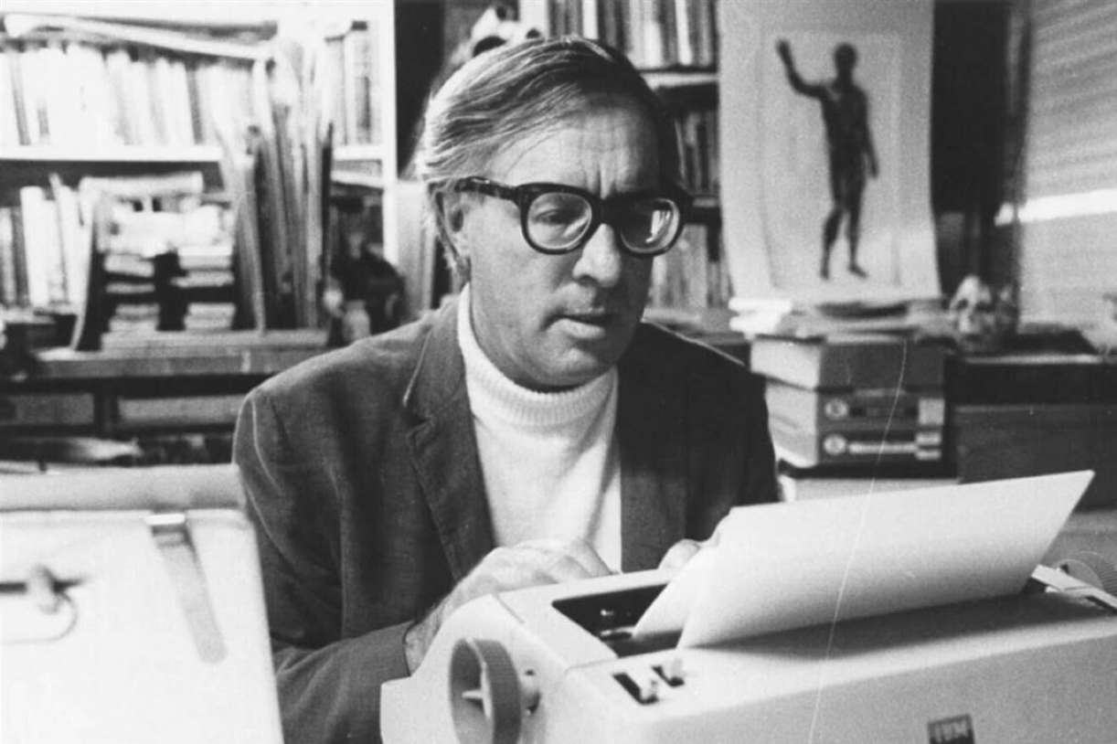

The Best of All Possible Worlds, Ray Bradbury

The Best of All Possible Worlds

The two men sat swaying side by side, unspeaking for the long while it took for the train to move through cold December twilight, pausing at one country station after another.

As the twelfth depot was left behind, the older of the two men muttered, ‘Idiot, Idiot!’ under his breath.

‘What?’ The younger man glanced up from his Times.

The old man nodded bleakly. ‘Did you see that damn fool rush off just now, stumbling after that woman who smelled of Chanel?’

‘Oh, her?’ The young man looked as if he could not decide whether to laugh or be depressed. ‘I followed her off the train once myself.’

The old man snorted and closed his eyes. ‘I too, five years ago.’

The young man stared at his companion as if he had found a friend in a most unlikely spot.

‘Did—did the same thing happen once you reached the end of the platform?’

‘Perhaps. Go on.’

‘Well, I was twenty feet behind her and closing up fast when her husband drove into the station with a carload of kids! Bang! The car door slammed. I saw her Cheshire-cat smile as she drove away. I waited half an hour, chilled to the bone, for another train. It taught me something, by God!’

‘It taught you nothing whatsoever,’ replied the older man dryly. ‘Idiot bulls, that’s all of us, you, me, them, silly boys jerking like laboratory frogs if someone scratches our itch.’

‘My grandpa once said. “Big in the hunkus, small in the brain, that is man’s fate.”’

‘A wise man. But, now, what do you make of her?’

‘That woman? Oh, she likes to keep in trim. It must pep up her liver to know that with a little mild eye-rolling she can make the lemmings swarm any night on this train. She has the best of all possible worlds, don’t you think?

Husband, children, plus the knowledge she’s neat packaging and can prove it five trips a week, hurting no one, least of all herself. And, everything considered, she’s not much to look at. It’s just she smells so good.’

‘Tripe,’ said the old man. ‘It won’t wash. Purely and simply, she’s a woman. All women are women, all men are dirty goats. Until you accept that, you will be rationalizing your glands all your life.

As it is, you will know no rest until you are seventy or thereabouts. Meanwhile, selfknowledge may give you whatever solace can be had in a sticky situation. Given all these essential and inescapable truths, few men ever strike a balance.

Ask a man if he is happy and he will immediately think you are asking if he is satisfied. Satiety is most men’s Edenic dream. I have known only one man who came heir to the very best of all possible worlds, as you used the phrase.’

‘Good Lord,’ said the young man, his eyes shining. ‘I wouldn’t mind hearing about him.’

‘I hope there’s time. This chap is the happiest ram, the most carefree bull, in history. Wives and girl friends galore, as the sales pitch says. Yet he has no qualms, guilts, no feverish nights of lament and self-chastisement.’

‘Impossible,’ the young man put in. ‘You can’t eat your cake and digest it, too!’

‘He did, he does, he will! Not a tremor, not a trace of moral seasickness after an all-night journey over a choppy sea of innersprings! Successful businessman. Apartment in New York on the best street, the proper height above traffic, plus a long-weekend Bucks County place on a more than correct little country stream where he herds his nannies, the happy farmer.

But I met him first at his New York apartment last year, when he had just married. At dinner, his wife was truly gorgeous, snow-cream arms, fruity lips, an amplitude of harvest land below the line, a plenitude above. Honey in the horn, the full apple barrel through winter, she seemed thus to me and her husband, who nipped her bicep in passing.

Leaving, at midnight, I found myself raising a hand to slap her on the flat of her flank like a thoroughbred. Falling down in the elevator, life floated out from under me. I nickered.’

‘Your powers of description,’ said the young commuter, breathing heavily, ‘are incredible.’

‘I write advertising copy,’ said the older. ‘But to continue. I met let us call him Smith again not two weeks later. Through sheer coincidence I was invited to crash a party by a friend. When I arrived in Bucks County, whose place should it turn out to be but Smith’s!

And near him, in the center of the living room, stood this dark Italian beauty, all tawny panther, all midnight and moonstones, dressed in earth colors, browns, siennas, tans, umbers, all the tones of a riotously fruitful autumn. In the babble I lost her name. Later I saw Smith crush her like a great sunwarmed vine of lush October grapes in his arms.

Idiot fool, I thought. Lucky dog, I thought. Wife in town, mistress in country. He is trampling out the vintage, et cetera, and all that. Glorious. But I shall not stay for the wine festival, I thought, and slipped away, unnoticed.’

‘I can’t stand too much of this talk,’ said the young commuter, trying to raise the window.

‘Don’t interrupt,’ said the older man. ‘Where was I?’

‘Trampled. Vintage.’

‘Oh, yes! Well, as the party broke up. I finally caught the lovely Italian’s name. Mrs Smith!’

‘He’d married again, eh?’

‘Hardly. Not enough time. Stunned, I thought quickly: He must have two sets of friends. One set knows his city wife. The other set knows this mistress whom he calls wife. Smith’s too smart for bigamy. No other answer. Mystery.’

‘Go on, go on,’ said the young commuter feverishly.

‘Smith, in high spirits, drove me to the train station that night. On the way he said. “What do you think of my wives?”

‘“Wives, plural?” I said.

‘“Plural, hell,” he said. “I’ve had twenty in the last three years, each better than the last! Twenty, count them, twenty! Here!” As we stopped at the station he pulled out a thick photo wallet. He glanced at my face as he handed it over. “No, no,” he laughed, “I’m not Bluebeard with a score of old theater trunks in the attic crammed full of former mates. Look!”

‘I flipped the pictures. They flew by like an animated film. Blondes, brunettes, redheads, the plain, the exotic, the fabulously impertinent or the sublimely docile gazed out at me, smiling, frowning. The flutter-flicker hypnotized, then haunted me. There was something terribly familiar about each photo.

‘“Smith,” I said, “you must be very rich to afford all these wives.”

‘“Not rich, no. Look again!”

‘I flipped the montage in my hands. I gasped. I knew.

‘“The Mrs Smith I met tonight, the Italian beauty, is the one and only Mrs Smith,” I said. “But, at the same time, the woman I met in New York two weeks ago is also the one and only Mrs Smith. It can only follow that both women are one and the same!”

‘“Correct!” cried Smith, proud of my sleuthing.

‘“Impossible!” I blurted out.

‘“No,” said Smith, elated. “My wife is amazing. One of the finest off-Broadway actresses when I met her. Selfishly I asked her to quit the stage on pain of severance of our mutual insanity, our rampaging up one side of a chaise-longue and down the other.

A giantess made dwarf by love, she slammed the door on the theater, to run down the alley with me. The first six months of our marriage, the earth did not move, it shook. But, inevitably, fiend that I am, I began to watch various other women ticking by like wondrous pendulums.

My wife caught me noting the time. Meanwhile, she had begun to cast her eyes on passing theatrical billboards. I found her nesting with the New York Times next-morning reviews, desperately tearful. Crisis! How to combine two violent careers, that of passion-disheveled actress and that of anxiously rambling ram?”

‘“One night,” said Smith, “I eyed a peach Melba that drifted by. Simultaneously, an old playbill blew in the wind and clung to my wife’s ankle. It was as if these two events, occurring within the moment, had shot a window shade with a rattling snap clear to the top of its roll. Light poured in! My wife seized my arm. Was she or was she not an actress? She was! Well, then, well! She sent me packing for twenty-four hours, wouldn’t let me in the apartment, as she hurried about some vast and exciting preparations.

When I returned home the next afternoon at the blue hour, as the French say in their always twilight language, my wife had vanished! A dark Latin put out her hand to me. ‘I am a friend of your wife’s,’ she said and threw herself upon me, to nibble my ears, crack my ribs, until I held her off and, suddenly suspicious, cried.

‘This is no woman I’m with—this is my wife!’ And we both fell laughing to the floor. This was my wife, with a different cosmetic, different couturier, different posture and intonation. ‘My actress!’ I said. ‘Your actress!’ she laughed. ‘Tell me what I should be and I’ll be it. Carmen?

All right, I’m Carmen, Brunhild? Why not? I’ll study, create and, when you grow bored, re-create. I’m enrolled at the Dance Academy. I’ll learn to sit, stand, walk, ten thousand ways. I’m chin deep in speech lessons, I’m signed at the Berlitz! I am also a member of the Yamayuki Judo Club—’ ‘Good Lord,’ I cried, ‘what for?’ ‘This!’ she replied, and tossed me head over heels into bed!’

‘“Well,” said Smith, “from that day on I’ve lived Riley and nine other Irishmen’s lives! Unnumbered fancies have passed me in delightful shadow plays of women all colors, shapes, sizes, fevers!

My wife, finding her proper stage, our parlor, and audience, me, has fulfilled her need to be the greatest actress in the land. Too small an audience? No! For I, with my everwandering tastes, am there to meet her, whichever part she plays. My jungle talent coincides with her wide-ranging genius. So, caged at last, yet free, loving her I love everyone. It’s the best of all possible worlds, friend, the best of all possible worlds.”’

There was a moment of silence.

The train rumbled down the track in the new December darkness.

The two commuters, the young and the old, were thoughtful now, considering the story just finished.

At last the young man swallowed and nodded in awe. ‘Your friend Smith solved his problem, all right.’

‘He did.’

The young man debated a moment, then smiled quietly. ‘I have a friend, too. His situation was similar, but—different. Shall I call him Quillan?’

‘Yes,’ said the old man, ‘but hurry. I get off soon.’

‘Quillan,’ said the young man quickly, ‘was in a bar one night with a fabulous redhead. The crowd parted before her like the sea before Moses. Miraculous, I thought, revivifying, beyond the senses!

A week later, in Greenwich, I saw Quillan ambling along with a dumpy little woman, his own age, of course, only thirty-two, but she’d gone to seed young. Tatty, the English would say; pudgy, snouty-nosed, not enough make-up, wrinkled stockings, spider’s-nest hair, and immensely quiet; she was content to walk along, it seemed, just holding Quillan’s hand.

Ha, I thought, here’s his poor little parsnip wife who loves the earth he treads, while other nights he’s out winding up that incredible robot redhead! How sad, what a shame. And I went on my way.

‘A month later I met Quillan again. He was about to dart into a dark entranceway in MacDougal Street, when he saw me. “Oh, God!” he cried, sweating. “Don’t tell on me! My wife must never know!”

‘I was about to swear myself to secrecy when a woman called to Quillan from a window above.

‘I glanced up. My jaw dropped.

‘There in the window stood the dumpy, seedy little woman!!

‘So suddenly it was clear. The beautiful redhead was his wife! She danced, she sang, she talked loud and long, a brilliant intellectual, the goddess Siva, thousand-limbed, the finest throw pillow ever sewn by mortal hand. Yet she was strangely—tiring.

‘So my friend Quillan had taken this obscure Village room where, two nights a week, he could sit quietly in the mouse-brown silence or walk on the dim streets with this good homely dumpy comfortably mute woman who was not his wife at all, as I had quickly supposed, but his mistress!

‘I looked from Quillan to his plump companion in the window above and wrung his hand with new warmth and understanding. “Mum’s the word!” I said. The last I saw of them, they were seated in a delicatessen, Quillan and his mistress, their eyes gently touching each other, saying nothing, eating pastrami sandwiches. He too had, if you think about it, the best of all possible worlds.’

The train roared, shouted its whistle and slowed. Both men, rising, stopped and looked at each other in surprise. Both spoke at once:

‘You get off at this stop?’

Both nodded, smiling.

Silently they made their way back and, as the train stopped in the chill December night, alighted and shook hands.

‘Well, give my best to Mr Smith.’

‘And mine to Mr Quillan!’

Two horns honked from opposite ends of the station. Both men looked at one car. A beautiful woman was in it. Both looked at the other car. A beautiful woman was in it.

They separated, looking back at each other like two schoolboys, each stealing a glance at the car toward which the other was moving.

‘I wonder,’ thought the old man, ‘if that woman down there is…’

‘I wonder,’ thought the young man, ‘if that lady in his car could be…’

But both were running now. Two car doors slammed like pistol shots ending a matinee.

The cars drove off. The station platform stood empty. It being December and cold, snow soon fell like a curtain.

The End