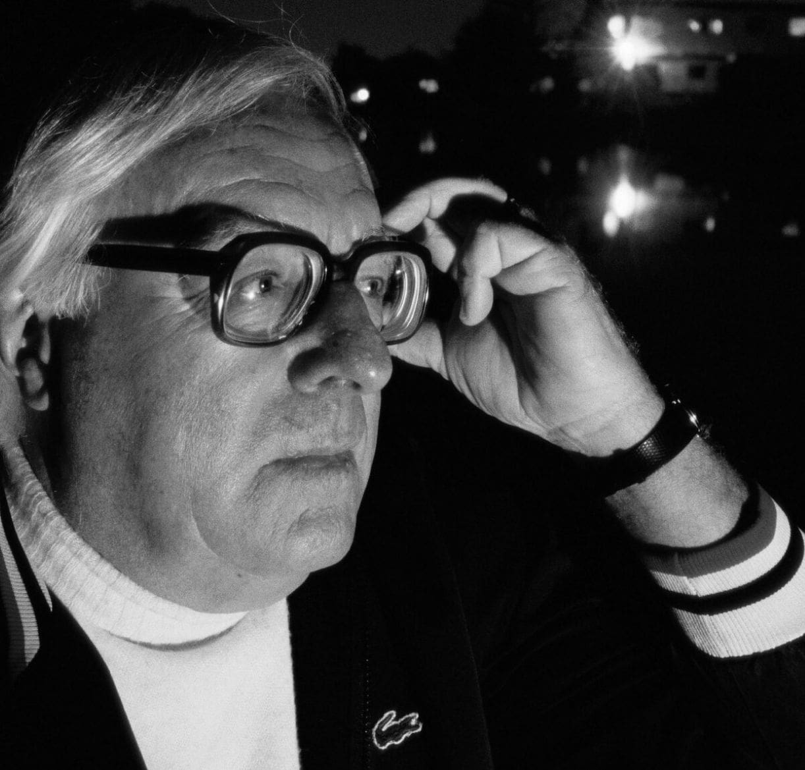

The Big Black and White Game, Ray Bradbury

The Big Black and White Game

The people filled the stands behind the wire screen, waiting. Us kids, dripping from the lake, ran between the white cottages, past the resort hotel, screaming, and sat on the bleachers, making wet bottom marks. The hot sun beat down through the tall oak trees around the baseball diamond.

Our fathers and mothers, in golf pants and light summer dresses, scolded us and made us sit still.

We looked toward the hotel and the back door of the vast kitchen, expectantly. A few colored women began walking across the shade-freckled area between, and in ten minutes the far left section of the bleachers was mellow with the color of their fresh-washed faces and arms.

After all these years, whenever I think back on it, I can still hear the sounds they made. The sound on the warm air was like a soft moving of dove voices each time they talked among themselves.

Everybody quickened into amusement, laughter rose right up into the clear blue Wisconsin sky, as the kitchen door flung wide and out ran the big and little, the dark and high-yellar uniformed Negro waiters, janitors, bus boys, boatmen, cooks, bottle washers, soda jerks, gardeners, and golflinks tenders.

They came capering, showing their fine white teeth, proud of their new red-striped uniforms, their shiny shoes rising and coming down on the green grass as they skirted the bleachers and drifted with lazy speed out on the field, calling to everybody and everything.

Us kids squealed. There was Long Johnson, the lawn-cutting man, and Cavanaugh, the soda-fountain man, and Shorty Smith and Pete Brown and Jiff Miller!

And there was Big Poe! Us kids shouted, applauded!

Big Poe was the one who stood so tall by the popcorn machine every night in the million-dollar dance pavilion farther down beyond the hotel on the lake rim. Every night I bought popcorn from Big Poe and he poured lots of butter all over it for me.

I stomped and yelled, ‘Big Poe! Big Poe!’

And he looked over at me and stretched his lips to bring out his teeth, waved, and shouted a laugh.

And Mama looked to the right, to the left, and back of us with worried eyes and nudged my elbow. ‘Hush,’ she said. ‘Hush.’

‘Land, land,’ said the lady next to my mother, fanning herself with a folded paper. ‘This is quite a day for the colored servants, ain’t it? Only time of year they break loose. They look forward all summer to the big Black and White game. But this ain’t nothing. You seen their Cakewalk Jamboree?’

‘We got tickets for it,’ said Mother. ‘For tonight at the pavilion. Cost us a dollar each. That’s pretty expensive, I’d say.’

‘But I always figure,’ said the woman, ‘once a year you got to spend. And it’s really something to watch them dance. They just naturally got…’

‘Rhythm,’ said Mother.

‘That’s the word,’ said the lady. ‘Rhythm. That’s what they got. Land, you should see the colored maids up at the hotel. They been buying sating yardage in at the big store in Madison for a month now.

And every spare minute they sit sewing and laughing. And I seen some of the feathers they bought for their hats. Mustard and wine ones and blue ones and violet ones. Oh, it’ll be a sight!’

‘They been airing out their tuxedos.’ I said. ‘I saw them hanging on lines behind the hotel all last week!’

‘Look at them prance,’ said Mother. ‘You’d think they thought they were going to win the game from our men.’

The colored men ran back and forth and yelled with their high, fluting voices and their low, lazy interminable voices. Way out in center field you could see the flash of teeth, their upraised naked black arms swinging and beating their sides as they hopped up and down and ran like rabbits, exuberantly.

Big Poe took a double fistful of bats, bundled them on his huge bull shoulder, and strutted along the first-base line, head back, mouth smiling wide open, his tongue moving, singing:

‘—gonna dance out both of my shoes,

When they play those Jelly Roll Blues;

Tomorrow night at the Dark Town Strutters’ Ball!’

Up went his knees and down and out, swinging the bats like musical batons. A burst of applause and soft laughter came from the left-hand grandstands, where all the young, ripply colored girls with shiny brown eyes sat eager and easy. They made quick motions that were graceful and mellow because, maybe, of their rich coloring. Their laughter was like shy birds; they waved at Big Poe, and one of them with a high voice cried, ‘Oh, Big Poe! Oh, Big Poe!’

The white section joined politely in the applause as Big Poe finished his cakewalk. ‘Hey, Big Poe!’ I yelled again.

‘Stop that, Douglas!’ said Mother, straight at me.

Now the white men came running between the trees with their uniforms on. There was a great thunder and shouting and rising up in our grandstand. The white men ran across the green diamond, flashing white.

‘Oh, there’s Uncle George!’ said Mother. ‘My, doesn’t he look nice?’ And there was my Uncle George toddling along in his outfit which didn’t quite fit because Uncle has a potbelly, and jowls that sit out over any collar he puts on. He was hurrying along, trying to breathe and smile at the same time, lifting up his pudgy little legs. ‘My, they look so nice,’ enthused Mother.

I sat there, watching their movements. Mother sat beside me, and I think she was comparing and thinking, too, and what she saw amazed and disconcerted her. How easily the dark people had come running first, like those slow-motion deer and buck antelopes in those African moving pictures, like things in dreams.

They came like beautiful brown, shiny animals that didn’t know they were alive, but lived. And when they ran and put their easy, lazy, timeless legs out and followed them with their big, sprawling arms and loose fingers and smiled in the blowing wind, their expressions didn’t say, ‘Look at me run, look at me run!’ No, not at all.

Their faces dreamily said. ‘Lord, but it’s sure nice to run. See the ground swell soft under me? Gosh, I feel good. My muscles are moving like oil on my bones and it’s the best pleasure in the world to run.’ And they ran. There was no purpose to their running but exhilaration and living.

The white men worked at their running as they worked at everything. You felt embarrassed for them because they were alive too much in the wrong way. Always looking from the corners of their eyes to see if you were watching.

The Negroes didn’t care if you watched or not; they went on living, moving. They were so sure of playing that they didn’t have to think about it any more.

‘My, but our men look so nice,’ said my mother, repeating herself rather flatly. She had seen, compared the teams. Inside, she realized how laxly the colored men hung swaying in their uniforms, and how tensely, nervously, the white men were crammed, shoved, and belted into their outfits.

I guess the tenseness began then.

I guess everybody saw what was happening. They saw how the white men looked like senators in sun suits. And they admired the graceful unawareness of the colored men. And, as is always the case, that admiration turned to envy, to jealousy, to irritation. It turned to conversation like:

‘That’s my husband, Tom, on third base. Why doesn’t he pick up his feet? He just stands there.’

‘Never you mind, never you mind. He’ll pick ’em up when the time comes!’

‘That’s what I say! Now, take my Henry, for instance. Henry mightn’t be active all the time, but when there’s a crisis—just you watch him. Uh—I do wish he’d wave or something, though. Oh, there! Hello, Henry!’

‘Look at that Jimmie Cosner playing around out there!’

I looked. A medium-sized white man with a freckled face and red hair was clowning on the diamond. He was balancing a bat on his forehead. There was laughter from the white grandstand. But it sounded like the kind of laughter you laugh when you’re embarrassed for someone.

‘Play ball!’ said the umpire.

A coin was flipped. The colored men batted first.

‘Darn it,’ said my mother.

The colored men ran in from the field happily.

Big Poe was first to bat. I cheered. He picked up the bat in one hand like a toothpick and idled over to the plate and laid the bat on his thick shoulder, smiling along its polished surface toward the stands where the colored women sat with their fresh flowery cream dresses stirring over their legs, which hung down between the seat intervals like crisp new sticks of ginger; their hair was all fancily spun and hung over their ears.

Big Poe looked in particular at the little, dainty-as-a-chicken-bone shape of his girl friend Katherine. She was the one who made the beds at the hotel and cottages every morning, who tapped on your door like a bird and politely asked if you was done dreaming, ’cause if you was she’d clean away all them old nightmares and bring in a fresh batch—please use them one at a time, thank yoah. Big Poe shook his head, looking at her, as if he couldn’t believe she was there.

Then he turned, one hand balancing the bat, his left hand dangling free at his side, to await the trial pitches. They hissed past, spatted into the open mouth of the catcher’s mitt, were hurled back. The umpire grunted. The next pitch was the starter.

Big Poe let the first ball go by him.

‘Stee-rike!’ announced the umpire. Big Poe winked good-naturedly at the white folks. Bang! ‘Stee-rike two!’ cried the umpire.

The ball came for the third time.

Big Poe was suddenly a greased machine pivoting; the dangling hand swept up to the butt end of the bat, the bat swiveled, connected with the ball—Whack! The ball shot up into the sky, away down toward the wavering line of oak trees, down toward the lake, where a white sailboat slid silently by. The crowd yelled, me loudest! There went Uncle George, running on his stubby, wool-stockinged legs, getting smaller with distance.

Big Poe stood for a moment watching the ball go. Then he began to run. He went around the bases, loping, and on the way home from third base he waved to the colored girls naturally and happily and they waved back, standing on their seats and shrilling.

Ten minutes later, with the bases loaded and run after run being driven in, and Big Poe coming to bat again, my mother turned to me. ‘They’re the most inconsiderate people,’ she said.

‘But that’s the game,’ I said. ‘They’ve only got two outs.’

‘But the score’s seven to nothing,’ my mother protested.

‘Well, just you wait until our men come to bat,’ said the lady next to my mother, waving away a fly with a pale blue-veined hand. ‘Those Negroes are too big for their britches.’

‘Stee-rike two!’ said the umpire as Big Poe swung.

‘All the past week at the hotel,’ said the woman next to my mother, staring out at Big Poe steadily, ‘the hotel service has been simply terrible. Those maids don’t talk about a thing save the Cakewalk Jamboree, and whenever you want ice water it takes them half an hour to fetch it, they’re so busy sewing.’

‘Ball one!’ said the umpire.

The woman fussed. ‘I’ll be glad when this week’s over, that’s what I got to say,’ she said.

‘Ball two!’ said the umpire to Big Poe.

‘Are they going to walk him?’ asked my mother of me. ‘Are they crazy?’ To the woman next to her: ‘That’s right. They been acting funny all week. Last night I had to tell Big Poe twice to put extra butter on my popcorn. I guess he was trying to save money or something.’

‘Ball three!’ said the umpire.

The lady next to my mother cried out suddenly and fanned herself furiously with her newspaper. ‘Land, I just thought! Wouldn’t it be awful if they won the game? They might, you know. They might do it.’

My mother looked at the lake, at the trees, at her hands. ‘I don’t know why Uncle George had to play. Make a fool of himself. Douglas, you run tell him to quit right now. It’s bad on his heart.’

‘You’re out!’ cried the umpire to Big Poe.

‘Ah,’ sighed the grandstand.

The side was retired. Big Poe laid down his bat gently and walked along the base line. The white men pattered in from the field looking red and irritable, with big islands of sweat under their armpits. Big Poe looked over at me. I winked at him. He winked back. Then I knew he wasn’t so dumb.

He’d struck out on purpose.

Long Johnson was going to pitch for the colored team.

He ambled out to the rubber, worked his fingers around in his fists to limber them up.

First white man to bat was a man named Kodimer, who sold suits in Chicago all year round.

Long Johnson fed them over the plate with tired, unassuming, controlled accuracy.

Mr Kodimer chopped. Mr Kodimer swatted. Finally Mr Kodimer bunted the ball down the third-base line.

‘Out at first base,’ said the umpire, an Irishman named Mahoney.

Second man up was a young Swede named Moberg. He hit a high fly to center field which was taken by a little plump Negro who didn’t look fat because he moved around like a smooth, round glob of mercury.

Third man up was a Milwaukee truck driver. He whammed a line drive to center field. It was good. Except that he tried to stretch it into a twobagger.

When he pulled up at second base, there was Emancipated Smith with a white pellet in his dark, dark hand, waiting.

My mother sank back in her seat, exhaling. ‘Well, I never!’

‘It’s getting hotter,’ said the lady elbow-next. ‘Think I’ll go for a stroll by the lake soon. It’s too hot to sit and watch a silly game today. Mightn’t you come along with me, missus?’ she asked Mother.

It went on that way for five innings.

It was eleven to nothing and Big Poe had struck out three times on purpose, and in the last half of the fifth was when Jimmie Cosner came to bat for our side again. He’d been trying all afternoon, clowning, giving directions, telling everybody just where he was going to blast that pill once he got hold of it.

He swaggered up toward the plate now, confident and bugle-voiced. He swung six bats in his thin hands, eying them critically with his shiny green little eyes. He chose one, dropped the others, ran to the plate, chopping out little islands of green fresh lawn with his cleated heels.

He pushed his cap back on his dusty red hair. ‘Watch this!’ he called out loud to the ladies. ‘You watch me show these dark boys! Ya-hah!’

Long Johnson on the mound did a slow serpentine windup. It was like a snake on a limb of a tree, uncoiling, suddenly darting at you. Instantly Johnson’s hand was in front of him, open, like black fangs, empty. And the white pill slashed across the plate with a sound like a razor.

‘Stee-rike!’

Jimmie Cosner put his bat down and stood glaring at the umpire. He said nothing for a long time. Then he spat deliberately near the catcher’s foot, took up the yellow maple bat again, and swung it so the sun glinted the rim of it in a nervous halo. He twitched and sidled it on his thinboned shoulder, and his mouth opened and shut over his long nicotined teeth.

Clap! went the catcher’s mitt.

Cosner turned, stared.

The catcher, like a black magician, his white teeth gleaming, opened up his oily glove. There, like a white flower glowing, was the baseball.

‘Stee-rike two!’ said the umpire, far away in the heat.

Jimmie Cosner laid his bat across the plate and hunched his freckled hands on his hips. ‘You mean to tell me that was a strike?’

‘That’s what I said,’ said the umpire. ‘Pick up the bat.’

‘To hit you on the head with,’ said Cosner sharply.

‘Play ball or hit the showers!’

Jimmie Cosner worked his mouth to collect enough saliva to spit, then angrily swallowed it, swore a bitter oath instead. Reaching down, he raised the bat, poised it like a musket on his shoulder.

And here came the ball! It started out small and wound up big in front of him. Powie! An explosion off the yellow bat. The ball spiraled up and up. Jimmie lit out for first base. The ball paused, as if thinking about gravity up there in the sky.

A wave came in on the shore of the lake and fell down. The crowd yelled. Jimmie ran. The ball made its decision, came down. A lithe high-yellar was under it, fumbled it. The ball spilled to the turf, was plucked up, hurled to first base.

Jimmie saw he was going to be out. So he jumped feet-first at the base.

Everyone saw his cleats go into Big Poe’s ankle. Everybody saw the red blood. Everybody heard the shout, the shriek, saw the heavy clouds of dust rising.

‘I’m safe!’ protested Jimmie two minutes later.

Big Poe sat on the ground. The entire dark team stood around him. The doctor bent down, probed Big Poe’s ankle, saying, ‘Mmmm,’ and ‘Pretty bad, Here.’ And he swabbed medicine on it and put a white bandage on it.

The umpire gave Cosner the cold-water eye. ‘Hit the showers!’

‘Like hell!’ said Cosner. And he stood on that first base, blowing his cheeks out and in, his freckled hands swaying at his side. ‘I’m safe. I’m staying right here, by God! No nigger put me out.’

‘No,’ said the umpire. ‘A white man did. Me. Get!’

‘He dropped the ball! Look up the rules! I’m safe!’

The umpire and Cosner stood glaring at each other.

Big Poe looked up from having his swollen ankle tended. His voice was thick and gentle and his eyes examined Jimmie Cosner gently.

‘Yes, he’s safe. Mr Umpire. Leave him stay. He’s safe.’

I was standing right there. I heard the whole thing. Me and some other kids had run out on the field to see. My mother kept calling me to come back to the stands.

‘Yes, he’s safe,’ said Big Poe again.

All the colored men let out a yell.

‘What’sa matter with you, black boy? You get hit in the head?’

‘You heard me,’ replied Big Poe quietly. He looked at the doctor bandaging him. ‘He’s safe. Leave him stay.’

The umpire swore.

‘Okay, okay. So he’s safe!’

The umpire stalked off, his back stiff, his neck red.

Big Poe was helped up. ‘Better not walk on that,’ cautioned the doctor.

‘I can walk,’ whispered Big Poe carefully.

‘Better not play.’

‘I can play,’ said Big Poe gently, certainly, shaking his head, wet streaks drying under his white eyes. ‘I’ll play good.’ He looked no place at all. ‘I’ll play plenty good.’

‘Oh,’ said the second-base colored man. It was a funny sound.

All the colored men looked at each other, at Big Poe, then at Jimmie Cosner, at the sky, at the lake, the crowd. They walked off quietly to take their places. Big Poe stood with his bad foot hardly touching the ground, balanced. The doctor argued. But Big Poe waved him away.

‘Batter up!’ cried the umpire.

We got settled in the stands again. My mother pinched my leg and asked me why I couldn’t sit still. It got warmer. Three or four more waves fell on the shore line. Behind the wire screen the ladies fanned their wet faces and the men inched their rumps forward on the wooden planks, held papers over their scowling brows to see Big Poe standing like a redwood tree out there on first base. Jimmie Cosner standing in the immense shade of that dark tree.

Young Moberg came up to bat for our side.

‘Come on. Swede, come on, Swede!’ was the cry, a lonely cry, like a dry bird, from out on the blazing green turf. It was Jimmie Cosner calling. The grandstand stared at him. The dark heads turned on their moist pivots in the outfield; the black faces came in his direction, looking him over, seeing his thin, nervously arched back. He was the center of the universe.

‘Come on, Swede! Let’s show these black boys!’ laughed Cosner.

He trailed off. There was a complete silence. Only the wind came through the high, glittering trees.

‘Come on, Swede, hang one on that old pill…’

Long Johnson, on the pitcher’s mound, cocked his head. Slowly, deliberately, he eyed Cosner. A look passed between him and Big Poe, and Jimmie Cosner saw the look and shut up and swallowed, hard.

Long Johnson took his time with his windup.

Cosner took a lead off base.

Long Johnson stopped loading his pitch.

Cosner skipped back to the bag, kissed his hand, and patted the kiss dead center on the plate. Then he looked up and smiled around.

Again the pitcher coiled up his long, hinged arm, curled loving dark fingers on the leather pellet, drew it back and—Cosner danced off first base. Cosner jumped up and down like a monkey. The pitcher did not look at him. The pitcher’s eyes watched him secretively, slyly, amusedly, sidewise. Then, snapping his head, the pitcher scared Cosner back to the plate. Cosner stood and jeered.

The third time Long Johnson made as if to pitch, Cosner was far off the plate and running toward second.

Snap went the pitcher’s hand. Bom went the ball in Big Poe’s glove at first base.

Everything was sort of frozen. Just for a second.

There was the sun in the sky, the lake and the boats on it, the grandstands, the pitcher on his mound standing with his hand out and down after tossing the ball; there was Big Poe with the ball in his mighty black hand; there was the infield staring, crouching in at the scene, and there was Jimmie Cosner running, kicking up dirt, the only moving thing in the entire summer world.

Big Poe leaned forward, sighted toward second base, drew back his mighty right hand, and hurled that white baseball straight down along the line until it reached Jimmie Cosner’s head.

Next instant, the spell was broken.

Jimmie Cosner lay flat on the burning grass. People boiled out of the grandstands. There was swearing, and women screaming, a clattering of wood as the men rushed down the wooden boards of the bleachers.

The colored team ran in from the field. Jimmie Cosner lay there. Big Poe, no expression on his face, limped off the field, pushing white men away from him like clothespins when they tried stopping him. He just picked them up and threw them away.

‘Come on, Douglas!’ shrieked Mother, grabbing me. ‘Let’s get home! They might have razors! Oh!’

That night, after the near riot of the afternoon, my folks stayed home reading magazines. All the cottages around us were lighted. Everybody was home. Distantly I heard music.

I slipped out the back door into the ripe summer-night darkness and ran toward the dance pavilion. All the lights were on, and music played.

But there were no white people at the tables. Nobody had come to the Jamboree.

There were only colored folks. Women in bright red and blue satin gowns and net stockings and soft gloves, with wine-plume hats, and men in glossy tuxedos. The music crashed out, up, down, and around the floor.

And laughing and stepping high, flinging their polished shoes out and up in the cakewalk, were Long Johnson and Cavanaugh and Jiff Miller and Pete Brown, and—limping—Big Poe and Katherine, his girl, and all the other lawn-cutters and boatmen and janitors and chambermaids, all on the floor at one time.

It was so dark all around the pavilion; the stars shone in the black sky, and I stood outside, my nose against the window, looking in for a long, long time, silently.

I went to bed without telling anyone what I’d seen.

I just lay in the dark smelling the ripe apples in the dimness and hearing the lake at night and listening to that distant, faint and wonderful music. Just before I slept I heard those last strains again:

‘—gonna dance out both of my shoes,

When they play those Jelly Roll Blues;

Tomorrow night at the Dark Town Strutters’ Ball!’

The end