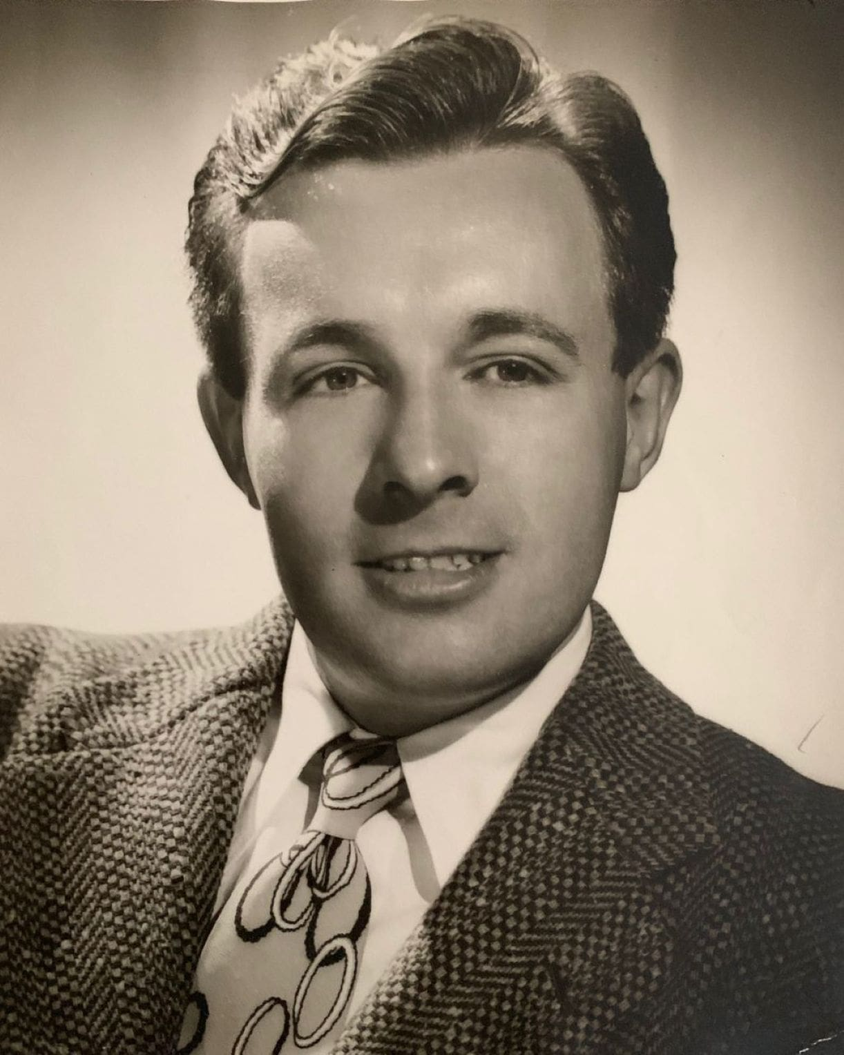

The Black Ferris, Ray Bradbury

The Black Ferris

The carnival had come to town like an October wind, like a dark bat flying over the cold lake, bones rattling in the night, mourning, sighing, whispering up the tents in the dark rain.

It stayed on for a month by the gray, restless lake of October, in the black weather and increasing storms and leaden skies.

During the third week, at twilight on a Thursday, the two small boys walked along the lake shore in the cold wind.

‘Aw, I don’t believe you,’ said Peter.

‘Come on, and I’ll show you,’ said Hank.

They left wads of spit behind them all along the moist brown sand of the crashing shore. They ran to the lonely carnival grounds. It had been raining.

The carnival lay by the sounding lake with nobody buying tickets from the flaky black booths, nobody hoping to get the salted hams from the whining roulette wheels, and none of the thin-fat freaks on the big platforms. The midway was silent, all the gray tents hissing on the wind like gigantic prehistoric wings.

At eight o’clock perhaps, ghastly lights would flash on, voices would shout, music would go out over the lake. Now there was only a blind hunchback sitting on a black booth, feeling of the cracked china cup from which he was drinking some perfumed brew.

‘There,’ said Hank, pointing.

The black Ferris wheel rose like an immense light-bulbed constellation against the cloudy sky, silent.

‘I still don’t believe what you said about it,’ said Peter.

‘You wait, I saw it happen. I don’t know how, but it did. You know how carnivals are: all funny. Okay; this one’s even funnier.’

Peter let himself he led to the high green hiding place of a tree.

Suddenly, Hank stiffened. ‘Hist! There’s Mr Cooger, the carnival man, now!’ Hidden, they watched.

Mr Cooger, a man of some thirty-five years, dressed in sharp bright clothes, a lapel carnation, hair greased with oil, drifted under the tree, a brown derby hat on his head. He had arrived in town three weeks before, shaking his brown derby hat at people on the street from inside his shiny red Ford, tooting the horn.

Now Mr Cooger nodded at the little blind hunchback, spoke a word. The hunchback blindly, fumbling, locked Mr Cooger into a black seat and sent him whirling up into the ominous twilight sky. Machinery hummed.

‘See!’ whispered Hank. ‘The Ferris wheel’s going the wrong way. Backwards instead of forwards!’

‘So what?’ said Peter.

‘Watch!’

The black Ferris wheel whirled twenty-five times around. Then the blind hunchback put out his pale hands and halted the machinery. The Ferris wheel stopped, gently swaying, at a certain black seat.

A ten-year-old boy stepped out. He walked off across the whispering carnival ground, in the shadows.

Peter almost fell from his limb. He searched the Ferris wheel with his eyes. ‘Where’s Mr Cooger!’

Hank poked him. ‘You wouldn’t believe! Now see!’

‘Where’s Mr Cooger at!’

‘Come on, quick, run!’ Hank dropped and was sprinting before he hit the ground.

Under giant chestnut trees, next to the ravine, the lights were burning in Mrs Foley’s white mansion. Piano music tinkled. Within the warm windows, people moved. Outside, it began to rain, despondently, irrevocably, forever and ever.

‘I’m so wet,’ grieved Peter, crouching in the bushes. ‘Like someone squirted me with a hose. How much longer do we wait?’

‘Ssh!’ said Hank, cloaked in wet mystery.

They had followed the little boy from the Ferris wheel up through town, down dark streets to Mrs Foley’s ravine house. Now, inside the warm dining room of the house the strange little boy sat at dinner, forking and spooning rich lamb chops and mashed potatoes.

‘I know his name,’ whispered Hank, quickly. ‘My mom told me about him the other day. She said, “Hank, you hear about the li’l orphan boy moved in Mrs Foley’s? Well, his name is Joseph Pikes and he just came to Mrs Foley’s one day about two weeks ago and said how he was an orphan run away and could he have something to eat, and him and Mrs Foley been getting on like hot apple pie ever since.”

That’s what my mom said,’ finished Hank, peering through the steamy Foley window. Water dripped from his nose. He held on to Peter who was twitching with cold. ‘Pete, I didn’t like his looks from the first, I didn’t. He looked—mean.’

‘I’m scared,’ said Peter, frankly wailing. ‘I’m cold and hungry and I don’t know what this’s all about.’

‘Gosh, you’re dumb!’ Hank shook his head, eyes shut in disgust. ‘Don’t you see, three weeks ago the carnival came. And about the same time this little ole orphan shows up at Mrs Foley’s.

And Mrs Foley’s son died a long time ago one night one winter, and she’s never been the same, so here’s this little ole orphan boy who butters her all around.’

‘Oh,’ said Peter, shaking.

‘Come on,’ said Hank. They marched to the front door and banged the lion knocker.

After a while the door opened and Mrs Foley looked out.

‘You’re all wet, come in,’ she said. ‘My land,’ she herded them into the hall. ‘What do you want?’ she said, bending over them, a tall lady with lace on her full bosom and a pale thin face with white hair over it. ‘You’re Henry Walterson, aren’t you?’

Hank nodded, glancing fearfully at the dining room where the strange little boy looked up from his eating. ‘Can we see you alone, ma’am?’ And when the old lady looked palely surprised, Hank crept over and shut the hall door and whispered at her.

‘We got to warn you about something, it’s about that boy come to live with you, that orphan?’

The hall grew suddenly cold. Mrs Foley drew herself high and stiff. ‘Well?’

‘He’s from the carnival, and he ain’t a boy, he’s a man, and he’s planning on living here with you until he finds where your money is and then run off with it some night, and people will look for him but because they’ll be looking for a little ten-year-old boy they won’t recognize him when he walks by a thirty-five-year-old man, named Mr Cooger!’ cried Hank.

‘What are you talking about?’ declared Mrs Foley.

‘The carnival and the Ferris wheel and this strange man, Mr Cooger, the Ferris wheel going backward and making him younger. I don’t know how, and him coming here as a boy, and you can’t trust him, because when he has your money he’ll get on the Ferris wheel and it’ll go forward, and he’ll be thirty-five years old again, and the boy’ll be gone forever!’

‘Good night, Henry Walterson, don’t ever come back!’ shouted Mrs Foley.

The door slammed. Peter and Hank found themselves in the rain once more. It soaked into and into them, cold and complete.

‘Smart guy,’ snorted Peter. ‘Now you fixed it. Suppose he heard us, suppose he comes and kills us in our beds tonight, to shut us all up for keeps!’

‘He wouldn’t do that,’ said Hank.

‘Wouldn’t he?’ Peter seized Hank’s arm. ‘Look.’

In the big bay window of the dining room now the mesh curtain pulled aside. Standing there in the pink light, his hand made into a menacing fist, was the little orphan boy. His face was horrible to see, the teeth bared, the eyes hateful, the lips mouthing out terrible words.

That was all. The orphan boy was there only a second, then gone. The curtain fell into place. The rain poured down upon the house. Hank and Peter walked slowly home in the storm.

During supper, Father looked at Hank and said, ‘If you don’t catch pneumonia, I’ll be surprised, Soaked, you were, by God! What’s this about the carnival?’

Hank fussed at his mashed potatoes, occasionally looking at the rattling windows. ‘You know Mr Cooger, the carnival man, Dad?’

‘The one with the pink carnation in his lapel?’ asked Father.

‘Yes!’ Hank sat up. ‘You’ve seen him around?’

‘He stays down the street at Mrs O’Leary’s boarding house, got a room in back. Why?’

‘Nothing,’ said Hank, his face glowing.

After supper Hank put through a call to Peter on the phone. At the other end of the line, Peter sounded miserable with coughing.

‘Listen, Pete!’ said Hank. ‘I see it all now. When that li’l ole orphan boy, Joseph Pikes, gets Mrs Foley’s money, he’s got a good plan.’

‘What?’

‘He’ll stick around town as the carnival man, living in a room at Mrs O’Leary’s. That way nobody’ll get suspicious of him. Everybody’ll be looking for that nasty little boy and he’ll be gone. And he’ll be walking around, all disguised as the carnival man. That way, nobody’ll suspect the carnival at all. It would look funny if the carnival suddenly pulled up stakes.’

‘Oh,’ said Peter, sniffling.

‘So we got to act fast,’ said Hank.

‘Nobody’ll believe us, I tried to tell my folks but they said hogwash!’ moaned Peter.

‘We got to act tonight, anyway. Because why? Because he’s gonna try to kill us! We’re the only ones that know and if we tell the police to keep an eye on him, he’s the one who stole Mrs Foley’s money in cahoots with the orphan boy, he won’t live peaceful. I bet he just tries something tonight. So, I tell you, meet me at Mrs Foley’s in half an hour.’

‘Aw,’ said Peter.

‘You wanna die?’

‘No.’ Thoughtfully.

‘Well, then. Meet me there and I bet we see that orphan boy sneaking out with the money, tonight, and running back down to the carnival grounds with it, when Mrs Foley’s asleep. I’ll see you there. So long. Pete!’

‘Young man,’ said Father, standing behind him as he hung up the phone. ‘You’re not going anywhere. You’re going straight up to bed. Here.’ He marched Hank upstairs. ‘Now hand me out everything you got on.’ Hank undressed. ‘There’re no other clothes in your room are there?’ asked Father. ‘No, sir, they’re all in the hall closet,’ said Hank, disconsolately.

‘Good,’ said Dad and shut and locked the door.

Hank stood there, naked. ‘Holy cow,’ he said.

‘Go to bed,’ said Father.

Peter arrived at Mrs Foley’s house at about nine-thirty, sneezing, lost in a vast raincoat and mariner’s cap. He stood like a small water hydrant on the street, mourning softly over his fate. The lights in the Foley house were warmly on upstairs. Peter waited for a half an hour, looking at the rain-drenched slick streets of night.

Finally, there was a darting paleness, a rustle in wet bushes.

‘Hank?’ Peter questioned the bushes.

‘Yeah.’ Hank stepped out.

‘Gosh,’ said Peter, staring. ‘You’re—you’re naked!’

‘I ran all the way,’ said Hank. ‘Dad wouldn’t let me out.’

‘You’ll get pneumonia,’ said Peter.

The lights in the house went out.

‘Duck,’ cried Hank, bounding behind some bushes. They waited. ‘Pete,’ said Hank. ‘You’re wearing pants, aren’t you?’

‘Sure,’ said Pete.

‘Well, you’re wearing a raincoat, and nobody’ll know, so lend me your pants,’ said Hank.

A reluctant transaction was made. Hank pulled the pants on.

The rain let up. The clouds began to break apart.

In about ten minutes a small figure emerged from the house, bearing a large paper sack filled with some enormous loot or other.

‘There he is,’ whispered Hank.

‘There he goes!’ cried Peter.

The orphan boy ran swiftly.

‘Get after him!’ cried Hank.

They gave chase through the chestnut trees, but the orphan boy was swift, up the hill, through the night streets of town, down past the rail yards, past the factories, to the midway of the deserted carnival. Hank and Peter were poor seconds, Peter weighted as he was with the heavy raincoat, and Hank frozen with cold. The thumping of Hank’s bare feet sounded through the town.

‘Hurry, Pete! We can’t let him get to that Ferris wheel before we do, if he changes back into a man we’ll never prove anything!’

‘I’m hurrying!’ But Pete was left behind as Hank thudded on alone in the clearing weather.

‘Yah!’ mocked the orphan boy, darting away, no more than a shadow ahead, now. Now vanishing into the carnival yard.

Hank stopped at the edge of the carnival lot. The Ferris wheel was going up and up into the sky, a big nebula of stars caught on the dark earth and turning forward and forward, instead of backward, and there sat Joseph Pikes in a black-painted bucket-seat, laughing up and around and down and up and around and down at little old Hank standing there, and the little blind hunchback had his hand on the roaring, oily black machine that made the Ferris wheel go ahead and ahead.

The midway was deserted because of the rain. The merry-go-round was still, but its music played and crashed in the open spaces. And Joseph Pikes rode up into the cloudy sky and came down and each time he went around he was a year older, his laughing changed, grew deep, his face changed, the bones of it, the mean eyes of it, the wild hair of it, sitting there in the black bucket-seat whirling, whirling swiftly, laughing into the bleak heavens where now and again a last split of lightning showed itself.

Hank ran forward at the hunchback by the machine. On the way he picked up a tent spike. ‘Here now!’ yelled the hunchback. The black Ferris wheel whirled around. ‘You!’ stormed the hunchback, fumbling out. Hank hit him in the kneecap and danced away. ‘Ouch!’ screamed the man, falling forward.

He tried to reach the machine brake to stop the Ferris wheel. When he put his hand on the brake, Hank ran in and slammed the tent spike against the fingers, mashing them. He hit them twice. The man held his hand in his other hand, howling. He kicked at Hank. Hank grabbed the foot, pulled, the man slipped in the mud and fell. Hank hit him on the head, shouting.

The Ferris wheel went around and around and around.

‘Stop, stop the wheel!’ cried Joseph Pikes-Mr Cooger, flung up in a stormy cold sky in the bubbled constellation of whirl and rush and wind.

‘I can’t move,’ groaned the hunchback. Hank jumped on his chest and they thrashed, biting, kicking.

‘Stop, stop the wheel!’ cried Mr Cooger, a man, a different man and voice this time, coming around in panic, going up into the roaring hissing sky of the Ferris wheel. The wind blew through the high dark wheel spokes. ‘Stop, stop, oh, please stop the wheel!’

Hank leaped up from the sprawled hunchback. He started in on the brake mechanism, hitting it, jamming it, putting chunks of metal in it, tying it with rope, now and again hitting at the crawling weeping dwarf.

‘Stop, stop, stop the wheel!’ wailed a voice high in the night where the windy moon was coming out of the vaporous white clouds now. ‘Stop…’ The voice faded.

Now the carnival was ablaze with sudden light. Men sprang out of tents, came running. Hank felt himself jerked into the air with oaths and beatings rained on him. From a distance there was a sound of Peter’s voice and behind Peter, at full tilt, a police officer with pistol drawn.

‘Stop, stop the wheel!’ In the wind the voice sighed away.

The voice repeated and repeated.

The dark carnival men tried to apply the brake. Nothing happened. The machine hummed and turned the wheel around and around. The mechanism was jammed.

‘Stop!’ cried the voice one last time.

Silence.

Without a word the Ferris wheel flew in a circle, a high system of electric stars and metal and seats. There was no sound now but the sound of the motor which died and stopped. The Ferris wheel coasted for a minute, all the carnival people looking up at it, the policeman looking up at it, Hank and Peter looking up at it.

The Ferris wheel stopped. A crowd had gathered at the noise. A few fishermen from the wharfhouse, a few switchmen from the rail yards. The Ferris wheel stood whining and stretching in the wind.

‘Look,’ everybody said.

The policeman turned and the carnival people turned and the fishermen turned and they all looked at the occupant in the black-painted seat at the bottom of the ride. The wind touched and moved the black wooden seat in a gentle rocking rhythm, crooning over the occupant in the dim carnival light.

A skeleton sat there, a paper bag of money in its hands, a brown derby hat on its head.

The end