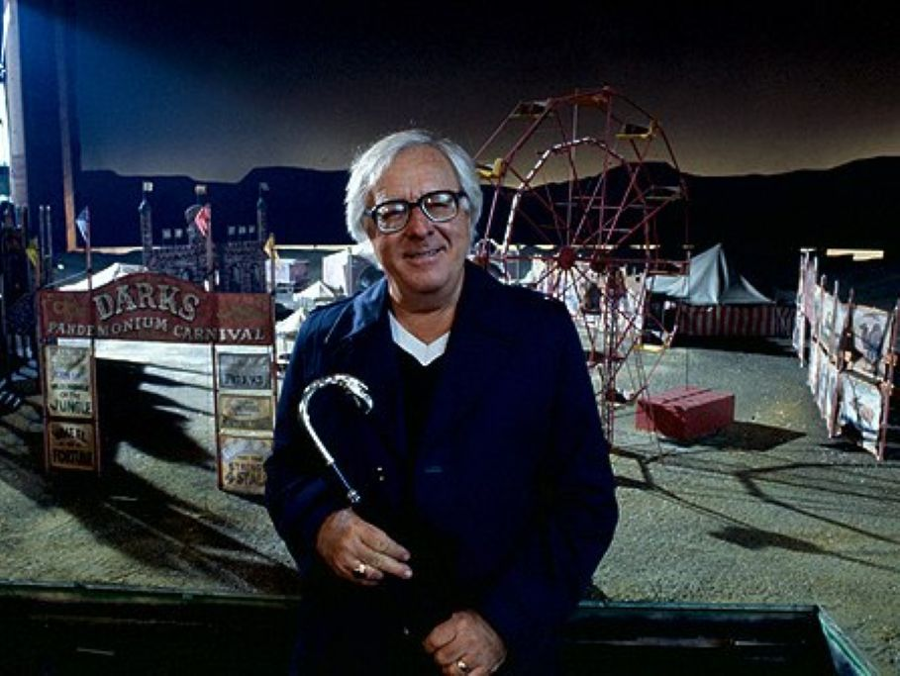

The Coffin, Ray Bradbury

The Coffin

There was any amount of banging and hammering for a number of days: deliveries of metal parts and oddments which Mr Charles Braling took into his little workshop with a feverish anxiety.

He was a dying man, a badly dying man, and he seemed to be in a great hurry, between racking coughs and spittlings, to piece together one last invention.

‘What are you doing?’ inquired his younger brother, Richard Braling. He had listened with increasing difficulty and much curiosity for a number of days to that banging and rattling about, and now he stuck his head through the work-room door.

‘Go far far away and let me alone,’ said Charles Braling, who was seventy, trembly and wet-lipped most of the time. He trembled nails into place and trembled a hammer down with a weak blow upon a large timber and then struck a small metal ribbon down into an intricate machine, and, all in all, was having a carnival of labor.

Richard looked on, bitter-eyed, for a long moment. There was a hatred between them. It had gone on for some years and now was neither any better nor any worse for the fact that Charlie was dying. Richard was delighted to know of the impending death, if he thought of it at all. But all this busy fervor of his old brothers stimulated him.

‘Pray tell,’ he said, not moving from the door.

‘If you must know,’ snarled old Charles, fitting in an odd thingumabob on the box before him, ‘I’ll be dead in another week and I’m—I’m building my own coffin!’

‘A coffin, my dear Charlie. That doesn’t look like a coffin. A coffin isn’t that complex. Come on now, what are you up to?’

‘I tell you it’s a coffin! An odd coffin, yes, but nevertheless,’ the old man shivered his fingers around in the large box, ‘—nevertheless a coffin!’

‘But it would be easier to buy one.’

‘Not one like this! You couldn’t buy one like this anyplace, ever. Oh, it’ll be a real fine coffin, all right.’

‘You’re obviously lying.’ Richard moved forward. ‘Why, that coffin is a good twelve feet long. Six feet longer than normal size!’

‘Oh, yes?’ The old man laughed quietly.

‘And that transparent top: who ever heard of a coffin lid you can see through? What good is a transparent lid to a corpse?’

‘Oh, just never you mind at all,’ sang the old man heartily. ‘La!’ And he went humming and hammering about the shop.

‘This coffin is terribly thick,’ shouted the young brother over the din. ‘Why, it must be five feet thick: how utterly unnecessary!’

‘I only wish I might live to patent this amazing coffin,’ said old Charlie. ‘It would be a god-send to all the poor peoples of the world. Think how it would eliminate the expenses of most funerals.

Oh, but, of course, you don’t know how it would do that, do you? How silly of me. Well, I shan’t tell you. If this coffin could be mass-produced—expensive at first, naturally—but then when you finally got them made in vast quantities, gah, but the money people would save.’

‘To hell with you!’ And the younger brother stormed out of the shop.

It had been an unpleasant life. Young Richard had always been such a bounder he never had two coins to clink together at one time: all of his money had come from old brother Charlie, who had the indecency to remind him of it at all times.

Richard spent many hours with his hobbies: he dearly loved piling up bottles with French wine labels, in the garden. ‘I like the way they glint,’ he often said, sitting and sipping, sipping and sitting. He was the only man in the county who could hold the longest gray ash on a fifty-cent cigar for the longest recorded time.

And he knew how to hold his hands so his diamonds jangled in the light.

But he had not bought the wine, the diamonds, the cigars—no! They were all gifts. He was never allowed to buy anything himself. It was always brought to him and given to him. He had to ask for everything, even writing paper.

He considered himself quite a martyr to have put up with taking things from that rickety old brother for so long a time. Everything Charlie ever laid his hand to turned to money; everything Richard had ever tried in the way of a leisurely career had failed.

And now, here was this old mole of a Charlie whacking out a new invention which would probably bring Charlie additional specie long after his bones were slotted in the earth!

Well, two weeks passed.

One morning, the old brother toddled upstairs and stole the insides out of the electric phonograph. Another morning he raided the gardener’s greenhouse. Still another time he received a delivery from a medical company. It was all young Richard could do to sit and hold his long gray cigar ash steady while these murmuring excursions took place.

‘I’m finished!’ cried old Charlie on the fourteenth morning, and dropped dead.

Richard finished out his cigar, and, without showing his inner excitement, he laid down his cigar with its fine long whitish ash, two inches long, a real record, and arose.

He walked to the window and watched the sunlight playfully glittering among the fat beetlelike champagne bottles in the garden.

He looked toward the top of the stairs where old dear brother Charlie lay peacefully sprawled against the banister. Then he walked to the phone and perfunctorily dialed a number.

‘Hello, Green Lawn Mortuary? This is the Braling residence. Will you send around a wicker, please? Yes. For brother Charlie. Yes. Thank you. Thank you.’

As the mortuary people were taking brother Charles out in their wicker they received instructions. ‘Ordinary casket,’ said young Richard. ‘No funeral service. Put him in a pine coffin. He would have preferred it that way—simple. Good-by.’

‘Now!’ said Richard, rubbing his hands together. ‘We shall see about this coffin’ built by dear Charlie. I do not suppose he will realize he is not being buried in his “special” box. Ah.’

He entered the downstairs shop.

The coffin sat before some wide-flung French windows, the lid shut, complete and neat, all put together like the fine innards of a Swiss watch. It was vast, and it rested upon a long long table with rollers beneath for easy maneuvering.

The coffin interior, as he peered through the glass lid, was six feet long. There must be a good three feet of false body at both head and foot of the coffin, then. Three feet at each end which, covered by secret panels that he must find some way of opening, might very well reveal—exactly what?

Money, of course. It would be just like Charlie to suck his riches into his grave with himself, leaving Richard with not a cent to buy a bottle with. The old bastard!

He raised the glass lid and felt about, but found no hidden buttons. There was a small sign studiously inked on white paper, thumbtacked to the side of the satin-lined box. It said:

THE BRALING ECONOMY CASKET. Copyright, April, 1946. Simple to operate. Can be used again and again by morticians and families with an eye to the future.

Richard snorted thinly. Who did Charlie think he was fooling? There was more writing:

DIRECTIONS: SIMPLY PLACE BODY IN COFFIN—

What a fool thing to say. Put body in coffin! Naturally! How else would one go about it? He peered intently and finished out the directions:

SIMPLY PLACE BODY IN COFFIN—AND MUSIC WILL START.

‘It can’t be—’ Richard gaped at the sign. ‘Don’t tell me all this work has been for a—’ He went to the open door of the shop, walked out upon the tiled terrace and called to the gardener in his greenhouse.

‘Rogers!’ The gardener stuck his head out. ‘What time is it?’ asked Richard. ‘Twelve o’clock, sir,’ replied Rogers. ‘Well, at twelve-fifteen, you come up here and check to see if everything is all right. Rogers,’ said Richard. ‘Yes, sir,’ said the gardener. Richard turned and went back into the shop. ‘We’ll find out—’ he said, quietly.

There would be no harm in lying in the box, testing it. He noticed small ventilating holes in the sides. Even if the lid were closed down there’d be air. And Rogers would be up in a moment or two. SIMPLY PLACE BODY IN COFFIN—AND MUSIC WILL START. Really, how naive of old Charlie! Richard hoisted himself up.

He was like a man getting into a bathtub. He felt naked and watched over. He put one shiny shoe into the coffin and crooked his knee and eased himself up and made some little remark to nobody in particular, then he put in his other knee and foot and crouched there, as if undecided about the temperature of the bath-water.

Edging himself about, chuckling softly, he lay down, pretending to himself (for it was fun pretending) that he was dead, that people were dropping tears on him, that candles were fuming and illuminating and that the world was stopped in mid-stride because of his passing.

He put on a long pale expression, shut his eyes, holding back the laughter in himself behind pressed, quivering lips. He folded his hands and decided they felt waxen and cold.

Whirr. Spung! Something whispered inside the box-wall. Spung!

The lid slammed down on him!

From outside, if one had just come into the room, one would have imagined a wild man was kicking, pounding, blathering, and shrieking inside a closet! There was a sound of a body dancing and cavorting. There was a thudding of flesh and fists. There was a squeaking and a kind of wind from a frightened man’s lungs.

There was a rustling like paper and a shrilling as of many pipes simultaneously played. Then there was a real fine scream. Then—silence.

Richard Braling lay in the coffin and relaxed. He let loose all his muscles. He began to chuckle. The smell of the box was not unpleasant. Through the little perforations he drew more than enough air to live on, comfortably. He need only push gently up with his hands, with none of this kicking and screaming, and the lid would open. One must be calm. He flexed his arms.

The lid was locked.

Well, still there was no danger. Rogers would be up in a minute or two. There was nothing to fear.

The music began to play.

It seemed to come from somewhere inside the head of the coffin. It was green music. Organ music, very slow and melancholy, typical of Gothic arches and long black tapers. It smelled of earth and whispers. It echoed high between stone walls.

It was so sad that one almost cried listening to it. It was music of potted plants and crimson and blue stained-glass windows. It was late sun at twilight and a cold wind blowing. It was a dawn with only fog and a faraway fog horn moaning.

‘Charlie, Charlie, Charlie, you old fool you! So this is your odd coffin!’ Tears of laughter welled into Richard’s eyes. ‘Nothing more than a coffin which plays its own dirge. Oh, my sainted grandma!’

He lay and listened critically, for it was beautiful music and there was nothing he could do until Rogers came up and let him out. His eyes roved aimlessly, his fingers tapped soft little rhythms on the satin cushions. He crossed his legs idly. Through the glass lid he saw sunlight shooting through the French windows, dust particles dancing on it. It was a lovely blue day.

The sermon began.

The organ music quieted and a gentle voice said:

‘We are gathered together, those who loved and those who knew the deceased, to give him our homage and our due—’

‘Charlie, bless you, that’s your voice!’ Richard was delighted. ‘A mechanical funeral, by God. Organ music and lecture. And Charlie giving his own oration for himself!’

The soft voice said. ‘We who knew and loved him are grieved at the passing of—’

‘What was that?’ Richard raised himself, startled. He didn’t quite believe what he had heard. He repeated it to himself just the way he had heard it:

‘We who knew and loved him are grieved at the passing of Richard Braling.’

That’s what the voice had said.

‘Richard Braling,’ said the man in the coffin. ‘Why. I’m Richard Braling.’

A slip of the tongue, naturally. Merely a slip. Charlie had meant to say ‘Charles’ Braling. Certainly. Yes. Of course. Yes. Certainly. Yes. Naturally. Yes.

‘Richard was a fine man,’ said the voice, talking on. ‘We shall see no finer in our time.’

‘My name again!’

Richard began to move about uneasily in the coffin.

Why didn’t Rogers come?

It was hardly a mistake, using that name twice. Richard Braling. Richard Braling. We are gathered here. We shall miss—We are grieved. No finer man. No finer in our time. We are gathered here. The deceased. Richard Braling. Richard Braling.

Whirrrr. Spung!

Flowers! Six dozen bright blue, red, yellow, sun-brilliant flowers leaped up from behind the coffin on concealed springs!

The sweet odor of fresh-cut flowers filled the coffin. The flowers swayed gently before his amazed vision, tapping silently on the glass lid. Others sprang up until the coffin was banked with petals and color and sweet odors. Gardenias and dahlias and daffodils, trembling and shining.

‘Rogers!’

The sermon continued.

‘—Richard Braling, in his life, was a connoisseur of great and good things—’

The music sighed, rose and fell, distantly.

‘Richard Braling savored of life, as one savors of a rare wine, holding it upon the lips—’

A small panel in the side of the box flipped open. A swift bright metal arm snatched out. A needle stabbed Richard in the thorax, not very deeply. He screamed. The needle shot him full of a colored liquor before he could seize it. Then it popped back into a receptacle and the panel snapped shut.

‘Rogers!’

A growing numbness, Suddenly he could not move his fingers or his arms or turn his head. His legs were cold and limp.

‘Richard Braling loved beautiful things. Music. Flowers,’ said the voice.

‘Rogers!’

This time he did not scream it. He could only think it. His tongue was motionless in his anaesthetized mouth.

Another panel opened. Metal forceps issued forth on steel arms. His left wrist was pierced by a huge sucking needle.

His blood was being drained from his body.

He heard a little pump working somewhere.

‘—Richard Braling will be missed among us—’

The organ sobbed and murmured.

The flowers looked down upon him, nodding their bright-petalled heads.

Six candles, black and slender, rose up out of hidden receptacles, and stood behind the flowers, flickering and glowing.

Another pump started to work. While his blood drained out one side of his body, his right wrist was punctured, held, a needle shoved into it, and the second pump began to force formaldehyde into him.

Pump, pause, pump, pause, pump, pause, pump, pause.

The coffin moved.

A small motor popped and chugged. The room drifted by on either side of him. Little wheels revolved. No pallbearers were necessary. The flowers swayed as the casket moved gently out upon the terrace under a blue clear sky.

Pump, pause, Pump, pause.

‘Richard Braling will be missed—’

Sweet soft music.

Pump, pause.

‘Ah, sweet mystery of life, at last—’ Singing.

‘Braling, the gourmet—’

‘Ah, at last I have the secret of it all—’

Staring, staring, his eyes egg-blind, at the little card out of the corners of his eyes:

THE BRALING ECONOMY CASKET…

DIRECTIONS SIMPLY PLACE BODY IN COFFIN—AND MUSIC WILL START.

A tree swung by overhead. The coffin rolled gently through the garden, behind some bushes, carrying the voice and the music with it.

‘Now it is the time when we must consign this part of this man to the earth—’

Little shining spades leaped out of the sides of the casket.

They began to dig.

He saw the spades toss up dirt. The coffin settled. Bumped, settled, dug, bumped and settled, dug, bumped and settled again.

Pulse, pause, pulse, pause. Pump, pause.

pulse, pump, pause.

‘Ashes to ashes, dust to dust—’

The flowers shook and jolted. The box was deep. The music played.

The last thing Richard Braling saw was the spading arms of the Braling Economy Casket reaching up and pulling the hole in after it.

‘Richard Braling, Richard Braling, Richard Braling, Richard Braling, Richard Braling…’

The record was stuck.

Nobody minded. Nobody was listening.

The end