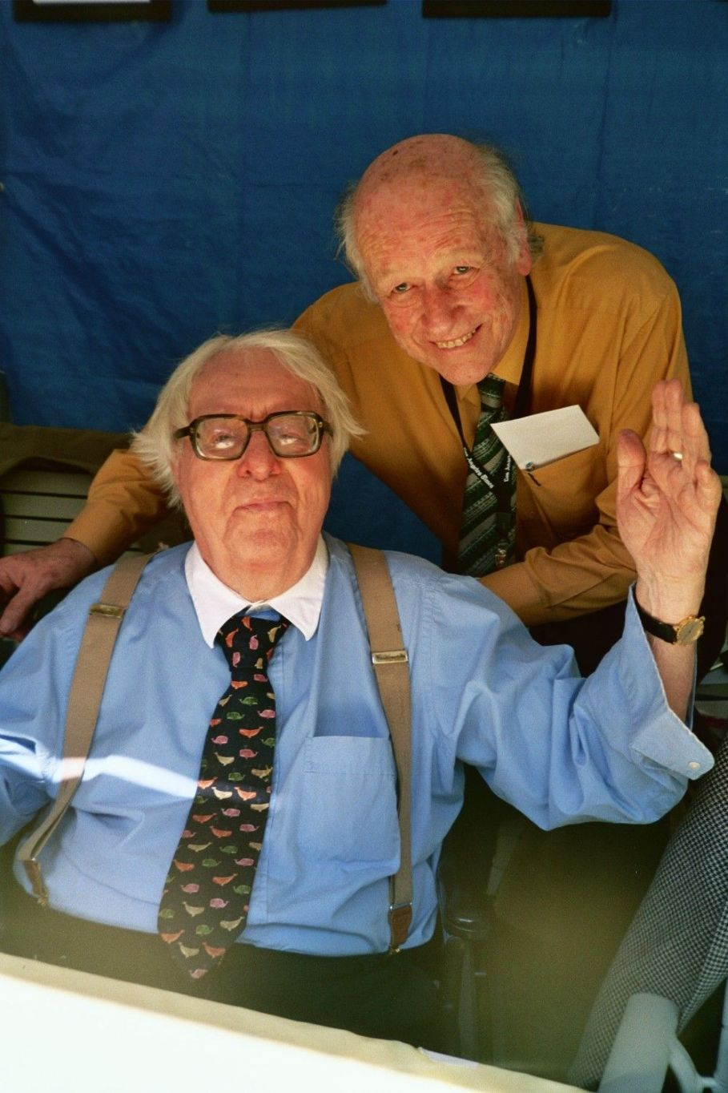

The Crowd, Ray Bradbury

The Crowd

Mr. Spallner put his hands over his face.

There was the feeling of movement in space, the beautifully tortured scream, the impact and tumbling of the car with wall, through wall, over and down like a toy, and him hurled out of it. Then — silence.

The crowd came running. Faintly, where he lay, he heard them running. He could tell their ages and their sizes by the sound of their numerous feet over the summer grass and on the lined pavement, and over the asphalt street, and picking through the cluttered bricks to where his car hung half into the night sky, still spinning its wheels with a senseless centrifuge.

Where the crowd came from he didn't know. He struggled to remain aware and then the crowd faces hemmed in upon him, hung over him like the large glowing leaves of down-bent trees.

They were a ring of shifting, compressing, changing faces over him, looking down, looking down, reading the time of his life or death by his face, making his face into a moon-dial, where the moon cast a shadow from his nose out upon his cheek to tell the time of breathing or not breathing any more ever.

How swiftly a crowd comes, he thought, like the iris of an eye compressing in out of nowhere.

A siren. A police voice. Movement. Blood trickled from his lips and he was being moved into an ambulance. Someone said, 'Is he dead?' And someone else said, 'No, he's not dead.' And a third person said, 'He won't die, he's not going to die.'

And he saw the faces of the crowd beyond him in the night, and he knew by their expressions that he wouldn't die. And that was strange. He saw a man's face, thin, bright, pale; the man swallowed and bit his lips, very sick. There was a small woman, too, with red hair and too much red on her cheeks and lips.

And a little boy with a freckled face. Others' faces. An old man with a wrinkled upper lip, an old woman, with a mole upon her chin. They had all come from — where? Houses, cars, alleys, from the immediate and the accident-shocked world. Out of alleys and out of hotels and out of street-cars and seemingly out of nothing they came.

The crowd looked at him and he looked back at them and did not like them at all. There was a vast wrongness to them. He couldn't put his finger on it. They were far worse than this machine-made thing that happened to him now.

The ambulance doors slammed. Through the windows he saw the crowd looking in, looking in. That crowd that always came so fast, so strangely fast, to form a circle, to peer down, to probe, to gawk, to question, to point, to disturb, to spoil the privacy of a man's agony by their frank curiosity.

The ambulance drove off. He sank back and their faces still stared into his face, even with his eyes shut.

The car wheels spun in his mind for days. One wheel, four wheels, spinning, spinning, and whirring, around and around.

He knew it was wrong. Something wrong with the wheels and the whole accident and the running of feet and the curiosity. The crowd faces mixed and spun into the wild rotation of the wheels.

He awoke.

Sunlight, a hospital room, a hand taking his pulse.

'How do you feel?' asked the doctor.

The wheels faded away. Mr. Spallner looked around.

'Fine — I guess.'

He tried to find words. About the accident. 'Doctor?'

'Yes?'

'That crowd — was it last night?'

'Two days ago. You've been here since Thursday. You're all right, though. You're doing fine. Don't try and get up.'

'That crowd. Something about wheels, too. Do accidents make people, well, a — little off.'

'Temporarily, sometimes. It wears off.'

He lay staring up at the doctor. 'Does it hurt your time sense?'

'Panic sometimes does.'

'Makes a minute seem like an hour, or maybe an hour seem like a minute?'

'Yes.'

'Let me tell you then.' He felt the bed under him, the sunlight on his face. 'You'll think I'm crazy. I was driving too fast, I know. I'm sorry now. I jumped the curb and hit that wall. I was hurt and numb, I know, but I still remember things. Mostly — the crowd.'

He waited a moment and then decided to go on, for he suddenly knew what it was that bothered him. 'The crowd got there too quickly. Thirty seconds after the smash they were all standing over me and staring at me. . . it's not right they should run that fast, so late at night. . .'

'You only think it was thirty seconds,' said the doctor. 'It was probably three or four minutes. Your senses — '

'Yeah, I know — my senses, the accident. But I was conscious! I remember one thing that puts it all together and makes it funny, God, so damned funny. The wheels of my car, upside down. The wheels were still spinning when the crowd got there!'

The doctor smiled.

The man in bed went on. 'I'm positive! The wheels were spinning and spinning fast — the front wheels! Wheels don't spin very long, friction cuts them down. And these were really spinning!'

'You're confused,' said the doctor.

'I'm not confused. That street was empty. Not a soul in sight. And then the accident and the wheels still spinning and all those faces over me, quick, in no time. And the way they looked down at me, I knew I wouldn't die. . .'

'Simple shock,' said the doctor, walking away into the sunlight.

They released him from the hospital two weeks later. He rode home in a taxi. People had come to visit him during his two weeks on his back, and to all of them he had told his story, the accident, the spinning wheels, the crowd. They had all laughed with him concerning it, and passed it off.

He leaned forward and tapped on the taxi window.

'What's wrong?'

The cabbie looked back. 'Sorry, boss town to drive in. Got an accident up detour!'

'Yes. No, no! Wait. Go ahead. Let's — let's take a look.'

The cab moved forward, honking.

'Funny damn thing,' said the cabbie. 'Hey, you! Get that fleatrap out the way!' Quieter. 'Funny thing — more damn people. Nosy people.'

Mr. Spallner looked down and watched his fingers tremble on his knee. 'You noticed that, too?'

'Sure,' said the cabbie. 'All the time. There's always a crowd. You'd think it was their own mother got killed.'

'They come running awfully fast,' said the man in the back of the cab.

'Same way with a fire or an explosion. Nobody around. Boom. Lotsa people around. I dunno.'

'Ever seen an accident — at night?'

The cabbie nodded. 'Sure. Don't make no difference. There's always a crowd.'

The wreck came in view. A body lay on the pavement. You knew there was a body even if you couldn't see it. Because of the crowd. The crowd with its back towards him as he sat in the rear of the cab. With its back towards him. He opened the window and almost started to yell. But he didn't have the nerve. If he yelled they might turn around.

And he was afraid to see their faces.

'I seem to have a penchant for accidents,' he said, in his office. It was late afternoon. His friend sat across the desk from him, listening. 'I got out of the hospital this morning and first thing on the way home, we detoured around a wreck.'

'Things run in cycles,' said Morgan.

'Let me tell you about my accident.'

'I've heard it. Heard it all.'

'But it was funny, you must admit.'

'I must admit. Now how about a drink.'

They talked on for half an hour or more. All the while they talked at the back of Spallner's brain a small watch ticked, a watch that never needed winding. It was the memory of a few little things. Wheels and faces.

At about five-thirty there was a hard metal noise in the street. Morgan nodded and looked out and down. 'What'd I tell you? Cycles. A truck and a cream-coloured Cadillac. Yes, yes.'

Spallner walked to the window.

He was very cold and as he stood there, he looked at his watch, at the small minute hand. One two three four five seconds — people running — eight nine ten eleven twelve — from all over, people came running — fifteen sixteen seventeen eighteen seconds — more people, more cars, more horns blowing.

Curiously distant, Spallner looked upon the scene as an explosion in reverse, the fragments of the detonation sucked back to the point of impulsion. Nineteen, twenty, twenty-one seconds and the crowd was there. Spallner made a gesture down at them, wordless.

The crowd had gathered so fast.

He saw a woman's body a moment before the crowd swallowed it up.

Morgan said. 'You look lousy. Here. Finish your drink.'

'I'm all right, I'm all right. Let me alone. I'm all right. Can you see those people? Can you see any of them? I wish we could see them closer.'

Morgan cried out, 'Where in hell are you going?'

Spallner was out the door, Morgan after him, and down the stairs, as rapidly as possible. 'Come along, and hurry.'

'Take it easy, you're not a well man!'

They walked out on to the street. Spallner pushed his way forward. He thought he saw a red-haired woman with too much red colour on her cheeks and lips.

'There!' He turned wildly to Morgan. 'Did you see her?'

'See who?'

'Damn it; she's gone. The crowd closed in!'

The crowd was all around, breathing and looking and shuffling and mixing and mumbling and getting in the way when he tried to shove through. Evidently the red-haired woman had seen him coming and run off.

He saw another familiar face! A little freckled boy. But there are many freckled boys in the world. And, anyway, it was no use, before Spallner reached him, this little boy ran away and vanished among the people.

'Is she dead?' a voice asked. 'Is she dead?'

'She's dying,' someone else replied. 'She'll be dead before the ambulance arrives. They shouldn't have moved her. They shouldn't have moved her.'

All the crowd faces — familiar, yet unfamiliar, bending over, looking down, looking down.

'Hey, mister, stop pushing.'

'Who you shovin', buddy?'

Spallner came back out, and Morgan caught hold of him before he fell. 'You damned fool. You're still sick. Why in hell'd you have to come down here?' Morgan demanded.

'I don't know, I really don't. They moved her, Morgan, someone moved her. You should never move a traffic victim. It kills them. It kills them.'

'Yeah. That's the way with people. The dumb saps.'

Spallner arranged the newspaper clippings carefully.

Morgan looked at them. 'What's the idea? Ever since your wreck you think every traffic scramble is part of you. What are these?'

'Clippings of motor car crackups, and photos. Look at them. Not at the cars,' said Spallner, 'but at the crowds around the cars.' He pointed. 'Here. Compare this photo of a wreck in the Wilshire District with one in Westwood. No resemblance. But now take this Westwood picture and align it with one taken in the Westwood District ten years ago.' Again he motioned. 'This woman is in both pictures.'

'Coincidence. The woman happened to be there once in 1936, again in 1946.'

'A coincidence once, maybe. But twelve times over a period of ten years, when the accidents occurred as much as three miles from one another, no. Here.' He dealt out a dozen photographs. 'She's in all of these!'

'Maybe she's perverted.'

'She's more than that. How does she happen to be there so quickly after each accident? And why does she wear the same clothes in pictures taken over a period of a decade?'

'I'll be damned, so she is.'

'And, last of all, why was she standing over me the night of my accident, two weeks ago!'

They had a drink. Morgan went over the files. 'What'd you do, hire a clipping service while you were in the hospital to go back through the newspapers for you?' Spallner nodded. Morgan sipped his drink. It was getting late. The street lights were coming on in the streets below the office. 'What does all this add up to?'

'I don't know,' said Spallner, 'except that there's a universal law about accidents. Crowds gather. They always gather. And people, like you and I, have wondered from year after year, why they gathered so quickly, and how. I know the answer. Here it is!'

He flung the clippings down. 'It frightens me.'

'These people — mightn't they be thrill-hunters, perverted sensationalists with a carnal lust for blood and morbidity?'

Spallner shrugged. 'Does that explain their being at all the accidents? Notice, they stick to certain territories. A Brentwood accident will bring out one group. A Huntington Park another. But there's a norm for faces, a certain percentage appear at each wreck.'

Morgan said, 'They're not all the same faces, are they?'

'Naturally not. Accidents draw normal people, too, in the course of time. But these, I find, are always the first ones there.'

'Who are they? What do they want? You keep hinting and never telling. Good Lord, you must have some idea. You've scared yourself and now you've got me jumping.'

'I've tried getting to them, but someone always trips me up, I'm always too late. They slip into the crowd and vanish. The crowd seems to offer protection to some of its members. They see me coming.'

'Sounds like some sort of clique.'

'They have one thing in common, they always show up together. At a fire or an explosion or on the sidelines of a war, at any public demonstration of this thing called death. Vultures, hyenas or saints, I don't know which they are, I just don't know. But I'm going to the police with it, this evening. It's gone on long enough. One of them shifted that woman's body today. They shouldn't have touched her. It killed her.'

He placed the clippings in a brief-case. Morgan got up and slipped into his coat. Spallner clicked the brief-case shut. 'Or, I just happened to think of it. . .'

'What?'

'Maybe they wanted her dead.'

'Why?'

'Who knows. Come along?'

'Sorry. It's late. See you tomorrow. Luck.' They went out together. 'Give my regards to the cops. Think they'll believe you?'

'Oh, they'll believe me all right. Good night.'

Spallner took it slow driving down-town.

'I want to get there,' he told himself, 'alive.'

He was rather shocked, but not surprised, somehow, when the truck came rolling out of an alley straight at him. He was just congratulating himself on his keen sense of observation and talking out what he would say to the police department in his mind when the truck smashed into his car. It wasn't really his car, that was the disheartening thing about it.

In a preoccupied mood he was tossed first this way and then that way, while he thought, what a shame, Morgan has gone and lent me his extra car for a few days until my other car is fixed, and now here I go again. The windshield hammered back into his face. He was forced back and forth in several lightning jerks. Then all motion stopped and all noise stopped and only pain filled him up.

He heard their feet running and running and running. He fumbled with the car door. It clicked. He fell out upon the pavement drunkenly and lay, ear to the asphalt, listening to them coming. It was like a great rainstorm, with many drops, heavy and light and medium, touching the earth. He waited a few seconds and listened to their coming and their arrival. Then, weakly, expectantly, he rolled his head up and looked.

The crowd was there.

He could smell their breaths, the mingled odours of many people sucking and sucking on the air a man needs to live by. They crowded and jostled and sucked and sucked all the air up from around his gasping face until he tried to tell them to move back, they were making him live in a vacuum.

His head was bleeding very badly. He tried to move and he realized something was wrong with his spine. He hadn't felt much at the impact, but his spine was hurt. He didn't dare move.

He couldn't speak. Opening his mouth, nothing came out but a gagging.

Someone said, 'Give me a hand. We'll roll him over and lift him into a more comfortable position.'

Spallner's brain burst apart.

'No! Don't move me!'

'We'll move him,' said the voice, casually.

'You idiots, you'll kill me, don't!'

But he could not say any of this out loud. He could only think it.

Hands took hold of him. They started to lift him. He cried out and nausea choked him up. They straightened him out into a ramrod of agony. Two men did it. One of them was thin, bright, pale, alert, a young man. The other man was very old and had a wrinkled upper lip.

He had seen their faces before.

A familiar voice said, 'Is — is he dead?'

Another voice, a memorable voice, responded, 'No. Not yet. But he will be dead before the ambulance arrives.'

It was all a very silly, mad plot. Like every accident. He squealed hysterically at the solid wall of faces. They were all around him, these judges and jurors with the faces he had seen before. Through his pain he counted their faces.

The freckled boy. The old man with the wrinkled upper lip.

The red-haired, red-cheeked woman. An old woman with a mole on her chin.

'I know what you're here for,' he thought. 'You're here just as you're at all accidents. To make certain the right ones live and the right ones die. That's why you lifted me. You knew it would kill. You knew I'd live if you left me alone.

'And that's the way it's been since time began, when crowds gather. You murder much easier, this way. Your alibi is very simple; you didn't know it was dangerous to move a hurt man. You didn't mean to hurt him.'

He looked at them, above him, and he was curious as a man under deep water looking up at people on a bridge. 'Who are you? Where do you come from and how do you get here so soon? You're the crowd that's always in the way, using up good air that a dying man's lungs are in need of, using up space he should be using to lie in, alone. Tramping on people to make sure they die, that's you. I know all of you.'

It was like a polite monologue. They said nothing. Faces. The old man. The red-haired woman.

Someone picked up his brief-case. 'Whose is this?' they asked.

'It's mine! It's evidence against all of you!'

Eyes, inverted over him. Shiny eyes under tousled hair or under hats.

Faces.

Somewhere — a siren. The ambulance was coming.

But, looking at the faces, the construction, the cast, the form of the faces, Spallner knew it was too late. He read it in their faces. They knew.

He tried to speak. A little bit got out:

'It — looks like I'll — be joining up with you. I — guess I'll be a member of your — group — now.'

He closed his eyes then, and waited for the coroner.

The end