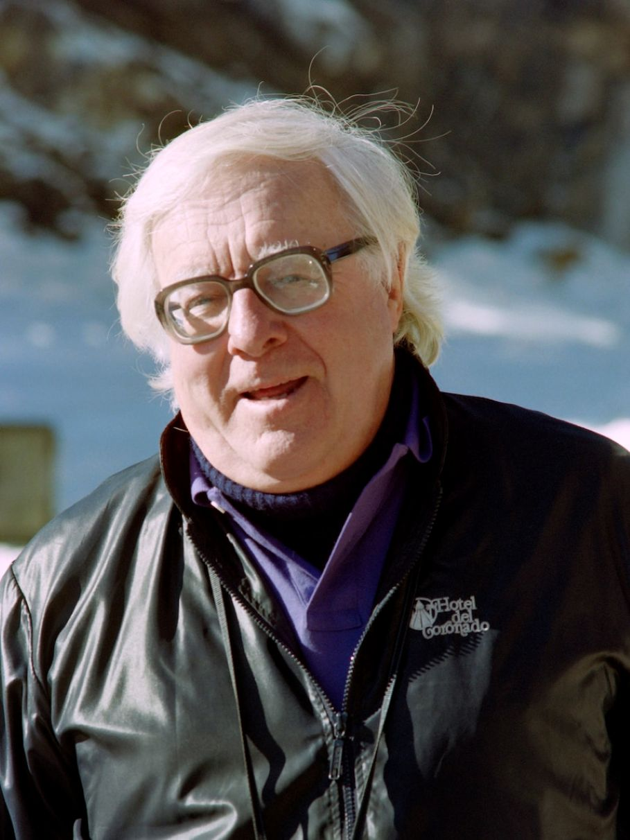

The Day It Rained Forever, Ray Bradbury

The Day It Rained Forever

The hotel stood like a hollowed dry bone under the very center of the desert sky where the sun burned the roof all day. All night, the memory of the sun stirred in every room like the ghost of an old forest fire.

Long after dusk, since light meant heat, the hotel lights stayed off. The inhabitants of the hotel preferred to feel their way blind through the halls in their never-ending search for cool air.

This one particular evening Mr Terle, the proprietor, and his only boarders, Mr Smith and Mr Fremley, who looked and smelled like two ancient rags of cured tobacco, stayed late on the long veranda. In their creaking glockenspiel rockers they gasped back and forth in the dark, trying to rock up a wind.

‘Mr Terle…? Wouldn’t it be really nice…someday…if you could buy…air conditioning…?’

Mr Terle coasted awhile, eyes shut.

‘Got no money for such things, Mr Smith.’

The two old boarders flushed; they hadn’t paid a bill now in twentyone years.

Much later Mr Fremley sighed a grievous sigh. ‘Why, why don’t we all just quit, pick up, get outa here, move to a decent city? Stop this swelterin’ and fryin’ and sweatin’.’

‘Who’d buy a dead hotel in a ghost town?’ said Mr Terle quietly. ‘No. No, we’ll just set here and wait, wait for that great day, January 29.’

Slowly, all three men stopped rocking.

January 29.

The one day in all the year when it really let go and rained.

‘Won’t wait long.’ Mr Smith tilted his gold railroad watch like the warm summer moon in his palm. ‘Two hours and nine minutes from now it’ll be January 29. But I don’t see nary a cloud in ten thousand miles.’

‘It’s rained every January 29 since I was born!’ Mr Terle stopped, surprised at his own loud voice. ‘If it’s a day late this year, I won’t pull God’s shirttail.’

Mr Fremley swallowed hard and looked from east to west across the desert toward the hills. ‘I wonder…will there ever be a gold rush hereabouts again?’

‘No gold,’ said Mr Smith. ‘And what’s more, I’ll make you a bet—no rain. No rain tomorrow or the day after the day after tomorrow. No rain all the rest of this year.’

The three old men sat staring at the big sun-yellowed moon that burned a hole in the high stillness.

After a long while, painfully, they began to rock again.

The first hot morning breezes curled the calendar pages like a dried snake skin against the flaking hotel front.

The three men, thumbing their suspenders up over their hat-rack shoulders, came barefoot downstairs to blink out at that idiot sky.

‘January 29…’

‘Not a drop of mercy there.’

‘Day’s young.’

‘I’m not.’ Mr Fremley turned and went away.

It took him five minutes to find his way up through the delirious hallways to his hot, freshly baked bed.

At noon, Mr Terle peered in.

‘Mr Fremley…?’

‘Damn desert cactus, that’s us!’ gasped Mr Fremley, lying there, his face looking as if at any moment it might fall away in a blazing dust on the raw plank floor. ‘But even the best damn cactus got to have just a sip of water before it goes back to another year of the same damn furnace. I tell you I won’t move again, I’ll lie here and die if I don’t hear more than birds pattin’ around up on that roof!’

‘Keep your prayers simple and your umbrella handy,’ said Mr Terle and tiptoed away.

At dusk, on the hollow roof a faint pattering sounded.

Mr Fremley’s voice sang out mournfully from his bed.

‘Mr Terle, that ain’t rain! That’s you with the garden hose sprinklin’ well water on the roof! Thanks for tryin’, but cut it out, now.’

The pattering sound stopped. There was a sigh from the yard below.

Coming around the side of the hotel a moment later, Mr Terle saw the calendar fly out and down in the dust.

‘Damn January 29!’ cried a voice. ‘Twelve more months! Have to wait twelve more months, now!’

Mr Smith was standing there in the doorway. He stepped inside and brought out two dilapidated suitcases and thumped them on the porch.

‘Mr Smith!’ cried Mr Terle. ‘You can’t leave after thirty years!’

‘They say it rains twenty days a month in Ireland,’ said Mr Smith. ‘I’ll get a job there and run around with my hat off and my mouth open.’

‘You can’t go!’ Mr Terle tried frantically to think of something; he snapped his fingers. ‘You owe me nine thousand dollars rent!’

Mr Smith recoiled; his eyes got a look of tender and unexpected hurt in them.

‘I’m sorry.’ Mr Terle looked away. ‘I didn’t mean that. Look now—you just head for Seattle. Pours two inches a week there. Pay me when you can, or never. But do me a favor: wait till midnight. It’s cooler then, anyhow. Get you a good night’s walk toward the city.’

‘Nothin’ll happen between now and midnight.’

‘You got to have faith. When everything else is gone, you got to believe a thing’ll happen. Just stand here with me, you don’t have to sit, just stand here and think of rain. That’s the last thing I’ll ever ask of you.’

On the desert sudden little whirlwinds of dust twisted up, sifted down. Mr Smith’s eyes scanned the sunset horizon.

‘What do I think? Rain, oh you rain, come along here? Stuff like that?’

‘Anything. Anything at all!’

Mr Smith stood for a long time between his two mangy suitcases and did not move. Five, six minutes ticked by. There was no sound, save the two men’s breathing in the dusk.

Then at last, very firmly, Mr Smith stooped to grasp the luggage handles.

Just then, Mr Terle blinked. He leaned forward, cupping his hand to his ear.

Mr Smith froze, his hands still on the luggage.

From away among the hills, a murmur, a soft and tremulous rumble.

‘Storm coming!’ hissed Mr Terle.

The sound grew louder; a kind of whitish cloud rose up from the hills.

Mr Smith stood tall on tiptoe.

Upstairs Mr Fremley sat up like Lazarus.

Mr Terle’s eyes grew wider and yet wider to take hold of what was coming. He held to the porch rail like the captain of a calm-foundered vessel feeling the first stir of some tropic breeze that smelled of lime and the ice-cool white meat of coconut. The smallest wind stroked over his aching nostrils as over the flues of a white-hot chimney.

‘There!’ cried Mr Terle. ‘There!’

And over the last hill, shaking out feathers of fiery dust, came the cloud, the thunder, the racketing storm.

Over the hill the first car to pass in twenty days flung itself down the valley with a shriek, a thud, and a wail.

Mr Terle did not dare to look at Mr Smith.

Mr Smith looked up, thinking of Mr Fremley in his room.

Mr Fremley, at the window, looked down and saw the car expire and die in front of the hotel.

For the sound that the car made was curiously final. It had come a very long way on blazing sulphur roads, across salt flats abandoned ten million years ago by the shingling off of waters.

Now, with wire-ravelings like cannibal hair sprung up from seams, with a great eyelid of canvas top thrown back and melted to spearmint gum over the rear seat, the auto, a Kissel car, vintage 1924, gave a final shuddering as if to expel its ghost upon the air.

The old woman in the front seat of the car waited patiently, looking in at the three men and the hotel as if to say, Forgive me, my friend is ill; I’ve known him a long while, and now I must see him through his final hour.

So she just sat in the car waiting for the faint convulsions to cease and for the great relaxation of all the bones which signifies that the final process is over. She must have sat a full half minute longer listening to her car, and there was something so peaceful about her that Mr Terle and Mr Smith leaned slowly toward her. At last she looked at them with a grave smile and raised her hand.

Mr Fremley was surprised to see his hand go out the window, above, and wave back to her.

On the porch Mr Smith murmured, ‘Strange. It’s not a storm. And I’m not disappointed. How come?’

But Mr Terle was down the path and to the car.

‘We thought you were…that is…’ He trailed off. ‘Terle’s my name, Joe Terle.’

She took his hand and looked at him with absolutely clear and unclouded light blue eyes like water that has melted from snow a thousand miles off and come a long way, purified by wind and sun.

‘Miss Blanche Hillgood,’ she said, quietly. ‘Graduate of the Grinnell College, unmarried teacher of music, thirty years high-school glee club and student orchestra conductor, Green City, Iowa, twenty years private teacher of piano, harp, and voice, one month retired and living on a pension and now, taking my roots with me, on my way to California.’

‘Miss Hillgood, you don’t look to be going anywhere from here.’

‘I had a feeling about that.’ She watched the two men circle the car cautiously. She sat like a child on the lap of a rheumatic grandfather, undecided. ‘Is there nothing we can do?’

‘Make a fence of the wheels, dinner gong of the brake drums, the rest’ll make a fine rock garden.’

Mr Fremley shouted from the sky. ‘Dead? I say, is the car dead? I can feel it from here! Well—it’s way past time for supper!’

Mr Terle put out his hand. ‘Miss Hillgood, that there is Joe Terle’s Desert Hotel, open twenty-six hours a day. Gila monsters and road runners please register before going upstairs. Get you a night’s sleep, free, we’ll knock our Ford off its blocks and drive you to the city come morning.’

She let herself be helped from the car. The machine groaned as if in protest at her going. She shut the door carefully with a soft click.

‘One friend gone, but the other still with me. Mr Terle, could you please bring her in out of the weather?’

‘Her, ma’am?’

‘Forgive me, I never think of things but what they’re people. The car was a man, I suppose, because it took me places. But a harp, now, don’t you agree, is female?’

She nodded to the rear seat of the car. There, tilted against the sky like an ancient scrolled leather ship prow cleaving the wind, stood a case which towered above any driver who might sit up in front and sail the desert calms or the city traffics.

‘Mr Smith,’ said Mr Terle, ‘lend a hand.’

They untied the huge case and hoisted it gingerly out between them.

‘What you got there?’ cried Mr Fremley from above.

Mr Smith stumbled. Miss Hillgood gasped. The case shifted in the two men’s arms.

From within the case came a faint musical humming.

Mr Fremley, above, heard. It was all the answer he needed. Mouth open, he watched the lady and the two men and their boxed friend sway and vanish in the cavernous porch below.

‘Watch out!’ said Mr Smith. ‘Some damn fool left his luggage here—’ He stopped. ‘Some damn fool? Me!’

The two men looked at each other. They were not perspiring any more. A wind had come up from somewhere, a gentle wind that fanned their shirt collars and flapped the strewn calendar gently in the dust.

‘My luggage…’ said Mr Smith.

Then they all went inside.

‘More wine, Miss Hillgood? Ain’t had wine on the table in years.’

‘Just a touch, if you please.’

They sat by the light of a single candle which made the room an oven and struck fire from the good silverware and the uncracked plates as they talked and drank warm wine and ate.

‘Miss Hillgood, get on with your life.’

‘All my life,’ she said, ‘I’ve been so busy running from Beethoven to Bach to Brahms, I never noticed I was twenty-nine. Next time I looked up I was forty. Yesterday, seventy-one. Oh, there were men; but they’d given up singing at ten and given up flying when they were twelve.

I always figured we were born to fly, one way or other, so I couldn’t stand most men shuffling along with all the iron of the earth in their blood. I never met a man who weighed less than nine hundred pounds. In their black business suits, you could hear them roll by like funeral wagons.’

‘So you flew away?’

‘Just in my mind, Mr Terle. It’s taken sixty years to make the final break. All that time I grabbed on to piccolos and flutes and violins because they make streams in the air, you know, like streams and rivers on the ground. I rode every tributary and tried every fresh-water wind from Handel on down to a whole slew of Strausses. It’s been the far way around that’s brought me here.’

‘How’d you finally make up your mind to leave?’ asked Mr Smith.

‘I looked around last week and said. “Why, look, you’ve been flying alone!” No one in all Green City really cares if you fly or how high you go. It’s always, “Fine, Blanche,” or “Thanks for the recital at the PTA tea, Miss H.” But no one really listening.

And when I talked a long time ago about Chicago or New York, folks swatted me and laughed. “Why be a little frog in a big pond when you can be the biggest frog in all Green City!” So I stayed on, while the folks who gave me advice moved away or died or both. The rest had wax in their ears. Just last week I shook myself and said. “Hold on! Since when do frogs have wings?”’

‘So now you’re headin’ west?’ said Mr Terle.

‘Maybe to play in pictures or in that orchestra under the stars. But somewhere I just must play at last for someone who’ll hear and really listen…’

They sat there in the warm dark. She was finished, she had said it all now, foolish or not—and she moved back quietly in her chair.

Upstairs someone coughed.

Miss Hillgood heard, and rose.

It took Mr Fremley a moment to ungum his eyelids and make out the shape of the woman bending down to place the tray by his rumpled bed.

‘What you all talkin’ about down there just now?’

‘I’ll come back later and tell you word for word,’ said Miss Hillgood. ‘Eat now. The salad’s fine.’ She moved to leave the room.

He said, quickly, ‘You goin’ to stay?’

She stopped half out the door and tried to trace the expression on his sweating face in the dark. He, in turn, could not see her mouth or eyes. She stood a moment longer, silently, then went on down the stairs.

‘She must not’ve heard me,’ said Mr Fremley.

But he knew she had heard.

Miss Hillgood crossed the downstairs lobby to fumble with the locks on the upright leather case.

‘I must pay you for my supper.’

‘On the house,’ said Mr Terle.

‘I must pay,’ she said, and opened the case.

There was a sudden flash of gold.

The two men quickened in their chairs. They squinted at the little old woman standing beside the tremendous heart-shaped object which towered above her with its shining columbined pedestal stop which a calm Grecian face with antelope eyes looked serenely at them even as Miss Hillgood looked now.

The two men shot each other the quickest and most startled of glances, as if each had guessed what might happen next. They hurried across the lobby, breathing hard, to sit on the very edge of the hot velvet lounge, wiping their faces with damp handkerchiefs.

Miss Hillgood drew a chair under her, rested the golden harp gently back on her shoulder, and put her hands to the strings.

Mr Terle took a breath of fiery air and waited.

A desert wind came suddenly along the porch outside, tilting the chairs so they rocked this way and that like boats on a pond at night.

Mr Fremley’s voice protested from above. ‘What’s goin’ on down there?’

And then Miss Hillgood moved her hands.

Starting at the arch near her shoulder, she played her fingers out along the simple tapestry of wires toward the blind and beautiful stare of the Greek goddess on her column, and then back. Then for a moment she paused and let the sounds drift up through the baked lobby air and into all the empty rooms.

If Mr Fremley shouted, above, no one heard. For Mr Terle and Mr Smith were so busy jumping up to stand riven in the shadows, they heard nothing save the storming of their own hearts and the shocked rush of all the air in their lungs. Eyes wide, mouths dropped, in a kind of pure insanity, they stared at the two women there, the blind Muse proud on her golden pillar, and the seated one, gentle eyes closed, her small hands stretched forth on the air.

Like a girl, they both thought wildly, like a little girl putting her hands out a window to feel what? Why, of course, of course!

To feel the rain.

The echo of the first shower vanished down remote causeways and roof drains, away.

Mr Fremley, above, rose from his bed as if pulled round by his ears.

Miss Hillgood played.

She played and it wasn’t a tune they knew at all, but it was a tune they had heard a thousand times in their long lives, words or not, melody or not. She played and each time her fingers moved, the rain fell pattering through the dark hotel.

The rain fell cool at the open windows and the rain rinsed down the baked floorboards of the porch. The rain fell on the roof top and fell on hissing sand, it fell on rusted car and empty stable and dead cactus in the yard.

It washed the windows and laid the dust and filled the rain barrels and curtained the doors with beaded threads that might part and whisper as you walked through. But more than anything the soft touch and coolness of it fell on Mr Smith and Mr Terle. Its gentle weight and pressure moved them down and down until it had seated them again.

By its continuous budding and prickling on their faces it made them shut up their eyes and mouths and raise their hands to shield it away. Seated there, they felt their heads tilt slowly back to let the rain fall where it would.

The flash flood lasted a minute, then faded away as the fingers trailed down the loom, let drop a few last bursts and squalls and then stopped.

The last chord hung in the air like a picture taken when lightning strikes and freezes a billion drops of water on their downward flight. Then the lightning went out. The last drops fell through darkness in silence.

Miss Hillgood took her hands from the strings, her eyes still shut.

Mr Terle and Mr Smith opened their eyes to see those two miraculous women way over there across the lobby somehow come through the storm untouched and dry.

They trembled. They leaned forward as if they wished to speak. They looked helpless, not knowing what to do.

And then a single sound from high above in the hotel corridors drew their attention and told them what to do.

The sound came floating down feebly, fluttering like a tired bird beating its ancient wings.

The two men looked up and listened.

It was the sound of Mr Fremley.

Mr Fremley, in his room, applauding.

It took five seconds for Mr Terle to figure out what it was. Then he nudged Mr Smith and began, himself, to beat his palms together. The two men struck their hands in mighty explosions. The echoes ricocheted around about in the hotel caverns above and below, striking walls, mirrors, windows, trying to fight free of the rooms.

Miss Hillgood opened her eyes now, as if this new storm had come on her in the open, unprepared.

The men gave their own recital. They smashed their hands together so fervently it seemed they had fistfuls of firecrackers to set off, one on another. Mr Fremley shouted. Nobody heard.

Hands winged out, banged shut again and again until fingers puffed up and the old men’s breath came short and they put their hands at last on their knees, a heart pounding inside each one.

Then, very slowly, Mr Smith got up and still looking at the harp, went outside and carried in the suitcases. He stood at the foot of the lobby stairs looking for a long while at Miss Hillgood.

He glanced down at her single piece of luggage resting there by the first tread. He looked from her suitcase to her and raised his eyebrows questioningly.

Miss Hillgood looked at her harp, at her suitcase, at Mr Terle, and at last back to Mr Smith.

She nodded once.

Mr Smith bent down and with his own luggage under one arm and her suitcase in the other, he started the long slow climb up the stairs in the gentle dark. As he moved, Miss Hillgood put the harp back on her shoulder and either played in time to his moving or he moved in time to her playing, neither of them knew which.

Half up the flight, Mr Smith met Mr Fremley who, in a faded robe, was testing his slow way down.

Both stood there, looking deep into the lobby at the one man on the far side in the shadows, and the two women further over, no more than a motion and a gleam. Both thought the same thoughts.

The sound of the harp playing, the sound of the cool water falling every night and every night of their lives, after this. No spraying the roof with the garden hose now any more. Only sit on the porch or lie in your night bed and hear the falling…the falling…the falling…

Mr Smith moved on up the stairs; Mr Fremley moved down.

The harp, the harp. Listen, listen!

The fifty years of drought were over.

The time of the long rains had come.

The end