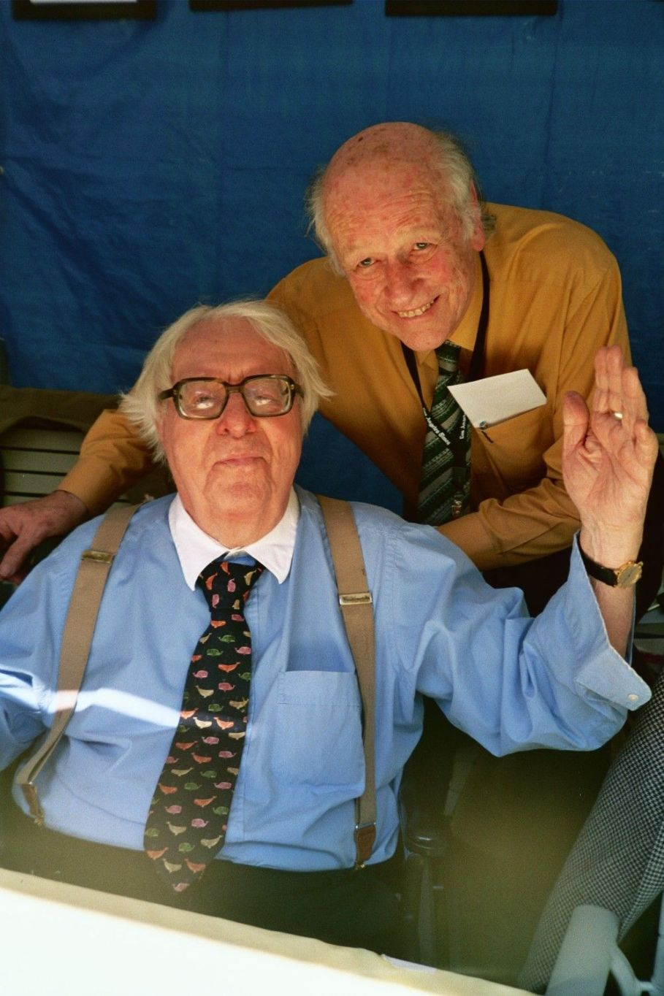

The Emissary, Ray Bradbury

The Emissary

HE knew it was autumn again, because Torry came romping into the house bringing the windy crisp cold smell of autumn with him. In every black curl of his dog-hair he carried autumn. Leaf flakes tangled in his dark ears and muzzle, dropping from his white vest, and off his flourished tail. The dog smelled just like autumn.

Martin Christie sat up in bed and reached down with one pale small hand. Torry barked and displayed a generous length of pink, rippling tongue, which he passed over and along the back of Martin's hand. Torry licked him like a lollypop. 'Because of the salt,' declared Martin, as Torry leaped upon the bed.

'Get down,' warned Martin. 'Mom doesn't like you up here.' Torry flattened his ears. 'Well. . .' Martin relented. 'Just for a while, then.'

Torry warmed Martin's thin body with his dog warmness. Martin relished the clean dog smell and the litter of fallen leaves on the quilt. He didn't care if Mom scolded. After all, Torry was new-born. Right out of the stomach of autumn Torry came, reborn in the firm sharp cold.

'What's it like outside, Torry? Tell me.'

Lying there, Torry would tell him. Lying there, Martin would know what autumn was like; like in the old days before sickness had put him to bed. His only contact with autumn now was this brief chill, this leaf-flaked fur; the compact canine representation of summer gone — this autumn-by-proxy.

'Where'd you go today, Torry?'

But Torry didn't have to tell him. He knew. Over a fall-burdened hill, leaving a pad-pattern in the brilliantly piled leaves, down to where the kids ran shouting on bikes and roller skates and wagons at Barstow's Park, that's where Torry ran, barking out his canine delight. And down into the town where rain had fallen dark, earlier; and mud furrowed under car wheels, down between the feet of week-end shoppers. That's where Torry went.

And wherever Torry went, then Martin could go; because Torry would always tell him by the touch, feel, consistency, the wet, dry, or crispness of his coat. And, lying there holding Torry, Martin would send his mind out to retrace each step of Torry's way through fields, over the shallow glitter of the ravine creek, darting across the marbled spread of the graveyard, into the wood, over the meadows; where all the wild, laughing autumn sports went on, Martin could go now through his emissary.

Mother's voice sounded downstairs, angrily.

Her short angry walking came up the hall steps.

Martin pushed. 'Down, Torry!'

Torry vanished under the bed just before the bedroom door opened and Mom looked in, blue eyes snapping. She carried a tray of salad and fruit juices, firmly.

'Is Torry here?' she demanded.

Torry gave himself away with a few rumps of his tail against the floor.

Mom set the tray down impatiently. 'That dog is more trouble. Always upsetting things and digging places. He was in Miss Tarkins's garden this morning, and dug a big hole. Miss Tarkins is mad.'

'Oh.' Martin held his breath. There was silence under the bed. Torry knew when to keep quiet.

'And it's not the only time,' said Mom. 'This is the third hole he's dug this week!'

'Maybe he's looking for something.'

'Something fiddlesticks! He's just a curious nuisance. He can't keep that black nose out of anything. Always curious!'

There was a hairy pizzicato of tail under the bed. Mom couldn't help smiling.

'Well,' she ended, 'if he doesn't stop digging in yards, I'll have to keep him in and not let him run.'

Martin opened his mouth wide. 'Oh, no, Mom! Don't do that! Then I wouldn't know — anything. He tells me.'

Mom's voice softened. 'Does he, son?'

'Sure. He goes around and comes back and tells what happens, tells everything!'

Mom's hand was spun glass touching his head. 'I'm glad he tells you. I'm glad you've got him.'

They both sat a moment, considering how worthless the last year would've been without Torry. Only two more months, thought Martin, of being in bed, like the doctor said, and he'd be up and around.

'Here, Torry!'

Jangling, Martin locked the special collar attachment around Torry's neck. It was a note, painted on a tin square:

'MY NAME IS TORRY. WILL YOU VISIT MY MASTER, WHO IS SICK? FOLLOW ME!'

It worked. Torry carried it out into the world every day.

'Will you let him out, Mom?'

'Yes, if he's good and stops his digging!'

'He'll stop; won't you, Torry?'

The dog barked.

You could hear the dog yipping far down the street and away, going to fetch visitors. Martin was feverish and his eyes stood out in his head as he sat, propped up, listening, sending his mind rushing along with the dog, faster, faster.

Yesterday Torry had brought Mrs. Holloway from Elm Avenue, with a story book for a present; the day before Torry had sat up, begged at Mr. Jacobs, the jeweller. Mr. Jacobs had bent and near-sightedly deciphered the tag message and, sure enough, had come shuffling and waddling to pay Martin a little how-do-you-do.

Now, Martin heard the dog returning through the smoky afternoon, barking, running, barking again.

Footsteps came lightly after the dog. Somebody rang the downstairs bell, softly. Mom answered the door. Voices talked.

Torry raced upstairs, leaped on the bed. Martin leaned forward excitedly, his face shining, to see who'd come upstairs this time. Maybe Miss Palmborg or Mr. Ellis or Miss Jendriss, or —

The visitor walked upstairs, talking to Mom. It was a young woman's voice, talking with a laugh in it.

The door opened.

Martin had company.

Four days passed in which Torry did his job, reported morning, afternoon and evening temperatures, soil consistencies, leaf colours, rain levels, and, most important of all, brought visitors.

Miss Haight, again, on Saturday. She was the young, laughing, handsome woman with the gleaming brown hair and the soft way of walking. She lived in the big house on Park Street. It was her third visit in a month.

On Sunday it was Reverend Vollmar, on Monday Miss Clark and Mr. Hendricks.

And to each of them Martin explained his dog. How in spring he was odorous of wild-flowers and fresh earth; in summer he was baked, warm, sun-crisp; in autumn, now, a treasure trove of gold leaves hidden in his pelt for Martin to explore out. Torry demonstrated this process for the visitors, lying over on his back, waiting to be explored.

Then, one morning, Mom told Martin about Miss Haight, the one who was so handsome and young and laughed.

She was dead.

Killed in a motoring accident in Glen Falls.

Martin held on to his dog, remembering Miss Haight, thinking of the way she smiled, thinking of her bright eyes, her closely cropped chestnut hair, her slim body, her quick walk, her nice stories about seasons and people.

So now she was dead. She wasn't going to laugh or tell stories any more. That's all there was to it. She was dead.

'What do they do in the graveyard, Mom, under the ground?'

'Nothing.'

'You mean they just lay there?'

'Lie there,' corrected Mom.

'Lie there. . .?'

'Yes,' said Mom, 'that's all they do.'

'It doesn't sound like much fun.'

'It's not supposed to be.'

'Why don't they get up and walk around once in a while if they get tired of lying there?'

'I think you've said enough, now,' said Mom.

'I just wanted to know.'

'Well, now you know.'

'Sometimes I think God's pretty silly.'

'Martin!'

Martin scowled. 'You'd think He'd treat people better than throw dirt in their faces and tell them to lay still for keeps. You'd think He'd find a better way. What if I told Torry to play dead-dog? He does it awhile, but then he gets sick of it and wags his tail or blinks his eyes, or pants, or jumps off the bed, and walks around. I bet those graveyard people do the same, huh, Torry?'

Torry barked.

'That will do!' said Mom, firmly. 'I don't like such talk!'

The autumn continued. Torry ran across forests, over the creek, prowling through the graveyard as was his custom, and into town and around and back, missing nothing.

In mid-October, Torry began to act strangely. He couldn't seem to find anybody to come to visit Martin. Nobody seemed to pay attention to his begging. He came home seven days in a row without bringing a visitor. Martin was deeply despondent over it.

Mom explained it. 'Everybody's busy. The war, and all. People have lots to worry over besides little begging dogs.'

'Yeah,' said Martin, 'I guess so.'

But there was more than that to it. Torry had a funny gleam in his eyes. As if he wasn't really trying, or didn't care, or — something. Something Martin couldn't figure out. Maybe Torry was sick. Well, to heck with visitors. As long as he had Torry, everything was fine.

And then one day Torry ran out and didn't come back at all.

Martin waited quietly at first. Then — nervously. Then — anxiously.

At supper time he heard Mom and Dad call Torry. Nothing happened. It was no use. There was no sound of paws along the path outside the house. No sharp barking in the cold night air. Nothing. Torry was gone. Torry wasn't coming home — ever.

Leaves fell past the window. Martin sank on his pillow, slowly, a pain deep and hard in his chest.

The world was dead. There was no autumn because there was no fur to bring it into the house. There would be no winter because there would be no paws to dampen the quilt with snow. No more seasons. No more time. The go-between, the emissary, had been lost in the wild thronging of civilization, probably hit by a car, or poisoned, or stolen, and there was no time.

Sobbing, Martin turned his face to his pillow. There was no contact with the world. The world was dead.

Martin twisted in bed and in three days the Hallowe'en pumpkins were rotting in trash cans, masks were burnt in incinerators, the bogeys were stacked away on shelves until next year. Hallowe'en was withdrawn, impersonal, untouchable. It had simply been one evening when he had heard horns blowing off in the cold autumn stars, people yelling and thumping windows and porches with soap and cabbages. That was all.

Martin stared at the ceiling for the first three days of November, watching alternate light and dark shift across it. Days got shorter, darker, he could tell by the window. The trees were naked. The autumn wind changed its tempo and temperature. But it was just a pageant outside his window, nothing more. He couldn't get at it.

Martin read books about the seasons and the people in that world that was now non-existent. He listened each day, but didn't hear the sounds he wanted to hear.

Friday night came. His parents were going to the theatre. They'd be back at eleven. Mrs. Tarkins, from next door, would come over for a while until Martin got sleepy, and then she would go home.

Mom and Dad kissed him good night and walked out of the house into the autumn. He heard their footsteps go down the street.

Mrs. Tarkins came over, stayed a while and then when Martin confessed to being tired, she turned out all the lights and went back home.

Silence, then. Martin just lay there and watched the stars moving slowly across the sky. It was a clear, moonlit evening. The kind when he and Torry had once run together across the town, across the sleeping graveyard, across the ravine, through the meadows, down the shadowed streets, chasing phantasmal childish dreams.

Only the wind was friendly. Stars don't bark. Trees don't sit up and beg. The wind, of course, did wag its tail against the house a number of times, startling Martin.

Now it was after nine o'clock.

If only Torry would come home, bringing some of the world with him. A burr or a rimed thistle, or the wind in his ears. If only Torry would come home.

And then, way off somewhere, there was a sound.

Martin arose in his covers, trembling. Starlight was reflected in his small eyes. He threw back the covers and tensed, listening.

There, again, was the sound.

It was so small it was like a needle-point moving through the air miles and miles away.

It was the dreamy echo of a dog — barking.

It was the sound of a dog coming across meadows and fields, down dark streets, the sound of a dog running and letting his breath out to the night. The sound of a dog circling and running. It came and went, it lifted and faded, it came forward and went back, as if it was being led by someone on a chain. As if the dog was running and somebody whistled under the chestnut trees and the dog ran back, circled, and darted again for home.

Martin felt the room revolve under him, and the bed tremble with his body. The springs complained with metal, tining voices.

The faint barking continued for five minutes, growing louder and louder.

Torry, come home! Torry, come home! Torry, boy, ok Torry, where've you been? Oh, Torry, Torry!

Another five minutes. Nearer and nearer, and Martin kept saying the dog's name over and over again. Bad dog, wicked dog, to go off and leave him for all these days. Bad dog, good dog, come home, oh, Torry, hurry home and tell me about the world! Tears fell and dissolved into the quilt.

Nearer now. Very near. Just up the street, barking. Torry!

Martin held his breath. The sound of dog feet in the piled dry leaves, down the path. And now — right outside the house, barking, barking, barking! Torry!

Barking to the door.

Martin shivered. Did he dare run down and let the dog in, or should he wait for Mom and Dad to come home? Wait. Yes, he must wait. But it would be unbearable if, while he waited, the dog ran away again. No, he would go down and release the lock and his own special dog would leap into his arms again. Good Torry!

He started to move from bed when he heard the other sound. The door opened downstairs. Somebody was kind enough to have opened the door for Torry.

Torry had brought a visitor, of course. Mr. Buchanan, or Mr. Jacobs, or perhaps Miss Tarkins.

The door opened and closed and Torry came racing upstairs and flung himself, yipping, on the bed.

'Torry, where've you been, what've you done all this week?'

Martin laughed and cried all in one. He grabbed the dog and held him. Then he stopped laughing and crying, suddenly. He just stared at Torry with wide, strange eyes.

The odour arising from Torry was — different.

It was a smell of earth. Dead earth. Earth that had lain cheek by jowl with unhealthy decaying things six feet under. Stinking, Stinking, rancid earth. Clods of decaying soil fell off Torry's paws. And — something else — a small withered fragment of — skin?

Was it? Was it! WAS IT!

What kind of message was this from Torry? What did such a message mean? The stench — the ripe and awful cemetery earth.

Torry was a bad dog. Always digging where he shouldn't dig. Torry was a good dog. Always making friends so easily. Torry took to liking everybody. He brought them home with him.

And now this latest visitor was coining up the stairs. Slowly. Dragging one foot after the other, painfully, slowly, slowly, slowly.

'Torry, Torry — where've you been!' screamed Martin.

A clod of rank crawling soil dropped from the dog's chest.

The door to the bedroom moved inwards.

Martin had company.

The End