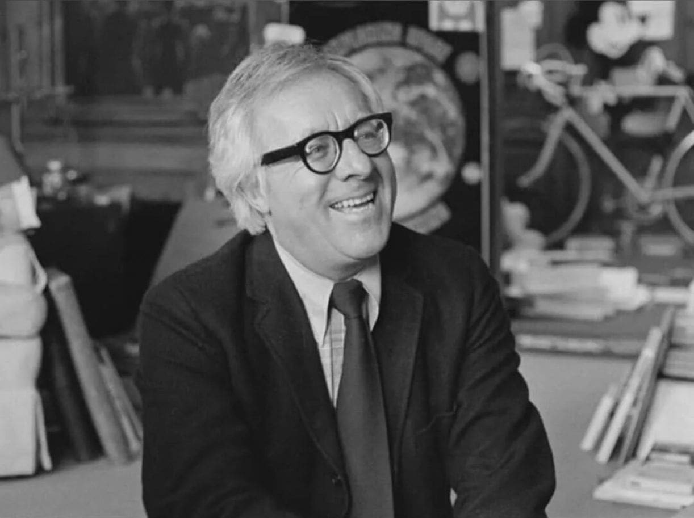

The F. Scott/Tolstoy/Ahab Accumulator, Ray Bradbury

The F. Scott/Tolstoy/Ahab Accumulator

“Why would you want to rewire, revise, and reconceive your Time Machine?” said my friend Billy Barlow.

“It’s one thing,” I replied, “to run back in time and place new printings of books by Melville, Poe, and Wilde on their deathbeds and wake them to see their glory. But …”

I paused.

“But another thing,” I finished, “to seek unhappy people and make them happy. Think of all the lost writers who wrote beautifully and lived miserably.”

“All writers are lost,” said Billy. “And miserable.”

“I’ll change that,” I said.

“Bull,” Billy said. “How, oh Lord God of miracles? With three wishes on a genie lamp? With—”

“Shut up. See that huge device stranded in the library?”

“That giant moth? Does it flap its wings?”

“It hums under its breath and vanishes.”

“The louder it hums the farther back in Time you go?”

“Right. Here’s my list of lost souls.”

Billy scowled at the list. “Hemingway? Melville? No way. Tolstoy? Why? F. Scott Fitzgerald and Zelda? Drunks!”

“Gimme that!” I grabbed the list, sat in the machine, cursed, pulled a lever, and said: “I’m not here.”

The machine hummed.

And I wasn’t.

The machine settled as gently as a great cellophane butterfly by Papa’s house in Idaho. God, I thought, what do I say?

I pried myself from the trembling wings, and had walked up on the porch to knock when the door opened. Hemingway stood there.

He looked sleepless. His broad pale face somehow expected me and here I was. He turned and walked back to a hall table, sat down, and nodded to a chair. I advanced, staring at what lay gleaming on the table: a steel African hunting rifle, the sort that knocked echoes off Kilimanjaro, and once killed elephants as white as the hot Kenya dust. Nearby lay a double-barreled shotgun.

I sat and saw on the table two glasses of clear grappa. I took one glass while Papa slugged his back.

“Well?” he said.

I ignored the table and said: “Don’t.”

“Don’t what?”

“Whatever you were going to do.”

“I wasn’t going to do anything,” said Papa.

“You were thinking it.”

“You read minds?”

“No. Just some of your stories. There was a doctor in one of them, your father? We all know what happened to him.”

“We all know that,” said Papa.

“Some say you still have his weapon.”

“Somewhere.”

“Well, let’s not mince words. If you do something silly, people will guess all the wrong motives.”

“There are no wrong motives for getting out when the getting’s good.”

“No. It’s not what you think, it’s what the academics write. They’ll pee on your grave, then change your title to The Sun Never Rises.”

“It can’t be touched. What I was once, for a while. I hate to brag, but …”

“Why not? You are Papa.”

Papa almost smiled, then lit a cigarette.

“How long have you read me?”

“Since algebra, behind the book. Eighth grade.”

“Great place, behind other books. In The Sun Also Rises, what was that to you?”

“Big doors opening, big gates, a whole world pouring out with places, pretty women, and toreros, both with nice backsides, and how to survive not being a man anymore.”

“That’s a lot to know when you’re a kid.”

“I was hungry. Don’t change the subject. If you leave now …”

“I haven’t left yet.”

“They’ll eat your entrails, Papa.”

“If they tear them out.”

“Eat your guts, throw them up, and eat them again.”

“Will they leave my manhood?”

“That goes first, so you can’t fight.”

“Hyenas, eh?”

“Dingos, buzzards, zopilotes, sharks.”

“The whole Harvard English Department?”

“And Ohio State.”

“That’s some list.” Papa stared into my face. “And who are you to make it? Why are you here? A nut?”

“A lover.”

“Blush when you say that.”

“Why should I, when it’s true?”

“Hell. A true believer.”

“No, someone who loves writing. Not fine. Just good.”

“Always was,” said Papa quietly.

“And you can be good again.”

“With a ruptured spleen, two broken ribs, a fractured fibula, and a cracked skull?”

“All that. Let the medics really cure your ribs, your leg, your head. With your body fixed, your nerves renewed, and the pain gone …”

“My writing will come back, too?”

“It must.”

“I don’t know if I can wait,” he said. “It’s bad to get up early, stand at your typewriter and work, then find it’s nothing and take a bottle to bed. Who do I do this for?”

“For yourself. Hell, no. Me.”

“Selfish bastard.”

“Damn right.”

He stared at me.

“Jesus, go write a book on philosophy.”

“No, just hygiene, if you’ll listen.”

Papa glanced at the door.

“Get outta here,” he said.

“If I can take the guns.”

“You crazy?”

“No, you. Pain makes you crazy. Your writing didn’t fail. It stopped because you were sick. You can’t think when pain cuts in. Ever try to write hungover? Never works. The critics knock your writing and forget that plane crash in Africa that wrecked it, left you mad. But maybe next week you’ll wake with no knife in your chest, no bad leg, no headache, and know how mad you were.”

“Am I mad now?”

“With yourself, and me for telling you.”

“You finished?”

“No, empty, Papa. Just remember, if you’re gone next year they’ll call your story ‘The Short Unhappy Life of Francis Macomber.’ Then For Whom No Bell Tolls. See?”

“I don’t need a third crash.”

“Well, then.” I reached for the guns.

“Don’t,” said Papa. “I’d find another way.”

“Take four aspirin. Kill the pain. I’ll call tomorrow.”

I walked to the front door.

“What’s your name?” he called.

I told him.

“Have a good life,” he said.

“No, Papa. You.”

I went out the door.

I was about fifty feet from the house when I thought I heard a loud sound, shut my eyes, and ran.

The vast monarch wings whispered, folded, stopped.

I looked in through a twilight door and saw:

An old man stamping, stamping, stamping forms in the customs shed at Nantucket.

I drew close and said, “Mr. Melville?”

He lifted the blind gaze of an ancient sea tortoise.

“Sir?” he said.

I suddenly did not fit my skin within my clothes.

“Sir, are you hungry?”

The old man searched his appetite.

I said, “May we dine and perhaps stroll the wharves?” I raised a small sack of apples and oranges, plus, in the other hand, a nameless book. He studied that book and at last took an immense time shrugging on an overcoat and let himself be led out into the clouded light of a sunless day. Facing away from the sea, he said: “You are a critic? From Boston?”

“No,” I said, “a mere reader.”

“There are no mere readers,” said the old man. “You are either out of a library or safely in. Book dust fills that air. Inhaled, it firms a man’s bones, brightens his eye, tunes his ear.

Thus a man is renewed breath by breath, when he swims the library deeps where multitudinous blind creatures wait. Your mind says rise and they swarm, over-brim, drown you with their stuffs. Drowned but alive, you are the atoll it floods without end. Thus, you are no mere reader, but a survivor of tides that surf from Shakespeare to Pope to Molière. Those lighthouses of being. Go there to survive the storms.

“That is,” he caught himself, “if I shut up and you had time to read.” He let his faint smile fade. “Why are we here on this dock?”

“Sir,” I said. “There is the sea, where you should go forever.”

“Swim round the Cape? Surprise China?”

“Why not?”

“Do you see this old man’s hand palsied from stamping and stamping the damned inspection forms?”

“No,” I said, “I see a sailor at sea with a dark islander, all tattoos, and a lost first mate whose captain struck God’s sun when it insulted him.” I continued: “Oh, dear Melville, stay off the land. The sea is yours. You’re like that ancient god who, thrown down, revived his life. Held high, he lost his power.

On earth, his life grew tall. But your power is water! Cast off now, be a sea beast reborn to compass points, arms spread to smite hurricanes from white whales’ flukes. Take St. Elmo’s fires to shave.

Earth, shore, town, and docks are tombs, coffin law-sheds, sunless days, lost burials. Earthbound, you dig your grave. Curse the land, throw down the customs stamp, be young ape-clambering the mast to dive, swim fast, the fair isles wait. I’m shut.”

“Shakespeare opened you.”

“Forgive.”

“Forgive me, then, who gave the White Whale’s oil to light the towns. Be you a Christian?”

“God counts me in.”

“Then Christian soul, be still as I judge ships and guess the tides.”

Old Melville stared long at the horizon, then gazed at the salt-worn fronts of the customhouse which knew no sound but the eternal stamping and stamping of sea forms out and in.

“Jack!” I whispered. Melville flinched. I caught my breath and thought: Jack, young Christ, far from Galilee, fine of form and face, Jack, good shipmate, like the morning sun. And Hawthorne?

Do we kidnap and jog along with him? Such talks you’d have! I’ll serve him for our feast of Time, while Jack thrusts his gaze to seize your heart and crack your eyes. Hawthorne for loud noons. Jack for speechless midnights, endless dawns.

“Jack,” whispered Herman Melville. “Alive?”

“I can make him live.”

“Your God machine, does it bless or curse? Does it create or act Time’s infidel?”

“It’s nameless, sir. A centrifuge to spin off years to make us young.”

“Can you do this?”

“And win King Richard’s crown? Yes!”

“Ah, God.” Melville’s voice broke as he pulled at his feet. “I cannot move!”

“Try!”

“It’s late,” he said. “I’m neither fish nor fowl. On land, Stonehenge. At sea I sink. Is there no place between?”

“Here.” I touched my head. “And here,” I touched my heart.

The old man’s eyes burned with tears.

“Oh! If I could live in that head or hide in that breast!”

“You are safely there.”

“I accept a night’s lodging,” he wept.

“No, Pequod’s captain,” I said. “A thousand days.”

“This joy breaks me! Hold!”

I held his quaking elbows.

“You,” he said, “have opened the library and let me breathe my past. Am I taller? Straighter? Is my voice clear?”

“Most clear.”

“My hands?”

“Are the hands of a sailor newborn.”

“Stay off land?”

“Stay off.”

“But look.” He pointed. “My legs are anchors! Much thanks for your miracle of words. Oh, thanks …”

And he wandered off into the customs shed.

I looked in upon this old man a thousand miles distant on the dark earth, saw his hand fly up, down, up, down, stamping the forms, eyes shut, gone blind, as I backed off to feel the huge wings brush my neck. I spun to let the great moth take me.

“O, Herman, stay!” I cried, but the shed was gone.

And I was spun forth in another time, a house, a door opened and shut, a small round man confronting me.

“How,” he said, “did you get in?”

“Down the chimney, under the door. And you are?”

“Count Leo Tolstoy!”

“Of War and Peace?”

“Is there another!?” he exclaimed. “How did you enter? For what purpose?”

“To help you run away!”

“Run—?”

“Away,” I said, “from home. For you are crazed. Your wife is berserk with jealousy.”

Count Leo Tolstoy froze. “How—?”

“It’s all in the books.”

“There are no books!”

“Not now, but soon! To claim your wife accused the chambermaids, the kitchen help, the gardener’s daughters, your accountant’s mistress, the milkman’s wife, your niece!”

“Stop!” cried Count Leo Tolstoy. “I refuse those beds!”

“They lie?”

“Yes, maybe, no, how dare you!”

“Because your wife threatens to tear the sheets, burn the bed, lock the door, decapitate your modus operandi.”

“No, yes! Guilty, innocent, guilty, innocent! Damn! Guilty! What a wife. Repeat!”

“Home. Run away from it.”

“That is what boys do!”

“Yes!”

“And you’d have me act half a life younger? You are a lunatic of solutions.”

“Better than a maniac of punishments.”

“Lower your voice!” he whispered. “She’s in the next room.”

“Then, let’s go!”

“She has stolen my underwear!”

“Wash and wear on the way.”

“To?”

“Anywhere!”

“But how long do I hide?”

“Until she swoons, apoplectic!”

“Superb! Who are you?”

“The only man on earth who has read War and Peace and remembered the names. Shall I list them?”

At this a fierce blow hit a far door.

“Thank God,” I said, “it’s locked.”

“What shall I pack?”

“A toothbrush! Quick!”

I threw the outer door wide. Count Leo Tolstoy stared out.

“What is that mist made of transparent leaves and milkweed?”

“Salvation!”

“It is beautiful.”

There was more banging on the door, a bray like an elephant.

“The maniac,” he cried.

“Do you wear running shoes?”

“I …”

“Run!”

He ran. The machine enfolded him.

The library door burst wide. A face of fury raged, an open furnace. “Where is he?” she cried.

“Who?” I said and vanished.

Perhaps I materialized to Billy Barlow, perhaps he materialized to me. But suddenly my machine took root in my library as Billy was glancing up Tolstoy, Melville, and Papa.

“Two losses and a win!” I said.

Billy shut Melville, closed Papa, smiled at Tolstoy.

“I made him leave madame,” I said.

“Did she enact Anna Karenina?”

“Throw herself under a train? No.”

“Pity. You off on more travels? White House, April ’65, maybe. Steal Mary Todd Lincoln’s theater tickets?”

“And risk her bite? No. Gangway!”

The golden wings soughed to touch by the waters of the marble fount near the Hotel Plaza. The fountains lifted quiet jets on a summer night. In the fount, wading, staggering, laughing, martini glasses raised to the moon, swayed a handsome man in a drenched tuxedo and a lovely woman in a silver gown. They whooped and hollered until my shout.

“Time!” I cried. “Zelda! Scottie! Everyone out!”

The end