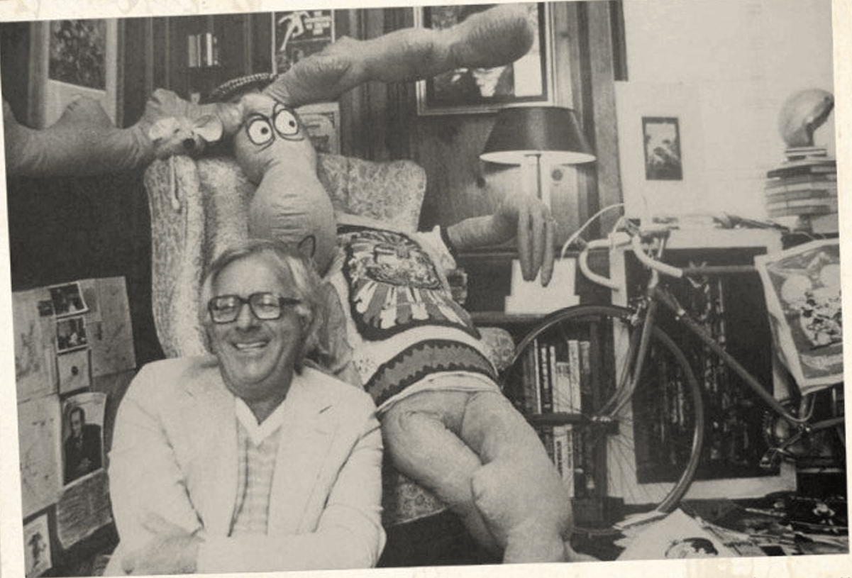

The Flight of the Good Ship Clarissa, Ray Bradbury

The Flight of the Good Ship Clarissa

Futuria Fantasia (1940)

The space rocket Clarissa was nine days out from Venus. The members of the crew were also out for nine days. They were hunters, fearless expeditionists who bagged game in Venusian jungles. At the start of our story they are busy bagging their pants, not to forget their eyes.

A sort of lull has fallen over the ship (Note: a lull is a time warp that frequently attacks rockets and seduces its members into a siesta) It was during this lull that Anthony Quelch sat sprawled at his typewriter looking as baggy as a bag of unripe grapefruit, ANTHONY QUELCH, the Cosmic Clamor Boy, with a face like turned linoleum on the third term, busy writing a book: "Fascism is Communism with a shave" for which he would receive 367 rubles, 10 pazinkas and incarceration in a cinema showing Gone With The Wind.

The boys upstairs were throwing a party in the control room. They had been throwing the same party so long the party looked like a worn out first edition of a trapeze artist. There is doubt in our mind as to whether they were trying to break the party up or just do the morning mopping and break the lease simultaneously. Arms, legs and heads littered the deck, The boys, it seems, threw a party at the drop of a chin, Sort of a space cataclysm with rules and little regulation— kind of an atomic convulsion in the front parlor.

The neighbors never complained. The neighbors were 450 million miles away. And the boys were tighter than a catsup bottle at lunch-time. The last time the captain had looked up the hatch and called to his kiddies in a gentle voice, "HELL!" the kiddies had thrown snowballs at him.

The captain had vanished. Clever way they make these space bombs nowadays. A few minutes previous the boys had been tearing up old Amazings and throwing them at one another, but now they contented themselves with tearing up just the editors. Palmer was torn in half and he sat in a corner arguing with himself about rejecting a story for an hour before someone put him through an orange juice machine killing him. (Orange juice sorry, now?)

And then they landed on Venus. How in heck they got back their so quick is a wonder of science, but there they were. "Come on, girls!" cried Quelch, "put on your shin guards, get out there and dig ditches for good old W.P.A and the Rover Boys Academy, earth branch 27!"

Out into the staggering rain-they dashed. Five minutes later they came back in, gasping, reeling. They had forgotten their corsets! The Venusians closed in like a million land-lords. "Charge, men!" cried Quelch, running the other way. And then - BATTLE! "What a fight, folks," cried Quelch, "Twenty thousand earth men against two Venusians! We're outnumbered, but we'll fight!" BLOOSH! "Correction- ten thousand men fighting!" KERBLOM! "One hundred men from earth left!" BOOM! "This is the last man speaking, folks! 'What a fight, I ain't had so much fun since—' Help, someone just clipped my corset strings!" BWOM! "Someone just clipped me!"

The field was silent. The ship lay gleaming in the pink light of dawn that was just blooming over the mountains like a pale flower.

The two Venusians Stood weeping over the bodies of the Earthlings like onion peelers or two women in a bargain basement. One Venusian looked at the other Venusian, and in a high-pitched, hoarse, sad voice said: "Aye, aye, aye—THIS—HIT SHOODEN HEPPEN TO A DOG — NOT A DOIDY LEEDLE DOG!" And dawn came peacefully, like beer barrels, rolling.

The end