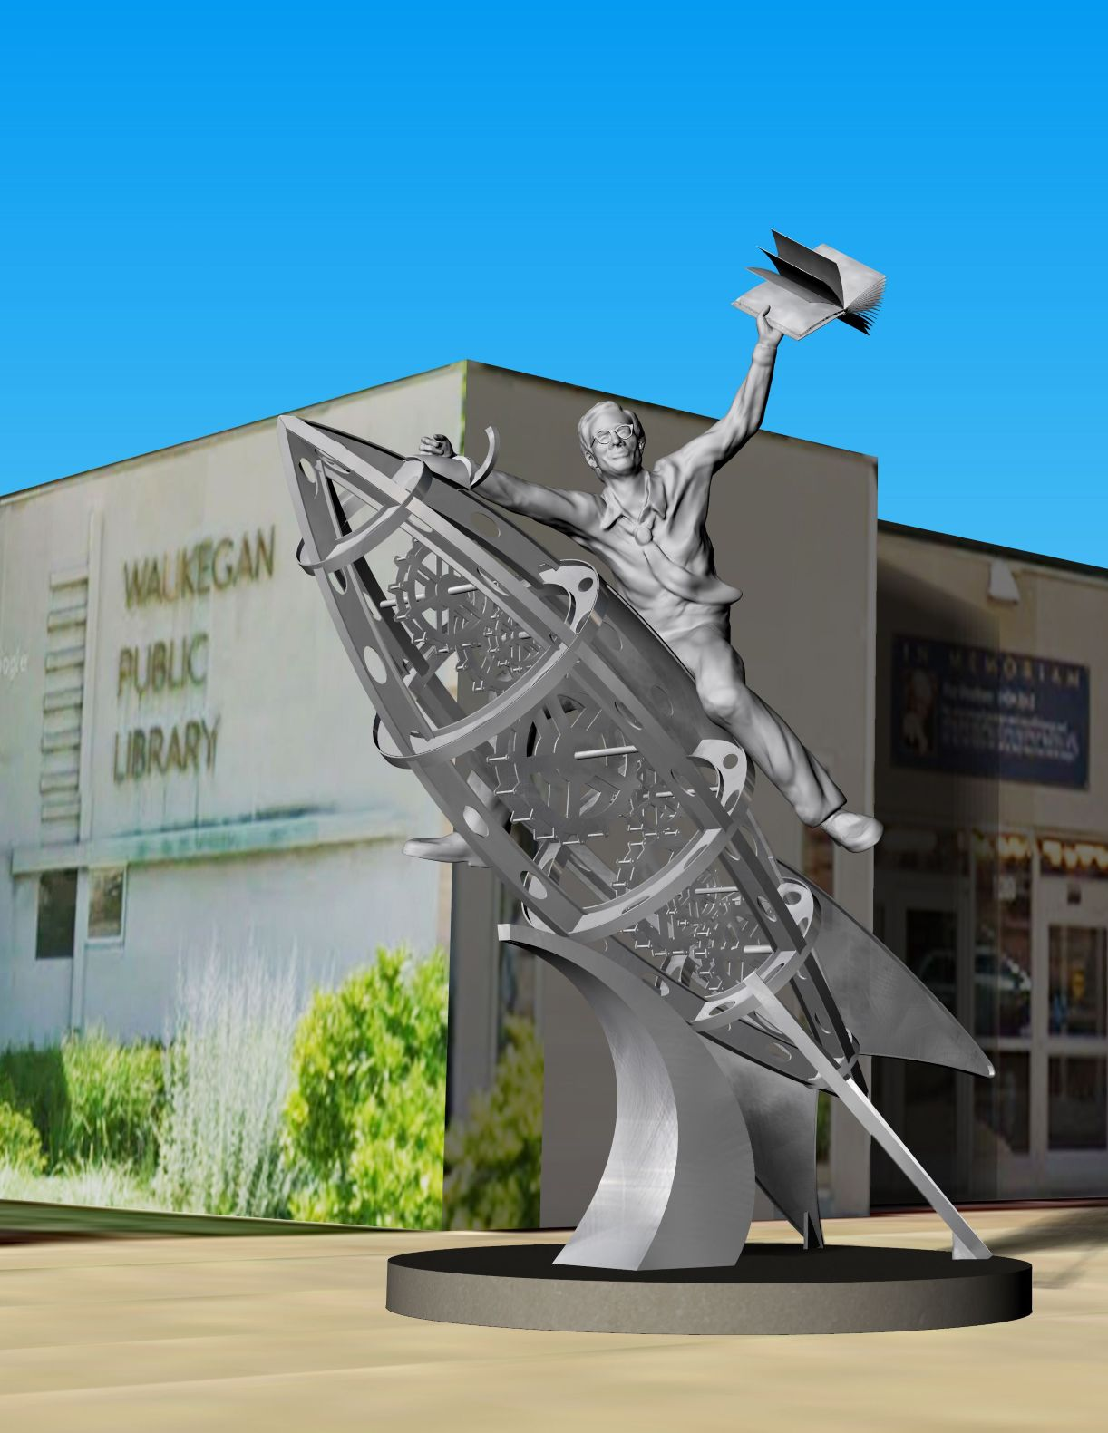

The Ghost In The Machine, Ray Bradbury

The Ghost In The Machine

The talk in the village in the year 1853 was, of course, about the madman above, in his sod-and-brick hut, with an untended garden and a wife who had fled, silent about his madness, never to return.

The people of the village had never drunk enough courage to go see what the special madness was or why the wife had vanished, tear-stained, leaving a vacuum into which atmospheres had rushed to thunder-clap.

And yet ...

On a sweltering hot day with no cloud to offer shadow comfort and no threat of rain to cool man or beast, the Searcher arrived. Which is to say, Dr. Mortimer Goff, a man of many parts, most of them curious and self-serving, but also traveling the world for some baroque event, or miraculous revelation.

The good doctor came tramping up the hill, stumbling over cobbles that were more stone than paving, having abandoned his coach-and-horses, fearful of crippling them with such a climb.

Dr. Goff it turned out, had come from London, inhaling fogs, bombarded by storms, and now, stunned by too much light and heat, this good if curious physician stopped, exhausted, to lean against a fence, sight further up the hill, and ask:

“Is this the way to the lunatic?”

A farmer who was more scarecrow than human raised his eyebrows and snorted, "That would be Elijah Wetherby."

''If lunatics have names, yes."

"We call him crazed or mad, but lunatic will do. It sounds like book learning. Are you one of those?"

"I own books, yes, and chemical retorts and a skeleton that was once a man, and a permanent pass to the London Historical and Scientific Museum-"

"All well and good," the farmer interrupted, "but of no use for failed crops and a dead wife. Follow your nose. And when you find the fool or whatever you name him, take him with you. We're tired of his shouts and commotions late nights in his iron foundry and anvil menagerie. Rumor says he will soon finish some monster that will run to kill us all."

"Is that true?" asked Dr. Goff.

"No, it lies easy on my tongue. Good day, Doctor, and God deliver you from the lightning bolts that wait for you above."

With this the farmer spaded the earth to bury the conversation.

So the curious doctor, threatened, climbed on, under a dark cloud which did not stop the sun.

And at last arrived at a hut that seemed more tomb than home, surrounded by land more graveyard than garden.

Outside the ramshackle sod-and-brick dwelling a shadow stepped forth, as if waiting, and became an old, very old, man.

"Well, there you are at last!" it cried.

Dr. Goff reared back at this. "You sound, sir, as if you expected me!"

"I did," said the old man, "some years ago! What took you so long?"

"You are not exactly cheek by jowl with London, sir."

"I am not," the old man agreed and added, "The name is Wetherby. The Inventor"

"Mr. Wetherby, the Inventor. I am Dr. Goff, the so-called Searcher, for I move in behalf of our good Queen, turning rocks, digging truffles, curious for stuffs that might delight her Majesty or fill her museums, shops, and streets in the greatest city in the world. Have I reached the right place?"

"And just in time, for I am now in my eightieth year and of inconsequential vigor. If you had arrived next year, you might have found me in the churchyard. Do come in!"

At this moment, Dr. Goff heard a gathering of people behind him, all with a most unpleasant muttering, so at Mr. Wetherby's beckoning, he was glad to enter, sit, and watch an almost rare whiskey being poured without invitation. When he had quaffed the glass, Dr. Goff swiveled his gaze about the room.

"Well, where is it?"

"Where is what, sir?"

"The lunatic device, the insane machine that goes nowhere but in going might run down a child, a lamb, a priest, a nun, or an old blind dog, where?"

"So I am that famous, am I?" The old man let a few crumbs of laughter fall from his toothless mouth. "Well, sir. I keep it locked in the goats' shed behind: the outhouse of machines. Finish that to strengthen your sanity when you at last behold the delight and grievance of my long inventive life. So!"

The doctor drank, was replenished and soon out the door, across a small, smooth circle of turf, and to a shed whose door was triple-kept with numerous padlocks and keys. Old Wetherby entered, lit many candles, and beckoned the good doctor in.

He pointed as to a manger. The medical Searcher looked, expecting a mother, crib, and holy babe by the way Wetherby gestured and cried:

"There she be!"

"Is it female, then?"

"Come to think, she is!"

And there in the candlelight was Wetherby's mechanical pride.

Dr. Goff coughed, to hide his chagrin.

"That, sir, is but a metal frame!"

"But what a frame to hold velocities! Ha!"

And the old man, young with fevers, rushed to seize a largish wheel which he transported to fit to the front part of the frame. Then he fetched yet another circular object to fit into the frame's rear.

"Well?" he cried.

"I see two wheels, half a cart, and no horse!"

"We will shoot all horses!" exclaimed Wetherby. "My invention, by the tens of thousands, will shy off all horses and banish manures. Do you know, each day in London a thousand tons of horse clods must be cleared, fertilizer wasted, not spread on neighbor fields but dumped as sludge down-Thames. God, how I talk!"

"But, sir, continue. Those look to be spinning wheels, borrowed from nearby farms?"

"They are, but spliced and strengthened with metal to sustain“ - Wetherby touched himself - “one hundred twenty pounds. And here's the saddle for that weight." Whereupon he fitted a saddle mid-frame. "And here the stirrups and ribbon to run the back wheel." So saying, he affixed a longish leather ribbon to one stirrup's rotary and tightened it on a spool at the rear.

"Do you begin to perceive, Doctor?"

"I am stranded in ignorance, sir.

"Well, then, be alert, for I now enthrone myself."

And the old man, light as a chimpanzee, slung himself in place on a leather seat mid-frame between the silent spinning wheels.

"I still see no horse, sir."

"I am the horse, Doctor. I am the horse a-gallop!"

And the old man thrust his feet in the stirrups to chum them up, around, and down; up, around, and down; as the rear wheels, provoked, did likewise, up, down, around, with a lovely hum, fastened in place on the platform planks.

"Aha." The doctor's face brightened. "This is a device to manufacture electrical power? Something from Benjamin Franklin's storm-lightning notebooks?!"

"Gods, no. It could make lightnings, yes! But this, sir, not seeming one, is a horse, and I its night rider! So!"

And Wetherby pumped and wheezed, wheezed and pumped, and the rear wheels, locked in place, spun faster, faster, with a siren whine.

"All very well," snorted the good doctor, "but the horse, if it is, and the rider, if you are, seem to be going nowhere! What will you call your machine?"

"I have had many nights and years to think." Wetherby pumped and wheezed. "The Velocitor, perhaps." Pumpwheeze. "Or the Precipitor, but no, that sounds as if I might be thrown from my 'horse.' The Galvanizer, yes? Or why not-" Wheeze-pump. "The Landstride or Diminisher, for-" Wheeze-pump. "It does diminish time and distance. Doctor, you know Latin, eh? So, feet to wheel, wheel run by feet name it!''

"The Elijah, your given name, sir, the Elijah."

“But he saw a wheel way in the middle of the air and it was a wheel in a wheel, is that not so?”

"When last I was in church, yes. And you are grounded, that is plain to see. Why not Velocipede, then? Having to do with speed and the applied toe and ankle?"

"Close-on, Dr. Goff, close-on. Why do you stare so fixedly?"

"It comes to mind that great times call forth great inventions. The inventor is child to his year and day. This is not a great time for such as you and yours. Did this century call you forth as its mightiest of all men of genius?"

Old Wetherby let his machine coast for a moment and smiled.

"No, I and my Tilda here, I call her Tilda, will instead be the gravity that calls forth the century. We will influence the year, the decade, and the millennium!"

"It is hard for me to believe," said the medical gentleman, "that you will build a road from your sill to the city on which to glide your not-inconsiderable dream."

"Nay, Doctor, the reverse is true. The city, and the world when they know me1 and this will run a concourse here to deliver me to fame."

"Your head knocks heaven, Mr. Wetherby," said the doctor dryly. "But your roots ache for sustenance, water, minerals, air. You stroke and pump wildly, but go nowhere. Once off that rack, will you not fall on your side, destroyed?"

"Nay, nay." Wetherby, in gusts, pumped again. "For I have discovered some physics, as yet nameless. The faster you propel this bodily device, the less tendency to fall left or right but continue straight, if no obstacles prevent!"

"With only two wheels beneath? Prove it. Release your invention, set it free in flight, let us see you sustain your forward motion without breaking your bum!"

"Oh, God, shut up!" cried Wetherby as his kindling legs thrashed the pedals, racketing round as he leaned into a phantom wind, eyes clenched against an invisible storm, and churned the wheels to a frenzy. "Don't you hear? Listen.

That whine, that cry, that whisper. The ghost in the machine, which promises things most new, unseen, unrealized, only a dream now but tomorrow - Great God, don't you see?! If I were on a real path this would be swifter than gazelles, a panic of deer! All pedestrians vanquished.

All coach-and-horses in dust! Not twenty miles a day, but thirty, forty miles in a single glorious hour! Stand off, Time. Beware, meadow-beasts! Here glides, in full plummet, Wetherby with nothing to stop him!"

"Aye," said the Searcher dryly, "you pump up a storm on that stand. But, set free, how would you balance on only two wheels!?”

"Like this!" cried Wetherby, and with a thrust of his hands and an uplift of frame, seized the Traveler, the Motion Machine, the Pathfinder, up free of its stand and in an instant plunged through the room and out the door, with Dr. Goff, in full pursuit, yelling:

"Stop! You'll kill yourself!"

"No, exhilarate my heart, oxygenate my blood!" cried Wetherby, and there he was in a chicken-yard he had trampled flat, paths some sixty feet around on which he now flailed his metal machine with scythings of ankle, toe, heel, and leg, sucking air, gusting out great laughs. "See? I do not fall! Two legs, two wheels, and: presto!"

"My God!" cried Dr. Goff, eyes thrust forth like hardboiled eggs. "God's truth! How so?!"

"I fly forward faster than I fall downward, an unguessed law of physics. But lo! I almost fly. Fly! Good-bye horses, doomed and dead!"

And with "dead" he was overcome with such a delirium of pant and pump, perspiration raining off him in showers, that with a great cry, he wobbled and was flung, a meteor of flesh, over and down on a coop where the chickens, in dumb feather-duster alarms, exploded in shrieks as Wetherby slid in one direction while his vehicle, self-motivated, wheels a-spin, mounted Dr. Goff, who jumped aside, fearful of being spliced.

Wetherby, helped to his feet, protested his trajectory:

"Ignore that! Do you at last understand?"

"Fractures, wounds, broken skulls, yes!"

"No, a future brave with motion, 'tween my legs. You have come a long way, Doctor. Will you adopt and further my machine?"

"Well," said the doctor, already out of the yard, into the house, and to the front door, his face confused, his wits a patch of nettles. "Ah," he said.

"Say you will, Doctor. Or my device dies, and I with it!"

"But.. ." said the doctor and opened the outer door, only to draw back, alarmed. "What have I done!" he cried.

Peering over his shoulder, Wetherby expressed further alarm. "Your presence is known, Doctor; the word has spread. A lunatic has come to visit a lunatic."

And it was true. On the road and in the front garden yard were some twelve or twenty farmers and villagers, some with rocks, some with clubs, and with looks of malice or outright hostility caught in their eyes and mouths.

"There they are!" someone cried.

"Have you come to take him away?" someone else shouted.

"Yah" echoed the struggling crowd, moving forward.

Thinking quickly, Dr. Goff replied, "Yes. I will take him away!" And turned back to the old man.

"Take me where, Doctor?" whispered Wetherby, clutching his elbow.

"One moment!" cried the doctor to the crowd, which then subsided in murmurs. "Let me think."

Standing back, cudgeling his bald spot, and then massaging his brow for rampant inspiration, Dr. Goff at last exhaled in triumph.

"I have it, by George. A genius of an idea, which will please both villagers, to be rid of you, and you, to be rid of them."

"What, what, Doctor?"

"Why, sir, you are to come down to London under cover of night and I will let you through the side door of my museum with your blasphemous toy of Satan .

"To what purpose?"

"Purpose? Why, sir, I have found the path, the smooth surface, the road you spoke of at some future time!"

"The road, the path, the surface?"

"The museum floors, marble, smooth, lovely, wondrous, ohmigod, for all your needs!"

"Needs?"

"Don't be thick. Each night, as many nights as you wish, to your heart's content, you can ride that wheeled demon round and round, past the Rembrandts and Turners and Fra Angelicos, through the Grecian statues and Roman busts, careful of porcelains, minding the crystals, but pumping away like Lucifer all night till dawn!"

"Oh, dear God," murmured Wetherby, "why didn't I think?"

"If you had you would've been too shy to ask!"

"The only place in the world with roads like future roads, paths like tomorrow's paths, boulevards without cobbles, pure as Aphrodite's cheeks! Smooth as Apollo's rump!"

And here Wetherby unlocked his eyes to let fall tears, pent up for months and long hilltop years.

"Don't cry," said Dr. Goff.

"I must, with joy, or burst. Do you mean it?"

"My good man, here's my hand!"

They shook and the shaking let free at least one drop of rain from the good doctor's cheek, also.

"The excitement will kill me," said Wetherby, wiping the backs of his fists across his eyes.

"No better way to die! Tomorrow night?"

"But what will people say as I lead my machine through the streets to your museum?"

"If anyone sees, say you're a gypsy who's stolen treasure from a distant year. Well, well, Elijah Wetherby, I'm off."

"Be careful downhill."

"Careful."

Half out the door, Dr. Goff tripped on a cobble and almost fell as a farmer said:

"Did you see the lunatic?"

"I did."

"Will you take him to a madhouse?"

"Yes. Asylum." Dr. Goff adjusted his cuffs. "Crazed. Worthless. You will see him no more!"

"Good!" said all as he passed.

"Grand," said Goff and picked his way down the stone path, listening.

And uphill was there not a final, joyful, wheel-circling cry from that distant yard?

Dr. Goff snorted.

"Think on it," he said, half aloud, "no more horses, no more manure! Think!"

And, thinking, fell on the cobbles, lurching toward London and the future.

The end