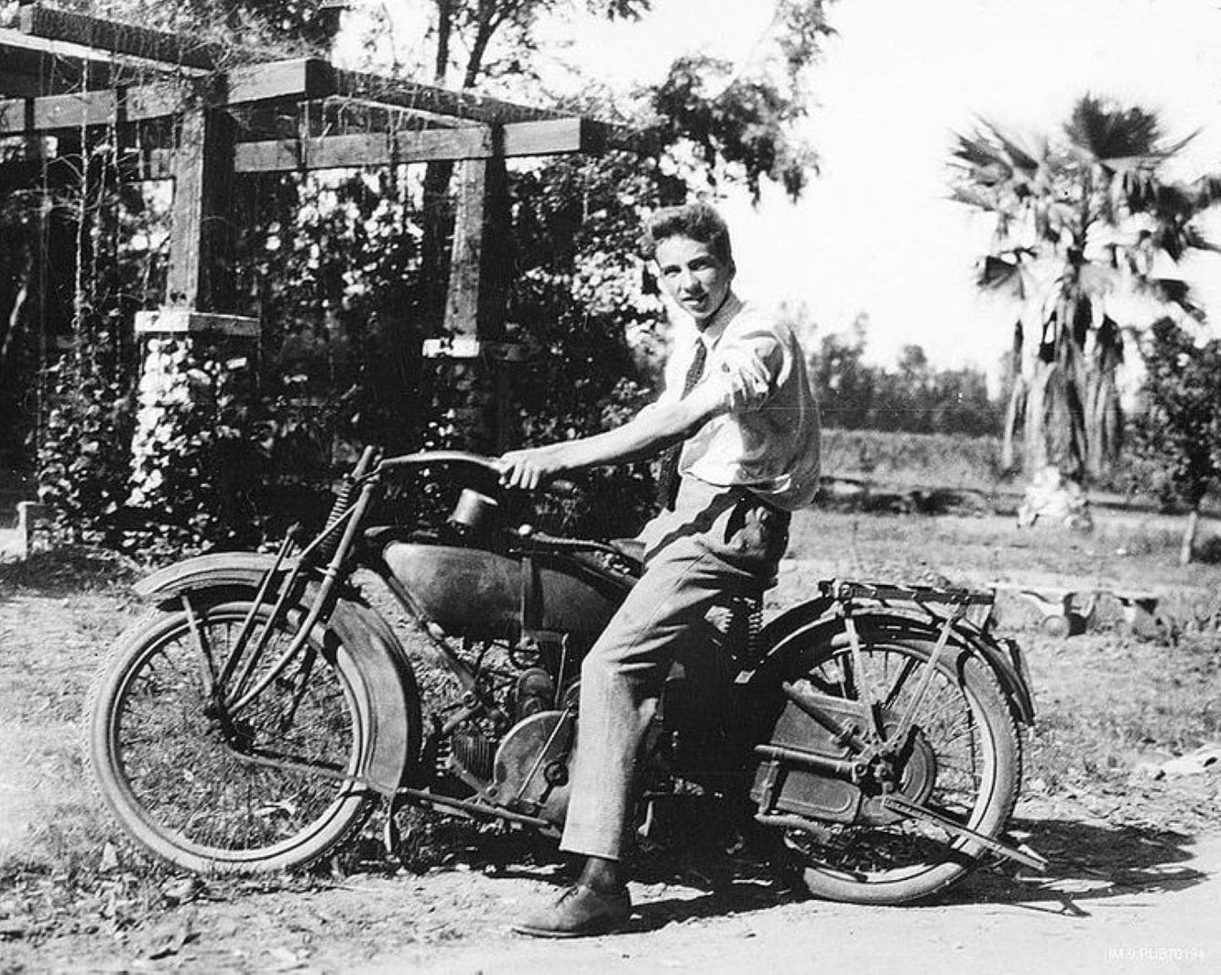

The Gift (short story) Ray Bradbury

The Gift

Tomorrow would be Christmas, and even while the three of them rode to the rocket port the mother and father were worried. It was the boy’s first flight into space, his very first time in a rocket, and they wanted everything to be perfect.

So when, at the customs table, they were forced to leave behind his gift, which exceeded the weight limit by no more than a few ounces, and the little tree with the lovely white candles, they felt themselves deprived of the season and their love.

The boy was waiting for them in the terminal room. Walking toward him, after their unsuccessful clash with the Inter-planetary officials, the mother and father whispered to each other.

“What shall we do?”

“Nothing, nothing. What can we do?”

“Silly rules!”

“And he so wanted the tree!”

The siren gave a great howl and people pressed forward into the Mars Rocket. The mother and father walked at the very last, their small pale son between them, silent.

“I’ll think of something,” said the father.

“What…?” asked the boy.

And the rocket took off and they were flung headlong into dark space.

The rocket moved and left fire behind and left Earth behind on which the date was December 24, 2052, heading out into a place where there was no time at all, no month, no year, no hour. They slept away the rest of the first “day.” Near midnight, by their Earth-time New York watches, the boy awoke and said, “I want to go look out the porthole.”

There was only one port, a “window” of immensely thick glass of some size, up on the next deck.

“Not quite yet,” said the father. “I’ll take you up later.”

“I want to see where we are and where we’re going.”

“I want you to wait for a reason,” said the father.

He had been lying awake, turning this way and that, thinking of the abandoned gift, the problem of the season, the lost tree and the white candles. And at last, sitting up, no more than five minutes ago, he believed he had found a plan. He need only carry it out and the journey would be fine and joyous indeed.

“Son,” he said, “in exactly one half-hour it will be Christmas.”

“Oh,” said the mother, dismayed that he had mentioned it. Somehow she had rather hoped that the boy would forget.

The boy’s face grew feverish and his lips trembled. “I know, I know. Will I get a present, will I? Will I have a tree? Will I have a tree? You promised —“

“Yes, yes, all that, and more.” said the father.

The mother started. “But —“

“I mean it,” said the father. “I really mean it. All and more, much more. Excuse me, now. I’ll be back.”

He left them for about twenty minutes. When he came back, he was smiling. “Almost time.”

“Can I hold your watch?” asked the boy, and the watch was handed over and he held it ticking in his fingers as the rest of the hour drifted by in fire and silence and unfelt motion.

“It’s Christmas now! Christmas! Where’s my present?”

“Here we go,” said the father and took his boy by the shoulder and led him from the room, down the hall, up a rampway, his wife following.

“I don’t understand,” she kept saying.

“You will. Here we are,” said the father.

They had stopped at the closed door of a large cabin. The father tapped three times and then twice in a code. The door opened and the light in the cabin went out and there was a whisper of voices.

“Go on in, son,” said the father.

“It’s dark.”

“I’ll hold your hand. Come on, Mama.”

They stepped into the room and the door shut, and the room was very dark indeed. And before them loomed a great glass eye, the porthole, a window four feet high and six feet wide, from which they could look out into space.

The boy gasped.

Behind him, the father and the mother gasped with him, and then in the dark room some people began to sing.

“Merry Christmas, son,” said the father.

And the voices in the room sang the old, the familiar carols, and the boy moved slowly until his face was pressed against the cool glass of the port. And he stood there for a long, long time, just looking and looking out into space and the deep night at the burning and the burning of ten billion, billion white and lovely candles….

The end