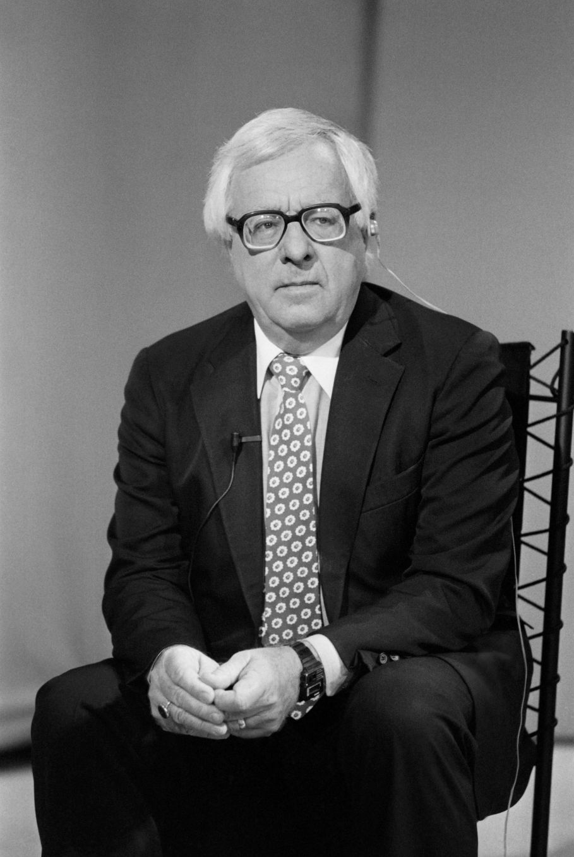

The Golden Kite, the Silver Wind, Ray Bradbury

The Golden Kite, the Silver Wind

‘In the shape of a pig?’ cried the Mandarin.

‘In the shape of a pig,’ said the messenger, and departed.

‘Oh, what an evil day in an evil year,’ cried the Mandarin. ‘the town of Kwan-Si, beyond the hill, was very small in my childhood. Now it has grown so large that at last they are building a wall.’

‘But why should a wall two miles away make my good father sad and angry all within the hour?’ asked his daughter quietly.

‘They build their wall,’ said the Mandarin, ‘in the shape of a pig! Do you see? Our own city wall is built in the shape of an orange. That pig will devour us, greedily!’

‘Ah.’

They both sat thinking.

Life was full of symbols and omens. Demons lurked everywhere, Death swam in the wetness of an eye, the turn of a gull’s wing meant rain, a fan held so, the tilt of a roof, and, yes, even a city wall was of immense importance. Travelers and tourists, caravans, musicians, artists, coming upon these two towns, equally judging the portents, would say, ‘The city shaped like an orange? No! I will enter the city shaped like a pig and prosper, eating all, growing fat with good luck and prosperity!’

The Mandarin wept. ‘All is lost! These symbols and signs terrify. Our city will come on evil days.’

‘Then,’ said the daughter, ‘call in your stonemasons and temple builders. I will whisper from behind the silken screen and you will know the words.’

The old man clapped his hands despairingly. ‘Ho, stonemasons! Ho, builders of towns and palaces!’

The men who knew marble and granite and onyx and quartz came quickly. The Mandarin faced them most uneasily, himself waiting for a whisper from the silken screen behind his throne. At last the whisper came.

‘I have called you here,’ said the whisper.

‘I have called you here,’ said the Mandarin aloud, ‘because our city is shaped like an orange, and the vile city of Kwan-Si has this day shaped theirs like a ravenous pig—’

Here the stonemasons groaned and wept. Death rattled his cane in the outer courtyard. Poverty made a sound like a wet cough in the shadows of the room.

‘And so,’ said the whisper, said the Mandarin, ‘you raisers of walls must go bearing trowels and rocks and change the shape of our city!’

The architects and masons gasped. The Mandarin himself gasped at what he had said. The whisper whispered. The Mandarian went on: ‘And you will change our walls into a club which may beat the pig and drive it off!’

The stonemasons rose up, shouting. Even the Mandarin, delighted at the words from his mouth, applauded, stood down from his throne. ‘Quick!’ he cried. ‘To work!’

When his men had gone, smiling and bustling, the Mandarin turned with great love to the silken screen. ‘Daughter,’ he whispered. ‘I will embrace you.’ There was no reply. He stepped around the screen, and she was gone.

Such modesty, he thought. She has slipped away and left me with a triumph, as if it were mine.

The news spread through the city; the Mandarin was acclaimed. Everyone carried stone to the walls. Fireworks were set off and the demons of death and poverty did not linger, as all worked together. At the end of the month the wall had been changed. It was now a mighty bludgeon with which to drive pigs, boars, even lions, far away. The Mandarin slept like a happy fox every night.

‘I would like to see the Mandarin of Kwan-Si when the news is learned. Such pandemonium and hysteria; he will likely throw himself from a mountain! A little more of that wine, oh Daughter-who-thinks-like-a-son.’

But the pleasure was like a winter flower; it died swiftly. That very afternoon the messenger rushed into the courtroom. ‘Oh Mandarin, disease, early sorrow, avalanches, grasshopper plagues, and poisoned well water!’

The Mandarin trembled.

‘The town of Kwan-Si,’ said the messenger, ‘which was built like a pig and which animal we drove away by changing our walls to a mighty stick, has now turned triumph to winter ashes. They have built their city’s walls like a great bonfire to burn our stick!’

The Mandarin’s heart sickened within him, like an autumn fruit upon the ancient tree. ‘Oh, gods! Travelers will spurn us. Tradesmen, reading the symbols, will turn from the stick, so easily destroyed, to the fire, which conquers all!’

‘No,’ said a whisper like a snowflake from behind the silken screen.

‘No,’ said the startled Mandarin.

‘Tell my stonemasons,’ said the whisper that was a falling drop of rain, ‘to build our walls in the shape of a shining lake.’

The Mandarin said this aloud, his heart warmed.

‘And with this lake of water,’ said the whisper and the old man, ‘we will quench the fire and put it out forever!’

The city turned out in joy to learn that once again they had been saved by the magnificent Emperor of ideas. They ran to the walls and built them nearer to this new vision, singing, not as loudly as before, of course, for they were tired, and not as quickly, for since it had taken a month to rebuild the wall the first time, they had had to neglect business and crops and therefore were somewhat weaker and poorer.

There then followed a succession of horrible and wonderful days, one in another like a nest of frightening boxes.

‘Oh, Emperor,’ cried the messenger, ‘Kwan-Si has rebuilt their walls to resemble a mouth with which to drink all our lake!’

‘Then,’ said the Emperor, standing very close to his silken screen, ‘build our walls like a needle to sew up that mouth!’

‘Emperor!’ screamed the messenger. ‘They make their walls like a sword to break your needle!’

The Emperor held, trembling, to the silken screen. ‘Then shift the stones to form a scabbard to sheathe that sword!’

‘Mercy,’ wept the messenger the following morn, ‘they have worked all night and shaped their walls like lightning which will explode and destroy that sheath!’

Sickness spread in the city like a pack of evil dogs. Shops closed. The population, working now steadily for endless months upon the changing of the walls, resembled Death himself, clattering his white bones like musical instruments in the wind. Funerals began to appear in the streets, though it was the middle of summer, a time when all should be tending and harvesting.

The Mandarin fell so ill that he had his bed drawn up by the silken screen and there he lay, miserably giving his architectural orders. The voice behind the screen was weak now, too, and faint, like the wind in the eaves.

‘Kwan-Si is an eagle. Then our walls must be a net for that eagle. They are a sun to burn our net. Then we build a moon to eclipse their sun!’

Like a rusted machine, the city ground to a halt.

At last the whisper behind the screen cried out:

‘In the name of the gods, send for Kwan-Si!’

Upon the last day of summer the Mandarin Kwan-Si, very ill and withered away, was carried into our Mandarin’s courtroom by four starving footmen. The two mandarins were propped up, facing each other. Their breaths fluttered like winter winds in their mouths. A voice said:

‘Let us put an end to this.’

The old men nodded.

‘This cannot go on,’ said the faint voice. ‘Our people do nothing but rebuild our cities to a different shape every day, every hour. They have no time to hunt, to fish, to love, to be good to their ancestors and their ancestors’ children.’

‘This I admit,’ said the mandarins of the towns of the Cage, the Moon, the Spear, the Fire, the Sword and this, that, and other things.

‘Carry us into the sunlight,’ said the voice.

The old men were borne out under the sun and up a little hill. In the late summer breeze a few very thin children were flying dragon kites in all the colors of the sun, and frogs and grass, the color of the sea and the color of coins and wheat.

The first Mandarin’s daughter stood by his bed.

‘See,’ she said.

‘Those are nothing but kites,’ said the two old men.

‘But what is a kite on the ground?’ she said. ‘It is nothing. What does it need to sustain it and make it beautiful and truly spiritual?’

‘The wind, of course!’ said the others.

‘And what do the sky and the wind need to make them beautiful?’

‘A kite, of course—many kites, to break the monotony, the sameness of the sky. Colored kites, flying!’

‘So,’ said the Mandarin’s daughter. ‘You, Kwan-Si, will make a last rebuilding of your town to resemble nothing more nor less than the wind. And we shall build like a golden kite. The wind will beautify the kite and carry it to wondrous heights.

And the kite will break the sameness of the wind’s existence and give it purpose and meaning. One without the other is nothing. Together, all will be beauty and co-operation and a long and enduring life.’

Whereupon the two mandarins were so overjoyed that they took their first nourishment in days, momentarily were given strength, embraced, and lavished praise upon each other, called the Mandarin’s daughter a boy, a man, a stone pillar, a warrior, and a true and unforgettable son.

Almost immediately they parted and hurried to their towns, calling out and singing, weakly but happily.

And so, in time, the towns became the Town of the Golden Kite and the Town of the Silver Wind. And harvestings were harvested and business tended again, and the flesh returned, and disease ran off like a frightened jackal.

And on every night of the year the inhabitants in the town of the Kite could hear the good clear wind sustaining them. And those in the Town of the Wind could hear the kite singing, whispering, rising, and beautifying them.

‘So be it,’ said the Mandarin in front of his silken screen.

The end