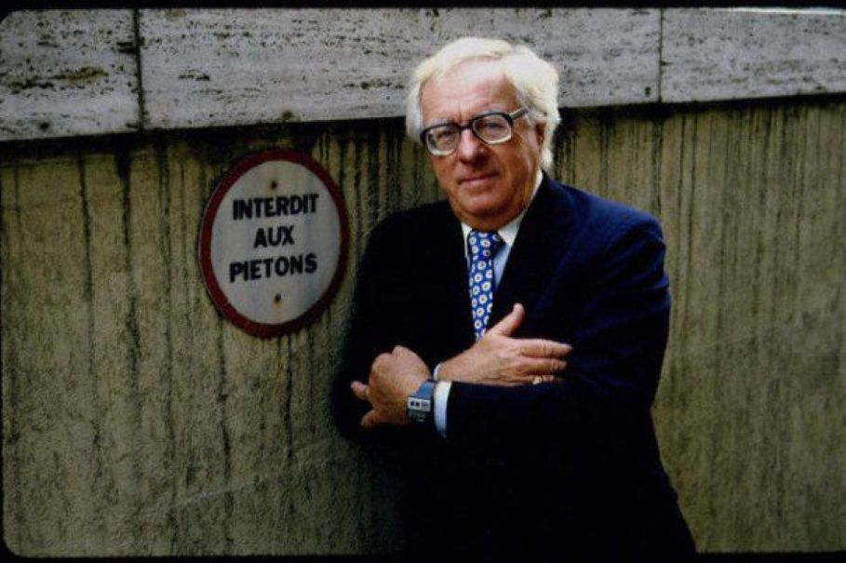

The Headpiece, Ray Bradbury

The Headpiece

THE parcel arrived in the late afternoon mail. Mr Andrew Lemon knew what was inside by shaking it. It whispered in there like a large hairy tarantula.

It took him some time to get up his courage, tremble the wrappings open, and remove the lid from the white cardboard box.

There the bristly thing lay on its snowy tissue bed, as imper¬sonal as the black horsechair clock-springs stuffed in an old sofa. Andrew Lemon chuckled.

'Indians come and gone, left this piece of a massacre behind as a sign, a warning. Well. There!'

And he fitted the new patent-leather black shining toupee to his naked scalp. He tugged at it like someone touching his cap to passers-by.

The toupee fitted perfectly, covering the neat coin-round hole which marred the top of his brow. Andrew Lemon gazed at the strange man in the mirror and yelled with delight.

'Hey there, who're you? Face's familiar, but, by gosh now, pass you on the street without looking twice! Why? Because,

it's gone! Darn hole's covered, nobody'd guess it was ever there. Happy New Year, man, that's what it is, Happy New Year!'

He walked around and around his little apartment, smiling, needing to do something, but not yet ready to open the door and surprise the world. He walked by the mirror, glancing sidewise at someone going past there, and each time laughed and shook his head. Then he sat down in the rocker and rocked, grinning, and tried to look at a couple of copies of Wild West Weekly and then Thrilling Movie Magazine.

But he couldn't keep his right hand from crawling up along his face, tremulously, to feel at the rim of that crisp new sedge above his ears.

'Let me buy you a drink, young fellow!'

He opened the fly-specked medicine cabinet and took three gulps from a bottle. Eyes watering, he was on the verge of cut¬ting himself a chew of tobacco when he stopped, listening.

Outside, in the dark hallway, there was a sound like a field-mouse moving softly, daintily on the threadbare carpeting.

'Miss Fremwell!' he said to the mirror.

Suddenly the toupee was off his head and into the box as if, frightened, it had scuttled back there of itself. He clapped the lid down, sweating cold, afraid of even the sound that woman made moving by like a summer breeze.

He tiptoed to the door that was nailed shut in one wall and bent his raw and now furiously blushing head. He heard Miss Fremwell unlock her door and shut it and move delicately about her room with little tinkles of chinaware and chimes of cutlery, turning in a merry-go-round to make her dinner.

He backed away from that door that was bolted, locked, latched, and driven shut with its four-inch hard-steel nails. He thought of the nights he had flinched in bed, thinking he heard her quietly pulling out the nails, pulling out the nails, touching at the bolts and slithering the latch . . . And how it always took him an hour to turn away towards sleep after that.

Now she would rustle about her room for an hour or so. It would grow dark. The stars would be out and shining when he tapped on her door and asked if she'd sit on the porch or walk in the park. Then the only way she could possibly know of this third blind and staring eye in his head would be to run her hand in a Braille-like motion there. But her small white fingers had never moved within a thousand miles of that scar which was no more to her than, well, one of those pockmarks off on the full moon tonight. His toe brushed a copy of Wonder Science Tales.

He snorted. Perhaps if she thought at all of his damaged head — she wrote songs and poems, didn't she, once in a while? — she figured that a long time back a meteor had run and hit him and vanished up there where there were no shrubs or trees, where it was just white, above his eyes. He snorted again and shook his head. Perhaps, perhaps. But however she thought, he would see her only when the sun had set.

He waited another hour, from time to time spitting out the window into the warm summer night.

'Eight-thirty. Here goes.'

He opened the hall door and stood for a moment looking back at that nice new toupee hidden in its box. No, he still could not bring himself to wear it.

He stepped along the hall to Miss Naomi Fremwell's door, a door so thinly made it seemed to beat with the sound of her small heart there behind it.

'Miss Fremwell,' he whispered.

He wanted to cup her like a small white bird in his great bowled hands, speak soft to her quietness. But then, in wiping the sudden perspiration from his brow, he found again the pit and only at the last quick moment saved himself from falling over, in, and screaming, down! He clapped his hand to that place to cover that emptiness. After he had held his hand tight tight to the hole for a long moment he was then afraid to pull his hand away. It had changed. Instead of being afraid he might fall in there, he was afraid something terrible, something secret, something private, might gush out and drown him.

He brushed his free hand across her door, disturbing little more than dust.

'Miss Fremwell?'

He looked to see if there were too many lamps lit under her doorsill, the light of which might strike out at him when she swung the door wide. The very thrust of lamplight alone might knock his hand away, and reveal that sunken wound. Then mightn't she peer through it like a keyhole, into his life?

The light was dim under the doorsill.

He made a fist of one hand and brought it down gently, three times, on Miss Fremwell's door.

The door opened and moved slowly back.

Later, on the front porch, feverishly adjusting and re-adjust¬ing his senseless legs, perspiring, he tried to work around to ask¬ing her to marry him. When the moon rose high, the hole in his brow looked like a leaf-shadow fallen there. If he kept one profile to her, the crater did not show, it was hidden away over on the other side of his world. It seemed that when he did this, though, he only had half as many words and felt only half a man.

'Miss Fremwell,' he managed to say, at last.

'Yes?' She looked at him as if she didn't quite see him.

'Miss Naomi, I don't suppose you ever really noticed me, lately.'

She waited. He went on.

'I've been noticing you. Fact is, well, I might as well put it right out on the line and get it over with. We been sitting out here on the porch for quite a few months. I mean we've known each other a long time. Sure, you're good fifteen years younger than me, but would there be anything wrong with our getting engaged, do you think?'

'Thank you very much, Mr Lemon,' she said quickly. She was very polite. 'But — '

'Oh, I know,' he said, edging forward with the words. 'I know! It's my head, it's always this darn thing up here on my head!'

She looked at his turned-away profile in the uncertain light.

'Why, no, Mr Lemon, I don't think I would say that, I don't think that's it at all. I have wondered a bit about it, certainly, but I don't think it's an interference in any way. A friend of mine, a very dear friend, married a man once, I recall, who had a wooden leg. She told me she didn't even know he had it, after a while.'

'It's always this darn hole,' cried Mr Lemon bitterly. He took out his plug of tobacco, looked at it as if he might bite it, decided not to and put it away. He formed a couple of fists and stared at them bleakly as if they were big rocks. 'Well, I'll tell you all about it, Miss Naomi. I'll tell you how it happened.'

'You don't have to if you don't want.'

'I was married once, Miss Naomi. Yes, I was, darn it. And one day my wife she just took hold of a hammer and hit me right on the head!'

Miss Fremwell gasped. It was as if she had been struck her¬self.

Mr Lemon brought one clenching fist down through the warm air.

'Yes, ma'am, she hit me straight-on with that hammer, she did. I tell you, the world blew up on me. Everything fell down on me. It was like the house coming down in one heap. That one little hammer buried me, buried me! The pain? I can't tell you!'

Miss Fremwell turned in on herself. She shut her eyes and thought, biting her lips. Then she said, 'Oh, poor Mr Lemon.'

'She did it so calm,' said Mr Lemon, puzzled. 'She just stood over me where I lay on the couch and it was a Tuesday afternoon about two o'clock and she said, "Andrew, wake up!" and I opened my eyes and looked at her is all and then she hit me with that hammer. Oh, Lord.'

'But why?' asked Miss Fremwell.

'For no reason, no reason at all. Oh, what an ornery woman.'

'But why should she do a thing like that?' said Miss Fremwell.

'I told you: for no reason.'

'She was crazy?'

'Must have been. Oh, yes, she must of been.'

'Did you prosecute her?'

'Well, no, I didn't. After all, she didn't know what she was doing.'

'Did it knock you out?'

Mr Lemon paused and there it was again, so clear, so tall, in his mind, the old thought of it. Seeing it there, he put it in words.

'No, I remember just standing up, I stood up and I said to her, "What'd you do?" and I stumbled towards her. There was a mirror. I saw the hole in my head, deep, and blood coming out. It made an Indian of me. She just stood there, my wife did. And at last she screamed three kinds of horror and dropped that hammer on the floor and ran out the door.'

'Did you faint then?'

'No. I didn't faint. I got out on the street some way and I mumbled to somebody I needed a doctor. I got on a bus, mind you, a bus! And paid my fare! And said to leave me by some doctor's house downtown. Everybody screamed, I tell you. I got sort of weak then, and next thing I knew the doctor was working on my head, had it cleaned out like a new thimble, like a bunghole in a barrel . . . '

He reached up and touched that spot now, fingers hovering over it as a delicate tongue hovers over the vacated area where once grew a fine tooth.

'A neat job. The doctor kept staring at me, too, as if he ex¬pected me to fall down dead any minute.'

'How long did you stay in the hospital?'

'Two days. Then I was up and around, feeling no better, no worse. By that time my wife had picked up and skedaddled.'

'Oh, my goodness, my goodness,' said Miss Ffemwell, recover¬ing her breath. 'My heart's going like an eggbeater. I can hear and feel and see it all, Mr Lemon. Why, why, oh, why did she do it?'

'I already told you, for no reason I could see. She was just took with a notion, I guess.'

'But there must have been an argument — ?'

Blood drummed in Mr Lemon's cheeks. He felt that place up there on his head glow like a fiery crater. 'There wasn't no argument. I was just sitting, peaceful as you please. I like to sit, my shoes off, my shirt unbuttoned, afternoons.'

'Did you — did you know any other women?'

'No, never, none!'

'You didn't — drink?'

'Just a nip once in a while, you know how it is.'

'Did you gamble?'

'No, no, no!'

'But a hole punched in your head like that, Mr Lemon, my land, my land! All over nothing?'

'You women are all alike. You see something and right off you expect the worst. I tell you there was no reason. She just fancied hammers.'

'What did she say before she hit you?'

'Just "Wake up, Andrew".'

'No, before that.'

'Nothing. Not for half an hour or an hour, anyway. Oh, she said something about wanting to go shopping for something or other, but I said it was too hot. I'd better lie down, I didn't feel so good. She didn't appreciate how I felt. She must have got mad and thought about it for an hour and grabbed that hammer and come in and gone kermash. I think the weather got her, too.'

Miss Fremwell sat back thoughtfully in the lattice shadow, her brows moving slowly up and then slowly down.

'How long were you married to her?'

'A year. I remember we got married in July and in July it was I got sick.'

'Sick?'

'I wasn't a well man. I worked in a garage. Then I got these backaches so I couldn't work and had to lie down afternoons. Elbe, she worked in the First National Bank.'

'I see,' said Miss Fremwell.

'What?'

'Nothing,' she said.

'I'm an easy man to get on with. I don't talk too much. I'm easy-going and relaxed. I don't waste money. I'm economical. Even Ellie had to admit that. I don't argue. Why, sometimes Ellie would jaw at me and jaw at me, like bouncing a ball hard on a house, but me not bouncing back. I just sat. I took it easy. What's the use of always stirring around and talking, right?'

Miss Fremwell looked over at Mr Lemon's brow in the moon¬light. Her lips moved but he could not hear what she said.

Suddenly, she straightened up and took a deep breath and blinked around surprised to see the world out beyond the porch lattice. The sounds of traffic came in. to the porch now, as if they had been tuned up, they had been so quiet for a time. Miss Fremwell took a deep breath and let it out.

'As you yourself say, Mr Lemon, nobody ever got anywhere arguing.'

'Right!' he said. 'I'm easy-going, I tell you — '

But Miss Fremwell's eyes were lidded now and her mouth was strange. He sensed this and tapered off.

A night wind blew fluttering her light summer dress and the sleeves of his shirt.

'It's late,' said Miss Fremwell.

'Only nine o'clock!'

'I have to get up early tomorrow.'

'But you haven't answered my question yet, Miss Frem¬well.'

'Question?' She blinked. 'Oh, the question. Yes.' She rose from the wicker seat. She hunted around in the dark for the screen doorknob. 'Oh now, Mr Lemon, let me think it over.'

'That's fair enough,' he said. 'No use arguing, is there?'

The screen door closed. He heard her find her way down the dark warm hall. He breathed shallowly, feeling of the third eye in his head, the eye that saw nothing.

He felt a vague unhappiness shift around inside his chest like an illness brought on by too much talking. And then he thought of the fresh white gift-box waiting with its lid on in his room. He quickened. Opening the screen door he walked down the silent hall and went into his room. Inside, he slipped and almost fell on a slick copy of True Romance Tales.

He switched on the light, excitedly, smiling, fumbled the box open and lifted the toupee from the tissues. He stood before the bright mirror and followed directions with the spirit gum and tapes, and tucked it here and stuck it there and shifted it again and combed it neat. Then he opened the door and walked along the hall to knock for Miss Fremwell.

'Miss Naomi?' he called, smiling.

The light under her door clicked out at the sound of his voice.

He stared at the dark keyhole with disbelief.

'Oh, Miss Naomi?' he said again, quickly.

Nothing happened in the room. It was dark. After a moment he tried the knob, experimentally. The knob rattled. He heard Miss Fremwell sigh. He heard her say something. Again, the words were lost. Her small feet tapped to the door. The light came on.

'Yes?' she said, behind the panel.

'Look, Miss Naomi,' he entreated. 'Open the door. Look.'

The bolt of the door snapped back. She jerked the door open about an inch. One of her eyes looked at him sharply.

'Look,' he announced proudly, adjusting the toupee so it very definitely covered the sunken crater. He imagined he saw him¬self in her bureau mirror and was pleased. 'Look here, Miss Fremwell!'

She opened the door a bit wider and looked. Then she slam¬med the door and locked it. From behind the thin panelling, her voice was toneless.

'I can still see the hole, Mr Lemon,' she said.

The end