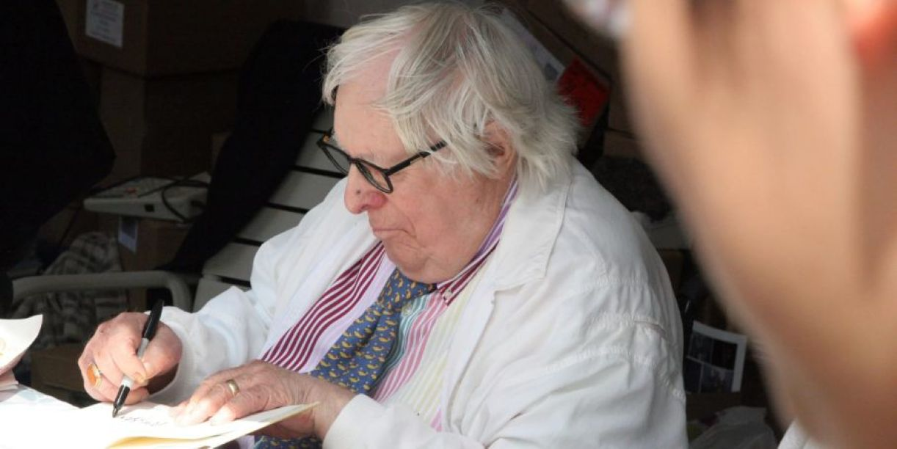

The Highest Branch on the Tree, Ray Bradbury

The Highest Branch on the Tree

A often remember his name, Harry Hands, a most unfortunate name for a fourteen-year-old boy in ninth grade in junior high in 1934, or in any other year, come to think of it.

We all spelled it 'Hairy' and pronounced it with similar emphasis.

Harry Hands pretended not to notice and became more arrogant and smart-ass, looking down his nose at us dumb peasants, as he called us.

We didn't see at the time that it was our harassment that made him pretend at arrogance and display wits that he probably only half had. So it went with Hands and his incredible moniker Hairy.

The second memory is often of his pants up a tree. That has stayed with me for a lifetime. I have never for a month forgotten. I can't very well say I recalled his pants up a tree every day, that would not be true.

But at least twelve times a year I would see Harry in full flight and us ninth graders after him, myself in the lead, and his pants in the air flung up to the highest branch and everyone laughing there on the school grounds and a teacher leaning out a window and ordering one of us, why not me, to climb and bring those pants down.

"Don't bother," Harry Hands said, blushing there, revealed in his boxer BVD underwear. "They're mine.I'llget 'em."

And Harry Hands climbed up, almost fell, and reached his pants but did not put them on, just clutched to the bole of the tree and when we all gathered below the tree, knocking each other's elbows and pointing up and laughing, simply looked down at us with the strangest grin and ...

Peed.

That's right.

Took aim and peed.

There was a mob flight of indignant teenagers, off away, but no one came back to climb up and drag him down, for when we started to come back, wiping our faces and shoulders with handkerchiefs, Harry yelled down:

"I hadthreeglasses of orange juice for lunch!"

So we knew he was still loaded and we all stood thirty feet back from the tree yelling euphemisms instead of epithets, the way our folks had taught us. After all, it was another time, another age, and the rules were observed.

Harry Hands did not put on his pants up there nor did he come down even though the principal came out and ordered him to leave and we backed off and heard the principal shouting up at Harry that the way was clear now and he could come down. But Harry Hands shook his head: noway.And the principal stood under the tree and we yelled to him to watch out, Harry Hands was armed and dangerous and hearing this the principal backed off, hastily.

Well, the long and short of it was, Harry Hands never came down, that is, we didn't see him do it, and we all got bored and went home.

Someone later said he came down at sunset or midnight, with no one around to see.

The next day, the tree was empty and Harry Hands was gone forever.

He never came back. He didn't even come back to protest to the principal, nor did his parents come or write a letter to lodge a complaint. We didn't know where Harry Hands lived, and the school wouldn't tell us, so we couldn't go find him, perhaps with the faintest notion that maybe we should apologize and ask him back. We knew he wouldn't come, anyway. What we had done was so horrendous, it could never be forgiven.

As the days passed and Harry Hands didn't show, most of us lay in bed at night and wondered howwewould feel if someone had "pantsed" us and threw our pants to the highest branch of some tree in front of God and everyone. It caused a lot of unexpected bed tossing and pillow punching, I don't mind saying. And most of us didn't look up at that tree for more than a few seconds before turning away.

Did any of us ever sweat over the dire consequences? Did we perspire on the obvious that perhaps he might have fallen just at midnight, to be harvested as broken bones at dawn? Or did we imagine he might have lurched himself out in a high-jump of doom, with the same shattered consequence? Did we think his father might lose his job or his mother take to drink?

We wrestled none of these or if we did, shut our traps to preserve our silent guilt. Thunder, as you know, occurs when lightning sucks back up its track and lets two handsful of white-hot air applaud. Harry Hands, whose parents were never seen, withdrew to a bang of thunder that only we ninth-grade second-rate criminals heard while waiting for sleep, which never came, to arrive.

It was a bad end to a good year and we all went off to high school and a few years later, going by the schoolyard, I saw that the tree had got some sort of disease and had been cut down, which was a relief. I didn't want some future generation to be surprised at the ghost shape of a pair of pants up there, hurled by a mob of apes.

But I run ahead of my story.

Why, you ask, why did we do that to Harry Hands? Was he some sort of super-villain who deserved our Christian persecution, a dumb sort of semi-crucifixion to appall the neighbors and ruin school history so that in the annals of time people would say, "1934, wasn't that the year that—" And fill in the blanks with Look, ma, no pants, no Hands.

What, in sum, was H.H.'s crime sublime?

It's a familiar case. Happens every year, every school, everywhere at one time or another. Except our case was more spectacular.

Harry Hands was smarter than anyone else in the whole school.

That was the first crime.

His second crime, worse than the first, was he didn't do a better job of hiding it.

It reminds me of an actor friend who a few years ago drove up to the front of my house in a brand-new super-powered XKE twelve-cylinder Jaguar and yelled at me, "Eat your heart out!"

Well, Harry Hands, in effect, had arrived at our school from somewhere back East—hadn't we all?—and flaunted his IQ from the first hour of day one.

Through every class from just after breakfast to just before lunch to last afternoon bell his arm was permanently up, you could have raised a flag on it, and his voice was demanding to be heard and damn if he wasn't right when the teacher gave him the nod.

A lot of collective bile was manufactured that day under all our tongues. The miracle was we didn't rip his clothes off on that first day.

We delayed because it was reported that in gym he had put on the boxing gloves and bloodied three or four noses before our coach told everyone to run out and do six laps around the block to lance our boils.

And, Jesus off the cross and running rings around us, wouldn't you know as we made the fifth lap, panting, tasting blood, here came Harry Hands, fresh as a potted daisy, jogging along, nice and easy, passing us and adding another lap to prove he was tireless.

By the end of the second day he had no friends. No one eventriedto be one. It was hinted that if anyone took up with this Hands guy, we would beat the tar out of them next time we did laps and were out of sight of our coach.

So Harry Hands came and went alone, with a look of the insufferable book reader and, worse, book rememberer, he forgot nothing and would offer data if someone paused, stuttered, or broke wind.

Did Harry Hands see his crucifixion coming? If he did, he smiled at the prospect. He was always smiling and laughing and being a good chum, although no one smiled or laughed back. We took our homework home. He did it in class in the last five minutes of the hour and then sat there, mightily pleased with his intellectual strengths, moistening his vocal chords for the next recitation.

Fade out. Fade in.

We all went away to life.

After about forty years it got so I only thought about Harry Hands once every two years instead of once every two months. It was in the middle of a sidewalk in downtown Chicago where I walked when I had two hours between trains, on my way to New York, that I met this stranger coming toward me, unrecognizable, and he had almost passed when he froze in midstride and half turned to me and said:

"Spaulding?" he said. "DouglasSpaulding?"

It was my turn to freeze and I mean I turned cold, for I had this ungodly feeling I was confronted by a ghost. A whole flock of geese ran over my grave. I cocked my head and eyed the stranger. He was dressed in a beautifully tailored blue-black suit with a silk shirt and a reticent tie. His hair was dark and moderately gray at the temples and he smelled of a mild cologne. He held out a well-manicured hand.

"Harry Hinds," he said.

"I don't think … " I said.

"YouareDouglas Spaulding, aren't you?"

"Yes, but—"

"Berendo Junior High School, class of summer 1935, thoughInever graduated."

"Harry," I said and stopped, his last name a stone in my mouth.

"Use to be Hands. Harry Hands. Changed it to Hinds, late spring 1935—"

Jut after you climbed down, I thought.

The wind blew around one of those Chicago corners.

I smelled pee.

I glanced to left and right. No horses in sight. No dogs.

Only Harry Hinds, aka Harry Hands waiting for me to open up.

I took his fingers as if they contained electric shocks, shook them quickly, pulled back.

"My goodness," he said. "Am I still poison?"

"No, but—"

"You look well," he said quickly. "Look as if you've had a good life. That's nice."

"You, too," I said, trying not to look at his expensively manicured nails and brightly polished shoes.

"I can't complain," he said, easily. "Where are you headed?"

"The Art Institute. I'm between trains. I have almost two hours' layover and always go to the museum to look at that big Seurat."

"It is big, isn't it, and beautiful. Mind if I come partway?"

"No, no. Please, join up."

We walked and he said, "It's on the way to my office, anyway, so we'll have to talk fast. Give me your resume, for old times' sake?"

We walked and I told. Not much for there wasn't much to detail. Fair life as a writer, nicely established, no international fame but a few fans across country and enough income to raise a family. "That's it," I said. "In a nutshell. End of resume."

"Congratulations," he said and seemed to mean it, nodding. "Well done."

"What about you?" I said.

"Well," he said, reluctantly. It was the only time in all the years, then and now, I ever saw him hesitate. He was looking sidewise at a building facade which seemed to make him nervous. I glanced over and saw:

Harry Hinds And Associates

Fifth And Sixth Floors

Harry caught my gaze and coughed. "It's nothing. I didn't mean to bring you here. Just passing—"

"My God," I said. "That's quite a building. Do you own the whole thing?'

"Own it, built it," he admitted, brightening somewhat, leaning toward the old young Harry of forty years back. "Not bad, eh?"

"Not bad at all," I said, gasping.

"Well, I'd better let you get on to the Seurat," he said, and shook my hand. "But hold on. Why not? Duck inside for just sixty seconds. Then I'll let you run. Yes?"

"Why not," I said, and he took my elbow and steered me, opening the door ahead of me and bowing a nod and leading me out into the center of a spacious marble lobby, an area some sixty feet high and eighty or ninety feet across, in the center of which was an arboretum with dense jungle foliage below and a buckshot scattering of exotic birds, but with only one singular dramatic piece in the middle.

It was a single tree of some forty or fifty feet in height, but it was hard to tell what kind of tree it was, maple, oak, chestnut, what? because there were no leaves on the tree. It was not even an autumn tree with the proper yellow and red and orange leaves. It was a barren winter tree that reached for a stark sky with empty twigs and branches.

"Ain't she a beaut?" said Harry Hinds, staring up.

"Well," I said.

"Remember when old Cap Trotter, our gym coach, used to make us go out and run around the block six or seven times to teach us manners—"

"I don't recall—"

"Yes, you do," said Harry Hinds, easily, looking at the interior sky. "Well, do you know what I used to do?"

"Beat us. Pull ahead and make the six laps. Win and not breathe hard. I remember now."

"No, you don't." Harry studied the glass roof seventy feet above. "I never ran the laps. After the first two I hid behind a parked car, waited for the last lap to come around, then jumped out and beat thehellout of all of you."

"Sothat'show you did it?" I said.

"The secret of my success," he said. "I've been jumping from behind cars on the last lap for years."

"God damn," I whispered.

"Yeah," he said, and studied the cornices of the interior court.

We stood there for a long moment, like the pilgrims at Lourdes waiting for the daily miracle. If it happened, I was not aware. But Harry Hinds was. He pointed with his nose and eyebrows up, up along that huge tree and said, "See anything up there?"

I looked and shook my head. "Nope."

"Yousure?" said Harry.

I looked again and shook my head.

"The highest branch on the tree?" said Harry.

"Nothing," I said.

"Funny." Harry Hinds snorted faintly. "How come I see it clearly?"

I did not ask what it was he was seeing.

I looked up at the bare tree in the middle of an arboretum in the center of the lobby of the Harold Hinds Foresight Corporation.

Did I expect to see the phantom outlines of a pair of pants way up there on the highest branch?

I did.

But there was nothing there. Only a high branch and no clothing.

Harry Hinds watched me looking at the tree and read my thought.

"Thanks," he said, quietly.

"What?" I said.

"Thanks to you, to all of you, for what you did," he said.

"What'd we do?" I lied.

"You know," he said, quietly. "And thanks. Come on."

And before I could protest, he led the way to the men's and raised his brows, nodding, did I need to go? I did.

Standing at the porcelains, unzipped, Harry looked down as he watered the daisies.

"You know," he smiled, "there isn't a day in my life, when I do this, that I don't remember that day forty years ago and me up the tree and you down below and me peeing on all of you. Not a day passes I don't remember. You, them, and peeing."

Standing there, I froze and did nothing.

Harry finished, zipped up, and stood remembering.

"Happiest day of my life," he said.

1997

The end